1
1. CHOOSE
المملكة العربية السعودية |  |  | اسم الطالب/ ......................................
وزارة التعليم
إدارة التعليم بمنطقة |  |  | المادة : انجليزي
مدرسة : |  |  | الزمن :
 |  |  | الصف : الثالث فصل ( )
شفهي | تحريري |  |  | المجموع
10 / | 10 / |  |  | 20 /
اختبار الفترة الأولى للفصل الأول - للعام الدراسي 1448– لغة انجليزية –– للصف الثالث
اسم الطالب / هـ الفصل /

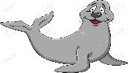
1 – What is that?
A . It's a seahorse. B . It's a seal.
2 – where do you live ?
A. I like some juice. B. I live in Riyadh .

2. CHOOSE OR
1.5

1. He can swim.

This is a computer. .2
3. The whale is small.






3. DO AS SHOWN BETWEEN BRACKETS
1.5

___________________ |  |  | 1– to - nice – you – meet . ( rearrange )
where | whose | who | 2- ______ skirt is this? It's mine. ( choose )
4. CHOOSE
1

your | my | his | 1 – I am a teacher , _____ name is Nora .
has | as | is | . As fast ___ a dolphin .2

3
5. CHOOSE
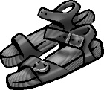 |  | 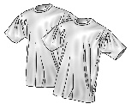 | 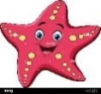 | 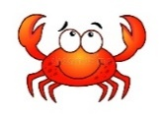  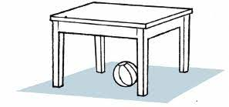 | 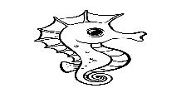
sandals | Thobe | T-shirts | starfish | fish | Seahorse
jacket | cap | Hat | cat | crab | whale

2

6.Choose the correct letter: ( ai - ea - ow - ee - oa - ou ) )

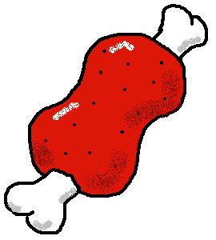 | 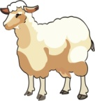 | 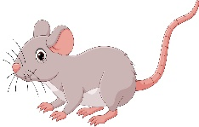 | 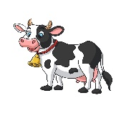
m_ _t | sh_ _ p | m_ _se | c_ _

___________________________________________________________________________________________________________________________________________________________________________________________________________________________________
Controlled writing

4

Good luck T.
III. DO AS SHOWN BETWEEN BRACKETS


Kingdom of Saudi Arabia
Ministry of Education
……..Education Directorate
………………… School
English Language
elementary Grade 3rd
period Exam
…………….\20
الاسم: الصف:

……\ 4 marks

General questions

A.Answer the questions
I am eleven years old. |  | What's your name? | 1
I live in Jeddah. |  | What are those? | 2
They are seahorses. |  | Where do you live? | 3
My name is Ali. |  | How old are you? | 4

Controlled Writing
……\ 1 marks
A-reorder.
1-a – It's - walrus
a- It‘s a walrus. b- walrus it's a .

……\ 4 marks

Reading short sentence
 | 1- He has a new computer.( )
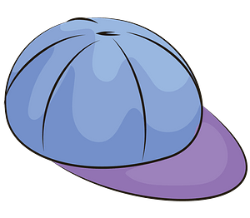 | 2- This is my T-shirt.( )
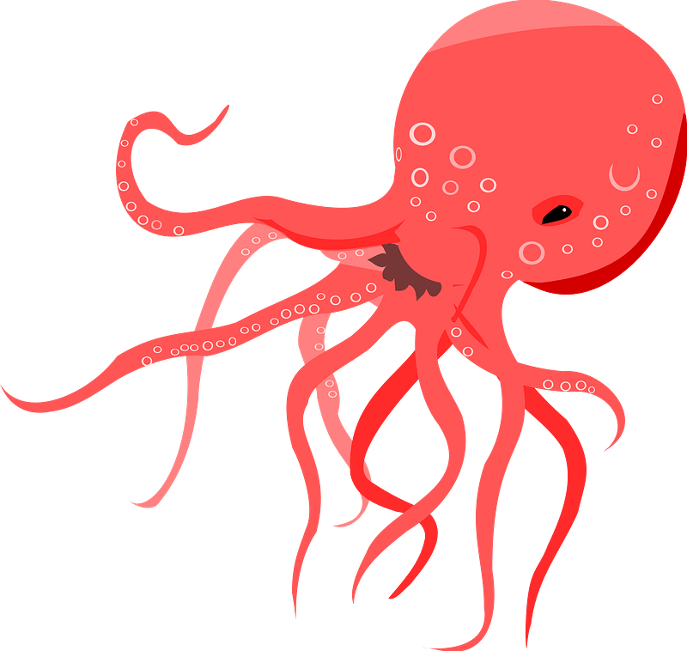 | 3- I think sharks are scary. ( )
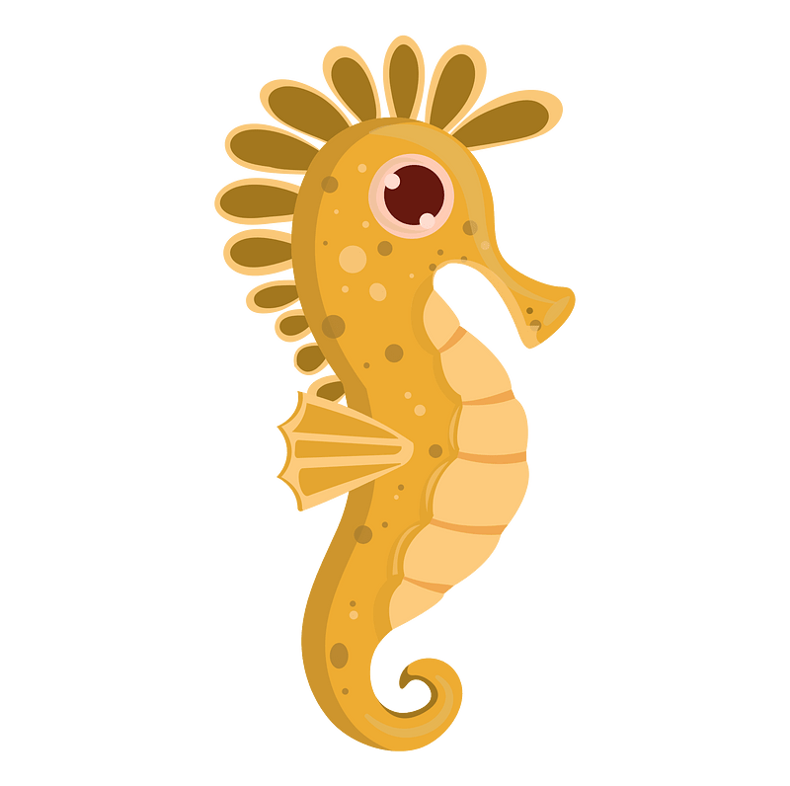 | 4- It's a seahorse ( )
A-Put ( ✔ ) or ( X )

……\ 4 marks

Grammar
A-Choose the correct answer.
c-are | b-have | a-has | 1- She ……………..a new bag.
c-am | b- my | a-mine | 2- I have a car. This car is ………………..
c- quietest | b- quiet | a- quieter | 3- A polar bear is as ………………as a fish.
c-fastest | b-faster | a-fast | 4- Sharks are……………. than whales.

Vocabulary
A.Choose the correct word under each picture
……\ 5 marks

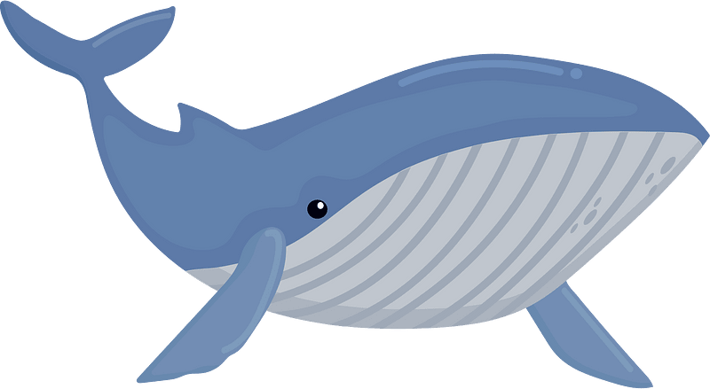 |  | 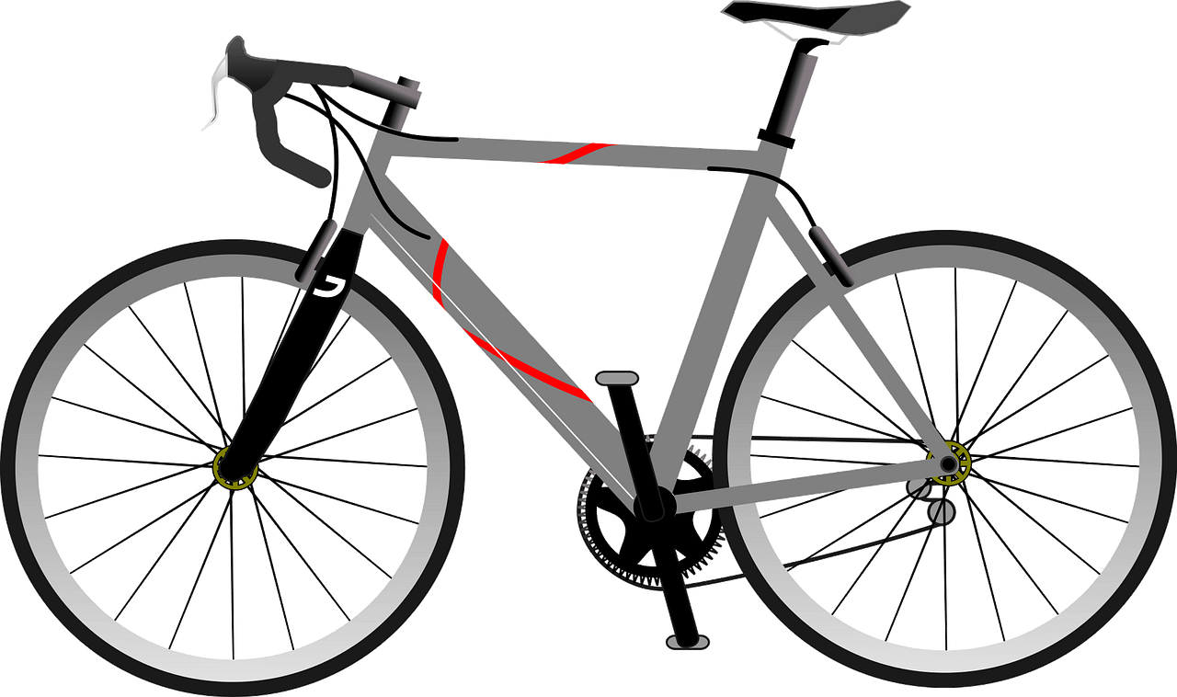 | 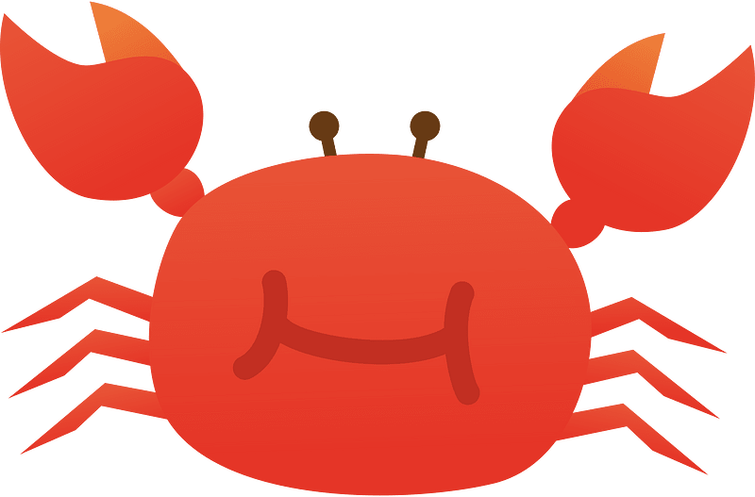 | 
starfish | pie | bicycle | eel | car
whale | rice | computer | crab | train
……\ 2 marks

Orthography
A. Fill in the missing letters


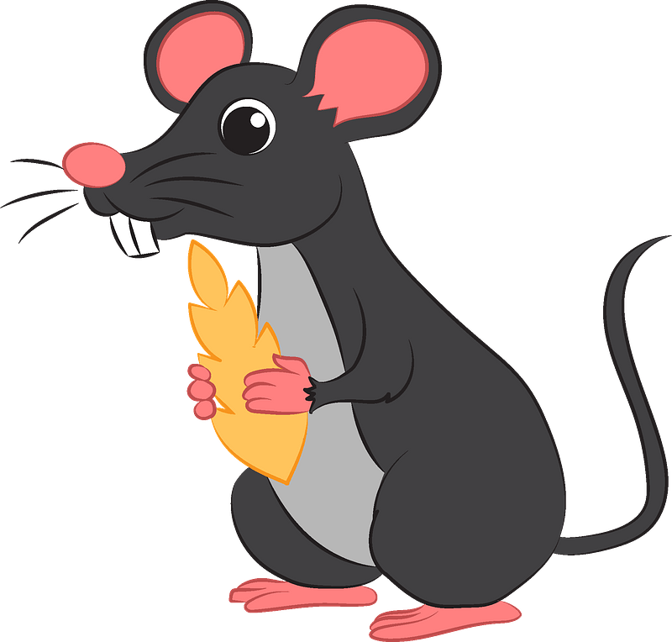
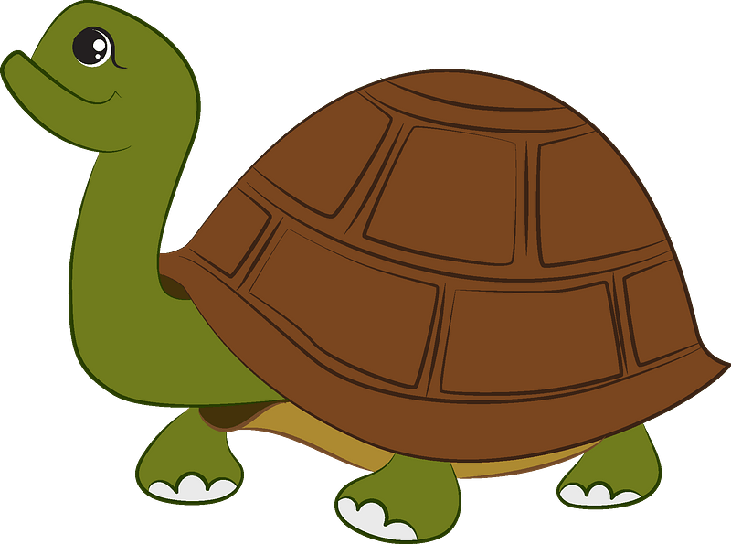

1-m……..se
( bl – kn – ou )
4-….urtle
(f - b - t )
3-t…..…
(kn – ie – cl)

2-r……..n
(bl - ee – ai)


Your teacher:

Your teacher …..:…………………………….


Kingdom of Saudi Arabia Third Elementary Grade
Ministry of Education First Term

10
……………Elementary School . . First Exam - 1448 AH
Name: ………………………………………………………….………………. Class : …………..
- General Questions:
- Choose the correct answer:
1- What is your name?
a- My name is Ali. |  |  |  |  |  | b- It is a dolphin.

2- Which animal has 8 legs?
a- It is a cat. |  |  |  |  |  | b- It is an octopus.

3- What is this?
a- It is a dog. |  |  |  |  |  | b- It is a shark.
- Controlled Writing:
- Rearrange the words to form a sentence:
to |  |  | you |  |  | Meet |  |  |  | Nice
- Reading short sentence:
- Read then write the correct number:

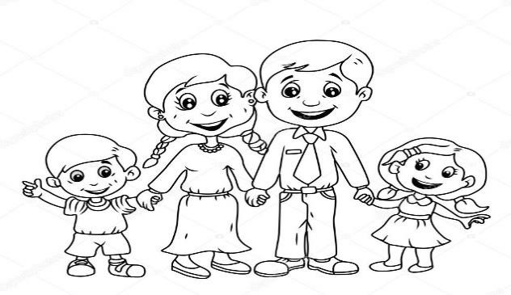

Hello. My name is
Sara
.

1
-

This is my father.

2
-

This is my
sister
.

3
-

This is my
mother
.

4
-

This is my brother.

- Grammar:
- Choose the correct answer:
- They ……… my friends.
- am |  |  |  | - is |  |  |  |  | - are
- This hat is …………
- I |  |  |  | - my |  |  |  |  | - mine
- Ali is ………… than Ahmed.
- tall |  |  |  | - taller |  |  |  |  | - tallest
- Vocabulary:
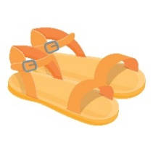
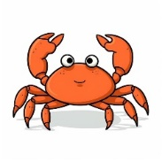
- Choose the correct answer:
 |  |  |  |  |  |  |  |  |  |  | 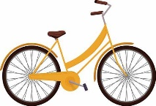
- starfish  - book |  | - sandals  - coat |  |  |  |  | - hat  - crab |  |  |  | - computer  - bicycle
- Orthography:

- Choose the correct missing letters:
pl __ __ |  |   ch __ __ se |  |  |  |  | 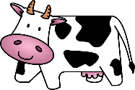  c __ __ |  |  |  | 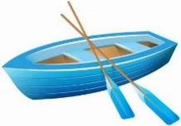  b __ __ t
ay | ow | oo |  |  | ee |  | ow | ie |  |  | ay | oa

BEST OF LUCK
Ms. Tahani Al-Ghamdi



اختبار فتري – الصف الثالث /
الاسم | الفصل | شفهي | تحريري | المجموع
 | / | 10 / | 10 / | 20 /
First Period Exam

1
1. CHOOSE
- What is your name ?
- I am 13 . | - My name is Ali .

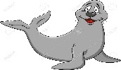

- What is that?
- It's a seal. | - It's a whale.

1.5
222
2. CHOOSE OR

This is a computer. | The whale is small. | This is a dolphin.
 |  | 

1

3. DO AS SHOWN BETWEEN BRACKETS

where | whose | who | 1- ______ skirt is this? It's mine . ( Choose )
slow | scary | fast | 2. Seahorse is ___________ . ( choose)

your | my | his | 1 – I am a teacher , _____ name is Nora .
have | has | is | 2. I _____ a box
4. CHOOSE
1

5. CHOOSE

3

 |  |  | 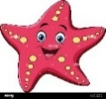 | 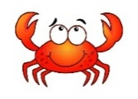 | 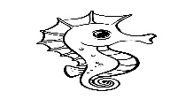
sandals | Thobe | T-shirts | starfish | fish | Seahorse
jacket | cap | Hat | cat | crab | whale

sh_ _ p | 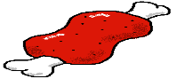  m_ _t | 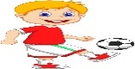  Pl_ _ | 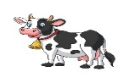  c_ _ | 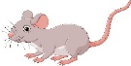  m_ _se
ea | ea | ay | ow | ow
ee | ee | ea | ou | ou
6. CHOOSE THE CORRECT LETTER
2.5

TEACHER :

English Language
elementary Grade …..
1st period Exam
…………….\20
Kingdom of Saudi Arabia
Ministry of Education
………………… School
Student's Name : class:

5

A-Choose the correct answer.

her | my | his | This is our little brother. ……..name is Ahmad. | 1
she | I | mine | Whose shoes are these? - They're ………….. | 2
has | are | have | He …………. a new bag. | 3
cutest | cuter | cute | A dolphin is ………………………... | 4
slowest | slower | slow | A snail is the …………………… | 5

2
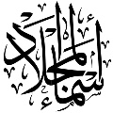
B- reorder.

1- cook \ you \ Can \ ?
………………………………………………………………………………………….………
2- have \ Thay \ a car.
……………………………………………….………………………………………………….

C-Answer the question.
1-what's that ?
3
It's a ( seahorse - fish - sharks ).


2-What are those?
Those are ( crocodile – seagull - baby seals).


3-What‘s that?
it's a ( squid – crab – Jellyfish ).
2

D.Match
Nice to meet you, too . |  | What's your name? | 1
My name is Ali. |  | Nice to meet you . | 2

4

E. Write the correct words under each picture
Sleep goat rice turtle

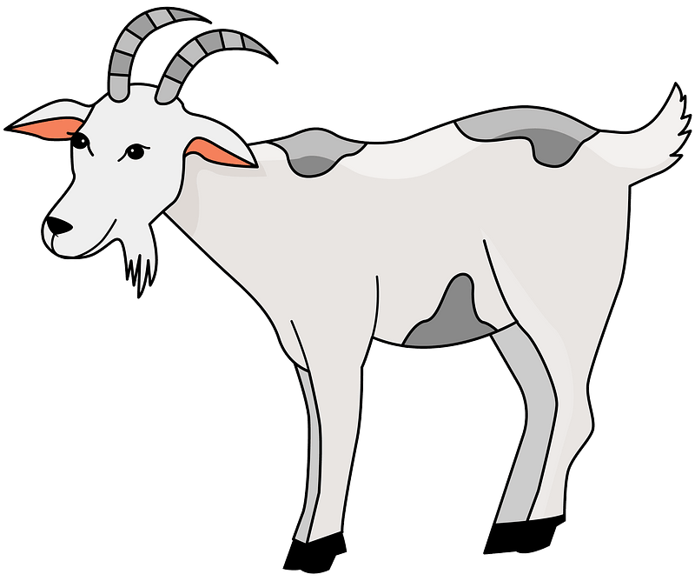

……………………….ر
……………………….ر
……………………….ر
……………………….ر

F.Complete the missing letters.
ee ay ou oa
4



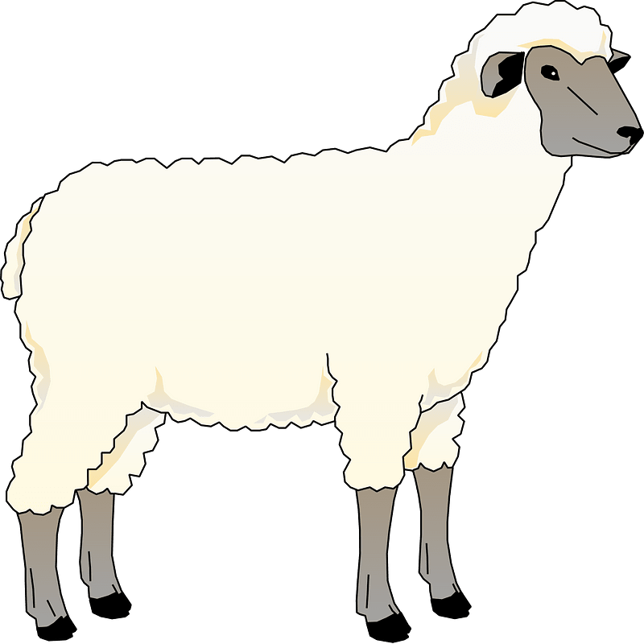


H…….se
Pl………
Sh……..p
C…….t


Your teacher:

