
Kingdom of Saudi Arabia
Ministry of Education
……..Education Directorate
………………… School
English Language
elementary Grade 4th
2nd period Exam
…………….\20
الاسم: الصف:

……\ 3 marks

General questions

A.Answer the questions
The tortoise is moving slowly. |  | What’s your favorite animal? | 1
My favorite animal is panda |  | How is the tortoise moving? | 2
I work at an animal shelter. |  | Where do you work as a vet? | 3

Controlled Writing

……\ 2 marks
A-reorder.
1- pets \The rabbits\ are \the cutes
a-the cutes pets are the rabbits b-The rabbits are the cutes pets.
2- live \ Tigers \ Asia \in
a-Asia tigers in live. b-Tigers live in Asia.

……\ 4 marks

Reading short sentence
 | 1- My parrot is chatty and friendly ( )
 | 2- Kangaroos have long tails. ( )
A-Put ( ✔ ) or ( X )
B. Choose the correct answer.
jungle | park | hospital | 1- A place where wild animals live.
mammals | fish | birds | 2-Kangaroos are ……… that live in grasslands.

……\ 4 marks

Grammar
A-Choose the correct answer.
c-who | b-where | a-when | 1-This is the day …….. my cat had kittens.
c-tall | b-tallest | a-taller | 2- Giraffes are the …animals s on the planet.
c-where | b-which | a-who | 3-The jungle is …………….. tiger live.
c-most friendly | b- more friendly | a- friendly | 4- The horse is ………..…. than frog.

Vocabulary
A.Choose the correct word under each picture
……\ 5 marks

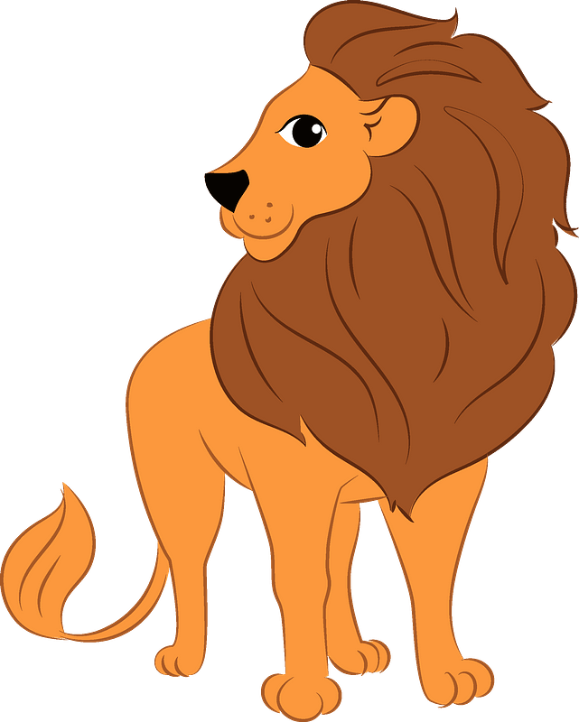 |  | 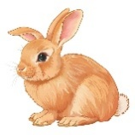 |  | 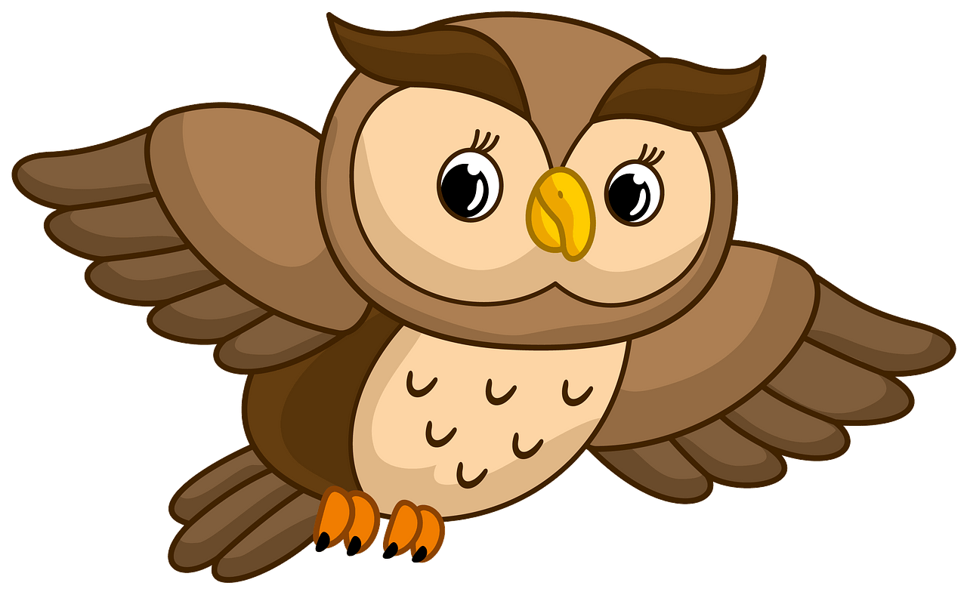
fish | vet | sheep | brave | owl
lion | headache | rabbit | doctor | tiger
……\ 2 marks

Orthography
A. Fill in the missing letters


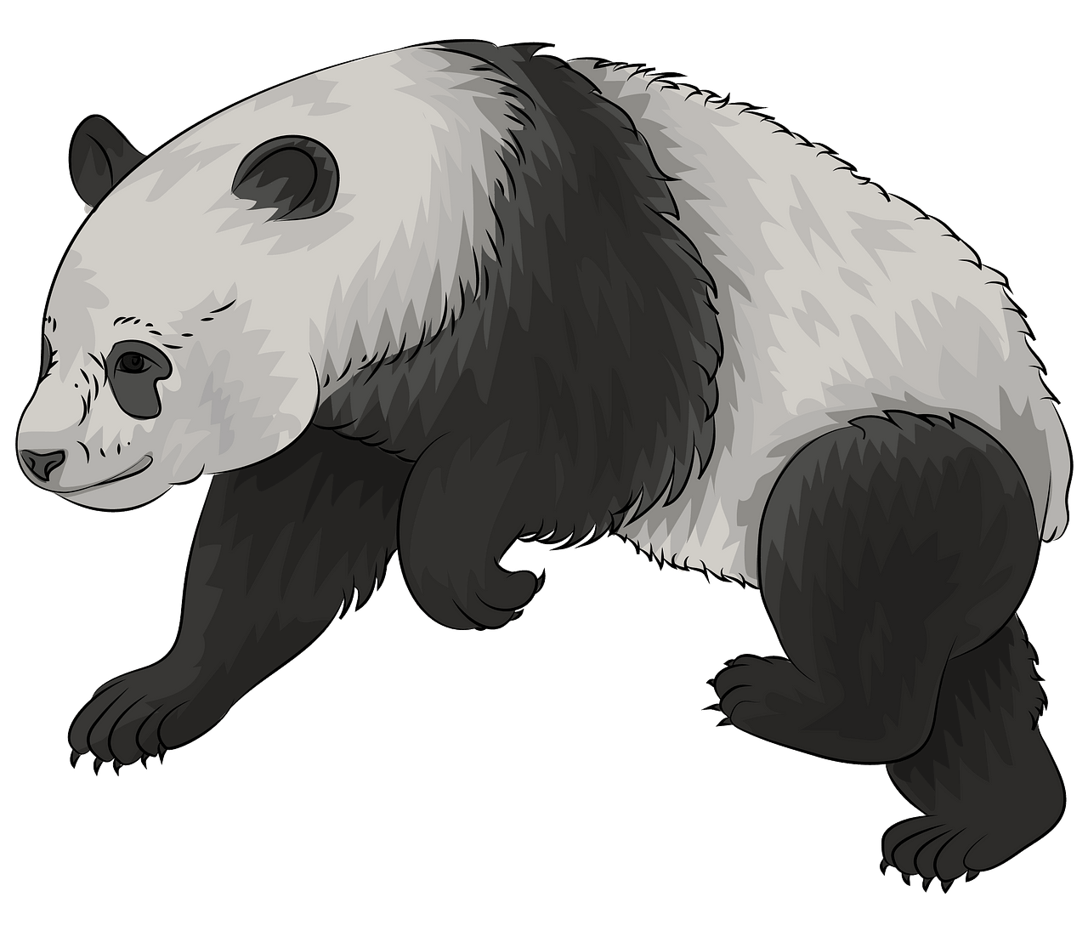
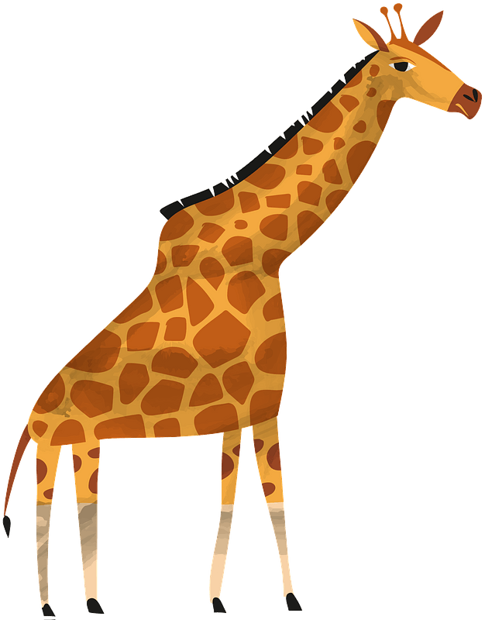


4-Pan..…a

( d – k - f )
2- …..ortoise

( r – t – y )
1- ……orilla

( z– r – g )

( s – t - o)
2-giraf…..e

( o – q – f )

( s – t - o)
Your teacher:


Your teacher …..:…………………………….


Kingdom of Saudi Arabia 4th Elementary Grade
Ministry of Education Third Term

10
………….. Elementary School . . Second Quiz – 1447 AH
Name: ………………………………………………………….………………. Class: …………..
- General Questions:
- Choose the correct answer:
1- What’s the matter?
a- I have a stomachache. |  |  |  |  | b- I should go to the hospital.
2- What do you do?
a- I like rabbits. |  |  |  |  | b- I am a vet.
- Controlled Writing:
- Read and write. Use the words in the box:
  In zoos, some birds often live in this.  ………………. | 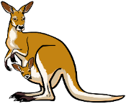  This animal jumps and has big legs.  ………………
kangaroo – stomach – cage
- Reading short sentence:
- Read the sentences then match them with the correct pictures:
 | a-_I put on my clothes.  b-_I take off my clothes.
 | a-_ He has an earache.  b-_ He has a cough.

- Grammar:
- Choose the correct answer:
- I want to ride my bike. You …………. wear a helmet.
- must |  |  |  | - mustn’t |  |  |  | - don’t have to
- Is there …………. to eat? I’m very hungry.
- someone |  |  |  | - nothing |  |  |  | - anything
- It was October …………… I visited Jeddah.
- where |  |  |  | - when |  |  |  | - whose
- The mouse is …………… than the frog.
- fast |  |  |  | - faster |  |  |  | - fastest
- Vocabulary:
- Choose the correct answer:
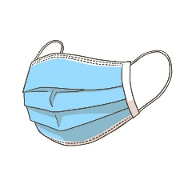 |  |  |  |  | 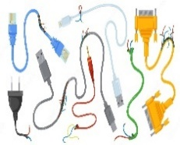 |  |  |  |  | 
- towel  - mask |  | - band aid  - first aid |  |  | - cables  - toys |  | - pretty  - friendly |  |  | - polar bear  - lion
- Orthography:
- Choose the correct missing letters:
  f__ll |  |   hu__t |  |  |   s__art |  |   bra__e |  |  |   pan__a
a | o | r | n |  | t | m | v |  | f | b | d

BEST OF LUCK
Ms. Tahani Al-Ghamdi
1– How often are you sick?
1
I. CHOOSE
A. I am strong. B. Sometimes .
2– What is your favorite animal?
A. It is cat. B. It is asleep.
المملكة العربية السعودية |  | اسم الطالب/هـ ......................................
وزارة التعليم |  | اسم الطالب/هـ ......................................
إدارة التعليم بمنطقة |  | المادة : انجليزي
مدرسة : |  | الزمن :
مدرسة : |  | الصف : الرابع فصل ( )
شفهي | تحريري | المجموع
10 / | 10 / | 20 /
اختبار الفترة الثانية – الفصل الثاني 1447هـ - الصف الرابع ابتدائي
اسم الطالب / هـ الفصل /

2. CHOOSE OR
1.5

They are in the zoo.
The parrot is in the cage.
The foot got stuck.


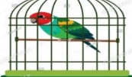



3. CHOOSE TO COMPLETE THE FOLLOWING:
1.5

Do as shown between brackets :

1- cats / the quietest / are / pets. (Rearrange)
………………………………………………………………………………………
2- The same meaning as [ sick ] . ( choose )
A. strong. B. ill

1
shouldn't | Have to | 1- You ________ be quiet in the hospital.
faster | fastest | 2- The horse is …………… than cow .
4. CHOOSE

3
5. Write the correct word:

Polar bear - backache - Vet - ice - interview - frightened

 | 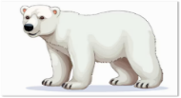 |   هذه الصورة بواسطة كاتب غير معروف مرخصة بالاسم CC BY-NC |  |  |   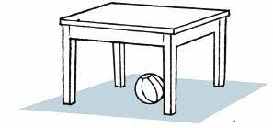

6. CHOOSE THE CORRECT LETTERS:
2

Choose the correct letter:

 | 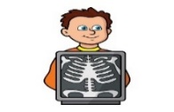 | 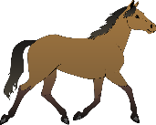 | 
ca_le | X-Ra_ | ho_se | nhappy_
b | e | r | u
f | y | n | o

___________________________________________________________________________________________________________________________________________________________________________________________________________________________________
Controlled writing

4

Good luck T.



Second Period Exam – Top Goal 1

مدرسة :
الاسم | الفصل | شفهي | تحريري | المجموع
 | / | 10 / | 10 / | 20 /
Choose the correct answer:
/ 1
1– How often are you sick?

A. I am strong. B. Sometimes .
2– What is your favorite animal?

A. It is cat. B. It is asleep.

____________________________________________________________________________________________________
Choose or :
/ 1.5
They are in the zoo. | The parrot is in the cage. | The foot got stuck.
 | 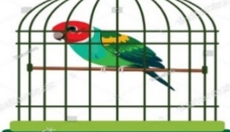 | 
______________________________________________________________________
1- cats / the quietest / are / pets. (Rearrange ) …………………………………………………………………………………………
strong | ill | high | 2 – The same meaning as [ sick ] . ( choose )
Do as shown between brackets :
/ 1.5

Choose the correct word:
/ 1
shouldn't | have to | 1- You ________ be quiet in the hospital.
faster | fastest | 2- The horse is …………… than cow .

/ 3
Choose the correct word:

 |  | هذه الصورة بواسطة كاتب غير معروف مرخصة بالاسم CC BY-NC
Vet | Polar bear | interview | happy | headache | ice
zoo | Panda | running | frightened | backache | flag
Choose the correct letter to fill in the blank:
/ 2
ca_le | X-Ra_ | ho_se | nhappy_
b | e | r | u
f | y | n | o

Good luck T.
Controlled writing

4

