
Kingdom of Saudi Arabia
Ministry of Education
………………… School
English Language
Intermediate Grade 2nd
2nd period Exam
……….\20

Student's Name : class:

……\ 5 marks
1-Read the following passage and answer the questions below:
Ibrahim was walking home from school when the rain suddenly started to fall. He felt surprised, but then he saw his friend Omar running toward him. Omar shared his umbrella, and they walked together. The cool rain made the weather nice, and they enjoyed jumping over small puddles on the way. Ibrahim forgot he was tired, and his mood became happy and excited. By the time they reached home, both friends were smiling and glad they shared that rainy moment together.
c-airport | b-park | a-home | 1- Where was Ibrahim going?
c-his uncle | b-his father | a-his friend | 2- Who did he meet in the rain?
c- a bag | b-an umbrella | a-a jacket | 3- What did Omar share?
A.Choose the correct answer.
B. Choose (True ) or ( False ) for each sentence.
1- They jumped over small puddles. ( )
2- The weather was very hot. ( )
……\ 5 marks
2-Choose the correct answer.

c-going | b-goes | a-go | 1- Imad is …………to climb a mountain.
c- travels | b loud | a- loudly | 2- Noura is a …………. speaker.
c- get | b- getting | a- gets | 3- How will he ………. to work?
c carried | b- carry | a- carrying | 4- I'll ………… your book.
c- felt | b- feels | a-feel | 5- If it’s hot and humid, I don’t ……..very active.

3-Do as shown between brackets.
……\ 2 marks
(answer)
1-is he going to play tennis?
Yes,……..………………………………………………………………………………….
(Reorder)
1- a soda \ Will \ give \ you \ me ?
……………………………………………………………………………………………….

……\ 4 marks
4- write the correct word under each picture ( napkins - cloudy – noisy – coral reefs )

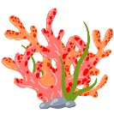




………………………
………………………
………………………
………………………

……\ 2 marks
5- Choose the correct answer.
1- it’s going to (rain – dry - weather) today. You need your umbrella.
2- a forest in a tropical area that receives a lot of rain(rainforest – tombs – ecosystem )

6.Choose the missing letter.
1- I’m aller….ic to shrimp. ( g – u – f )
2- It's ten degrees belo…. zero (-10). ( d – w – p )

……\ 2 marks

7- write the missing letter

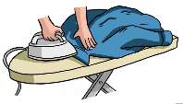

iro….
Win….y

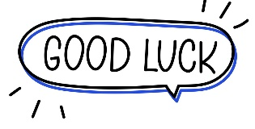

Your teacher:


Kingdom of Saudi Arabi Name: ……………………………
Ministry of education Class: 2nd Intermediate Grade
10 /
………Intermediate School Second Quiz – 1447 AH Second Term
- Comprehension:
Read the passage to answer the questions below:
Once there was a boy named Sam. Sam lived in the cold, cold place of Alaska. Sam had a polar bear friend. Sam and his polar bear would go fishing every day on the ice. Sam loved his polar bear because he was big and white, and loved to fish with him.
One day when the two friends were fishing, they caught the biggest fish either of them had ever seen. The fish was red with purple stripes. They were so excited they ran all the way home with the fish.
- Choose the correct answer:
- Where did Sam live?
- Alaska b- Africa c- Australia
- What color was the big fish?
- Blue and green b- Yellow and black c- Red with purple stripes

- Check ( T ) or ( F ) :
- Sam lived in a hot place. ( )
- Sam and his polar bear go fishing every day. ( )

- Grammar:
- Choose:
- (How – Who – When) is your best friend?
- He put (so – so many – so much) salt that we couldn’t eat it.
- Jeddah is (modern – more modern – most modern) than Abha.
- If it (rain – rains – will rain), they won’t play tennis.

- Do as shown between brackets:
- (Rewrite the sentence using adverbs of manner)
- Omar is a careful driver.
…………………………………………………..
- Sara will stay home on Saturday. (Make a Yes/No question)
…………………………………………………..

- Vocabulary:
- Write the words under the pictures:
oasis – mosquito – doorknob – hurricane
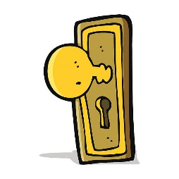

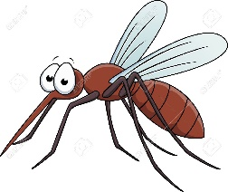

_____________ _______________ ________________

- Classify the words:
cheetah – fall – windy

Seasons | Animals | Weather words

- Orthography:
- Choose the correct missing letters:
- I am alle__gic to dairy products.
- k | - l | - r
- Jeddah is a coast__l city.
- a | - e | - i
- There will be a chess com__etition next week.
- d | - p | - q
- The color of lea__es is green in summer.
- f | - v | - b

Good Luck
Ms. Tahani Al-Ghamdi


Kingdom of Saudi Arabia
Ministry of Education
………… Education Directorate............
…………..……………….. Intermediate School

Total
المجموع | تحريري | شفهي
20 | 10 | 10

Second Period Exam _ Second Term
Second Intermediate Grade

Name ………………………………… Class ………………………………
__________________________________________________________________________________________
/ 2
Comprehension

Read the following then answer the questions:

I live in a big house. It has a modern living room and a comfortable bedroom. Today, the weather is very hot and sunny, so I am wearing my favorite T-shirt and shorts. Yesterday, I went to the mall to buy a new jacket. It was a real bargain because it was on sale!
A- Put (√ ) for true or ( ᵡ ) for false :

( ) | 1. The writer lives in a small house .
( ) | 2. The weather today is hot and sunny .

B- Choose the right answer:

comfortable | noisy | old | modern | 1- There is a _________ Livingroom.
cap | jacket | shorts | T-shirt | 2- The writer bought a new ________.
_________________________________________________________________
/ 2.5
Grammar

Choose the right answer:

1- The elephant is ________ than the horse.
A. big B. bigger C. biggest D. the biggest
2 - What are you ________ to do tomorrow?
A. go B. goes C. going D. went
3 - It ________ snows in the desert; it's impossible.
A. always B. often C. never D. usually
4 - This is ________ film I have ever seen.
A. good B. better C. best D. the best
5 - They are going ________ a museum next week.
A. visit B. to visit C. visiting D. visited

/ 2
Vocabulary

A- Choose the best answer to fill in the blank:
1. A ________ is much faster than a bicycle.
book | tree | spoon | plane
2. I want to go ________ in the desert next weekend.
studying | flying | camping | sleeping
3. In ________, the weather is very cold and it sometimes snows.
winter | fall | spring | summer
4- We need to pack our ________ for the trip.
shoes | suitcase | window | table
B- Put the right word under its picture:
/ 2.5
 |  |  | 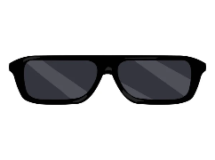 | 

Sunglasses - Suitcase - Umbrella - Laptop - Camera

_______________________________________________________________________________
/ 1
Orthography

Choose the correct letter:
a | o | u | 1. Summer is the h_ttest season.
v | d | b | 2. I am going to tra_el by plane.

Good luck T.

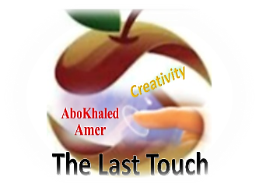

المملكة العربية السعودية
وزارة التعليم
الادارة العامة للتعليم بمنطقة ----------------
مدرسة ------------------ المتوسطة
Second Term- Second Session Test
Name: ------------------------------------------------------ Grade: 2nd Inter.
ABOKHALEDAMER
0557325813
1. Write the correct number under its picture: (6M)
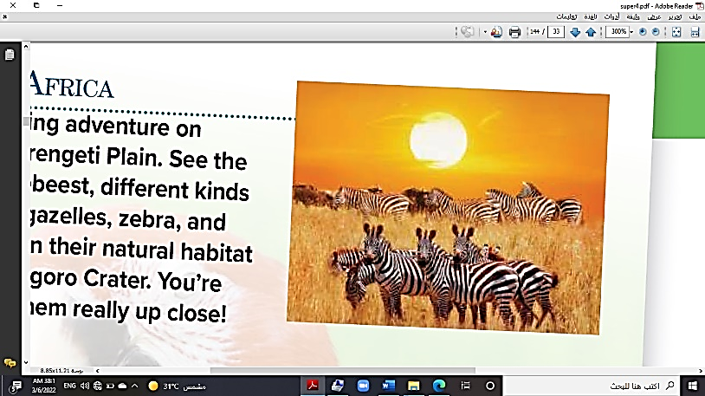
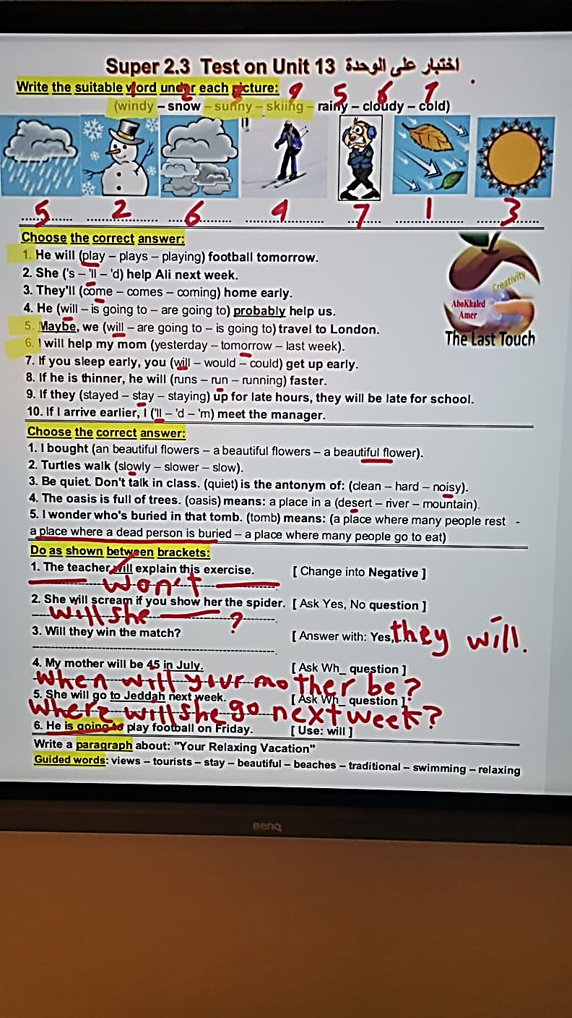
1.sunny 2.skiing 3.mosque 4.zebra 5.windy 6.rainforest
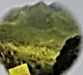
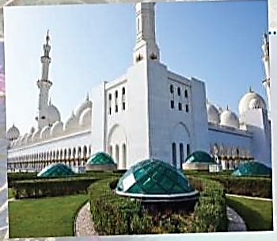

( ) ( ) ( ) ( ) ( ) ( )
2. Choose the correct answer: (6M)
1. She's not (going – goes – go) to visit Petra.
2. We're not going (too – to – toe) visit London.
3. Are you going to (travel – travels – traveling) to Jordan?
4. He will (play – plays – playing) football tomorrow.
5. Maybe, we (will – are going to – is going to) travel to London.
6. I will help my mom (yesterday – tomorrow – last week).
3. Rearrange the following: (4 M)
1. Is she – travel – going to – to Rome? -----------------------------------------------------------
2. take – They – are going to – a bus. -----------------------------------------------------------
3. long – w ill – How – you – stay? ------------------------------------------------------------
4. arrive in – You're – are going to – the morning. -----------------------------------------------
4. Match the Real Talk: (4M)
1. Will you do me a favor? A. lose one’s job.
2. I have no idea. B. shout loudly.
3. be fired C. I don't know.
4. shriek D. Will you help me?
(2) Top Goal - YouTube End of Questions https://t.me/abokhaledamer

