

Kingdom of Saudi Arabia
Ministry of Education
………………… School
English Language
Intermediate Grade 3rd
2nd period Exam
……….\20

Student's Name : class:

……\ 5 marks
1-Read the following passage and answer the questions below:
Saad and Ali are brothers. Saad has new headphones. One afternoon, Ali takes the headphones. Saad looks for his headphones but cannot find them. He checks his room and the living room. Then he sees Ali using them. Saad feels upset. Ali notices Saad’s face and understands the problem. He stops using the headphones and gives them back. Saad feels better. The brothers talk together and decide to share kindly and take turns next time.
c- calculator | b- pencil | a-headphones | 1- What did Saad have?
c-in the evening | b-in the morning | a-in the afternoon | 2- When did Ali take the headphones?
c- upset | b-excited | a-hungry | 3- How did Saad feel?
A.Choose the correct answer.

B. Choose (True ) or ( False ) for each sentence.
1- Saad and Ali are brothers ( )
2- Saad looks for his headphones in the kitchen. ( )
2-Choose the correct answer.
……\ 4 marks

c-where | b-which | a-who | 1- English is a language……...is easy to learn.
c-what | b- when | a-while | 2- My brother was watching TV… he was eating dinner.
c-yet | b-just | a-after | 3- Sara has …………….had a dinner.
c- waits | b- waiting | a- wait | 4- He can’t stand ………..in line.
……\ 3 marks
3-Do as shown between brackets.
( Correct)
a- Ali is such fast that he won the race………………
b-Badria couldn’t sleep last night. She mustn't be tired. ………….
(reorder)
a- we\ May\ have \ cookies \ some \?
………………………………………………………………………………….….

……\ 4 marks
4- write the correct word under each picture ( nail polish - scissors - thief – fake )

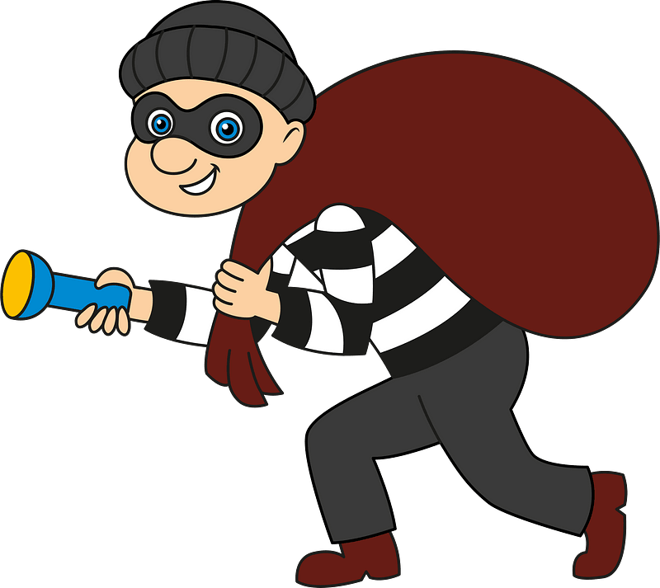

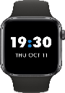

………………………
………………………
………………………
………………………

……\ 2 marks
5- Choose the correct answer.
1- It is very annoying when someone ( stand – change – share) TV channel without asking.
2- A ( rude – athletic -friendly) person is someone who likes to be with others.

6.Choose the missing letter.
1- While I am la….y, my sister is really hard-working.( z – c – w )
2- Blindness and paralysis are examples of disa…..ilities ( b – h – k )

……\ 2 marks

7- write the missing letter

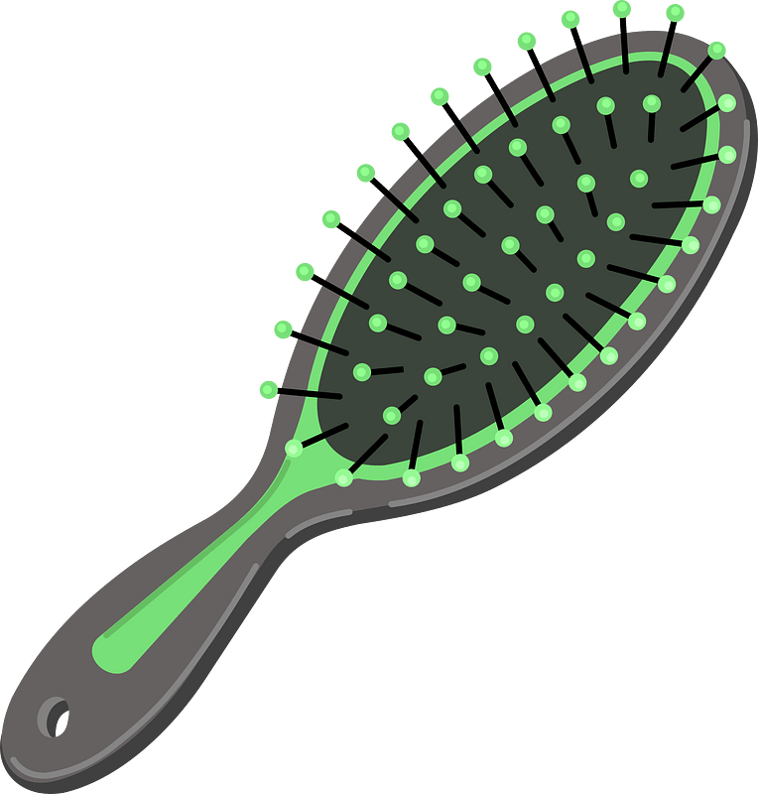


Hair bru…….h
Ma……azine

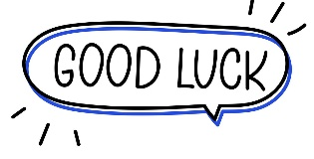

Your teacher:


Kingdom of Saudi Arabia Name: ……………………………
Ministry of education Class: 3rd Intermediate Grade
10 /
…… Intermediate School Second Quiz - 1447 Second Term
- Comprehension:
Read the passage to answer the questions below:
My best friend’s name is Maha. She is in my class. Her surname is Al-Ali. She is very tall. Her eyes are green and her hair is brown. It is long and straight. She is always smiling and wants everyone to be happy. She is very kind and likes to help other children. I hope Maha will always be in my class.

- Choose the correct answer:
- Maha’s hair is ………………
- curly b- wavy c- straight
- Maha’s eyes are …………….
- brown b- green c- black
- Check ( T ) or ( F ) :
- The writer and Maha are in the same class. ( )
- Maha is a selfish person. ( )

- Grammar:
- Choose:
- A clown is a person (who – which – when – where) makes children laugh.
- My brother was watching TV while he (eat – eats – ate – was eating) dinner.
- He enjoys (read – reads – reading – to read) novels.
- The meal was (so – such – so many – so much) delicious that we ate too much.

- Do as shown between brackets:
- (Rewrite the sentence with a two-word verb in two ways)
- Turn off the TV.
…………………………………
…………………………………
- done/the dishes/hasn’t/Jana/yet (Unscramble the sentences)
Jana …………………………………………….

- Vocabulary:
- Write the words under the pictures:
pedal cab – thief – spill – hair dryer – nail polish
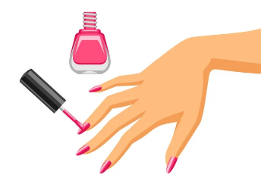
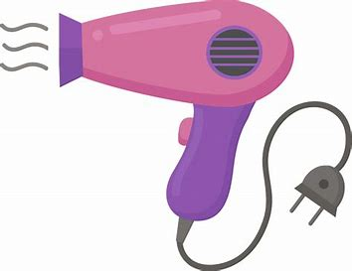
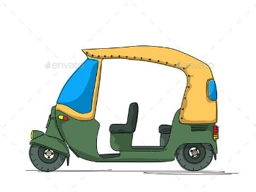


_____________ _______________ ________________ ______________
- Classify the words:
honest – pessimistic

- Orthography:
- Choose the correct missing letters:
- There were two security guards on d__ty outside the building.
- i | - o | - u
- I caught him trying to s__eal my bike.
- b | - t | - d
- Would you tu__n down your radio a little?
- r | - s | - z
- A n__phew is a son of one’s brother or sister.
- a | - e | - i

Good Luck
Ms. Tahani Al-Ghamdi


Kingdom of Saudi Arabia
Ministry of Education
………… Education Directorate............
…………..……………….. Intermediate School

Total
المجموع | تحريري | شفهي
20 | 10 | 10

Second Period Exam _ Second Term
Third Intermediate Grade

Name ………………………………… Class ………………………………
__________________________________________________________________________________________
/ 2
Comprehension

Read the following then answer the questions:
Ali is a friendly student who is always ready to help others. One day, while he was walking to school, he saw a boy who was crying. The boy said that someone had taken his bag. Ali quickly tried to help him. He has already looked around the street and asked people if they had seen anything. Finally, they found the bag near a small shop. The boy was very happy, and he thanked Ali for his kindness.

A- Put (√ ) for true or ( ᵡ ) for false :

( ) | 1. Ali ignored the boy and went to school.
( ) | 2. The boy lost his bag

B- Choose the right answer:

running | laughing | crying | playing | 1- The boy was _____ when Ali saw him
car | shop | tree | house | 2- They find the bag near a small _________ .
_________________________________________________________________
/ 2.5
Grammar

Choose the right answer:

1- The man ______ helped me is very kind.
A. which B. who C. where D. when
2- I ______ watching TV when my friend called me.
A. am B. was C. were D. is
3- She has ______ finished her homework.
A. yet B. already C. still D. ago
4- He hasn’t cleaned his room ______ .
A. already B. just C. yet D. ever
5- They are interested in ______ football.
A. play B. played C. playing D. plays

/ 2
Vocabulary

A- Choose the best answer to fill in the blank:
1. A person who is always kind and helps others is ______.
lazy | helpful | selfish | rude
2. If something is missing, it is ______.
broken | clean | found | lost
3. He made a ______ about the noise in the class.
story | lesson | complaint | game
4- Someone who takes things without permission is a ________ .
thief | teacher | student | driver
B- Put the right word under its picture:
/ 2.5
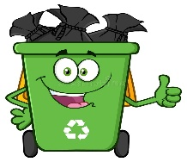 | 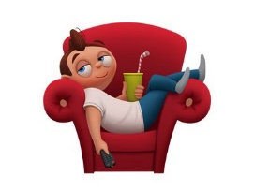 |  |  | 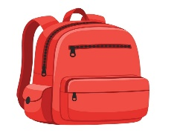

noisy - lazy - backpack - garbage - angry
- windbreaker - dust - laundry

_______________________________________________________________________________
/ 1
Orthography

Choose the correct letter:
k | x | l | 1. My phone is bro__en
r | d | s | 2. The room is very mes__y

Good luck T.

