

English Language
elementary Grade 3rd
2nd period Exam
…………….\20
Kingdom of Saudi Arabia
Ministry of Education
……..Education Directorate
………………… School
الاسم: الصف:

……\ 4 marks

General questions

A.Answer the questions
Yes, I drank milk this morning. |  | What time does your school start? | 1
It’s 90 SAR |  | Did you drink milk this morning? | 2
It starts at 8 o‘clock. |  | What‘s the matter? | 3
I have a stomachache. |  | How much is this jacket? | 4

Controlled Writing
……\ 1 marks
A-reorder.
1- live \ I \Jeddah \ in

a-I live in Jeddah b-Jeddah live I in

……\ 4 marks

Reading short sentence
A-Put ( ✔ ) or ( X )

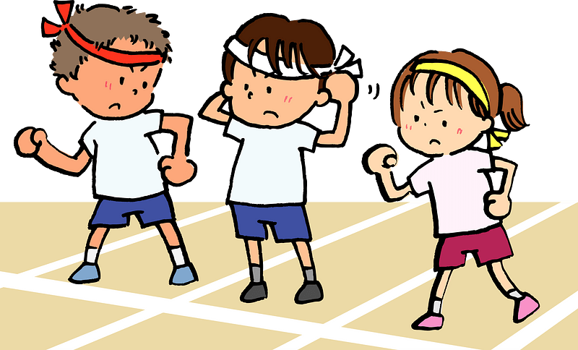 | 1- This year I like P.E ( )
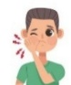 | 2- I have a headache. ( )
B. Choose the correct answer
c-kitchen | b-bed room | a-library | 1-The best place in our school is …………
c-write | b-book | a-drink | 2- I should …………a lot of water.

……\ 4 marks

Grammar
A-Choose the correct answer.
c-which | b-when | a-who | 1-………...subject do you like most this year?
c-liked | b-likes | a-like | 2- Last year I ……. Math.
c-watches | b- watched | a- watch | 3- Omar shouldn‘t ……..too much TV.
c- ate | b- eats | a- eat | 4- Did you …….. breakfast this morning?

Vocabulary

A.Choose the correct word under each picture
……\ 5 marks

 | 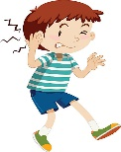 | 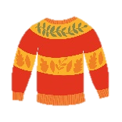 | 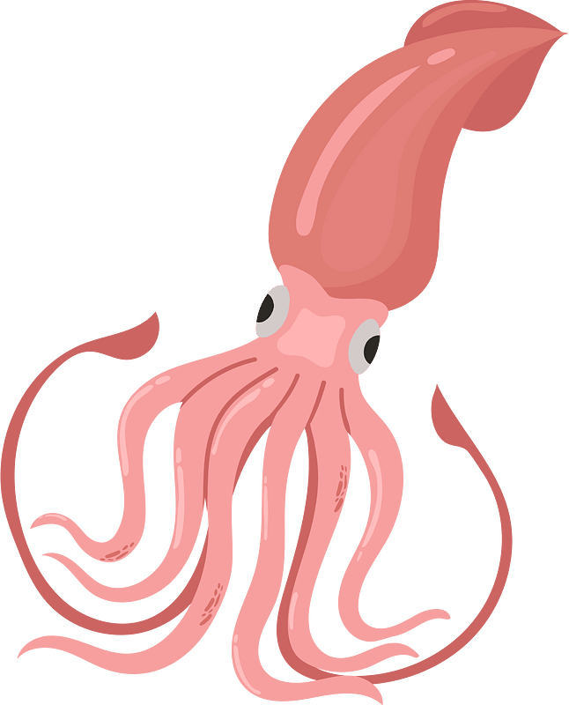 | 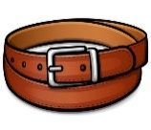  
belt | headache | scan | Squid | science
skirt | earache | Sweater | tiger | Math
……\ 2 marks

Orthography
A. Fill in the missing letters.

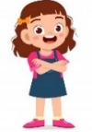
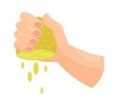
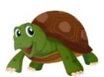

3-g..…l
( th- ir – fl)
4-….ate
(sk – sq – sc)
2-t….tle
(ur – ir – oa)
1-….ueeze
(sk – sq – sc)

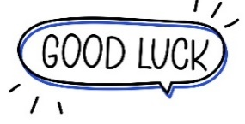
Your teacher:

Your teacher …..:…………………………….


Kingdom of Saudi Arabia Third Elementary Grade
Ministry of Education Second Term

10
……. Elementary School . . . Second Exam - 1447 AH
Name: ………………………………………………………….………………. Class: …………..
- General Questions:
- Match the questions with the correct answers:
1- What’s the matter? |  |  |  |  |  |  |  |  |  | No, I didn’t.
2- Did you get up early this morning? |  |  |  |  |  |  |  |  |  | It starts at 7:00.
3- Which city do you live in? |  |  |  |  |  |  |  |  |  | I have a stomachache.
4- What time does your school start? |  |  |  |  |  |  |  |  |  | I live in Al-Lith.
- Controlled Writing:
- Write the past form of the following verb:
Base Form |  |  |  |  |  |  | Simple Past
play
- Reading short sentence:
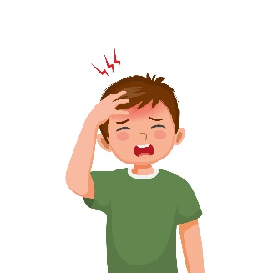
- Read the sentences then choose the correct sentence for each picture:
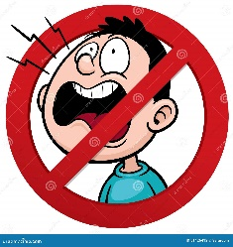 |  |  | 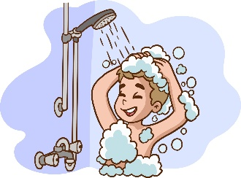
a-_Don’t shout  b-_Do your homework | a. I have a toothache.  b. I have a headache. | a-_He likes science.  b-_He likes PE. | a. I brush my teeth.  b. I take a bath or shower.

- Grammar:
- Choose the correct answer:
- Last year I ………….. in the 2nd grade.
- am |  |  |  |  | - is |  |  |  |  |  |  | - was
- I didn’t ………… milk this morning.
- drank |  |  |  |  | - drink |  |  |  |  |  |  | - drinks
- Vocabulary:
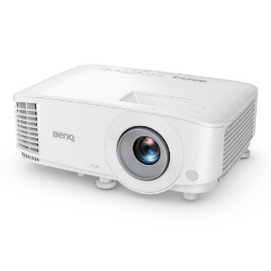
- Choose the correct answer:
 |  |  | 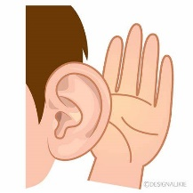 |  |  |  |  | 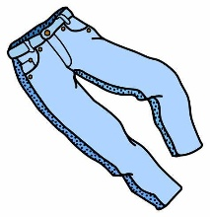 |  |  |  |  |  | 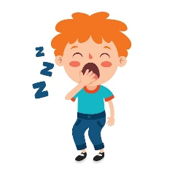
- projector  - computer |  |  | - listen  - speak |  |  |  |  | - trousers  - belt |  |  |  |  |  | - grumpy  - sleepy
- Orthography:
- Choose the correct missing letters:
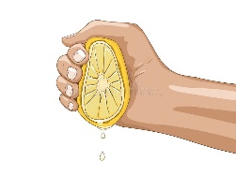  __ __ ueeze |  | 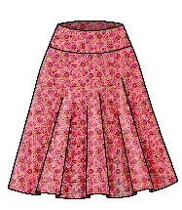  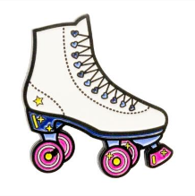  __ __ irt |  |  |  | 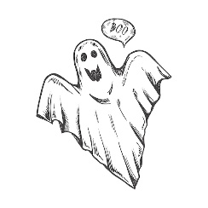  __ __ ary |  |  |  |  |   b __ __ ger |  |  |  | 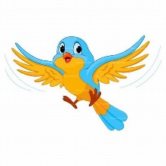  b __ __ d
sk | sq | sc |  | sk |  | sc |  |  | sq |  | ir |  | ur |  | ir | ur

BEST OF LUCK
Ms. Tahani Al-Ghamdi

1
I. CHOOSE
المملكة العربية السعودية |  |  | اسم الطالب/ه ......................................
وزارة التعليم
إدارة التعليم بمنطقة |  |  | المادة : انجليزي
مدرسة : |  |  | الزمن :
 |  |  | الصف : فصل ( )
شفهي | تحريري |  |  | المجموع
10 / | 10 / |  |  | 20 /
اختبار الفترة الثانيه للفصل الثاني - للعام الدراسي 1447– لغة انجليزية –– للصف الثالث ابتدائي
اسم الطالب / هـ الفصل /

1 – How many students are there in your school?

A . About 500 . B . Yes, I am .
2 – What should you do to live a healthy life ?
A. I should go to bed early. . B. I should skip breakfast.

2. CHOOSE OR
1.5

1. This year I like math .

Our school has a bus ..2
3. I should do some exercise.


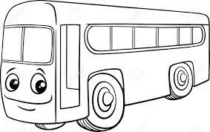

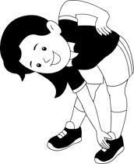

3. DO AS SHOWN BETWEEN BRACKETS
1.5

___________________________ |  | 1- in – live – I - Riyadh . ( rearrange )
Good night | Good morning | 2– Greeting usually say it at night . ( choose )

4. CHOOSE
1
4. CHOOSE
went | go | 1 – Last week we ______ to Abha
play | played | 2- The PAST TENSE of ( play) is

________________________________________________________________________________________________________________________________________________________________________________________________________________________________

T-shirt - flag - Don’t shout

3
5. CHOOSE
     | 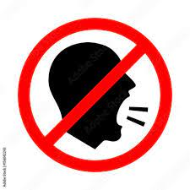 | 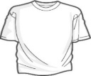

\

6. CHOOSE THE RIGHT LETTERS:
2

Choose the correct letter:

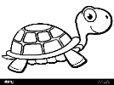  t_ _tle | 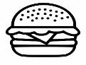  b_ _ger |   _ _ y | 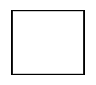  _ _an
er | ur | sc | sq
ur | ar | sk | sc

Controlled writing

4

______________________________________________________________________________________

Good luck

