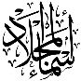

English Language
Intermediate Grade 1st
2nd period Exam
……….\20
Kingdom of Saudi Arabia
Ministry of Education
………………… School

Student's Name : class:

……\ 5 marks
1-Read the following passage and answer the questions below:
Ahmad woke up early on Eid morning feeling very excited. He wore his new white thobe and went with his father to the mosque to pray. After the prayer, Ahmad greeted his friends. Then, he visited his grandparents and received gifts. At home, his mother prepared delicious food, and the family sat together happily. In the evening, Ahmad played games with his cousins and shared sweets. It was a joyful and special day for him.
1-What did Ahmad wear on Eid?
c-sport clothes. | b-old clothes. | a-A new white thobe.
2- Where did Ahmad go with his father?
c-mall | b- mosque | a- park
3- What did Ahmad do in the evening?
c-studied | b- played with his cousins. | a-cooked the lunch.
A.Choose the correct answer.
B. C. Put ( ✓ ) or ( ✕ )
1- Ahmad felt excited on Eid morning. ( ).
2- Ahmad received books from his grandparents. ( ).
2-Choose the correct answer.
……\ 5 marks

c- swimming | b- swim s | a- swim | 1-They enjoy ………. in the summer.
c- studying | b- study | a- studied | 2- I need to ………..hard.
c- watched | b- watching | a- watch | 3- We are …………a film on TV this evening.
c-eating | b-eat | a- eats | 4- They shouldn’t ………. junk food.
c- wears | b- wearing | a- wear | 5-I'm going to……….. jeans.

3-Do as shown between brackets.
……\ 2 marks
(answer )
a- Can he write stories?
No, …………………………………………………….

(Give the negative )
a- Mark is going to wear jeans.
………………………………………………………………………………………………………

……\ 4 marks
4- write the correct word under each picture ( skirt – fireworks – forest - pants )

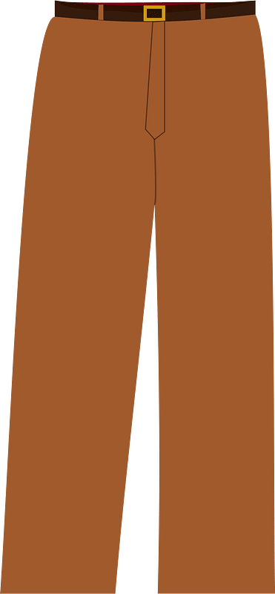

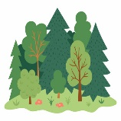


………………………
………………………
………………………
………………………

……\ 2 marks
5- Choose the correct answer.
a- a place you can go shopping and meet friends ( mall – hospital – school).
b- In Saudi Arabia, all the women wear ( laptop – abaya – lamp )
.
2- Saudi men wear ( thobe- suit – tie ).

……\ 2 marks
6.Choose the missing letter.
a- They ate in an Italian restauran…. ( t – o – I )
b- Is it better to have a rain…oat or an umbrella? ( v – c – a)

7- write the missing letter

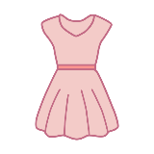
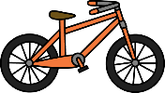

dres…
…..ike

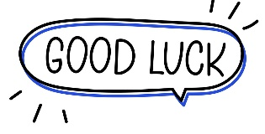

Your teacher:


Kingdom of Saudi Arabia Name: ……………………………
Ministry of education Class: 1st Intermediate Grade
10 /
……. Intermediate School Second Quiz – 1447AH Second Term
- Comprehension:
Read the passage to answer the questions below:
Jenny is a beautiful eight-year-old girl. She has black hair and brown small eyes. Jenny loves books. She loves reading a lot. She is in third grade. She reads all the time: morning, afternoon, and night. She reads for everybody: mom, dad, sister, brother, grandma, teachers, and friends. She likes to read about places but she loves to read about animals.
- Choose the correct answer:
- This text is about ………………
- Jenny’s family b- Jenny’s hobby c- Jenny’s cat
- Jenny is ……… years old.
- 8 b- 9 c- 10

- Check ( T ) or ( F ) :
- Jenny has brown hair and black eyes. ( )
- Jenny reads for her parents only. ( )

- Grammar:
- Choose:
- I can (speak – speaks – speaking) English.
- Do you enjoy (go – to go – going) to football matches?
- Sara goes to bed (at – in – on) 10 o’clock.
- She is wearing a (red new shoes – new red shoes – shoes red new).

- Do as shown between brackets:
- I want (buy) some stickers. (Correct the verb)
…………………………………………………………
- Talal is going to buy a car. (Change into negative)
…………………………………………………………

- Vocabulary:
- Write the words under the pictures:
fish – dress – work out – sneakers

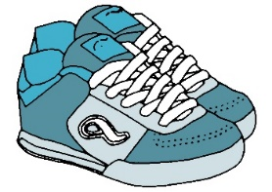


_____________ ________________ ______________

- Classify the words:
lunch – tie – bookstore

Clothes | Meals | Places in a town

- Orthography:
- Choose the correct missing letters:
- I always have a boiled egg for brea__fast.
- c | - k | - f
- You can go shopping and meet friends. This place is a m__ll.
- a | - o | - i
- The color of my school uni__orm was dark green.
- c | - m | - f
- In the summer, Ali wears shorts and san__als.
- b | - d | - p

Good Luck
Ms. Tahani Al-Ghamdi


Kingdom of Saudi Arabia
Ministry of Education
………… Education Directorate............
…………..……………….. Intermediate School

Total
المجموع | تحريري | شفهي
20 | 10 | 10

Second Period Exam _ Second Term
First Intermediate Grade

Name ………………………………… Class ………………………………
__________________________________________________________________________________________
/ 2
Comprehension

Read the following then answer the questions:

My school is in a village. I live far from the school, so I need to get up at 5 a.m. I go to school by car, but when it rains a lot I stay at home. Our school has 150 students and 6 classrooms. There are six teachers, three for grades 1–3, the others for grades 4–6. We study all the subjects in Arabic, our first language, but we also learn English. Our school has a generator for electricity, and it has three computers.
A- Put (√ ) for true or ( ᵡ ) for false :

( ) | 1. His school is in a city .
( ) | 2. The school has six classrooms.

B- Choose the right answer:

bike | train | bus | car | 1- He goes to school by ______.
five | three | four | two | 2- There are _____ computers in the school.
_________________________________________________________________
/ 2.5
Grammar

Choose the right answer:

1- I get up at 5 o'clock ____ the mooring .
A. on B. in C. at D. up
2 - Saeed is _________ in Riyadh this year.
A. study B. studies C. studying D. studied
3 - They don’t like ____________ .
A. to read B. read C. reads D. in read
4 - I ______ speak English, but I can’t speak Chinese
A. don't B. am C. do D. can
5 - He ___ going to wear jeans.
A. is B. am C. are D. were

/ 2
Vocabulary

A- Choose the best answer to fill in the blank:
1. _______ You can buy books. .
supermarket | airport | bookstore | bank
2. The mall is _________ near the hospital .
big | located | travel | going
3. You can open an account in the _________.
school | hotel | bank | restaurant
4- What kind of _______ do you like wearing?
streets | clothes | books | food

B- Put the right word under its picture:
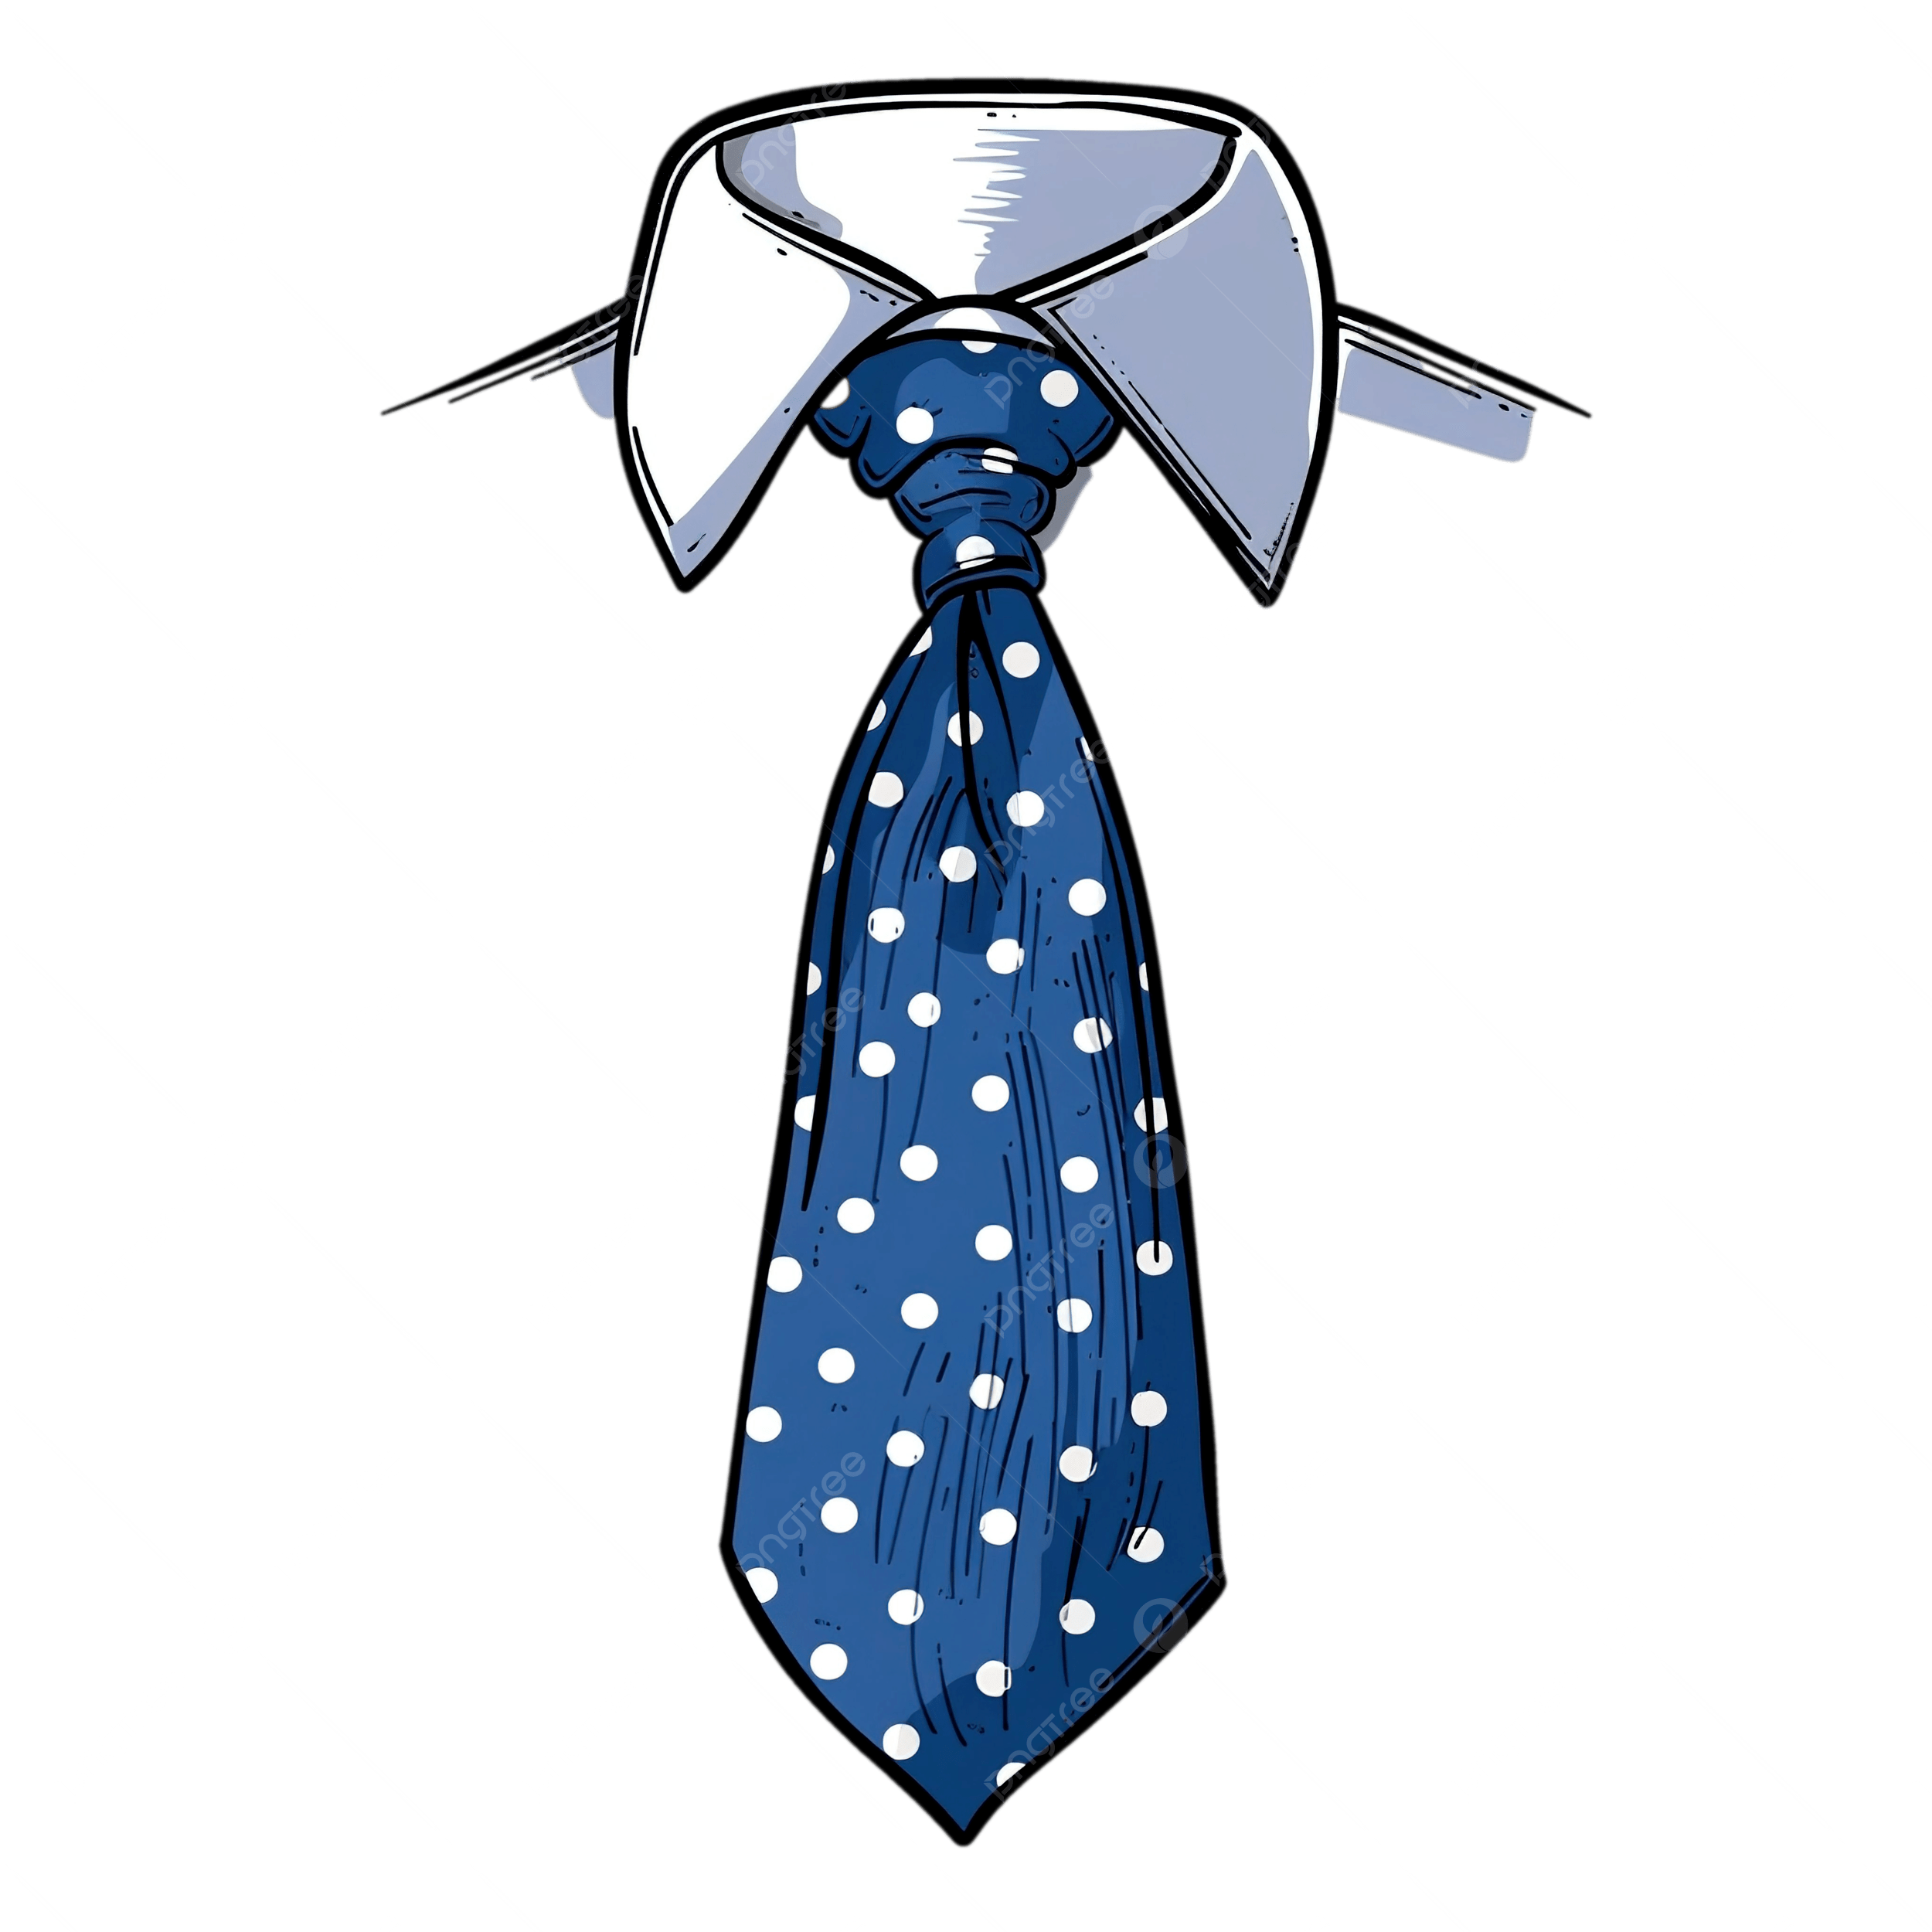 | 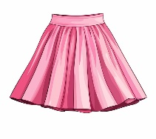 | 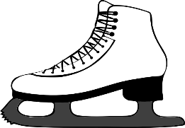 | 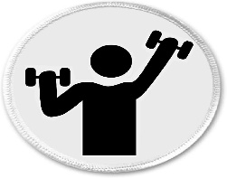 | 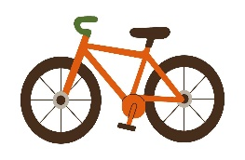
/ 2.5
gym - ice-skate - bike - skirt - tie

_______________________________________________________________________________
/ 1
Orthography

Choose the correct letter:
s | m | r | 1. He usually does his homewo_k before dinner.
d | v | f | 2. They have a fantastic winter _acation in Abha.

Good luck T.

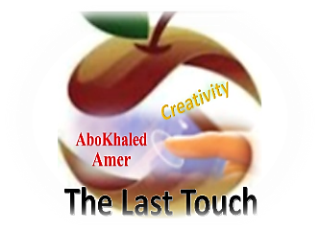

المملكة العربية السعودية
وزارة التعليم
الادارة العامة للتعليم بمنطقة ----------------
مدرسة ------------------ المتوسطة
Second Term- Second Session Test
Name: ------------------------------------------------------ Grade: 1st Inter.
ABOKHALEDAMER
0557325813
1. Write the correct number under its picture: (6M)
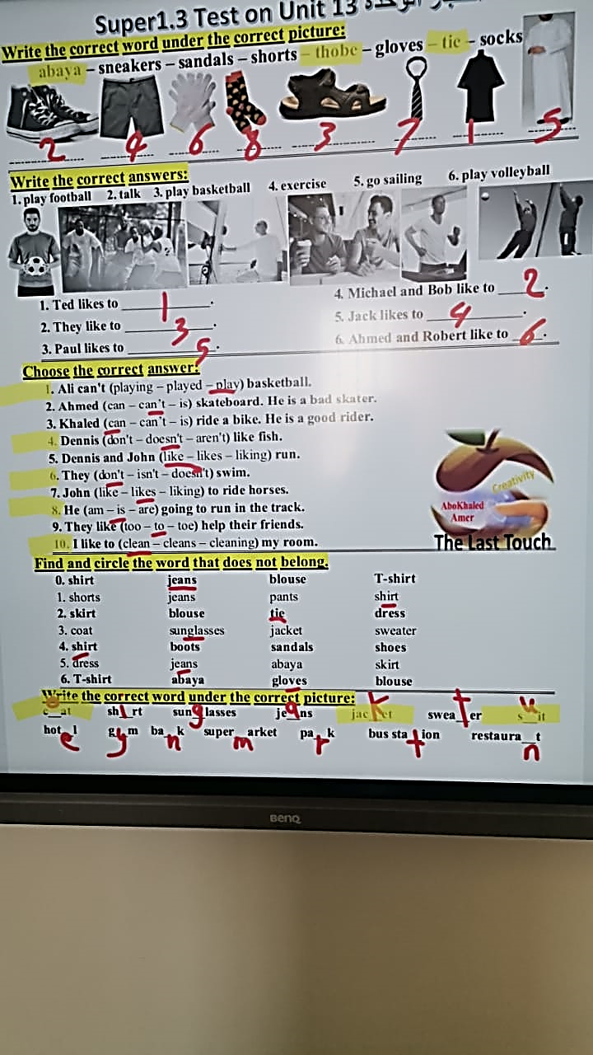
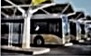
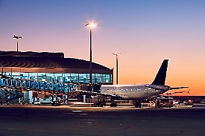
1. bus station 2. bank 3. airport 4. tie 5. abaya 6. thobe


( ) ( ) ( ) ( ) ( ) ( )
2. Match the place and things: (4M)
1. ----- park a. You can exercise.
2. ------ gym b. You can buy books.
3. ------ bookstore c. Visitors can sleep there.
4. ------ hotel d. We have a barbecue.
3. Choose the correct answer: (8M)
1. I (can – can't – don't) swim. Can you tell me how to swim?
2. She can (drive – drives – driving) a car carefully.
3. (Do – Does – Doing) you like ice cream?
4. Can you (helping – helps – help) me do my homework?
5. Does she clean the room? Yes, she (do – can – does).
6. Dennis (like – likes – liking) fish.
7. He (am – is – are) going to run in the track.
8. I to (clean – cleans – cleaning) my room.
4. Supply the missing letters: (2M)
1. Scho__l 2. resta__rant 3. c__at 4. s__it

(2) Top Goal - YouTube End of Questions https://t.me/abokhaledamer

