
Kingdom of Saudi Arabia
Ministry of Education
……..Education Directorate
………………… School
English Language
elementary Grade ...
2nd period Exam
…………….\20
الاسم: الصف:


……\ 3 marks

General questions

A.Answer the questions
I check in at the hotel. |  | What is your favorite way to travel? | 1
My favorite way to travel is by plane. |  | What do you do when you arrive at a hotel? | 2
Yes, I would like to travel. |  | Would you like to travel? | 3

Controlled Writing
……\ 2 marks
A-reorder.
1- fun \The tour \ was
a-fun was the tour b-The tour was fun.
2- my bag\ I \ prepare
a- I prepare my bag. b-prepare I my bag

……\ 4 marks

Reading short sentence
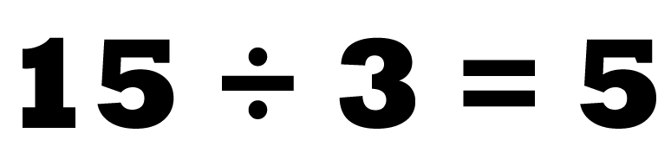 | 1-Multiply means adding the same number many times. ( )
 | 2- He will check out of the hotel early. ( )
A-Put ( ✔ ) or ( X )
B. Choose the correct answer
c-gym | b-platform | a- park | 1- The passengers wait at ………….
c-hurry | b-suitcase | a-office | 2-You carry your clothes in a……………………...

……\ 4 marks

Grammar
A-Choose the correct answer.
c-visit | b- visits | a- visited | 1- We have ………the beach.
c-most | b- already | a-done | 2- She has…….arrived at the hotel.
c-yet | b-just | a-more | 3- Have you finished your homework …..?
c- flown | b- flow | a-fly | 4- He hasn’t ………on a plane.

Vocabulary

A.Choose the correct word under each picture
……\ 5 marks

 | 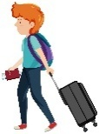 | 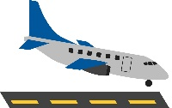 | 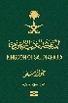 | 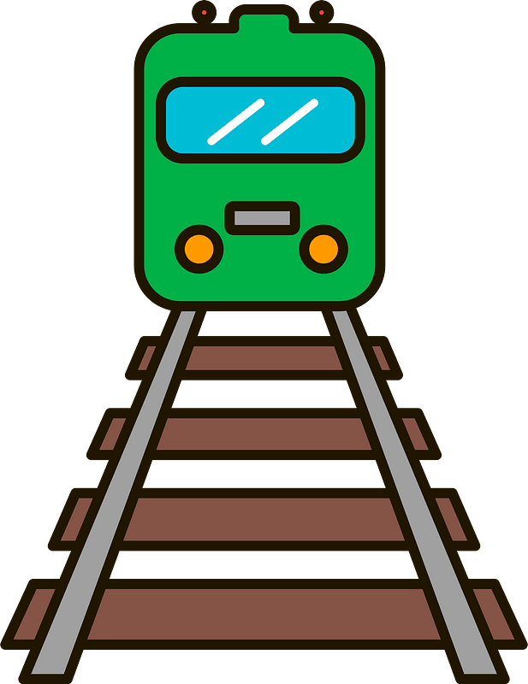
farm | security | find out | passport | railroad
plane | passenger | land | terminal | tour
……\ 2 marks

Orthography
A. Fill in the missing letters

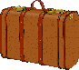
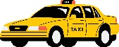
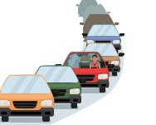
1-ta…….i
( r – w - x )
4- tra..fic
( n – q – f )

( s – t - o)
3-…uitcase
( o – s - p )

2-hur…y
( i - r - l )

Your teacher:

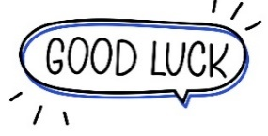
Your teacher …..:…………………………….


Kingdom of Saudi Arabia 5th & 6th Elementary Grade

10
Ministry of Education Second Term
…… Elementary School Second Exam - 1447 AH
Name: ………………………………………………………….………………. Class : …………..
- General Questions:
  - Match the questions with the correct answers:
A | B
1. What items do you need for fishing? |  | We should wear the right equipment.
2. What do you know about being safe outdoors? |  | Go climbing in the mountains.
 |  | I need fishing rod for fishing.
  - Choose the correct answer:
1- Did you have fun on your trip?
a- Yes, I was. | b- Yes, I did.
2- Which activities can make you tired, scared, or bored?
a- playing video games. | b- hiking in the forest.

- Reading Short Sentences:
  - Read the sentences then match them with the correct pictures:
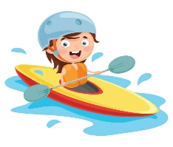 | 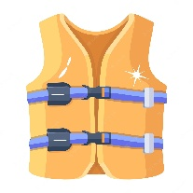 | 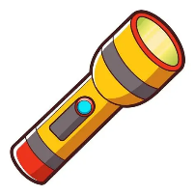 | 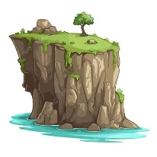
a-_I go surfing on the waves.  b-_I go canoeing on the lake. | a- It is a life jacket.  b- It is a raft. | a- It is a flashlight.  b- It is a surfboard. | a-_That is a cliff.  b-_That is a forest.

- Grammar:
  - Choose the correct answer:
    - She (learn – learned – learning) how to climb yesterday.
    - They didn’t (see – saw – seeing) the snake.
    - We were canoeing (when – while) it started raining.
    - We ate hot dogs while we (sit – sits – were sitting) around the campfire.

- Vocabulary:
  - Write the words under the correct pictures:
horseback riding – thirsty – river – climbing

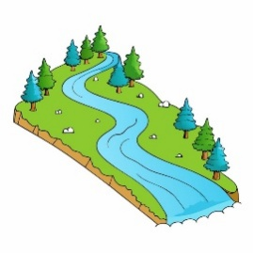 | 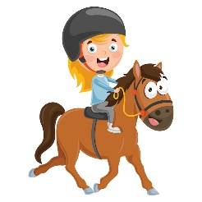 | 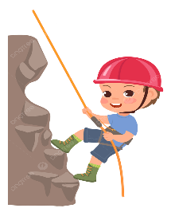 | 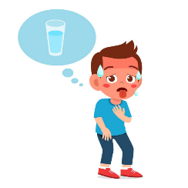

- Orthography:
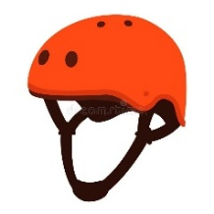  h__lmet |  | 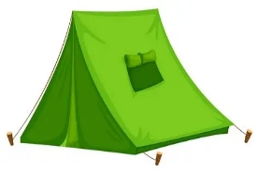  ten__ |  | 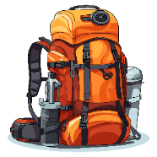  back__ack |  | 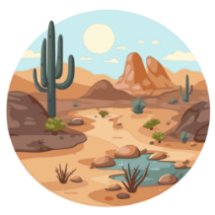  de__ert
i | E | t | b | b | p | z | s
  - Choose the correct missing letters:

BEST OF LUCK
Ms. Tahani Al-Ghamdi

1
1– Do you prefer activities you do outdoors or at home?

A. I like activities. B. I like outdoor activities.
I. CHOOSE
2– What is your favorite way to travel ?
A. By plane . B. I sometimes go to the beach.
المملكة العربية السعودية |  | اسم الطالب/هـ ......................................
وزارة التعليم |  | اسم الطالب/هـ ......................................
إدارة التعليم بمنطقة |  | المادة : انجليزي
مدرسة : |  | الزمن :
مدرسة : |  | الصف : فصل ( )
شفهي | تحريري | المجموع
10 / | 10 / | 20 /
اختبار الفترة الثانيه – الفصل الثاني 1447هـ - الصف ابتدائي
اسم الطالب / هـ الفصل /

2. CHOOSE OR
1.5

She put on her helmet.
He has a fun trip.
Put everything in a suitcase

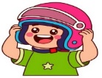

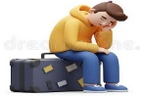
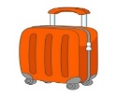

3. CHOOSE TO COMPLETE THE FOLLOWING:
1.5

Do as shown between brackets :

1- yesterday / raining / It / was (Rearrange)
………………………………………………………………………………………
2- __________ To go up in the sky. ( choose )
A. Take off. B. go out

1
was reading | read | 1- Mary ______________ in her tent when I saw her .
have travelled | has travelled | 2- I ______ with my friends.
4. CHOOSE

3
5. Write the correct word:

Taxi - Passport - Sleeping bag - Subway - backpack - Railroad

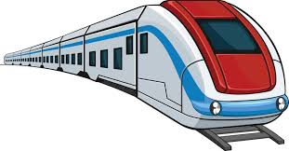 | 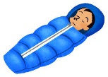 | 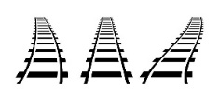 |  | 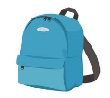 | 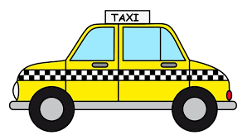  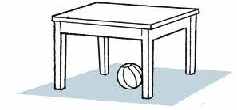

6. CHOOSE THE CORRECT LETTERS:
2

Choose the correct letter:

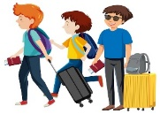 | 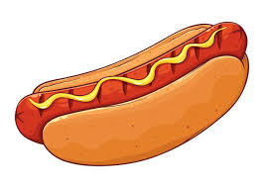 |  | 
Passen_ er | Hot _og | Statio_ | Check _ut
f | d | n | o
g | b | m | a

___________________________________________________________________________________________________________________________________________________________________________________________________________________________________
Controlled writing

4

Good luck T.

