1
1– What is your favorite kind of story?
I. CHOOSE
A. Yes, I like B. Horror story.
2– What activity do you do outside?

A. No, I am not . B. Hiking in the. forest.
المملكة العربية السعودية |  |  | اسم الطالب/هـ ......................................
وزارة التعليم
إدارة التعليم بمنطقة |  |  | المادة : انجليزي
مدرسة : |  |  | الزمن :
 |  |  | الصف : فصل ( )
شفهي | تحريري |  |  | المجموع
10 / | 10 / |  |  | 20 /
اختبار الفترة الأولى – الفصل الثاني 1447هـ - الصف ابتدائي
اسم الطالب / هـ الفصل /

2. CHOOSE OR
1.5

The bear was sick.
He was walking.
I was fishing .

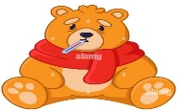




3. CHOOSE TO COMPLETE THE FOLLOWING:
1.5

Choose the word to complete the chart about types of word :
Noun | Verb | Adjective

Word | Word Class
1- comedy
2- act
3- mysterious

1
is | was | were | 1- They _____ eating in the kitchen.
seeing | saw | see | 2- I _____ a bear yesterday .
4. CHOOSE
5. CHOOSE
3

whisper - canoe - mystery

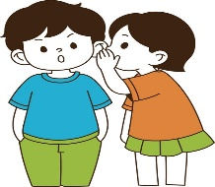 |  | 

6. CHOOSE THE CORRECT LETTERS:
2

Choose the correct letter:

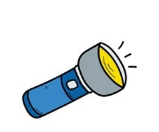 | 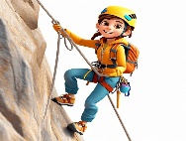 |  | 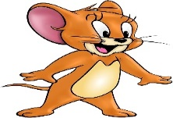
Flas_light | ing_clim | ducu_entary | toon_ca
h | d | f | r
k | b | m | s

___________________________________________________________________________________________________________________________________________________________________________________________________________________________________
Controlled writing

4

Good luck T.


Kingdom of Saudi Arabia
Ministry of Education
……..Education Directorate
………………… School
English Language
elementary Grade ...
1st period Exam
…………….\20
الاسم: الصف:


……\ 4 marks

General questions

A.Answer the questions
My favorite character is Spiderman. |  | What’s your favorite type of story? | 1
He was sleeping. |  | What activity do you do outside? | 2
I go rock climbing. |  | Who is your favorite story character? | 3
I like thriller stories. |  | What was your brother doing? | 4

Controlled Writing
……\ 1 marks
A-reorder.
1- a fairy tale\ I \ reading \was.
a-reading a fairy tale I was b-I was reading a fairy tale.

……\ 4 marks

Reading short sentence
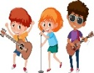 | 1- Musical actors have to sing and dance. ( )
 | 2- He feels scared when he watches horror movies. ( )
A-Put ( ✔ ) or ( X )
B. Choose the correct answer
c-surfboard | b-tent | a- fishing rod | 1- He went fishing. He took his……….
c-comedian | b-act | a- document | 2- My parents …..family vacations on video

……\ 4 marks

Grammar
A-Choose the correct answer.
c- watched | b- watch | a- watching | 1- I was ……….. a movie.
c-Is | b-Was | a-Were | 2-………they buying tickets for a concert?
c- Wrote | b- writing | a- write | 3- What about …….. a story about us?
c- sees | b- see | a- saw | 4- I didn’t ……… a bear.

Vocabulary

A.Choose the correct word under each picture
……\ 5 marks

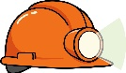 | 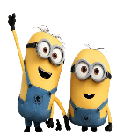 | 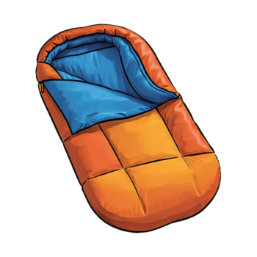 | 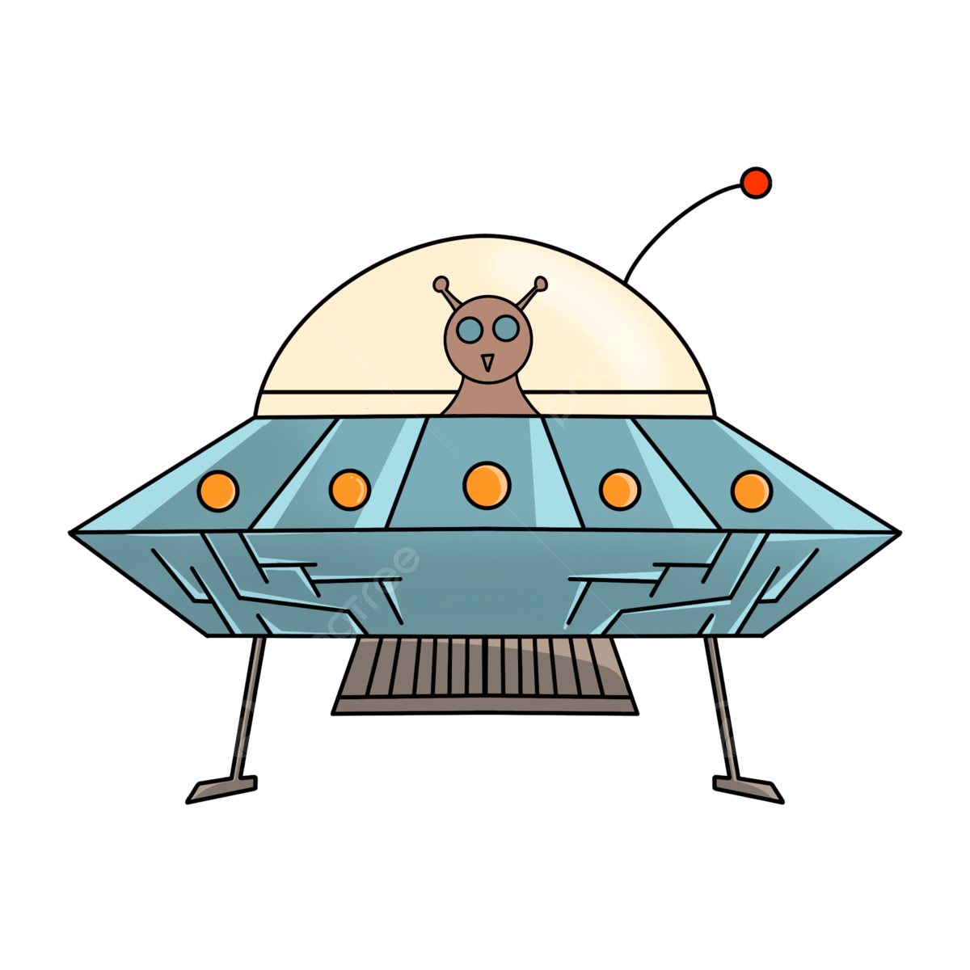 | 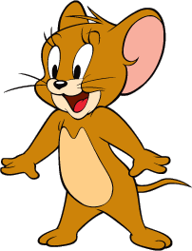
Helmet | animation | flashlight | Sci-fi | cartoon
surfboard | drama | Sleeping bag | play | horror
……\ 2 marks

Orthography
A. Fill in the missing letters

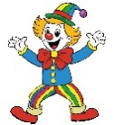

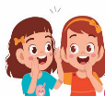
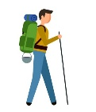

4- co……edy
( m – q - t )

2-m…..stery
( o – k – y )

( s – t - o)
3-…..iking
( d– h - t )

1- whis.…er
( p – d – f )

( s – t - o)

Your teacher:

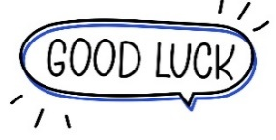
Your teacher …..:…………………………….


Kingdom of Saudi Arabia 5th & 6th Elementary Grade

10
Ministry of Education Second Term
…… Elementary School First Exam - 1447 AH
Name: ………………………………………………………….………………. Class : …………..
- General Questions:
- Choose the correct answer:
1- What are the people in stories called?
a- climax & resolution |  |  |  |  | b- characters
2- What can you draw to plan a story?
a- a storyboard |  |  |  |  | b- a shopping list
3- How many acts in a story?
a- There are 3 acts in a story. |  |  |  |  |  | b- There are 5 acts in a story.
- Reading short sentence:
- Read the sentences then match them with the correct pictures:
 | 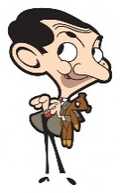 | 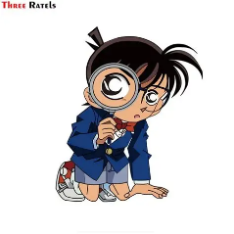 | 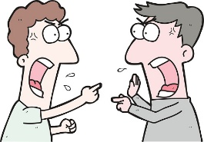
a-It is a cartoon.  b-It is a horror story. | a- It is a comedy story.  b- It is a drama. | a- It is an animation.  b- It is a mystery movie. | a-They were arguing.  b-They were agreeing.

III. Grammar:
- Choose the correct answer:
- He was ……………. a movie.
- watch |  |  | - watched |  |  |  |  | - watching
- Why don’t we ………………… a pizza?
- order |  |  | - orders |  |  |  |  | - ordered
- What about ………………. tennis?
- play |  |  | - playing |  |  |  |  | - played
V. Vocabulary:
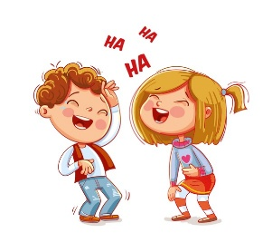
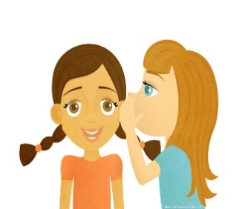
- Choose the correct answer:
 |  |  |  |  |  | 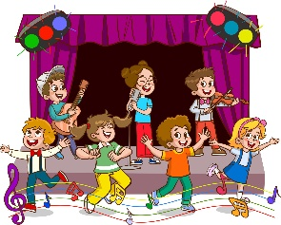
- appear  - whisper |  | - astronaut  - detective |  |  |  | - musical  - thriller |  |  | - laugh  - decide
- Fill in the blanks with the words from the box.
horror – fairy tale – drama
1- …………….…: It’s a story for children about things and characters that aren’t real.
2- …………….…: This kind of story creates a feeling of fear.
VI. Orthography:

- Choose the correct missing letters:
boo__case |  | 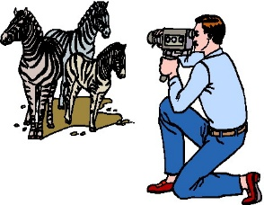  do__umentary |  |  |  | 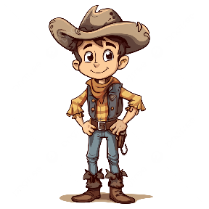  cow__oy |  |  | 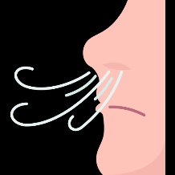  b__eath
x | k | c |  | k |  | d | b |  | r | l

BEST OF LUCK
Ms. Tahani Al-Ghamdi

Storylines Unit 5 : End of Unit Test
الدرجة:

اسم الطالب/ة :
الفصل :

General Questions
Match each question with the correct answer:

- What do you draw to plan a story? |  | a. a book
- What about watching a movie? |  | b. The one with the ice queen
- What did you take out of the bookcase? |  | c. sci-fi
- What does "Astronauts" in space describe? |  | d. Storyboard
- What is your favorite 3D animation movie? |  | e. That’s a good idea

Read and write T (True) or F (False):

1- Most stories follow a five-act structure. ( )
2- Comedy is the story type that makes us laugh a lot. ( )
Controlled Writing
Write about The Lost Seats . Use the questions and the words to help you .

Who are your characters? Where are they?
Fahad and Reem / movie theater
What was happening at the beginning?
buying tickets - choosing a movie

What problem appeared? How did they feel? couldn't find – seats / nervous - confused

How did it end?
found – seats - happy

……………………………………………………………………………..
……………………………………………………………………………..
……………………………………………………………………………..
……………………………………………………………………………..
……………………………………………………………………………..
……………………………………………………………………………..
……………………………………………………………………………..

Reading Short Sentences
Yesterday at 6:30 p.m., Faisal was sitting in the living room. His sister Reem was drawing a cartoon character, and their dad was cooking dinner. Outside, the wind was strong, and dark clouds were moving across the sky.
Faisal’s phone rang, but he didn’t answer because he was watching a video about movie scenes for school. A few minutes later, his friend texted: “Where are you?” Faisal replied, “Sorry! I was studying and I wasn’t checking my messages.”
Later that night, they met online. Faisal asked, “What were you doing at 7 o’clock?” His friend said, “I was helping my little brother with homework.”

Read the paragraph and put ✔ or ✘:

- Faisal was sitting in the living room at 6:30 p.m. ( )
- Faisal answered the phone when it rang. ( )
- Reem was drawing a cartoon character. ( )

Read the paragraph and answer the questions:

- Outside, the wind was ________.
- Faisal replied that he wasn’t ________ his messages.
- Faisal didn’t answer the phone because he was ________ a video

Read the paragraph and answer the questions:

Elena and Vicky wanted to create a short story for class. Elena decided to make the main character a brave girl, but Vicky wished the story had a funny ending. They sat together and talked quietly because the teacher was speaking. Suddenly, a small cat appeared at the classroom door. The cat looked lost and a little scared. Elena whispered, “Let’s help it.” Vicky nodded and smiled. They made the cat the main character of their story. In Act I, the cat was alone. In Act II, it met friendly kids. In Act III, it found its home. When they finished, they felt happy because their story had clear events and strong action verbs.

- Why did Elena and Vicky talk quietly?________________________________
- What appeared at the classroom door?________________________________
- How did the cat feel when it appeared?________________________________

Read the paragraph and choose the correct answer:

1) What did Vicky want for the ending of the story?
A) A scary ending
B) A funny ending
C) A sad ending
D) A long ending
2) In which act did the cat meet friendly kids?
A) Act I
B) Act II
C) Act III
D) Act IV
3) (Inference) Why did Elena and Vicky choose the cat as the main character?
A) Because the teacher asked them to use an animal
B) Because they wanted a story about space
C) Because the cat looked lost and needed help
D) Because they didn’t like brave characters

Grammar
Choose the correct answer :

- They ____ during the horror movie
a) was screaming b) screamed c) were screaming
- ____________watch a movie tonight?
a) Why don’t we b) How about c) What about
- ____ you enjoying the cartoon?
a) Did b) Were c) Was
- At lunchtime, we ____ on our storyboard
a) was working b) were working c) working
5- She ____ a play. She was watching a documentary
a) didn’t watching b) wasn’t watch c) wasn’t watching
6- ____ changing the ending?
a) Why don’t b) Why don’t we c) What about

Vocabulary
Write the correct word under each picture:
whisper | plot | adventure | chest | talk show
castle | cowboys | play | presentation | thriller

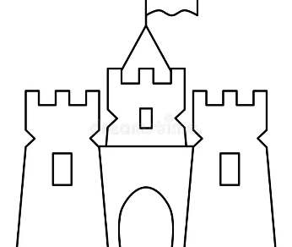  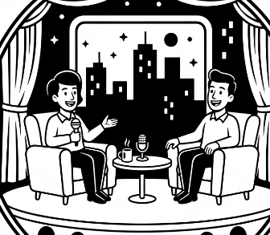 |  | 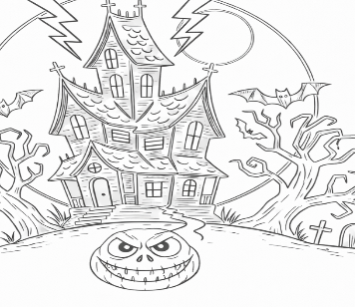 | 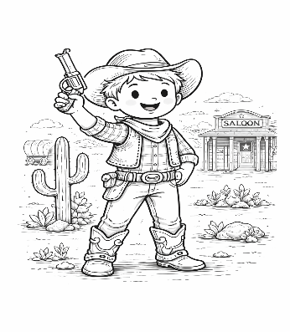 | 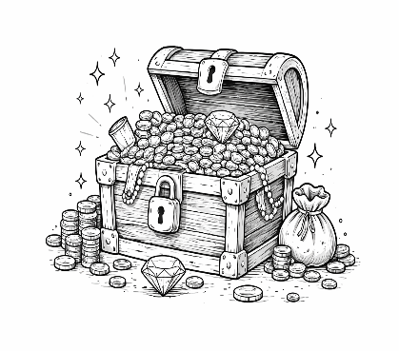

 | 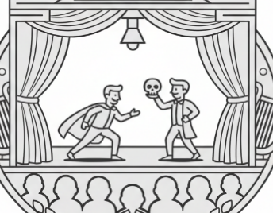 | 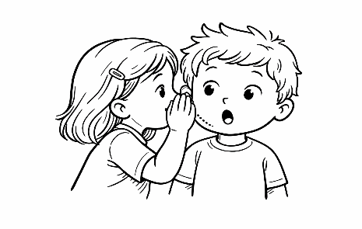 | 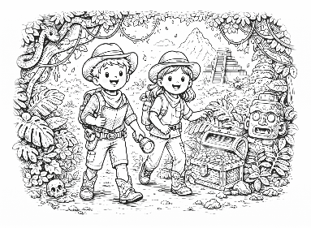 | 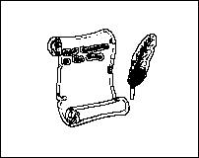

Choose the correct word :

- The monster ______to see what was out there in the real world
a) appeared b) decided c) whispered
- My parents _________ our trips with their camera.
a) documentary b) documenting c) document
- It is a __________ with detectives and a twist in the plot
a) mystery b) animation c) musical
- ____ actors have to act, sing, and dance
a) western b) musical c) cartoons
- Jim Carrey is a great ____________
a) comedying b) comedian c) comedy
- My favorite __________ is the cowboy
a) character b) storyboard c) friend
- In this kind of story, a detective tries to solve a crime
a) mystery b) horror c) documentary
Orthography
Choose the missing letter:
- anima_ion ( s - o - t )
- sp_ce ( a - e - i )
- screa_ing ( n - m - q )
- chara_ters ( s - c - k )
- w_sh ( y - u - i )

Choose the correct spelling:

- (thriler - thriller - thrilller)
- (western - westarn - westren)
- (inventid - invanted - invented)
- (acting - actting - actin)
- (install - instal - instell)
- (cloun – clown - clowen)
- (storybord - storyboard - storyboardd)
- (comedian - comidean - commedian)
- (disastar - disester - disaster)
- (climax - climex - climaxe)

End of Questions

