1
I. CHOOSE
المملكة العربية السعودية |  |  | اسم الطالب/ه ......................................
وزارة التعليم
إدارة التعليم بمنطقة |  |  | المادة : انجليزي
مدرسة : |  |  | الزمن :
 |  |  | الصف : فصل ( )
شفهي | تحريري |  |  | المجموع
10 / | 10 / |  |  | 20 /
اختبار الفترة الأولى للفصل الثاني - للعام الدراسي 1447– لغة انجليزية –– للصف الثالث ابتدائي
اسم الطالب / هـ الفصل /

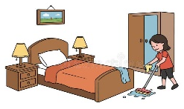
1 – What did you do over the weekend?

A . I am 10 years. B . I cleaned my room .
2 – I won a table tennis game 21 to 3 .
A. Congratulations. B. Sorry about that .

2. CHOOSE OR
1.5

1. He kicked the ball.

She watched TV. .2
3. I caught a big fish.

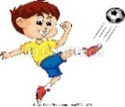
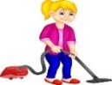

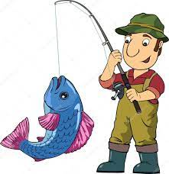

3. DO AS SHOWN BETWEEN BRACKETS
1.5

_______________________ |  |  | 1– breakfast – cooked – she . ( rearrange )
grocer's | park | bank | 2– I went to the ____ to buy some milk. ( choose )

4. CHOOSE
1
4. CHOOSE
some | many | much | 1 – How____ oil do you need ?
wining | won | win | 1- The PAST TENSE of win is ______ .

________________________________________________________________________________________________________________________________________________________________________________________________________________________________

French fries - Trampoline - carrots

3
5. CHOOSE
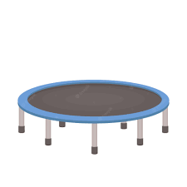     | 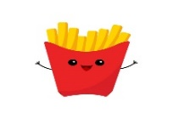 | 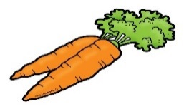

\

6. CHOOSE THE RIGHT LETTERS:
2

Choose the correct letter:

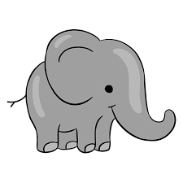  ele_ _ant | 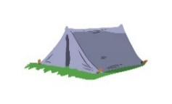  te_ _ | 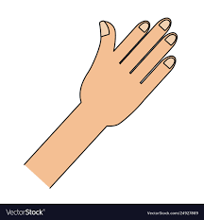  ha_ _ | 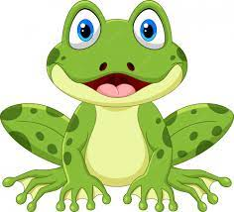  _rog
gh | nd | nd | f
ph | nt | nt | d

Controlled writing

4

______________________________________________________________________________________

Good luck


Kingdom of Saudi Arabia 3rd Elementary Grade

10
Ministry of Education Second Term
…… Elementary School First Exam - 1447 AH
Name: ………………………………………………………….………………. Class : …………..
- General Questions:
- Choose the correct answer:
1- How much flour do we need?
a- We don’t have any oil. |  |  |  |  | b- 2 cups of flour
2- What good things happened to you last year?
a- I saw a rainbow. |  |  |  |  | b- I broke my leg.
3- What did they cook?
a- We went to an adventure park. |  |  |  |  |  | b- They cooked pasta.
- Reading short sentence:
- Read the sentences then match them with the correct pictures:
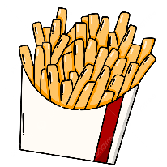 | 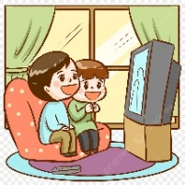 |  | 
a. I’d like French fries.  b. I’d like green salad. | a. They kicked a ball.  b. They watched a film. | a. He had an operation.  b. He had a cake. | a. I won a match.  b. I lost a match.

III. Grammar:
- Choose the correct answer:
- He didn’t ………… any meat.
- have |  |  | - has |  |  |  |  | - had
- How …………. milk do you drink?
- long |  |  | - many |  |  |  |  | - much
- We have …………. sugar.
- a |  |  | - some |  |  |  |  | - any
V. Vocabulary:
- Choose the correct answer:
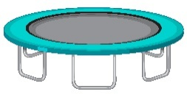 |  |  |  |  |  | 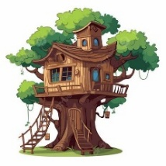 |  |  | 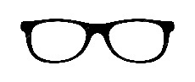
- trampoline  - magazine |  | - peppers  - mushrooms |  |  |  | - tree house  - elevator |  |  | - phone  - glasses
- Read and write the comments.
That’s scary - Congratulations! – Sorry about that.
1- I watched a film about sharks. ( …………………………………………)
2- We lost a basketball game 20 to 8. ( …………………………………………)
VI. Orthography:
- Choose the correct missing letters:
  pai__ __ |  |   __ rog |  |  |  | 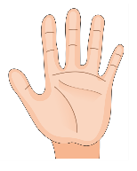  ha__ __ |  |  | 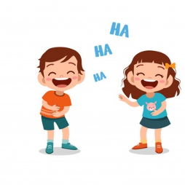  lau__ __
nd | nt | v |  | f |  | nd | nt |  | ph | gh

BEST OF LUCK
Ms. Tahani Al-Ghamdi


Kingdom of Saudi Arabia
Ministry of Education
……..Education Directorate
………………… School
English Language
elementary Grade 3rd
2nd period Exam
…………….\20
الاسم: الصف:


……\ 4 marks

General questions

A.Answer the questions
Congratulations! |  | I stayed home | 1
I cooked breakfast. |  | What happened to you yesterday? | 2
I caught a cold |  | What did you do over the weekend? | 3
That's boring. |  | I won a basketball game. | 4

Controlled Writing
……\ 1 marks
A-reorder.
1- outside \They \played.
a-They played outside b- outside played they

……\ 4 marks

Reading short sentence
 | 1- My uncle had an operation. ( )
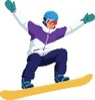 | 2- You can buy a snowboard at a sport store. ( )
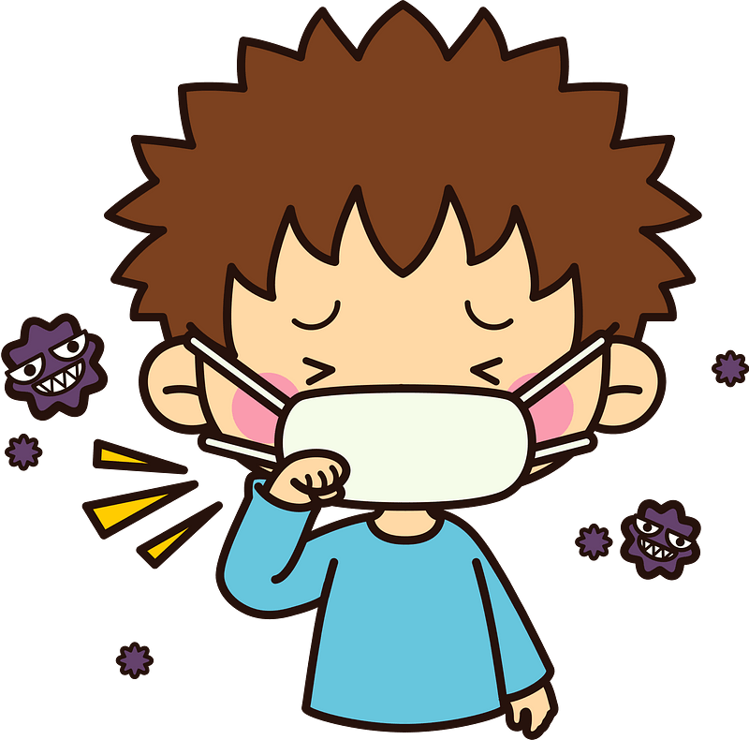 | 3- I was sick. ( )
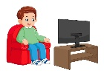 | 4- Mohammed kicked his new football. ( )
A-Put ( ✔ ) or ( X )

……\ 4 marks

Grammar
A-Choose the correct answer.
c-old | b-much | a- many | 1-How ……tomatoes do you have?
c-some | b-an | a-any | 2-They have ………cookies.
c-went | b-goes | a- go | 3- Last year , I ………to Japan.
c-much | b-many | a- any | 4- we don’t have …….fries.

Vocabulary

A.Choose the correct word under each picture
……\ 5 marks

 | 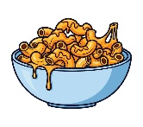 |  | 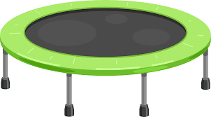 | 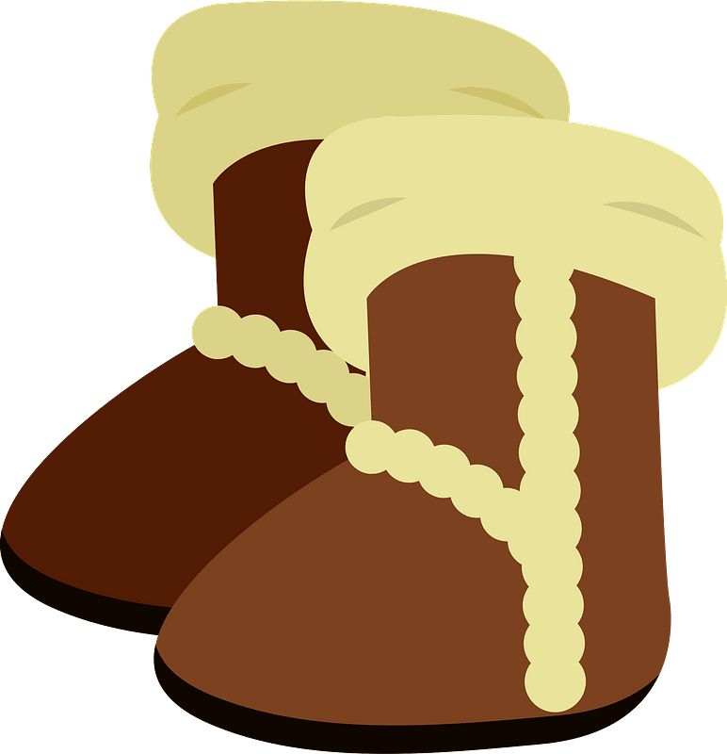
milk | macaroni | tree | Trampoline | boots
Salad | pizza | rocket | elephant | T-shirt
……\ 2 marks

Orthography
A. Fill in the missing letters

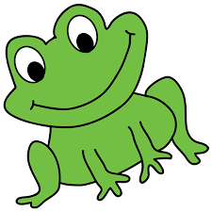
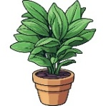
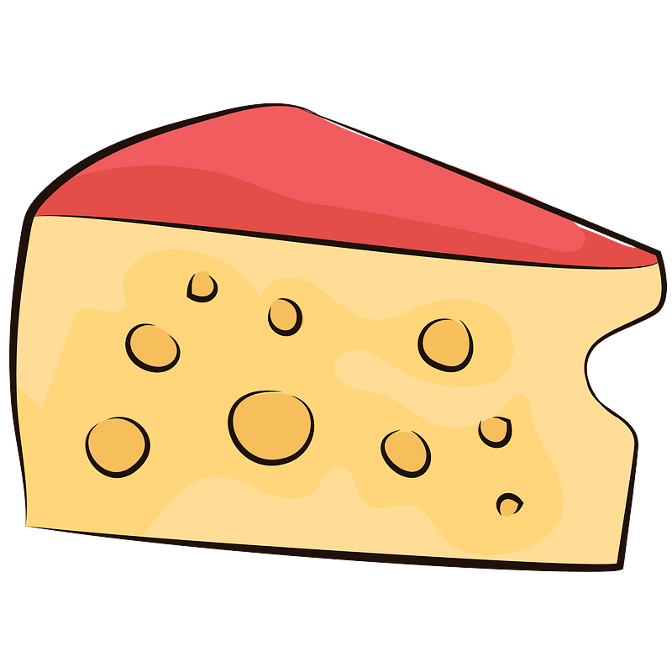
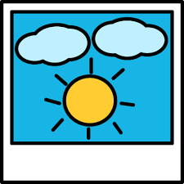

2-….rog
( th – r -f )

….rog
1-…..oto
(ph -gh – f )

…..oto
3-pla……
( cl – nt – gh)
4- c…eese
( r – o – h)

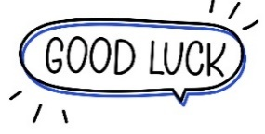
Your teacher:

Your teacher …..:…………………………….



اختبار الفترة الأولى – الصف الثالث الابتدائي/
الاسم | الفصل | شفهي | تحريري | المجموع
 | / | 10 / | 10 / | 20 /
First Period Exam

1
1. CHOOSE
- What did you do over the weekend?
- I am 10 years. | - I cleaned my room .

- I won a table tennis game 21 to 3 .
- Congratulations. | B. Sorry about that .

1.5
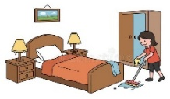
222
2. CHOOSE OR

He kicked the ball. | She watched TV. | I caught a big fish.

1.5

3. DO AS SHOWN BETWEEN BRACKETS

1- breakfast – cooked – she . ( Rearrage ) …………………………………………………………………………………………
grocer's | park | bank | 2– I went to the ___ to buy some milk.( choose )

some | many | much | 1 – How____ oil do you need ?
wining | won | win | 1- The PAST TENSE of win is ______ .
4. CHOOSE
1

5. CHOOSE

3

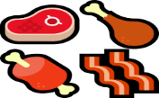 | 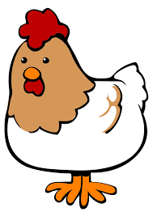 | 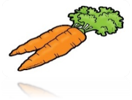 | 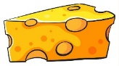 | 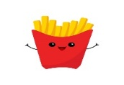  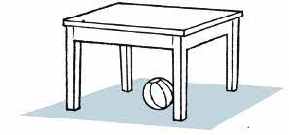
meat | chicken | carrots | orange | French fries | Trampoline
rice | bear | banana | cheese | apple | Ladder

ele_ _ant | te_ _ | ha_ _ | 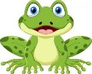  _rog
gh | nd | nd | f
ph | nt | nt | d
6. CHOOSE THE CORRECT LTTER
2

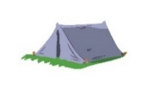

TEACHER :

