1
1– What activity do you like to do in the summer?
I. CHOOSE
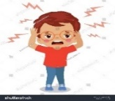
A. I am happy. B. I go to the beach
2– What is the matter?

A. I have a headache. B. I am sleeping.
المملكة العربية السعودية |  |  | اسم الطالب/هـ ......................................
وزارة التعليم
إدارة التعليم بمنطقة |  |  | المادة : انجليزي
مدرسة : |  |  | الزمن :
 |  |  | الصف : الرابع فصل ( )
شفهي | تحريري |  |  | المجموع
10 / | 10 / |  |  | 20 /
اختبار الفترة الأولى – الفصل الثاني 1447هـ - الصف الرابع ابتدائي
اسم الطالب / هـ الفصل /

2. CHOOSE OR
1.5

He is riding his bike.
Swim in the lake .
She is crying .

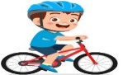
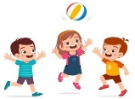

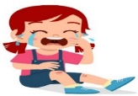

3. DO AS SHOWN BETWEEN BRACKETS:
1.5

........................................................... |  |  | 1- anything / I / don't / see/ ( Rearrange)
close | dry | high | 2 – The opposite of law is ________ . ( choose )

1
climbs | to climb | climbing | 1- I decided _______ the hill.
Couldn't | mustn't | Should | 1- You______ drink a lot of water. It is good for your health.
4. CHOOSE

4
5. CHOOSE

couch - flag - mountain - foot

 | 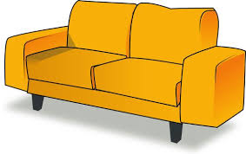 | 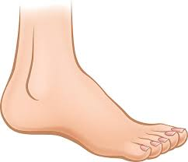 | 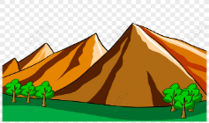

6. CHOOSE THE CORRECT LETTERS:
1

Choose the correct letter:

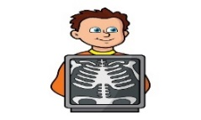 | 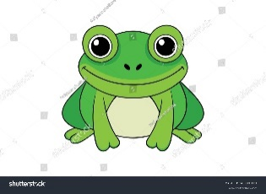
X-Ra_ | rog_ _
e | fr
y | dr

___________________________________________________________________________________________________________________________________________________________________________________________________________________________________
Controlled writing

4

Good luck T.


Kingdom of Saudi Arabia 4th Elementary Grade

10
Ministry of Education Second Term
…… Elementary School First Exam - 1447 AH
Name: ………………………………………………………….………………. Class : …………..
- General Questions:
- Choose the correct answer:
1- What can you do at the beach?
a- I can swim there. |  |  |  |  | b- I can sleep there.
2- What did you do on your vacation?
a- It is a mountain. |  |  |  |  | b- I went riding on my bike.
3- Could you ride a horse?
a- No, I couldn’t. |  |  |  |  |  | b- No, I don’t.
- Reading short sentence:
- Read the sentences then match them with the correct pictures:
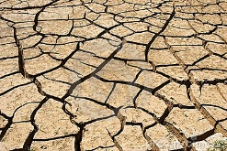 | 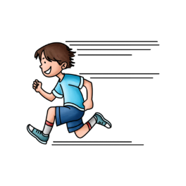 | 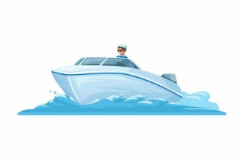 | 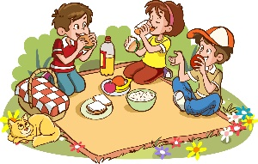
a-_It is a deep lake.  b-_It is a dry ground. | a-_He runs fast.  b-_He rides a horse. | a-_I climb a mountain.  b-_I take a boat trip. | a-_We had a picnic.  b-_We took a photo.

III. Grammar:
- Choose the correct answer:
- She wants …………… a nurse.
- be |  |  | - to be |  |  |  |  | - being
- He went …………… yesterday.
- shop |  |  | - to shop |  |  |  |  | - shopping
- I could …………….. when I was 2.
- read |  |  | - to read |  |  |  |  | - reading
V. Vocabulary:
- Choose the correct answer:
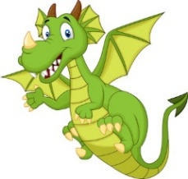 |  |  |  |  |  | 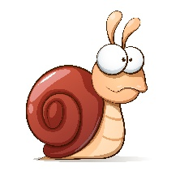 |  |  | 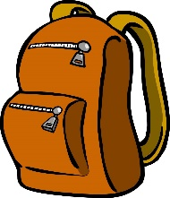
- lion  - dragon |  | - flag  - umbrella |  |  |  | - camel  - snail |  |  | - backpack  - board
- Fill in the blanks with the words from the box.
desert – hill – Earth
1- …………….…: The planet we live on.
2- …………….…: Very dry land, usually with sand
VI. Orthography:
- Choose the correct missing letters:
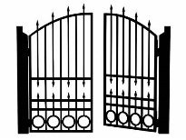  __ate |  | 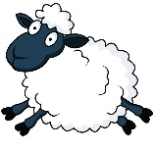  __ __ eep |  |  |  | 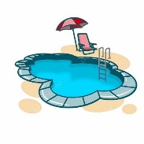  __ool |  |  | 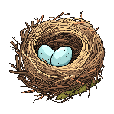  __est
j | g | sh |  | ch |  | b | p |  | n | m

BEST OF LUCK
Ms. Tahani Al-Ghamdi


Kingdom of Saudi Arabia
Ministry of Education
……..Education Directorate
………………… School
English Language
elementary Grade 4th
1st period Exam
…………….\20
الاسم: الصف:


……\ 4 marks

General questions

A.Answer the questions
My favorite outdoor place is a field. |  | What is the matter? | 1
You should clean the cut. |  | What is your favorite outdoor place? | 2
Yes, he could. |  | What should you do? | 3
He has a stomachache. |  | Coud he run fast ? | 4

Controlled Writing
……\ 1 marks
A-reorder.
1- could \ He \ photos\ take
a-He could take photos. b-photos take He could.

……\ 4 marks

Reading short sentence
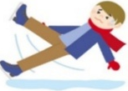 | 1- I tried to ice skate but it was very difficult. ( )
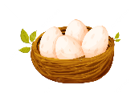 | 2- There are some eggs in the nest. ( )
A-Put ( ✔ ) or ( X )
B. Choose the correct answer
c-ocean | b-island | a- desert | 1- Very dry land, usually with sand.
c-put on | b-cut | a-cry | 2- Something you do when you are sad.

……\ 4 marks

Grammar
A-Choose the correct answer.
c-s explores | b- explored | a-explore | 1- Faris decided to……..the cave.
c-hikes | b- hike | a-hiking | 2- Omar likes ……………in the hills.
c- climbing | b- climb | a- climbs | 3-Could they ………… the mountain?
c- shouting | b- shout | a- shouted | 4- I mustn't ……….in the hospital.

Vocabulary

A.Choose the correct word under each picture
……\ 5 marks

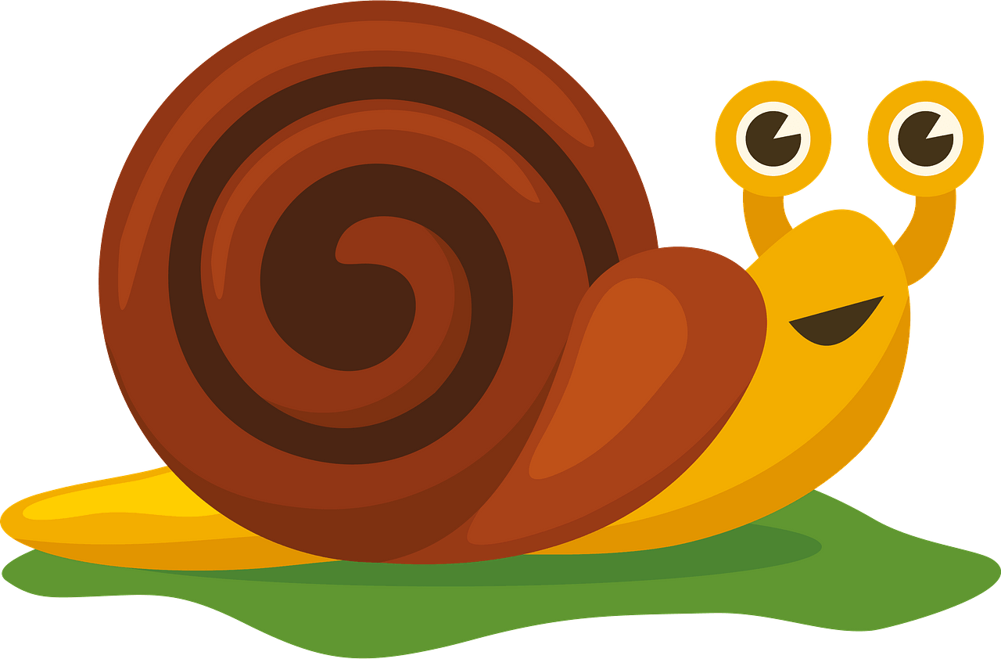 | 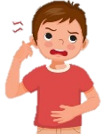 | 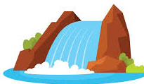 | 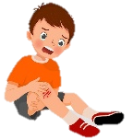 | 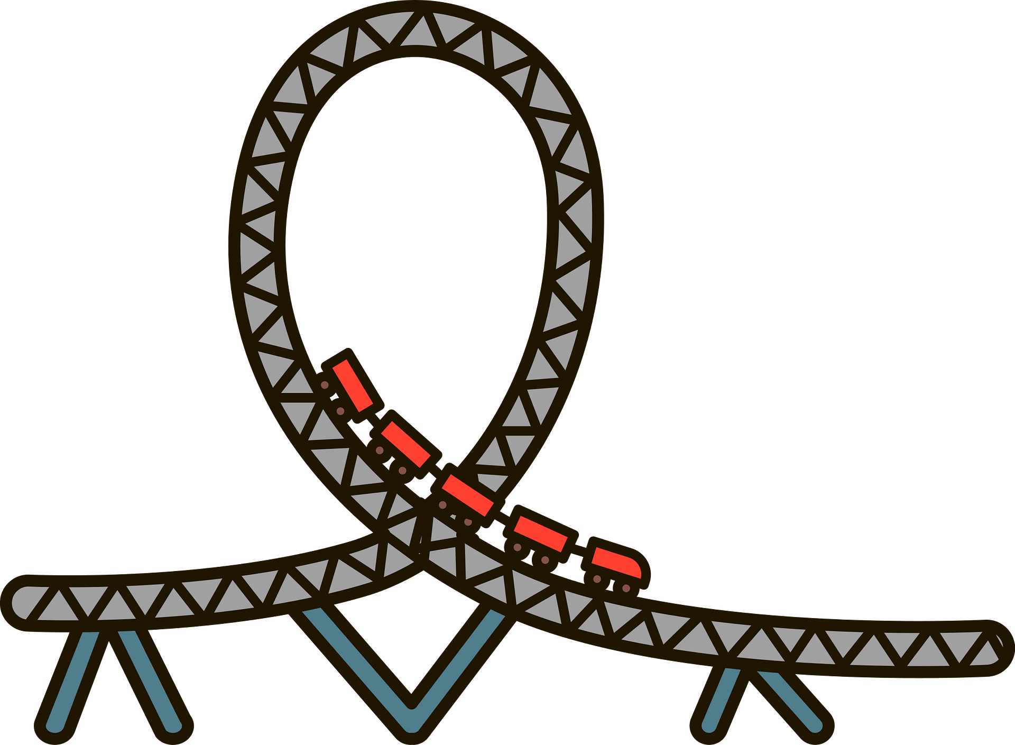
tiger | Take off | waterfall | hurt | roller coaster
snail | earache | Earth | x-ray | elbow
……\ 2 marks

Orthography
A. Fill in the missing letters
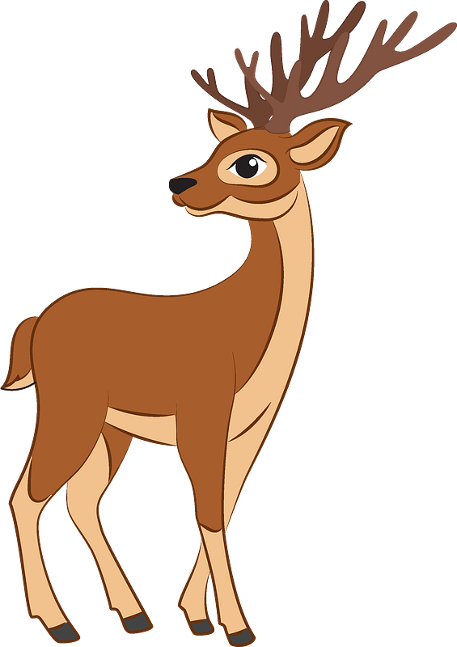

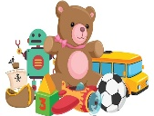
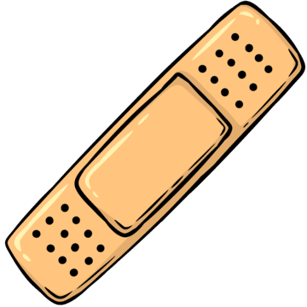

3- hi….l
( q– e – l )

( s – t - o)
1- dee….
( r – p - a )

2-..…oys
( p – t – k )

( s – t - o)
4- band ai…
( h – u - d )


Your teacher:

Your teacher …..:…………………………….



First Period Exam – Top Goal 1

مدرسة :
الاسم | الفصل | شفهي | تحريري | المجموع
 | / | 10 / | 10 / | 20 /
Choose the correct answer:
/ 1
1– What activity do you like to do in the summer?

A. I am happy. B. I go to the beach.
2– What is the matter?

A. I have a headache. B. I am sleeping.
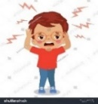
____________________________________________________________________________________________________
Choose or :
/ 1.5
He is riding his bike. | Swim in the lake . | She is crying .
______________________________________________________________________
/ 1.5
1- anything / I / don't / see/ (Rearrange ) ……………………………………………………………………………
close | dry | high | 2 – The opposite of low is ________ . ( choose )
Do as shown between brackets :

Choose the correct word:
/ 1
to climb | climbing | 1- I decided _______ the hill.
mustn't | Should | 2- You______ drink a lot of water. It is good for your health

/ 3
Choose the correct word:

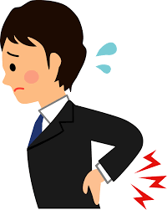 | 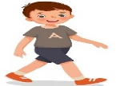 | 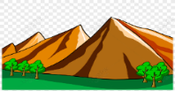 |  |  | 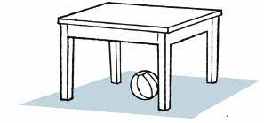
head | climb | forest | foot | couch | bag
back | walk | mountain | hand | ladder | flag
Choose the correct letter to fill in the blank:
/ 2
 | 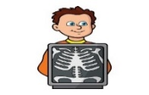 | 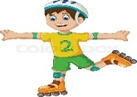
ck_l | X-Ra_ | kate_ | _og
u | e | s | fr
o | y | l | dr

Good luck T.
Controlled writing

4

