

Kingdom of Saudi Arabia
Ministry of Education
………………… School
English Language
Intermediate Grade 2nd
1st period Exam
……….\20

Student's Name : class:

……\ 5 marks
1-Read the following passage and answer the questions below:
Ahmad wakes up early on Saturday morning to help his family at home. First, he makes his and cleans his room.. After that, Ahmad helps his mother in the kitchen by washing the dishes . In the afternoon, he waters the plants in the garden. Later, Ahmad helps his father carry the groceries and tidy the living room. At the end of the day, Ahmad feels happy because he knows helping at home is important.
c-Ahmad | b-Omar | aAli | 1- What is the boy’s name?
c- dining room | b- garage | a-His room | 2- What does Ahmad clean?
c-The floor | b- The car | a-The plants | 3- What does Ahmad water?
A.Choose the correct answer.
B. C. Put ( ✓ ) or ( ✕ )
1- Ahmad wakes up late on Saturday( ).
2- Ahmad washes the dishes with his father. ( ).
……\ 5 marks
2-Choose the correct answer.
c-buys | b- bought | a-buy | 1- You should………this jacket.
c-going | b-goes | a- go | 2- Let’s………..out for dinner.
c- so much | b-so | a- such | 3- it was …….windy that we couldn’t go sailing.
c-him | b-his | a- he | 4- Omar has a bike. This is …………bike.
c- follow | b- following | a- followed | 5- We must ……….. the rules.

3-Do as shown between brackets.
……\ 2 marks
A-(correct)
1-The coffee is to hot. ……………………….

B.(reorder)
1- some \ Let's\ pizza \ order .
……………………………………………………………………………………………

……\ 4 marks
4- write the correct word under each picture ( shark – wallet – scarf – do the laundry )




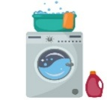

………………………
………………………
………………………
………………………

……\ 2 marks
5- Choose the correct answer.
1- The students ( played -complained- ate) that the test was difficult.
2- You can find a man's suit in ( men's - women's – accessories )department.

6.Choose the missing letter.
1- Street markets have the best p…ices. ( l – r – q )
2- The ba…..ana is the most popular fruit in the world. ( n – m – o )

……\ 2 marks

7- write the missing letter

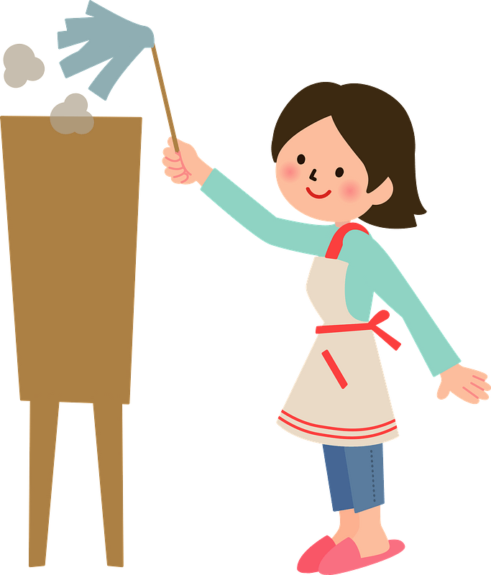
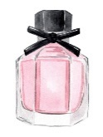

..….erfume
dus…....
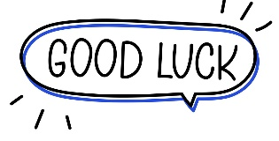

Your teacher:


Kingdom of Saudi Arabia Name: ……………………………
Ministry of education Class: 2nd Intermediate Grade
10 /
…… Intermediate School Quiz (1) - 1447 Second Term
- Comprehension:
Read the passage to answer the questions below:
Jim and his brother, Ted love the snow. When it snows, they go outside and play. Jim and Ted like to build a snowman. They put a hat and scarf on their snowman. They also use a carrot for the nose. Then, they go home, and their mom gives them hot cocoa.
- Choose the correct answer:
- This text takes place in the ……………… season.
- summer b- winter c- spring
- The boys use the ………………. for the nose.
- apple b- cucumber c- carrot

- Check ( T ) or ( F ) :
- Jim and Ted are friends. ( )
- The mother prepares coffee for kids. ( )

- Grammar:
- Choose:
- You should (eat – ate – eating) healthy food.
- I can’t play now. I (has to – have to – had to) study for a test.
- This house is (they – their – theirs).
- Faten didn’t buy any sunglasses because they were (one – ones – too) expensive.

- Do as shown between brackets:
- (Make a suggestion)
- I am bored. (go/ the beach)
………………………………………………...
- (Complete the sentence with one or ones):
- I am eating some red apples and some green ………………

- Vocabulary:
- Classify the words:
swimming – suit - bracelet

Outerwear | Activities | Jewelery

- Write the words under the pictures:
do the laundry – perfume – go bowling – iron the clothes

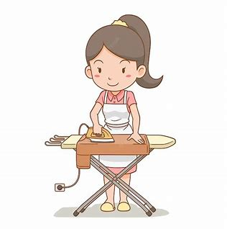
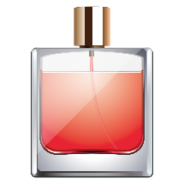
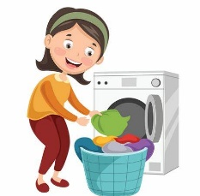

________________ __________________ ___________________

- Orthography:
- Choose the correct missing letters:
  - We use an u__brella for protection from the rain.
- r | - n | - m
  - The boots are on sa__e.
- l | - r | - c
  - There is a lot of du__t on this table.
- c | - s | - z
  - Don’t forget to take out the gar__age.
- b | - d | - p

Good Luck
Ms. Tahani Al-Ghamdi

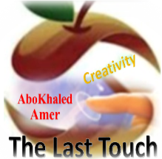

المملكة العربية السعودية
وزارة التعليم
الادارة العامة للتعليم بمنطقة: --------
مدرسة: متوسطة -----------------------

Second Term 1447 H
First Session Test
اسم الطالب: --------------------------------------------------------------------- الصف: الثاني المتوسط
Write the correct word under each picture: (6 M)
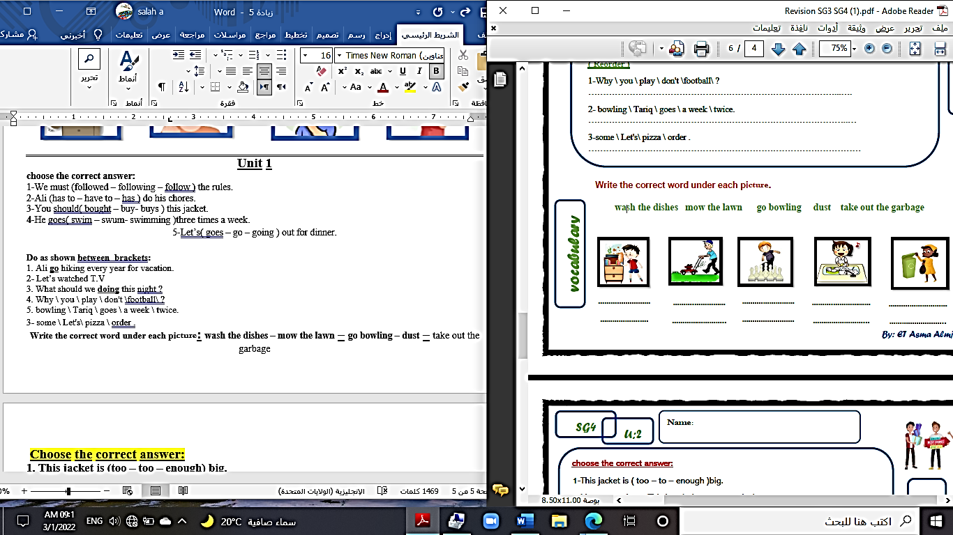
1. umbrella 2. bowling 3. belt 4. shark 5. falcon 6. dust 7. car
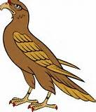
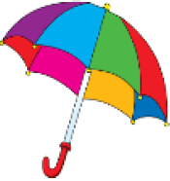
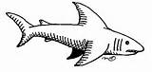
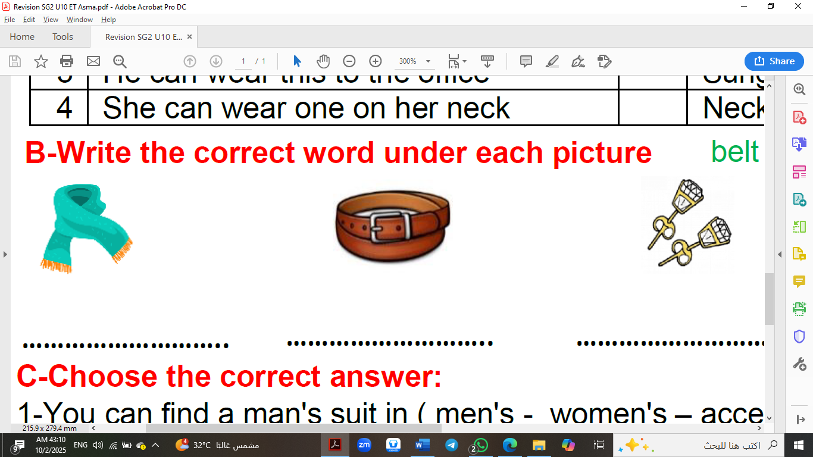

( ) ( ) ( ) ( ) ( ) ( )
Match: (3M)
1. Come on ------ the name of a product.
2. Let down ----- disappoint someone.
3. brand ----- used to encourage someone to do something.
------ eat at home.
Choose the correct answer: (6M)
1- Ηe goes ( swim – swum – swimming ) three times a week.
2- Let’s ( goes – go – going ) out for dinner.
3. That is a fast car. Is it (your – yours – you)?
4. Which coat do you like? The black (one – ones – two).
5. Sara is the (tall – taller – tallest) her mother.
6. He is (smart – smarter – smartest) than his friend.

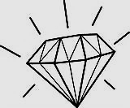
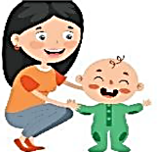
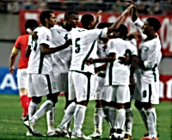
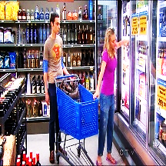
Write the missing letter: (5 M) ( p – w – b – n – e )

ba__ysit t__am diamo__d s___imming sho__ping

End of Questions

Kingdom of Saudi Arabia
Ministry of Education
………… Education Directorate............
…………..……………….. Intermediate School

Total
المجموع | تحريري | شفهي
20 | 10 | 10

First Period Exam _ Second Term
Second Intermediate Grade

Name ………………………………… Class ………………………………
__________________________________________________________________________________________
/ 2
Comprehension

Read the following then answer the questions:

Shopping is something many people enjoy. Families enjoy their time shopping by taking
their kids to the mall. Families usually go shopping on weekends. People can eat at the restaurants
in the shopping mall when they finish shopping. Riyadh has some of the world’s most beautiful modern shopping malls. Al-Bat’ha District is home to many traditional markets.
A- Put (√ ) for true or ( ᵡ ) for false :

( ) | 1. Riyadh doesn't have beautiful modern shopping malls.
( ) | 2. Al-Bat’ha District is home to many traditional markets. .

B- Choose the right answer:

Tuesday | Sunday | weekends | Monday | 1- Families usually go shopping on _____.
clothes | kids | bags | cars | 2- Families enjoy taking their _____to malls.
_________________________________________________________________
/ 2.5
Grammar

Choose the right answer:

1- Ηe goes _________ three times a week.
A. swim B. swimming C. swims D. to swim
2 - I _______ do my homework.
A. has to B. am C. have to D. let's
3 - Whose backpack is this? It is _____ .
A. her B. you C. me D. mine
4 - Which coat do you like? The green ____ .
A. ones B. one C. two D. them
5 - Can I have another cookie? Yes, ____ ____.
A. he can B. I can't C. you can D. I could

/ 2
Vocabulary

A- Choose the best answer to fill in the blank:
1. Teenage children spend too much time on the _________.
ground | chairs | internet | books
2. You mustn't cross the street when the ______ is red.
fire | street | car | light
3. Haraj is a large market where people buy and sell both new and _____ items.
fast | used | expensive | big
4- I spend my ______ mostly on food and video games .
money | things | eyes | foot
B- Put the right word under its picture:
/ 2.5
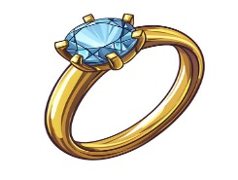 | 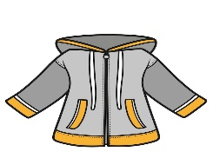 | 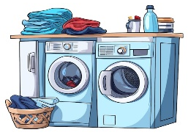 |  | 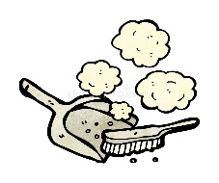

shopping - ring - windbreaker - dust - laundry

_______________________________________________________________________________
/ 1
Orthography

Choose the correct letter:
q | m | l | 1. Visitors go to the local sou_s for more than just shopping
v | d | t | 2. Go horseback ri_ing

Good luck T.

