
Kingdom of Saudi Arabia
Ministry of Education
………………… School
English Language
Intermediate Grade 3rd
1st period Exam
……….\20

Student's Name : class:

……\ 5 marks
1-Read the following passage and answer the questions below:
Ali and his father went to a garage sale early on Saturday morning. The garage sale was near their house. They saw many old things like toys, books, and clothes. Ali looked at everything carefully. He found a small red toy car and showed it to his father. His father asked the seller for the price and bought the toy because it was cheap. Ali also saw old storybooks and helped his father choose one. . Ali felt happy and enjoyed spending time with his father.
1-Where did Ali and his father go?
c- garage sale | b-bank | a-museum
2- What day did they go to the garage sale?
c-on Sunday | b-on Monday | a- on Saturday
3- They saw many old things like …….., books, and clothes.
c-cars | b-football | a- toys
A.Choose the correct answer.
B. Put ( ✓ ) or ( ✕ )
1- The garage sale was near their house. ( )
2- The toy car was very expensive.( )
……\ 5 marks
2-Choose the correct answer.
c- doesn't | b-aren't | a- didn't | 1- She studied in London, ……. she?
c-see | b- seen | a- saw | 2- Sara should……….. the doctor.
c-stop | b-stopping | a- stops | 3- You must ………. at the traffic light.
c-slows | b- slowly | a- slow | 4- Omar drives ……………… .
c- parking | b- park | a- parks | 5- Don't …………… your car there.

3-Do as shown between brackets.
……\ 2 marks
( use adverb of manner)
a- They are fast runner.
……………………………………………………………………………………..
(reorder)
a- Why\ we \ order \a pizza \ don't \ ?
………………………………………………………………………………….….

……\ 4 marks
4- write the correct word under each picture ( windshield wiper – hose – saw - trunk )



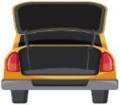


………………………
………………………
………………………
………………………

……\ 2 marks
5- Choose the correct answer.
1- Three children born at the same time : ( baby – child – triplets).
2- Study and research : (investigate – trend – heredity)

6.Choose the missing letter.
1- She was wearing a bei…e dress. ( s – g – z )
2- You must obey the road …..igns. ( q – s – u )

……\ 2 marks

7- write the missing letter



s…….ord
…..ot
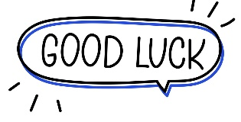

Your teacher:


Kingdom of Saudi Arabia Name: ……………………………
Ministry of education Class: 3rd Intermediate Grade
10 /
…… Intermediate School Quiz (1) - 1447 Second Term
- Comprehension:
Read the passage to answer the questions below:
Ali has a scooter. His scooter is green. His uncle gave him the scooter on his 9th birthday as a present. Ali loves it so much! Every Saturday, Ali and his brother go to the park nearby their house. He rides the scooter while his brother rides his bike. They have so much fun at the park.
- Choose the correct answer:
- At the weekend, Ali goes to the ………………
- toy shop b- park c- school
- On Ali’s birthday, his …………… gave him a gift.
- mother b- brother c- uncle

- Check ( T ) or ( F ) :
- Ali’s brother has a scooter. ( )
- Ali is 8 years old. ( )

- Grammar:
- Choose:
- Let’s (go – went – going) to the beach this afternoon.
- She ate a burger, (don’t she – doesn’t she – didn’t she)?
- Mona is a good cook. She cooks (good – well – better).
- You (must – mustn’t – shouldn’t) listen to your teacher.

- Do as shown between brackets:
- Why don’t we have a garage sale?
………………………………………………….. (Refuse the suggestion)
- (Report the requests and commands)
- Nada: “Clean the room”.
………………………………………………………

- Vocabulary:
- Classify the words:
knife – vacuum cleaner – stop

Things used for cleaning | Things used for cooking | Traffic signs

- Write the words under the pictures:
ignition – broom – rearview mirror – hammer



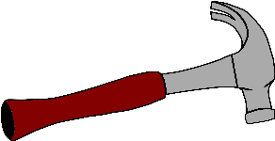

________________ __________________ ___________________

- Orthography:
- Choose the correct missing letters:
- They have a lot of anti__ue furniture in their house.
- c | - k | - q
- We use a fo__k to eat food.
- l | - r | - c
- He was arrested for driving without a licen__e.
- c | - s | - z
- We must o__ey the road signs.
- b | - d | - p

Good Luck
Ms. Tahani Al-Ghamdi



المملكة العربية السعودية
وزارة التعليم
الادارة العامة للتعليم بمنطقة: -----------
مدرسة: متوسطة--------------------------

Second Term 1447 H
First Session Test
اسم الطالب: --------------------------------------------------------------------- الصف: الثالث المتوسط
Write the correct word under each picture: (6 M)
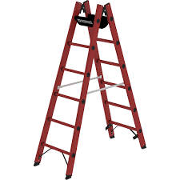
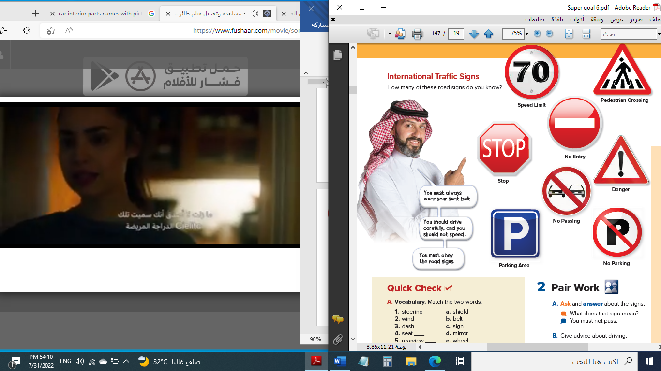
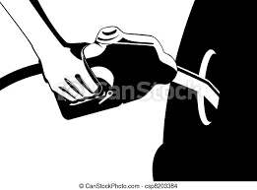
1. hammer 2. No Parking 3. ladder 4. knife 5. Stop 6. gas tank 7. fish
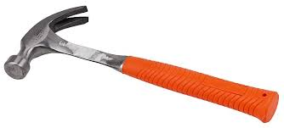
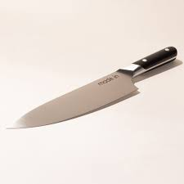

( ) ( ) ( ) ( ) ( ) ( )
Match the following: (6M)
a. board | ---- | 1. I'm doing 60.
b. a way to respond to an introduction. | ---- | 2. steering
c. wheel | ---- | 3. dash
d. a machine to cut lawn. | ---- | 4. How do you do?
e. I'm driving 60 kilometers per hour. | ---- | 5. lawn mower
f. something which you use to cook food. | ---- | 6. pot
g. play football. | ----
Choose the correct answer: (6M)
1. She doesn't come, ( doesn't she – she doesn't – does she – she does )?
2. He ( have – are – were – is ) able to clean the room.
3. Tomorrow, I ( was – am – will – have ) be able to come.
4. You (must – mustn't – is must – should ) stop at the traffic lights.
5. You ( should – shouldn't – is should – must ) eat when you're driving.
6. She plays ( quiet – quietly – quietness – quieter ).
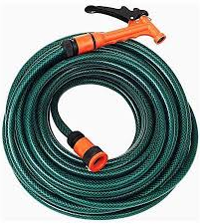


Supply the missing Letter: (2M) ( g – o – s – t )

spo__n sea__ belt ho__e dan__er

End of Questions https://t.me/Super_Goal123

Kingdom of Saudi Arabia
Ministry of Education
………… Education Directorate............
…………..……………….. Intermediate School

Total
المجموع | تحريري | شفهي
20 | 10 | 10

First Period Exam _ Second Term
Third Intermediate Grade

Name ………………………………… Class ………………………………
__________________________________________________________________________________________
/ 2
Comprehension

Read the following then answer the questions:

Bobby Shafran started a new semester at Sullivan Community College in New York. The previous semester Eddy Galland was a student there. The two teens looked exactly alike. Another student confused Bobby with Eddy, and then he realized that the boys were probably brothers. That student introduced Bobby to Eddy. The two boys found out that they were in fact twins, born at the same time. The boys were orphans and grew up in two different families
A- Put (√ ) for true or ( ᵡ ) for false :

( ) | 1.The previous semester Eddy was a student at Sullivan Community College .
( ) | 2. The boys were orphans and grew up in the same family .

B- Choose the right answer:

Tokyo | Washington | New York | London | 1- Sullivan Community College is in _____.
cousins | twins | friends | teachers | 2- Bobby and Eddy were in fact ______ .
_________________________________________________________________
/ 2.5
Grammar

Choose the right answer:

1- You live in Dammam, ___ ___?
A. aren't you B. do you C. don't you D. doesn’t he
2 - ______ you coming with us?
A. Aren't B. Don't C. Haven't D. Isn't
3 - She didn’t work in a school, ____ ____?
A. didn't she B. did she C. doesn't she D. does she
4 - How did she walk? She walked _________.
A. slow B. happy C. quick D. quickly
5 - The adverb form of good is _______.
A. good B. will C. well D. going

/ 2
Vocabulary

A- Choose the best answer to fill in the blank:
1. Someone you don’t know left a message on your _________ .
school | chair | cell phone | book
2. ______ is a child who has lost his parents .
Aunt | Confuse | Twin | Orphan
3. What do you use to clean the living room ?
a wall | a vacuum cleaner | a ladder | a sofa
4- The _____ turns the car on.
GPS | signal light | headlight | ignition
B- Put the right word under its picture:
/ 2.5
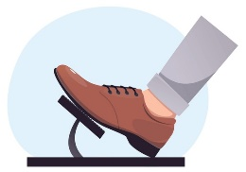 | 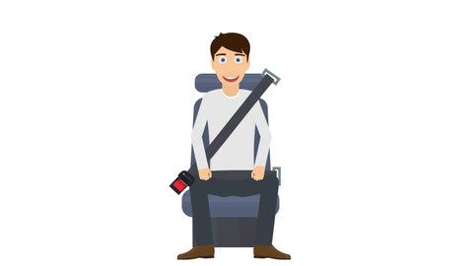 |  | 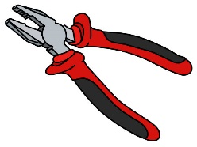 | 

pliers - hammer - seat belt - hose - break pedal
- windbreaker - dust - laundry

_______________________________________________________________________________
/ 1
Orthography

Choose the correct letter:
k | x | l | 1. Was Ahmed able to fi_ the car?
v | d | s | 2. She found a set of nice crystal gla_ses

Good luck T.

