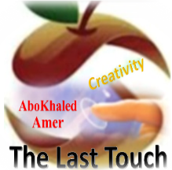

المملكة العربية السعودية
وزارة التعليم
الادارة العامة للتعليم بمنطقة: ------------
مدرسة: ثانوية ----------------------------

Second Term 1447 H
First Session Test
اسم الطالب: --------------------------------------------------------------------- الصف: الثالث الثانوي
Write the correct word: (6M)
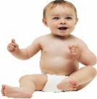


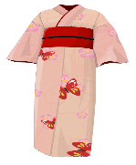

1. wealthy – 2. telephone – 3. antibiotics – 4. thunder – 5. baby – 6. kimono – 7. car

( ) ( ) ( ) ( ) ( ) ( )
Match the Real Talk: (6M)
A | B
1- Don’t sweat it. | ( ) irresponsible person.
2- flake. | ( ) Don’t worry about it.
3. (no) big deal. | ( ) (not) something of great importance.
4. iffy. | ( ) extremely happy.
5. on cloud nine. | ( ) uncertain.
6. break | ( ) significant opportunity.
 | ( ) shock someone.
Choose the correct answer: (6M)

1. She might have ( cook – cooks – cooking – cooked ) lunch.
2. They ( have – must – was – were ) supposed to come on time.
3. I was supposed to ( travel – travels – traveled – traveling ) abroad.
4. He ran ( such – very – so – and ) fast that he won the race.
5. Ali is ( such – very – so ) a determined person that he always manages to succeed.
6. After ( meets – meet – meeting ) online, we discovered that we live in the same town.
Supply the correct letter: (2M) ( v – b – o – n )

1. assassi__ate 2. resem__lance 3. b__ost 4. no__elty

End of Questions

