
Kingdom of Saudi Arabia
Ministry of Education
………..Education Directorate
………………… secondary School
English Language
Grade 2nd secondary
1st period Exam
Second term
………\10
Student's Name : class:

Reading comprehension ✦
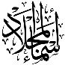
……\ 2 marks
1-Read the following passage and answer the questions below:
Ali went to the golf course early in the morning to practice golf. The weather was nice and calm. He held his golf club carefully and tried to hit the ball straight. At first, he missed the ball, but he did not give up. He practiced again and again, and his shots became better. By the end of the day, Ali felt happy and proud because he improved his golf skills.

1- Where did Ali go?
c- to school | b- To the golf course | a- to the park
2- What did Ali use to hit the ball?
c-puck | b-stick | a- golf club

……\ 4 marks
Grammar ✦
A. Choose the correct answer.

c-to | b- enough | a-too | 1- You are walking …………. slowly.
c- studies | b- study | a- studying | 2- She has been …………English since 2009.
c- give | b- giving | a- gives | 3- Can you ……….me your pen?
c- smart | b- smartest | a- smarter | 4- You are as ……….. as your brother.
B. Do as shown between brackets.

1.( Reorder)
a- We had a ( delicious , Indian , big ) feast for dinner last night.
……………………………………………………………..……………………………………….

2-( Use adverb of manner)
a- Sara is a good writer.
………………………………………………………………………………………………….…..

……\ 4 marks
✦ Vocabulary
A-Complete the missing words ( originated - worn )
1- We’ve had this couch too long. It’s starting to look ………………
2- The board chess ……………………..in India in the 6Th century.
B- Write the correct word under each picture

rink - skiing - canyon - barbecue
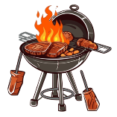
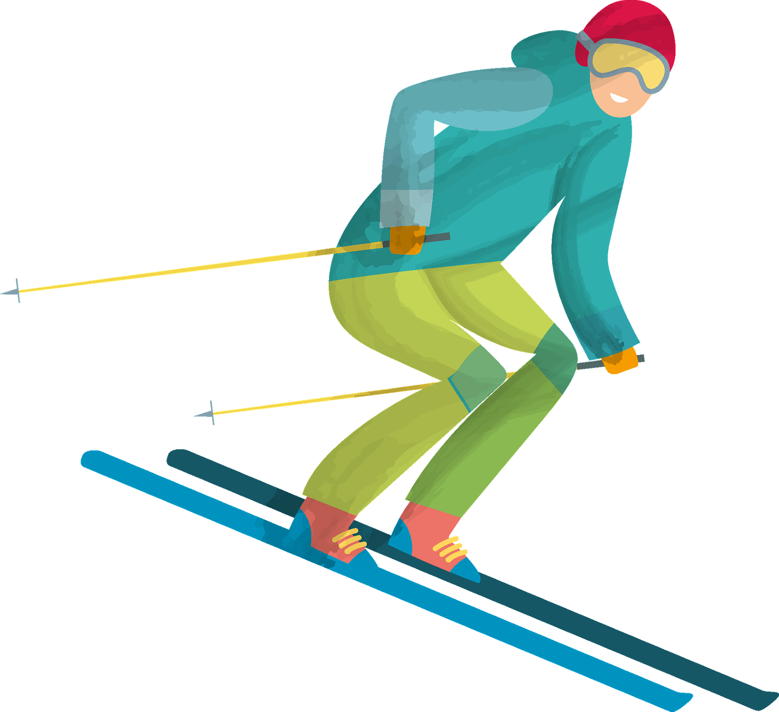

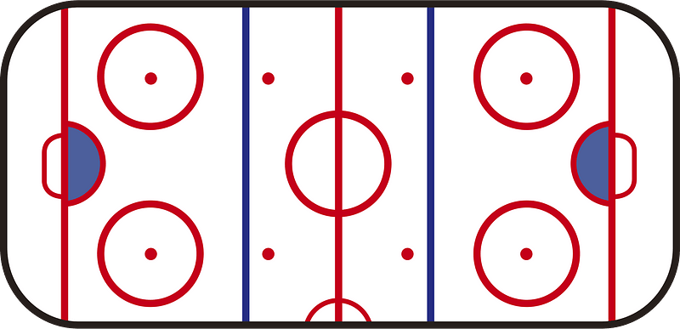

…………………………
…………………………
…………………………
…………………………

The end of the questions
Good luck
Your teacher ………………………

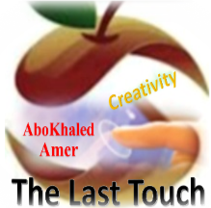

المملكة العربية السعودية
وزارة التعليم
الادارة العامة للتعليم بمنطقة: -----------
مدرسة: ثانوية ---------------------------

Second Term 1447 H
ABOKHALEDAMER
0557325813
First Session Test
اسم الطالب: --------------------------------------------------------------------- الصف: الثاني الثانوي
Write the correct word: (6M)
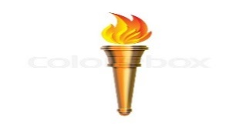
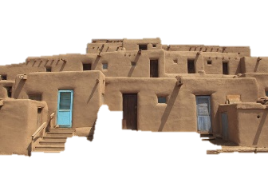
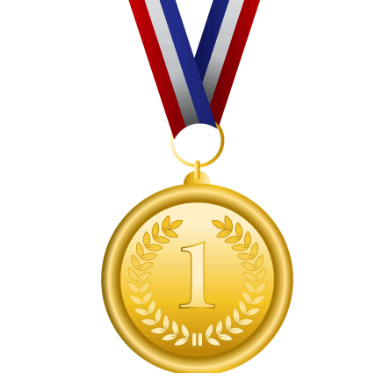
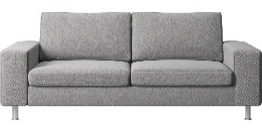
1.Olympic Games 2.medal 3.couch 4.adobe house 5.torch 6.pillow 7. car
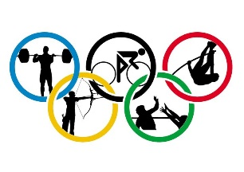
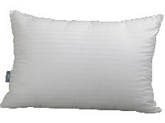

( ) ( ) ( ) ( ) ( ) ( )
Match the Real Talk: (6M)
A | B
1- hold on | ( ) thousand
2- up for | ( ) stop for a moment
3- hub | ( ) ready for
4- grand | ( ) center
5- guts | ( ) Of course,
6- You bet | ( ) courage
 | ( ) school
Choose the correct answer: (6M)
1. Our new apartment is in ( brick – small ) building.
2. You are walking ( too – enough – to ) slowly.
3. I am tall ( too – enough – more ) to play basketball.
4. Can you ( give – gives – gave ) me your pen ?
5. ( Swim – Swimming – Swims ) in the ocean is difficult.
6. This is the ( more exciting – most exciting – many exciting ) sporting event I’ve been to in a long time.
Supply the correct letter: (2M) ( e – m – r – o )
1. ma__athon 2. g__ld 3. hom__ 4. __aterial

(2) Top Goal - YouTube End of Questions https://t.me/abokhaledamer

