Name: ……………………………………… Ms. Tahani
Class: 2nd Intermediate
Revision Sheet _ Unit ( 1 ) : Are You Here on Vacation?
- Vocabulary:
- Write the words under the pictures:
elevator – reception desk – credit card – conference – hotel


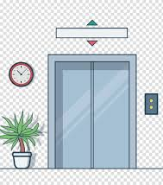



_______________ _ __________________ ___________________ __________________

- Classify the words:
Take care – Hi – See you tomorrow – Good morning

Greetings | Farewells

- Match:
- Here you are a- see you later.
- Have a nice stay b- an expression used to wish someone a good time in a place.
c- an expression used when you give something to someone.
.

- Fill in the blank with the correct words in the box:
festival – fill in – reservation – address – introduce

- Let me ………………… myself.
- I will call the hotel and make a …………………...
- Please, ……………… the form with a blue pen.
- The town has a summer ……………….in the park.

- Grammar:
- Choose:
- I (am – is – are) a smart student.
- Nada (am – is – are) a nurse.
- Ali and Ahmed (am – is – are) brothers.
- (What – When – Why) are you absent yesterday?
- The bank is (between – next to – near) the hospital and the restaurant.
- I would like (make – to make – makes) a reservation.
- Could you (spell – to spell – spelling) your last name?

- Do as shown between brackets:
- Faten (am) a principle. (Correct the verb)
…………………………………………………..
- They …….. friends. (Complete the sentence with verb be)
…………………………………………………..
- The bus stop is between the corner. (Correct the mistake)
…………………………………………………..
- Hatem is a math teacher. (Change into negative)
……………..……………………………………
- The exam is on Wednesday. (Make a Yes/No question)
……………………………………………………….
- Where is your name? (Correct the mistake)
……………………………………………………….

Name: ……………………………………… Ms. Tahani
Class: 2nd Intermediate
Revision Sheet _ Unit ( 2 ) : What Are They Making?
- Vocabulary:
- Write the words under the pictures:
detective – ladder – director – actor – martial arts


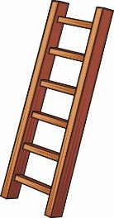

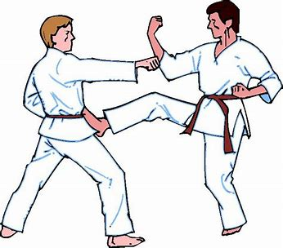

________________ __________________ ___________________ __________________

- Classify the words:
What are you doing? – That’s great – No, that’s wrong – I love that

Approval expressions | Disapproval expressions

- Circle the odd word:
- cameraman – director – location – actor

- Match the word with its opposite:
- inside a- behind
- in front of b- under
- over c- away
. d- outside

- Fill in the blank with the correct words in the box:
stuntman – scene – script – film – feed

- Words can’t describe the beauty of the ……………….
- The ……………. is well-written.
- The baby is too young to ………… itself.
- Have you ever watched this ……………….?

- Match:
- So a- a strong “no” answer
- Not at all b- a way to start a new topic in a conversation
- All by myself c- that kind of thing
d- with no one else’s help

- Grammar:
- Choose:
- I (am – is – are) playing tennis.
- Rashed (read– reads – is reading) a novel now.
- Ali and Ahmed are (eat – eating – ate) their sandwiches.
- I (liking – like – likes) martial arts film.
- (Is – Am – Are) Hanan sleeping now?
- Samar (is loving – love – loves) flowers.
- (Open – Opening – Opens) the windows.
- The cameraman is standing (under – behind – outside) the camera.

- Do as shown between brackets:
- Fahad is walking. (Change into negative)
…………………………………………………..
- The children are studying. (Make a Yes/No question)
…………………………………………………..
- I (am wanting) a new mobile. (Correct the mistake)
…………………………………………………..
- Sit down. (Negate)
……………………………………………………
- Don’t feed the fish. (Change into affirmative)
…………………………………………………….
- The actors are ready to perform (under) the camera. (Correct the mistake)
…………………………………………………….

Name: …………………………………… Ms. Tahani
Class: 2nd Intermediate
Revision Sheet _ Unit ( 3 ) : Who’s Who
- Vocabulary:
- Write the words under the pictures:
pilot – waiter – salary – company – bridge

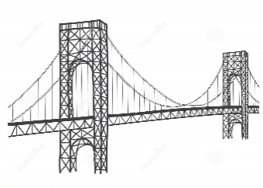




________________ __________________ __________________ __________________
- Circle the odd word:
- Jobs: graphic designer – nurse – hospital – psychologist
- Work places: travel agency – salesperson – furniture store – call center

- Match the word with its opposite:
- boring a- satisfying
- difficult b- full time
- part time c- easy
. d- interesting

- Classify the words:
company – marketing manager – president – advertising firm

Jobs | Work places

- Fill in the blank with the correct words in the box:
organize – engineer – design – tour – exotic

- Fahad wants to be an ……………….in the future.
- Shahad likes to wear ………………. clothes.
- We will hire an architect to ………………...our new house.
- We went on a …………………. of the museum.

- Grammar:
- Choose:
- Ali (work – works – working) in the hospital.
- Sara and Nada (work – works – working) in the hospital.
- The student (don’t – doesn’t – does no) study math.
- The students (don’t – doesn’t – do no) study math.
- Tala doesn’t (teach – teaches – teaching) speak Japanese.
- I want (be – to be – being) a lawyer.
- I like reading books (and – but – because) magazines.
- Amal will go to the hospital (and – but – because) she is ill.
- Jana went to the mall (and – but – because) she didn’t buy anything.
- This is the boy (who – which – when) had an accident.
- The flowers (who – which – when) grow in this garden are beautiful.

- Do as shown between brackets:
- Thamer works in the restaurant. (Make a Yes/No question)
…………………………………………………..
- The boys play football in the garden. (Make a Yes/No question)
…………………………………………………..
- Rasha bakes a cake. (Change into negative)
………………………………………………….
- The students read the novel. (Change into negative)
…………………………………………………
- Dictionaries are books (who) are very useful for me. (Correct the mistake)
…………………………………………………
- This is the doctor (which) helped me. (Correct the mistake)
………………………………………………….
- I want (be) a dentist. (Correct the verb)
………………………………………………….

Name: …………………………………… Ms. Tahani
Class: 2nd Intermediate
Revision Sheet _ Unit ( 4 ) : Favorite Pastimes
- Vocabulary:
- Write the words under the pictures:
food court – cook – climb – hang out – draw

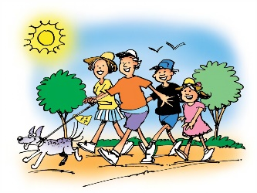


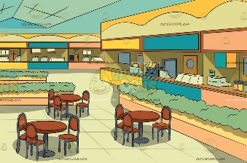

________________ __________________ __________________ __________________
- Circle the odd word:
- Hobby: reading – drawing – usually – cooking
- Adverbs of frequency: always – sometimes – relaxing – never

- Match the word with its opposite:
- safe a- unknown
- popular b- pastime
. c- dangerous

- Fill in the blank with the correct words in the box:
exercise – send – meet – leisure – play

- We will ……………. at eight on Tuesday.
- Make ……………… a part of your daily routine.
- I will …………… you a copy of the file.
- They …………...tennis twice a week.

- Match:
- stuff like that a - I understand
- I see b- a way to make an invitation
c- that kind of thing

- Grammar:
- Choose:
- I know how to (ski – skis – skiing).
- Sara (don’t – doesn’t – not does) know how to cook.
- I (don’t – doesn’t – not do) know how to play golf.
- Amal can’t stand (wait – waits – waiting) in line.
- My brother enjoys (fix -fixing – to fix) broken bicycles.
- Tala wants (play – to play – playing) games online.
- I would like (to go – going – go) to Japan next week.
- (Read – Reading – To read) books is my hobby.

- Do as shown between brackets:
- (Play) football is a popular sport. (Correct the mistake)
…………………………………………………
- I enjoy (spend) time with my family on weekends. (Correct the mistake)
………………………………………………….
- I would like (drink) some coffee. (Correct the mistake)
………………………………………………….
- Fatimah goes shopping. (Use “usually”)
…………………………………………………..
- Rawan makes her bed in the morning. (Use “always”)
…………………………………………………..
- father – smokes – never – My (Rearrange)
…………………………………………………...

Name: ……………………………………… Ms. Tahani
Class: 2nd Intermediate
Revision Sheet _ Unit ( 5 ) : Is There Any Ice Cream?
- Vocabulary:
- Write the words under the pictures:
drink – lettuce – menu – onion – chicken

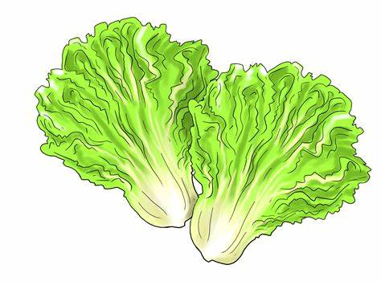

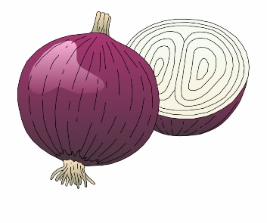
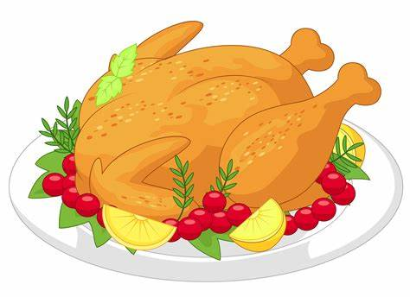

________________ __________________ ___________________ __________________
- Classify the words:
cheesecake – cucumber – shrimp – mango

Vegetables | Fruit | Dessert | Seafood

- Circle the odd word:
- Foods: sandwich – steak – appetizer – soup
- Drinks: milk – juice – tea – cookie
- Cooking methods: grilled – fried – sauce – steamed
- Parts of a menu: desserts – apple pie – main courses – beverages

- Match:
- giant a- I want to think. This is a way to have more time to answer
- I’ll have b- big
- let me see c- away
. d- I want, when ordering food

- Fill in the blank with the correct words in the box:
order – baked – salad – roasted – fish

- Salmon is a very popular type of …………….
- The waiter came to take their ……………..
- Rasha ………………. a chicken for dinner.
- Nada ……………. a cake for her friend.

- Choose the correct answer:
- I had only one (bottle – cup – piece) of cake.
- Every morning, I like to have a (cup – piece – slice) of coffee.
- I’d like a large (piece – glass – loaf) of orange juice, please.

- Grammar:
- Choose:
- I have (a – an – some) apple.
- I have (a – an – some) apples.
- I have (a – an – some) pen.
- There is (a – any – some) milk in the fridge.
- There isn’t (a – any – some) milk in the fridge.
- Is there (a – any – some) milk in the fridge?
- Would you like (a – any - some) milk?
- When the water boils, (putting – puts – put) the spaghetti in the pot.
- I don’t like the soup. It is (enough – too – to) salty.
- Don’t add more salt. The soup is salty (enough – too – to).
- We have (too – to – enough) eggs, but we don’t have (too – to – enough) sugar.
- I don’t like the soup. There is (too – too much – too many) salt in it.
- I don’t like the soup. There are (too – too much – too many) carrots in it.
- The soup is too hot (eat – to eat – eating).
- I have enough vegetables (make – making – to make) a salad.

- Do as shown between brackets:
- I don’t have …….. time to cook dinner. (Use ‘too’ or ‘enough’)
…………………………………………………..
- There are …… people in this café. We can’t find a table. (Use‘too much’or‘too many’)
…………………………………………………..
- There is not (some) juice in the grocery. (Correct the mistake)
…………………………………………………..
- (Mark the nouns with C for count or N for noncount)
- ………juice
- ………eggs
- ………tomatoes
- ………chocolate
- ………cheese
- ………sandwiches

Name: …………………………………… Ms. Tahani
Class: 2nd Intermediate
Revision Sheet _ Unit ( 7 ) : What Happened?
- Vocabulary:
- Write the words under the pictures:
traffic light – intersection – sleepy – scared – angry

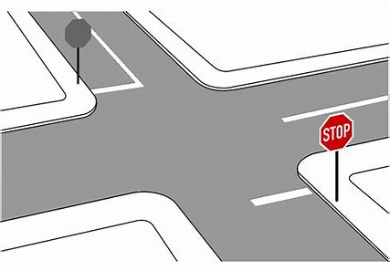
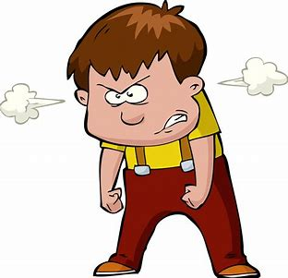
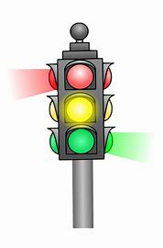


________________ __________________ __________________ __________________
- Classify the words:
nervous – Where – tired – How

Feeling | Five W’s

- Circle the odd word:
- Feeling : sad – happy – driver – worried

- Match:
- witness a- someone who saw an event
- insurance b- don’t get angry
- injury c- payment for costs of an accident
- don’t lose your cool d- where two roads cross
f- hurt from an accident

- Fill in the blank with the correct words in the box:
fortunately – busy – hurt – mess – accident

- Ali was injured badly in the …………………..
- I was late, but ……………….. the meeting hadn’t started.
- Lama cried because she had ………..…….. her knee.
- I’m sorry, but I’m ………………… right now.

- Match the opposites:
- outgoing a- sad
- stupid b- cheap
- happy c- smart
- expensive d- silly
e- shy

- Grammar:
- Choose:
- There (was – were – are) a book on the desk.
- There (was – were – is) two bikes in the garden.
- A: (Where – Why – What) are you worried?
B: Because I have a test tomorrow.
- A: Why are you absent yesterday?
B: (So – Ago – Because) I was sick.
- They saw Reema in her room 10 minutes (because – age – ago).
- Do you have (someone – nothing – anything) to eat in the fridge?
- I didn’t know about the meeting. (No one – Nothing – Anything) told me.
- A: What do you want to drink?
B: (Nothing – Someone – No one), I am not thirsty.
- Yesterday I saw (nothing – someone – anything) playing with a ball in the park.
- We stayed at home (so – because – neither) it was raining.
- Farah was ill, (so – because – neither) she had to stay in bed.
- A: I am a good student.
B: (So – Neither – Because) am I.
- A: I am not scared.
B: (So – Neither – Because) am I.
- A: I speak English.
B: (So – Neither – Because) do I.
- A: I don’t speak Chinese.
B: (So – Neither – Because) do I.
- A: I never speak French.
B: (So – Neither – Because) do I.

- Do as shown between brackets:
- There was a car in the garage. (Change into negative)
…………………………………………………..
- There were three books on the shelf. (Change into negative)
…………………………………………………..
- (Complete the sentences with so or because)
- I am going to make a cake, …………. I need some eggs and flour.
- She is going to stay at home …………….she has to study for an exam.
- (Show agreement with the statements. Use so or neither)
- I am happy today.
………………………………….
- I eat fruit and vegetables.
………………………………….
- I played football yesterday.
………………………………….
- I am not hungry.
…………………………………
- I don’t have a driver’s license.
…………………………………
- I didn’t sleep early.
…………………………………

Name: …………………………………… Ms. Tahani
Class: 2nd Intermediate
Revision Sheet _ Unit ( 8 ) : What’s Wrong?
- Vocabulary:
- Write the words under the pictures:
sore throat – vomit – stomachache – symptom – shoulder


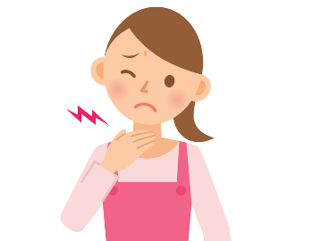
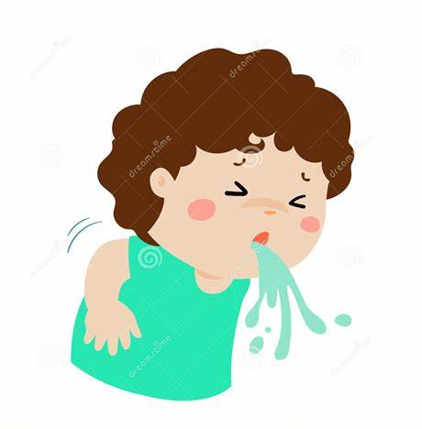
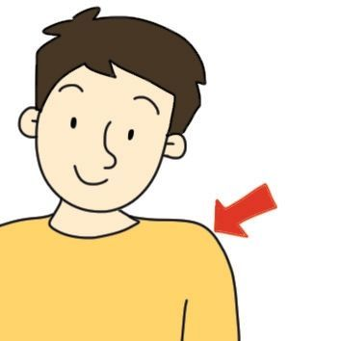

________________ __________________ __________________ __________________
- Classify the words:
chest – fever – neck – cold

Illnesses | Parts of the body

- Circle the odd word:
- illnesses: headache – earache – knee – diarrhea
- parts of the body: nose – medicine – arm – leg

- Match:
- I just did a- not a great amount
- Nothing much b- get angry
- ill c- I did that a short time ago
d- sick

- Fill in the blank with the correct words in the box:
dizzy – sneeze – prescription – toothache – rest

- Ali has a …………………. He should go to the dentist.
- I felt ……………… when I looked down from the top of the tower.
- When you have a cold, you …………………...a lot .
- The doctor gave me a ………..………….. for pain killers.

- Match the word with its opposite:
- bored a- sad
- strong b- fine
- happy c- weak
- sick d- thirsty
e- interested

- Grammar:
- Choose:
- You (should – shouldn’t – not should) eat so much.
- You (should – shouldn’t – not should) study hard.
- You should (sleep – slept – sleeping) early.
- What do you do (who – what – when) you have a cold?
- Omar is sick. (He – She – They) should see a doctor.
- Sami gave (he – him – his) a watch on his graduation.
- Amal has two sisters. (Her – Their – She) names are Lama and Hind.
- That jacket is (I – my – mine).
- You and (I – my – me) will go to the supermarket.
- The teacher gave Leen and (I – my – me) gifts.

- Do as shown between brackets:
- (Use should or shouldn’t)
- I have an earache. I …………….. go to the doctor.
- I ……………. be noisy in the library.
- He …………….. push his friends in the playground.
- She ……………. tidy her bedroom and keep it clean.

- Him and me are the same age. (Correct the mistake)
…………………………………………………..
- Can you come to the meeting with we? (Correct the mistake)
…………………………………………………..

- (Replace the underlined words with the correct pronouns or possessive adjectives)
- Eman is my friend. I sit next to Eman in the class.
………………………………………….
- I should take the medicine three times a day. The medicine tastes terrible!
………………………………………….
- That room is Abeer’s.
………………………………………….
- Mom’s job is difficult.
………………………………………….

- (Complete the table):

Subject pronouns | Object pronouns | Possessive adjectives | Possessive pronouns
I |  | My
She |  |  | hers
 | him | His
It |  | Its
 | them |  | theirs
You |  | Your
 | us |  | ours

