Name : ………………………………………. Ms. Tahani
Class : 3rd Intermediate
Revision Sheet _ Unit ( 1 ) : Lifestyle
- Vocabulary:
- Write the words under the pictures:
devoted employee – exercise freak – Internet addict – vegetarian






_______________ _______________ _______________ _______________
- Fill in the blank with the correct words in the box:
devoted employee – exercise freak – Internet addict – vegetarian

- Omar spends a lot of time at the gym. He is an ……………………………..
- Ali always eats vegetables. He is a ………………………………………….
- Khaled regularly chats online. He is an ……………………………………..
- Majed often spends a lot of time at the office. He is a ………………………

- Match:
A | B
- Exercise freak | - does not interest at all
- Turn (someone) off | - a word to introduce a change in topic
- Anyway | - someone who exercises a lot
- You see | - a phrase to introduce an explanation

- Grammar:
- Choose:
- Amal usually (get – gets – got) a haircut every two months.
- Nora never (watch – watches – watched) TV on the weekend.
- (Do – Does – Did) you hang out with your friends at the mall?
- (Do – Does – Did) she drink coffee?
- Reem and Hind are friends. (Both – All – Neither) of them are teachers.
- Reem and Hind are friends. (Both – All – Neither) of them is a teacher.
- There are 4 teachers in the lab. (All – Both – neither) of them teach science.
- I have many pens in my pencil case, but (both – neither – none) of them are red.
- Dana and Nada are teachers. Both of them (teach – teaches – teaching) English.
- Samar and Hanan are teachers. Neither of them (teach – teaches – teaching) PE.
- A: (How long – How often – How) do you work out at the gym?
B: Twice a week.
- A: (How long – How often – How) do you use your cell phone?
B: One hour a day.

- Do as shown between brackets:
- Eman washes the dishes after dinner. (Use “sometimes”)
……………………………………………………………….
- Fahad ( get ) a haircut every week. (Correct the verb)
……………………………………………………………….
- Maha arrives at work on time. (Change into negative)
…………………………………………………………………
- Rana and her family hang out on the weekend. (Change into negative)
…………………………………………………………………
- Sara checks her email on Monday. (Make Yes/No question)
…………………………………………………………………
- Ahmed and Ali drive their cars carefully. (Make Yes/No question)
…………………………………………………………………
- Yara and Layan never eat meet. Neither of them are vegetarian. (Correct the mistake)
…………………………………………………………………
- Hala and Ghala are twins. Both of them is 16. (Correct the mistake)
…………………………………………………………………

Name : ………………………………………. Ms. Tahani
Class : 3rd Intermediate
Revision Sheet _ Unit (2) : Life Stories
- Vocabulary:
- Write the words under the pictures:
gathered – infant – donate – appointment – litter

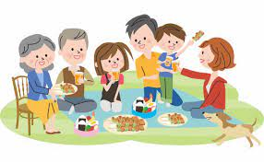



_______________ _______________ _______________ _______________
- Fill in the blank with the correct words in the box:
abroad – puzzle – encourage – twin – proud

- I want to study English ………………………in UK.
- Waleed’s parents ……………………him in his studies.
- My sister has ……………………sons.
- I can't answer that ………………; I give up.

- Match:
A | B
- support someone to succeed | - in other countries
- humanitarian | - important opportunity
- abroad | - encouraged
- big break | - a person who helps others

- Grammar:
- Choose:
- Amal (wear – wears – wore) a blue dress last night.
- Nouf (played – plays – play) tennis yesterday.
- (Do – Does – Did) you hang out with your friends last Friday?
- Sahar didn’t (sleep – slept – sleeping) early last night.
- Reem (was – were – is) born in Riyadh.
- I (am – was – were) born in 2013.
- I used to (ride – rode – rides) a bike when I was 8.
- When I was a child, I didn’t (use – used – using) to play video game.
- My husband works (in – on – at) Jeddah.
- I am going on vacation (in – on – at) August.
- There are many flowers (in – on – at) spring.
- The movie starts (in – on – at) 10 o’clock.
- I did my homework (yesterday – ago – last).
- I was in grade eight (yesterday – ago – last) year.
- Hanan didn’t meet her cousin three months (yesterday – ago – last).

- Do as shown between brackets:
- Fahad (send) a gift to his daughter three days ago. (Correct the verb)
……………………………………………………………….
- Maha (arrive) at home on ten minutes ago. (Correct the verb)
…………………………………………………………………
- Bayan got a haircut last week. (Change into negative)
…………………………………………………………………
- Deema visited her uncle last weekend. (Make a YES/No question)
…………………………………………………………………….
- Faten sent an email to her aunt. (Make a YES/No question)
……………………………………………………………………..
- Lama bought a skirt. (Change into passive)
……………………………………………………………………..
- Jana / doll / used / with / play / her / to (Rearrange )
……………………………………………………………………..

Name: ………………………………………. Ms. Tahani
Class: 3rd Intermediate
Revision Sheet _ Unit (3): When Are You Travelling?
- Vocabulary:
- Write the words under the pictures:
gate – vaccination – liquid – containers – baggage
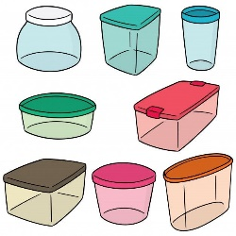

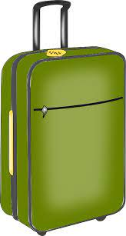


_______________ _______________ _______________ _______________

- Circle the odd word:
- ticket – passport – stranger – boarding pass
- across – around – very – through

- Fill in the blank with the correct words in the box:
flight – leave – check – suitcase – accent – climate

- Sara speaks with an American ……………….
- Rana packed a small ………………… for the weekend.
- I ……………… my mailbox every five days.
- Don’t forget to lock the door when you ……………….
- The city has a warm …………………

- Match:
A | B
- pretty | - traditions
- heritage | - special
- recite  - pick up | - busy and lively  - learn
- unique | - repeat from memory  - very / quite

- Grammar:
- Choose:
- Eman (cooks – cooked – is cooking) now.
- Dana and Sara (are going – went – go) to the mall tomorrow.
- I am going to (travelling – travel – travelled) to London next week.
- Ahmed probably (stay – staying – will stay) in a hotel.
- Maybe I (will leave – leave – leaving) early in the morning.
- Hanan is staying up late (do – does – to do) her homework.
- When they were on vacation, they (go – went – will go) skiing.
- When they are on vacation, they probably (go – went – will go) skiing.
- Until the bus (come – came – coming), we played cards to kill time.
- When I get home, I (call – called – will call) you.
- While you talk on the phone, I (get – got – will get) coffee.
- Muslims walk (through – across – around) the Kabah.
- The weather is (cold so – so cold so – so cold).

- Do as shown between brackets:
- Farah probably (send) a gift to her friend tomorrow. (Correct the verb)
……………………………………………………………….
- Maha (visit) her grandparents next weekend. (Correct the verb)
…………………………………………………………………
- Bayan probably will go to the park. (Change into negative)
…………………………………………………………………
- My teachers are helpful. (Use “really”)
…………………………………………………………………….
- The train passed (around) a tunnel. (Correct the mistake)
……………………………………………………………………

Name: ……………………………………… Ms. Tahani
Class: 3rd Intermediate
Revision Sheet _ Unit ( 4 ) : What Do I Need to Buy?
- Vocabulary:
- Write the words under the pictures:
watermelon – crab – parsley – garlic - condiment

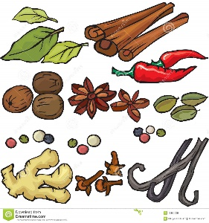




________________ __________________ ___________________ __________________
- Classify the words:
yogurt – cucumber – squid – papaya

Vegetables | Fruit | Dairy Products | Seafood

- Circle the odd word:
- Meat: sausage – lamb – avocado – beef
- Dairy products: milk – cheese – butter – cookie
- Cooking verbs: grill – fry – rice – steam

- Match:
- I can’t wait a- Everything is organized
- Everything’s under control b- I can’t eat any more
c- I am very eager for something
.

- Fill in the blank with the correct words in the box:
recipes – teaspoon – mix – add – boil

- The water is beginning to ……………
- This book has 50 delicious ……………...
- ………………. all the ingredients together in a bowl.
- I need a ……………. to stir my tea.

- Grammar:
- Choose:
- I like my coffee with (a little – a few – many) milk and sugar.
- There are (a little – a few – much) monkeys at the zoo.
- Have you travelled to (a little – many – much) countries?
- How (much – many – few) money has Fahad got?
- I want to drink (nothing – anything – something).
- I don’t want to buy (nothing – anything – something).
- The fridge is empty. There is (nothing – anything – something) to eat here.
- He cut (myself – himself – herself) yesterday.
- You should be careful when you cook, or you can burn (myself – yourself – himself).
- Samar hurt (myself – itself – herself) when she climbed a tree yesterday.
- Lama and Leen solve the problem (herself – itself – themselves).
- I was thirsty (so – because – first) I drank a glass of water.
- I am studying English (so – because – first) I love languages.

- Do as shown between brackets:
- I am too busy, ………. I can’t go to the cinema. (Use ‘so’ or ‘because’)
…………………………………………………..
- ……..…… cheese is there? (Use ‘How much’ or ‘How many’)
…………………………………………………..
- Is there (something) I can help you with? (Correct the mistake)
…………………………………………………..
- I bought (herself) a new laptop. (Correct the mistake)
…………………………………………………..

Name: ……………………………………… Ms. Tahani
Class: 3rd Intermediate
Revision Sheet _ Unit ( 5 ) : Since When?
- Vocabulary:
- Write the words under the pictures:
brick – printer – stove – paper clips – credit cards

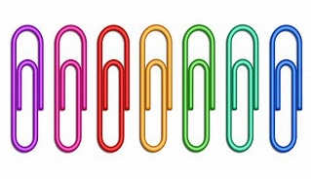

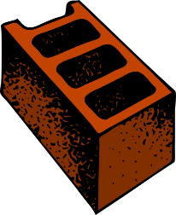
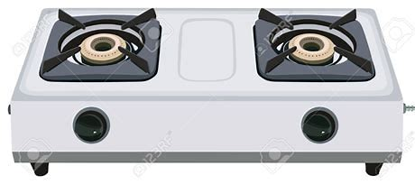

________________ __________________ ___________________ __________________
- Classify the words:
he – her – him – she – me – they – I – them

Subject pronouns |  | Object pronouns

- Circle the odd word:
- Inventions: camera – oven – television – people

- Match:
- long-time no see a- get married
- settle down b- congratulations!
- sequence c- I haven’t seen you for a long time
- interrupt d- stop in the middle
- accomplish e- action or events in a particular order
f- succeed in doing something

- Fill in the blank with the correct words in the box:
available – clumsy – invent – portable – conventional – successful

- Most food tastes better when it is cooked in a ………………….……oven.
- Free ticket is ………………...only to students.
- People can …………… things to make life easy.
- Tala had been ………………. at every job she had done.
- I always carry a ……………….computer with me.

- Match the word with its opposite:
- huge a- heavy
- slow b- cheap
- light c- widespread
- expensive d- small
e- fast
- Grammar:
- Choose:
- (Have – Has – Did) you ever travelled to London?
- (Have – Has – Did) you travel to London last year?
- Rama has (study – studies – studied) English for five years.
- Lana hasn’t received an email (for – since – ago) Monday.
- Joud hasn’t received an email (for – since – ago) three days.
- Rateel has lived in New York (for – since – ago) 2020.
- Leen has had his new mobile (for – since – ago) two months.
- Lara was in Paris two years (for – since – ago).
- Waad has worn glasses (for - since – ago) the age of seven.
- Layan has taught Chinese (for – since – ago) she was 22.
- How (long – many – much) have you played football?

- Do as shown between brackets:
- Lama (eat) lunch at the mall yesterday. (Correct the verb)
…………………………………………………..
- Seba (play) tennis since 2022. (Correct the verb)
…………………………………………………..
- Wala has learned French …….. April. (Use ‘since’ or ‘for’)
…………………………………………………..
- Abeer has been sick …….. two days. (Use ‘since’ or ‘for’)
…………………………………………………..
- Deema bakes a cake. (Change into passive)
…………………………………………………...
- Raseel baked a cake. (Change into passive)
……………………………………………………
- Fatimah has baked a cake. (Change into passive)
……………………………………………………
- A story is written by Ruba. (Change into active)
……………………………………………………
- A story was written by AlJazi. (Change into active)
……………………………………………………
- A story has been written by Hajar. (Change into active)
……………………………………………………

Name: ……………………………………… Ms. Tahani
Class: 3rd Intermediate
Revision Sheet _ Unit ( 6 ) : Do You Know Where It Is?
- Vocabulary:
- Write the words under the pictures:
bullet train – bridge – commuters – fountain - suburb



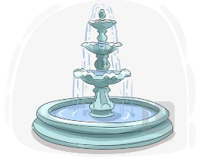
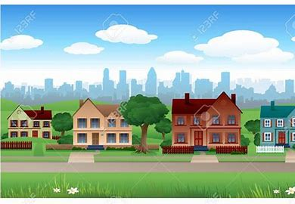

________________ __________________ ___________________ __________________
- Classify the words:
crime rate – taxis – kilometres

Vehicle | Measurement words | Features of town

- Circle the odd word:
- Vehicle: car – stadium – bus – taxi
- Features of town: green area – cost of housing – clean air – mile

- Match:
- run down a- holds
- consecutive b- an unbroken series
- leading c- in needed of fixing / not looked after
- combination d- popular
e- mixture

- Fill in the blank with the correct words in the box:
renovate – fare – survey – efficient – transportation

- There is public ………………………. available throughout the city.
- The ……………… questions were not very clear.
- The homeowners decided to ………………. their old kitchen.
- Ali is very ……………….. at his job.

- Match the word with its opposite:
- narrow a- high
- low b- cheap
- polluted c- wide
- cozy d- uncomfortable
e- clean

- Grammar:
- Choose:
- Fadi is (tall – taller – tallest) .
- Hatem is (tall – taller – tallest) than Samer.
- Rama is the (tall – taller – tallest) student in the class.
- The chair is (comfortable – more comfortable – most comfortable).
- The sofa is (comfortable – more comfortable – most comfortable) than the chair.
- The bed is the (comfortable – more comfortable – most comfortable) furniture.
- Leen’s marks are (good – better – best) than her friend.
- Dammam has the (bad – worse – worst) weather in Saudi Arabia.
- Your sister is as (smart – smarter – smartest) as you.
- Your mobile (is not as – is as not – not is as) new as mine.
- (A – An – The) sun rises in the east and sets in the west.
- The bird is flying in (the – a – an) sky.

- Do as shown between brackets:
- Where is the supermarket? (Make indirect question)
…………………………………………………..
- When does the shop open? (Make indirect question)
…………………………………………………..
- Wafa’s hair is long than Faten’s. (Correct the mistake)
…………………………………………………..
- Dana is in the Jeddah on vacation. (Correct the mistake)
…………………………………………………..

