Name: ……………………………………… Ms. Tahani
Class: 1st Intermediate
Revision Sheet _ Unit ( 1 ) : Good Morning
- Vocabulary:
- Write the words under the pictures:
scissors – pencil – friend – family – principle



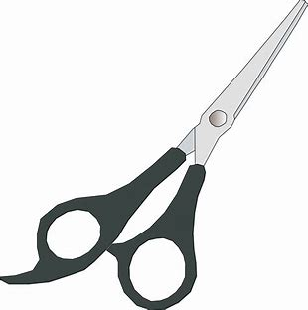
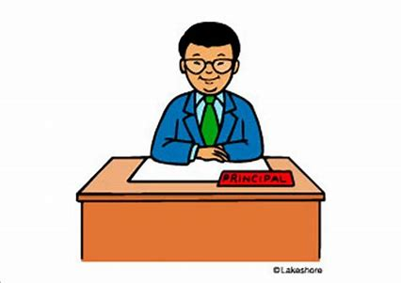

________________ __________________ ___________________ __________________

- Classify the words:
Take care – Good afternoon – See you later - Hello

Greeting | Saying goodbye

- Circle the odd word:
- School Supplies: pen – crayon – food – books
- Parts of the day: evening – night – teacher – morning

- Match the word with its opposite:
- single a- small
- man b- woman
- big c- classmate
. d- married

- Fill in the blank with the correct words in the box:
cut – write – restaurant – student

- Amal is a new ……………………at our school.
- We ………………. with a pen or pencil.
- We ……………… with scissors.

- Grammar:
- Choose:
- I (am – is – are) an English teacher.
- Rana (am – is – are) a nurse.
- Ali and Ahmed (am – is – are) brothers.
- I am Nada. This is (my – her – his) mother.
- She is a doctor. (My – Her – Your) name is Hanan.

- Do as shown between brackets:
- Fahad (am) a principle. (Correct the verb)
…………………………………………………..
- They …….. children. (Complete the sentence with verb be)
…………………………………………………..
- This is my sister. (His) name is Lara. (Correct the mistake)
…………………………………………………..
- You are smart. (Use the short form of the verb)
……………………………………………………
Name: …………………………………… Ms. Tahani
Class: 1st Intermediate
Revision Sheet _ Unit ( 2 ) : What Day Is Today?
- Vocabulary:
- Write the words under the pictures:
ticket – parrot – dolphin – turtle – listen
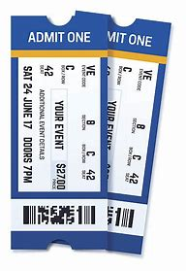
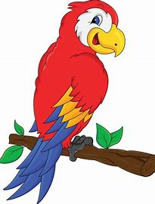

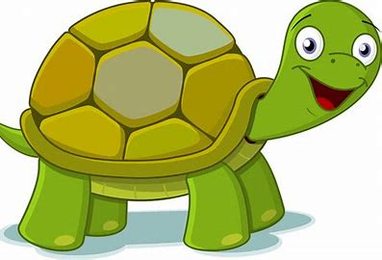

________________ __________________ __________________ __________________
- Classify the words:
April – Friday – Tuesday – October

Months of the year | Days of the week

- Circle the odd word:
- Animals: parrot – turtle – holiday – elephant
- Ordinal Numbers: second – eight – tenth – third
- Cardinal Numbers: one – ten – first – two

- Match:
- Guess what? a- when we tell someone something that will surprise them
- You’re welcome b- not very much
. c- a polite reply to “Thank you”

- Fill in the blank with the correct words in the box:
Monday – June – page – adolescent – eighth

- Look at …………. eleven.
- The day after Sunday is ……………….
- The sixth month of the year is ………………...
- August is the ……………….. month of the year.

- Choose the correct answer:
- 11 in words is (ten – eleven – twelve).
- 26 in words is (twenty-six – sixty-two – twenty sixth).

- Grammar:
- Choose:
- A: (What – When – How old) are you?
B: I am 13 years old.
- A: (What – When – How old) is your name?
B: My name is Sara.
- A: (What – When – How old) is your final exam?
B: It is in May.
- I have an appointment with the dentist (in – on – at) Monday.
- Our vacation is (in – on – at) January.
- They are doctors. (Their – Her – Your) names are Ahmed and Ali.
- (Closing – Closed – Close) your book.

- Do as shown between brackets:
- The English classes are (in) Sunday and Monday. (Correct the mistake)
…………………………………………………..
- The Saudi National Day is (on) September. (Correct the mistake)
…………………………………………………..
- The boys are ten years old. (Your) names are Ali and Omar. (Correct)
…………………………………………………..
- (When) is your name? (Correct the mistake)
…………………………………………………..

Name: …………………………………… Ms. Tahani
Class: 1st Intermediate
Revision Sheet _ Unit ( 3 ) : What’s That?
- Vocabulary:
- Write the words under the pictures:
sculpture – headphone – radio – bicycle – key chains

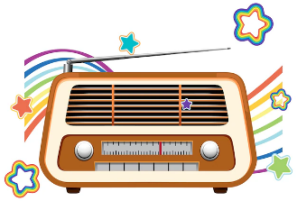

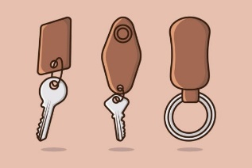

________________ __________________ __________________ __________________
- Circle the odd word:
- Museum items: fossil – cat – dinosaur – skeleton
- Words to describe: big – nice – souvenir - small

- Match:
- enormous a- interesting
- modern b- very big
. c- new

- Classify the words:
strange – meteor – old – poster

Museum items | Words to describe

- Fill in the blank with the correct words in the box:
calculator – guide – toy – follow – famous

- The child lost his …………….
- I buy a ………………. for math classes.
- Messi is a ………………... football player.
- The museum ………………. speaks many languages.

- Grammar:
- Choose:
- (This – That – These) are my keys.
- (This – These – Those) is my sister.
- That (am – is – are) Amal’s house.
- Those (am – is – are) expensive watches.
- (Come – Comes – Coming) in, please.
- (No – Don’t – Doesn’t) sit down.
- (The – A – An) sun rises in the east and sets in the west.
- My mother has (a – an – the) new dress.
- Rana always carries (a – an – the) umbrella in her briefcase.

- Do as shown between brackets:
- This is a car. (Change to the plural)
…………………………………………………..
- That is an orange. (Change to the plural)
…………………………………………………..
- These boys are smart. (Change to the singular)
…………………………………………………..
- Those are watches. (Change to the singular)
…………………………………………………..
- Take photographs. (Change into negative)
………………………………………………….
- Don’t close the window. (Change into affirmative)
…………………………………………………
- (Use a or an)
- ………. key - …….. car
- ………. airplane - …….. egg
- ………. mango - …….. ice cream

Name: …………………………………… Ms. Tahani
Class: 1st Intermediate
Revision Sheet _ Unit ( 4 ) : Around the World
- Vocabulary:
- Write the words under the pictures:
tourist – world – address – on business – language




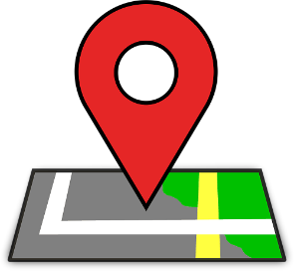

________________ __________________ __________________ __________________
- Classify the words:
Egypt – Spanish – Riyadh – Paris – Omani - China

Country | Nationality | Capital

- Circle the odd word:
- Countries: France – Saudi Arabia – Brazil – American
- Nationalities: Chinese – London – Russian – Saudi
- Capital: Cairo – Madrid – Jordan – Muscat

- Match:
- Excuse me a- a way to ask someone the same question
- How about you? b- not very much
. c- an expression to get someone’s attention

- Fill in the blank with the correct words in the box:
vacation – hot – viewer – email – bus

- The students go to their school by …………….
- The weather in Jeddah is ……………….
- They went to Europe on ………………...
- My ………………. address is on my business card.

- Grammar:
- Choose:
- (What – When – Where) are you from?
- Mr. Ali is here (from – in – on) business.
- Lama is an Omani student. She is (from – in – on) Oman.
- Jeddah and Makkah are (from – in – on) Saudi Arabia.
- You (aren’t – not are – are no) from Japan.
- A: Is she from Saudi Arabia?
B: Yes, (she is not – is she – she is).
- A: Are they Chinese?
B: No, (are they not – they are not – they are).

- Do as shown between brackets:
- The man from China is (in) vacation. (Correct the mistake)
…………………………………………………..
- (What) is she from? (Correct the mistake)
…………………………………………………..
- Are you from India? (Answer the question)
…………………………………………………..
- Are you a student? (Answer the question)
…………………………………………………..
- Can you open the window?
………………………………………………….. (Agree)
………………………………………………….. (Refuse)
- I can help you.
………………………………………………….. (Accept)
………………………………………………….. (Refuse)

Name: …………………………………… Ms. Tahani
Class: 1st Intermediate
Revision Sheet _ Unit ( 5 ) : Families, Families
- Vocabulary:
- Write the words under the pictures:
family – baby – married – parent – grandparent






________________ __________________ __________________ __________________
- Classify the words:
niece – son – uncle – sister – nephew – aunt

Male members in the family | Female members in the family

- Circle the odd word:
- Male members in the family: grandfather – uncle – daughter – nephew
- Female members in the family: mother – niece – aunt – brother
- family: sister – single – brother – parent

- Match:
- I’ve got a- No. Not very much
- Not really b- Thank you
. c- I have

- Fill in the blank with the correct words in the box:
cousin – children – husband – miss – daughter

- They called their first ……………… after her grandmother.
- ………………. need lots of love and affection.
- A ………………... is the son or daughter of an uncle or aunt.
- Faten married her ……………. Hamed in 1998.

- Choose the correct answer:
- My mother’s mother is my (aunt – daughter – grandmother).
- My parents’ child is their daughter or (brother – cousin – son).
- My uncle’s wife is my (mother- aunt – grandmother).

- Grammar:
- Choose:
- I (have – has – is) a car.
- Hanan (have – has – am) a big house.
- They (have – has – is) three children.
- You (don’t – doesn’t – not) have a sister.
- He (don’t -doesn’t – not) have a bike.
- Do you have (some – any – a lot of) cousins?
- I have (any – a lot of – of a lot) uncles.
- This is (Amal – Amal’s – Amals’) book.
- My (brother – brother’s – brothers’) name is Ahmed.
- My (brothers – brother’s – brothers’) names are Fadi and Ali.
- (How many – How much – How) brothers do you have?
- (What – Why – Who) is your best friend?

- Do as shown between brackets:
- This is (Reems’) pen. (Correct the mistake)
…………………………………………………..
- Tala has a beautiful dress. (Change into negative)
…………………………………………………..
- The boy has a ball. (Make a Yes/No question)
…………………………………………………..
- The aunt of Sahar (Write the possessive)
……………………………………………………
- (Write the plural):
- That man: ………………………
- This tooth: ……………………...
- This key: ………………………..
- This country: ……………………
- That shelf: ………………………

Name: …………………………………… Ms. Tahani
Class: 1st Intermediate
Revision Sheet _ Unit ( 6 ) : Is There a view ?
- Vocabulary:
- Write the words under the pictures:
curtains – rug – sink – balcony – bathtub



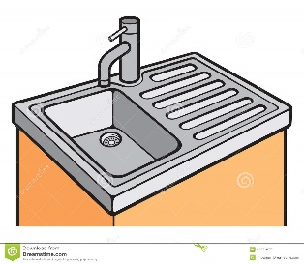
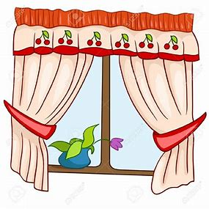

________________ __________________ __________________ __________________
- Classify the words:
shower – bed – sofa – stove

Living room | Bathroom | Bedroom | Kitchen

- Circle the odd word:
- House parts: garage – lamp – living room – yard
- Dining room: chair – table – toilet – vase
- Garden: washer – tree – flowers – grass
- Furniture: armchair – closet – laundry room – dryer

- Match the opposites:
- upstairs a- small
- big b- behind
- in front of c- cold
- hot d- unusual
. e- downstairs

- Fill in the blank with the correct words in the box:
view – apartment – mirror – crowded – comfortable

- These new shoes are not …………………… to wear.
- You can see a beautiful ………………. from our balcony.
- His …………………... is in a really good location.
- Abha was very ……………….. last summer.

- Grammar:
- Choose:
- There (am – is – are) a car in the garage.
- There (am – is – are) four chairs in the kitchen.
- I can walk, (and – but – or) I can’t fly.
- I want to go to the party (and – but – or) I am tired.
- You can buy the blue (and – but – or) the red dress.
- The rug is (in – on – under) the table.
- The poster is (in – on – under) the wall.
- The lamp is (in – on – under) the table.
- The board is (in front of – under – on) the students.

- Do as shown between brackets:
- There is a cat on the sofa. (Change into negative)
…………………………………………………..
- There are flowers in the yard. (Change into negative)
…………………………………………………..
- There is a ball under the bed. (Make a Yes/No question)
…………………………………………………..
- There are three apples in the refrigerator. (Make a Yes/No question)
……………………………………………………
- I like drawing, (or) I don’t like reading. (Correct the mistake)
……………………………………………………
- You can play football (but) tennis. (Correct the mistake)
……………………………………………………
- There is a sofa (or) an armchair in the living room. (Correct the mistake)
……………………………………………………

Name: …………………………………… Ms. Tahani
Class: 1st Intermediate
Revision Sheet _ Unit ( 7 ) : Where Do You Live?
- Vocabulary:
- Write the words under the pictures:
pharmacy – corner – swimming pool – bus stop – gym


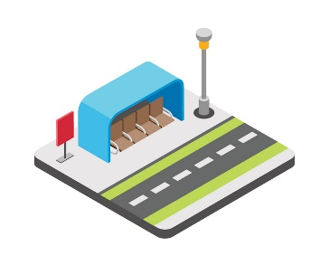



________________ __________________ __________________ __________________
- Classify the words:
bookstore – turn right – go straight – airport

Places in neighborhood | Give directions

- Circle the odd word:
- Places in neighborhood: post office – bank – mall – curtains
- Give directions: go up – sauna – turn left – go to the corner

- Match the opposites:
- left a- open
- closed b- famous
- different c- right
- up. d- same
e- down

- Fill in the blank with the correct words in the box:
floor – convenience store – trust – get off – station

- Give me a call when you ……………………. the bus.
- I looked for Layan and Lora at the bus ………………. .
- Mayar lives on the second …………………... .
- I am going to the ……………………... to buy some bread.

- Grammar:
- Choose:
- I live (in – on – at) Dubia.
- Huda lives (in – on – at) the fourth floor.
- Nada lives (in – on – at) Main Street.
- The bank is (next to – near – between) the pharmacy and the restaurant.
- The bus stop is (next to – on – between) the corner.
- Nora is (tall – taller – tallest).
- Jawaher is (tall – taller – tallest) than Dalia.
- Bushra is the (tall – taller – tallest) student in the class.
- Jeddah is (modern – more modern – most modern).
- Jeddah is (modern – more modern – most modern) than Abha.
- Riyadh is the (modern – more modern – most modern) city in KSA.
- Ali’s mark is (good – better – best) than Hassan’s.
- Dr Omar is the (good – better – best) doctor in the city.

- Do as shown between brackets:
- Planes are (fast) than cars. (Correct the mistake)
…………………………………………………..
- The ring is (expensive) than the necklace. (Correct the mistake)
…………………………………………………..
- Adel’s mark is (bad) than Ahmed’s. (Correct the mistake)
…………………………………………………..
- Cheetah is the (fast) animal in the world. (Correct the mistake)
…………………………………………………..
- A Ferrari is the (expensive) car. (Correct the mistake)
…………………………………………………..
- That restaurant has (bad) food in the town. (Correct the mistake)
…………………………………………………..
- Shmookh lives ……….. the tenth floor. (Use in or on)
…………………………………………………..
- Rawan lives ………. Dammam. (Use in or on)
…………………………………………………..
- Amani lives ……….. Sari Street. (Use in or on)
…………………………………………………..

Name: …………………………………… Ms. Tahani
Class: 1st Intermediate
Revision Sheet _ Unit ( 8 ) : What Are You Doing?
- Vocabulary:
- Write the words under the pictures:
deliver – magazine – hang out – drink – wear





________________ __________________ __________________ __________________
- Classify the words:
science fiction – watch – comedy – study

Kinds of film | Verbs

- Circle the odd word:
- Kinds of film: action – comedy – sandwich – documentary

- Match:
- What’s up? a- looking for information
- checking out b- teenagers
. c- What’s happening?

- Fill in the blank with the correct words in the box:
food court – busy – generation – actor – speak

- I will be …………… cleaning the house.
- He can …………….. three languages.
- They ate dinner at the mall’s ……………………..
- Nasser AlQasabi is a famous ……………….

- Match the word with its opposite:
- advantage a- comfortable
- safe b- dangerous
c- disadvantage

- Grammar:
- Choose:
- We (am – is – are) studying now.
- He (am – is – are) playing volleyball now.
- I (am – is – are) eating now.
- Sara is (read – reads – reading) a story now.
- The children are (sleep – sleeps – sleeping).
- I would (like – to like – like to) a salad.
- I would (like – to like – like to) go to the mall.
- I would like (watch – to watch – watching) a comedy.

- Do as shown between brackets:
- He is chatting with a friend. (Change into negative)
…………………………………………………..
- They are surfing the internet. (Make a Yes/No question)
…………………………………………………..
- Is she drinking coffee? (Answer the question)
Yes, ……………………………
No, …………………………….
- I would like to a burger and fries. (Correct the mistake)
……………………………………………………
- I would like have lunch at the food court. (Correct the mistake)
……………………………………………………

