Name: ................................... Ms. Tahani
Class: 4th Elementary / ........
Revision Sheet: Welcome!
- General Questions:
  - Match the questions with the correct answers:
- What are you afraid of? |  | my little brother
- Which food do you think smells terrible? |  | I go to school by bus
- Who is naughty in your family? |  | spiders
- What school subject is more difficult? |  | When I got gifts from my friends
- What makes you surprised? |  | I think fish
 |  | Math

- Controlled Writing:
  - Rearrange the words to form sentences:
    - early – My sister – sleeps – always
……………………………………………..
    - never – the class – eat – I – in
……………………………………………..
    - often – go – the gym – They – to
……………………………………………..
B- Do as shown between brackets:
    - (Match the adverb of frequency with the checks () and crosses ()):
always – sometimes – never – usually – often
2. (Write the short form of the following ordinal numbers):
Ordinal numbers | Short form of ordinal numbers |  | Ordinal numbers | Short form of ordinal numbers
twelfth |  |  | third
First |  |  | fifth


- Reading Short Sentence:

  - Read then put (T) or (F):
- My little brother is very naughty. ( )
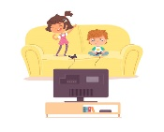
- I don’t like the taste of cheese. It’s terrible. ( )
- They are playing in the playground. ( )

- They are different T-shirts. ( )
  - Read the sentences then match them with the correct pictures:
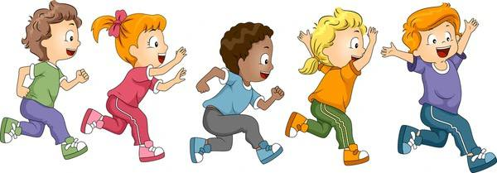

( ) ( ) ( ) ( ) ( )
In this race:
    - Dana was the second child. 4- Ahmed was the first child.
    - Adel was the fifth child. 5- Sara was the fourth child.
    - Fahad was the third child.

- Grammar:
  - Choose the correct answer:
    - Huda is ( tall – taller – tallest ) than Rana.
    - Hanan is the ( tall – taller – tallest ) student in my class.
    - Math is ( difficult – more difficult – most difficult ) than history.
    - Art is the ( interesting – more interesting – most interesting ) school subject.
    - Talal’s mark is ( good – better – best ) than Ali’s mark.
    - I think Abha has the ( bad – worse – worst ) weather in winter in Saudi Arabia.
    - She ( was – were – are ) in Makkah last weekend.
    - They ( was – were – is ) swimming in the pool.
    - He ( was – were – are ) absent in the class yesterday.
    - You ( was – were – is ) good at basketball.
- Vocabulary:
  - Write the words under the correct pictures:
afraid – brilliant – dangerous – different – exciting – naughty – terrible – surprised

 |  |  | 
 | 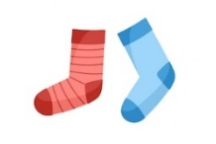 |  | 
- Orthography:
  - Fill in the missing letters:
 | 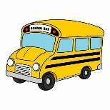 |  |  | 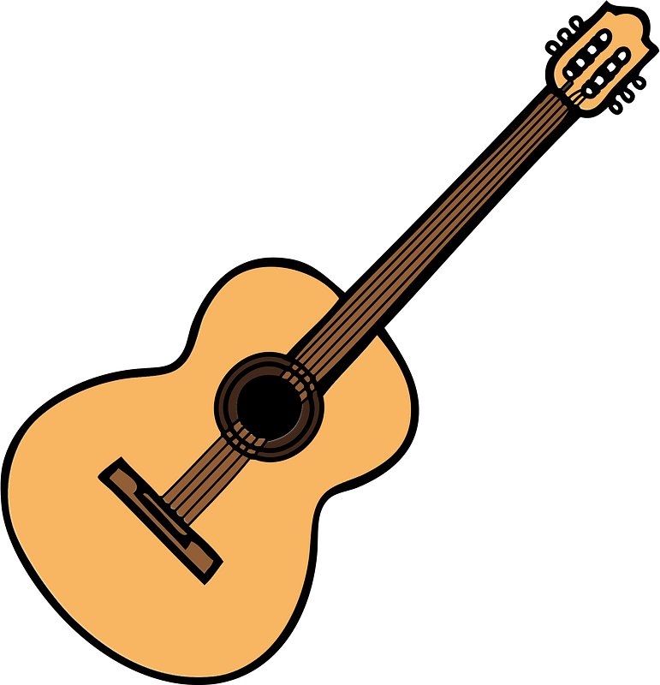   |  |  | 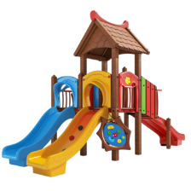 | 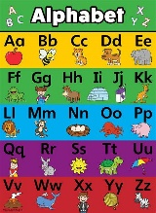
b__lloons | b__s | ca__era | d__ums | g__itar | ph__to |  | play__round | pos__er

Name: ................................... Ms. Tahani
Class: 4th Elementary / ........
Revision Sheet _ Unit (1): Family Events
- General Questions:
  - Match the questions with the correct answers:
- How many brothers do you have? |  | It is mine
- How often do you see your cousins? |  | I go to school by bus
- Whose dress is this? |  | I have 3 brothers
- Who is chatty in your family? |  | I always see them
 |  | My sister likes to talk a lot

- Controlled Writing:
  - Rearrange the words to form sentences:
    - photos – I – take – rarely
……………………………………………..
    - often – does – How – basketball? – play – Waleed
……………………………………………..
  - Classify the words:
aunt – daddy – granny – dad – mom – aunty – grandma – mommy

Formal |  | Informal

  - Fill in the missing words:
never – parents – hers – grandma – weak

    - Your mom and dad are your …………………….
    - always , usually , sometimes , rarely , …………….
    - Sara is not strong. She is ……………….
    - Nada is my mom’s mom. She is my ……………….
    - It is her hat. It is ………………

- Reading Short Sentence:
  - Read then put (T) or (F):
- My dad’s brother is my grandfather. ( )
- Your mom and dad are your children. ( )
- My cousin doesn’t talk a lot. He is shy. ( )
- Lucy likes to talk a lot. She is chatty. ( )

  - Read the sentences then match them with the correct pictures:
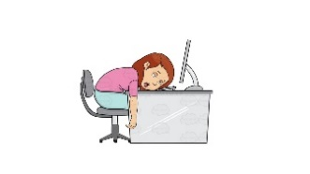 |  |  | 
a-_She is strong.  b-_She is tired. | a-_She is shy.  b-_She is lazy. | a-_I always read book  b-_I never read book | a-_I often go cycling  b-_I often go fishing
  - Circle the odd word:
    - Female family members: aunt – grandson – granddaughter – mom
    - Male family members: dad – uncle – grandson – wife
    - Adjectives: helpful – rabbit – lazy – weak
    - Adverbs of frequency: never – rarely – sometimes – granny

  - Match the word with its opposite:
- weak a- wife
- always b- strong
- husband c- never
- Grammar:
  - Choose the correct answer:
1-How often (do – does) you see your uncles? | 6-It is my pen. It is (hers – mine).
2-How often (do – does) she walk in the park? | 7-It is her dress. It is (hers – mine).
3-(How often – Whose) do you go to the movie theatre? | 8-They are their books. They are (theirs – his).
4-(How often – Whose) bag is this? | 9-They are his shoes. They are (theirs – his).
5-I (never go – go never) to school by bike. | 10- She (always sleeps – sleeps always) early.

- Vocabulary:
  - Write the words under the correct pictures:
helpful – lazy – cycling – grown-ups – pizza

 | 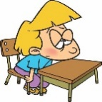 |  | 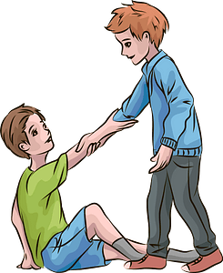
- Orthography:
  - Fill in the missing letters:
 |  |  |  |  | 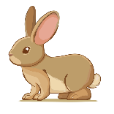 | 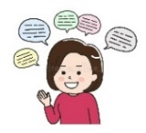 | 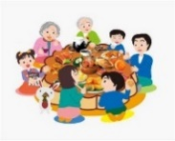
parr__t | st__ong | gran__parents | fa__ily | k__tten | r__bbit | chatt__ | gatheri__g

Name: ................................... Ms. Tahani
Class: 4th Elementary / ........
Revision Sheet _ Unit (2): Chores
- General Questions:
  - Match the questions with the correct answers:
- What time do you get up in the morning? |  | I am watching TV
- What are you doing now? |  | sometimes
- Can I help you with your homework? |  | I ride my bike home
- How often do you sweep the floor? |  | At 6 o’clock
 |  | Yes, please!
- Controlled Writing:
  - Rearrange the words to form sentences:
    - chocolate – Grandma – makes – cake
……………………………………………..
    - you – my car? – Can – help me – wash
……………………………………………..
  - Do as shown between brackets:
    - (Change into negative)
She sleeps early every day.  ………………………………………. | They sleep early every day.  ……………………………………….
She is sleeping now.  ………………………………………. | They are sleeping now.  ……………………………………….
    - (Write O “offer” or R “request”)
      - Can you help me set the table? …………..
      - Can I help you wash the dishes? …………..
  - Fill in the missing words:
takes out – feed – sweep – wash – clears
My brother and I help our grandparents on Saturdays. I usually (1)……………... the floor. Then, I (2)……………... the animals. My brother (3)……………... the trash. My brother always (4)……………... the table after we eat and then I (5)……………... the dishes for my grandma.

- Reading Short Sentence:
  - Match the word with its opposite:
- get dressed a- dirty
- get on b- get undressed
- before c- get off
- clean d- after
  - Read then write (action) or (thing):
- My mother usually gives me a ride to school. ( )
- I don’t like to ride my bike to school. ( )
- We leave school at 12 o’clock every day. ( )
- I put the leaves in the trash can. ( )


  - Read the sentences then match them with the correct pictures:
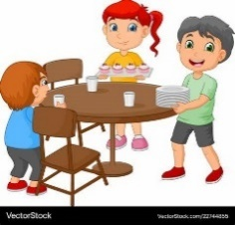 |  |  | 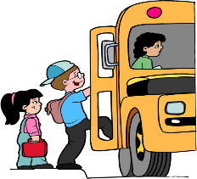
a-_They set the table.  b-_They cut the grass. | a-_She wakes up.  b-_She clears the table. | a-_I feed the animals.  b-_I get dressed. | a-_I get on the bus.  b-_I get off the bus.

- Grammar:
  - Choose the correct answer:
1-Hind always (reads – is reading) stories. | 5-(Does – Is) Ali catch the bus?
2-Hind (reads – is reading) a story now. | 6-(Does – Is) Ali catching the bus?
3-They (play – are playing) football every day. | 7-(Do – Are) they visiting their grandparents?
4-They (play – are playing) football today. | 8-(Do – Are) they visit their grandparents?

- Vocabulary:
  - Write the words under the correct pictures:
comic book – take out the trash – sweep the floor – wash the dishes


 |  | 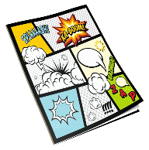 | 

- Orthography:
  - Fill in the missing letters:
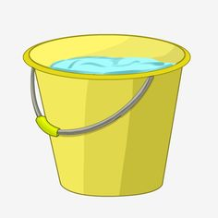 |  |  |  | 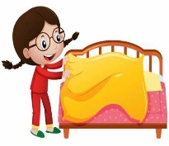 | 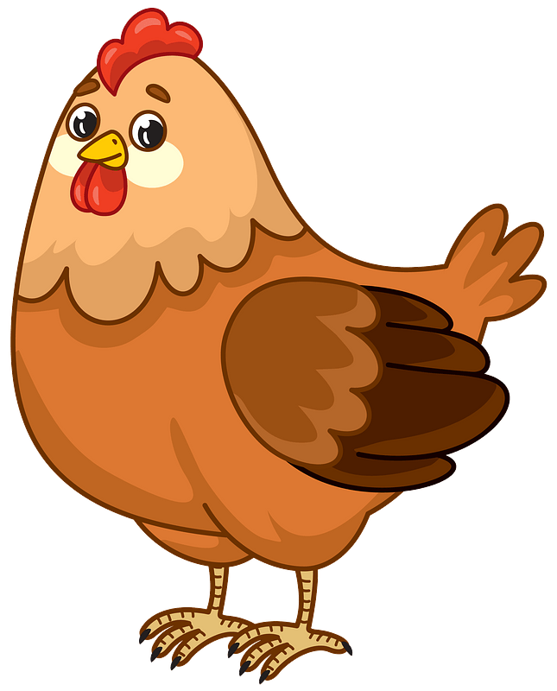 | 
b__cket | du__t | lea__es | trash c__n | ma__e the bed | chicke__ | b__oom

Name: ................................... Ms. Tahani
Class: 4th Elementary / ........
Revision Sheet _ Unit (3): Stories
- General Questions:
  - Match the questions with the correct answers:
- Did he play soccer at school? |  | It was good.
- What do you like to do for fun? |  | My mom is very late.
- How was your day at school yesterday? |  | I like to jump rope.
- What is your favourite story? |  | Yes, he did.
 |  | Cinderella

- Controlled Writing:
  - Rearrange the words to form sentences or questions:
    - waited – the bus – I – for
……………………………………………..
    - he – the movie? – like – Did
……………………………………………..

  - Complete the information about a story:
on the top of a mountain –
an old man and two young friends –
The Kind Man

Title:
…………………………………….
Setting:
…………………………………….
Characters:
………………………………………………………….

  - Do as shown between brackets:
    - (Write the past form of the following verbs)
Base Form | Simple Past | Base Form | Simple Past
dream |  | play
stop |  | carry
plan |  | score

- Reading Short Sentence:

  - Read the sentences then match them with the correct pictures:
 |  |  | 
a-_I call my friend.  b-_I carry the books. | a-_She looks sad.  b-_She looks happy. | a-_I fix the hose.  b-_I water the plants. | a-_He robbed the house.  b-_He clapped his hand.

- Grammar:
  - Choose the correct answer:
1-He (play – plays – played) soccer yesterday. | 4-She (didn’t call – didn’t called) her mom.
2-He didn’t (play – plays – played) soccer. | 5-(Does – Did) he send an e-mail last week?
3-He (laughs – laughed) at my joke last night. | 6-Did you (invite – invited) your friends?

- Vocabulary:
  - Write the words under the correct pictures:
jump – worm – fix – drop – cry – clap

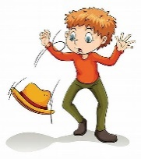 | 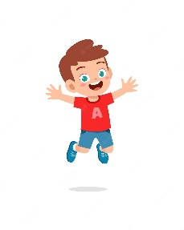 |  |  | 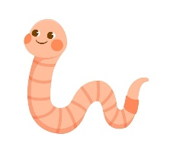 | 

- Orthography:
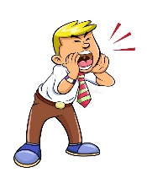
  - Fill in the missing letters:
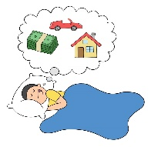 | 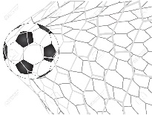 |  | 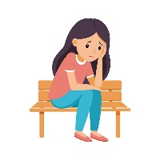 |  | 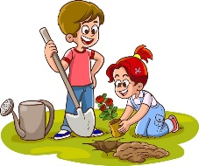 | 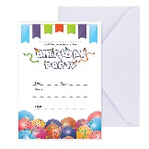
d__eam | sc__re | shou__ | a__one | mo__ster | pl__nt | inv__te

Name: ................................... Ms. Tahani
Class: 4th Elementary / ........
Revision Sheet _ Unit (4): After-School Fun
- General Questions:
  - Match the questions with the correct answers:
- Do you want to play hide and seek? |  | I go swimming.
- What activities do you do in your free time? |  | I usually do it on the weekend.
- Did you go shopping on Saturday? |  | Because I had to buy clothes.
- When do you do the activity? |  | No, I prefer to play board games.
- Why did you go to the shopping mall? |  | No, I didn’t.
- Controlled Writing:
  - Rearrange the words to form sentences or questions:
    - catch – I – ball – the
……………………………………………..
    - took photos – zoo – at the – She
……………………………………………..
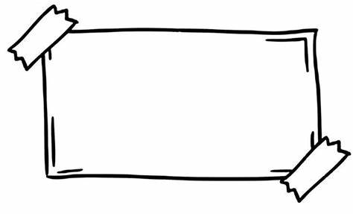
  - Complete the poster. Use the words in the box:
models – Enjoy – sports – fun – dress

AFTER-SCHOOL CLUB
Come to the after-school club. It’s ……………..!
- Meet lots of new people.
- ……………… lots of different activities.
- Learn new things.
Inside:
Make ……………….. and ……………….. up
Outside:
Go swimming and play …………………..

  - Do as shown between brackets:
    - (Write the past form of the following verbs)
Base Form | Simple Past | Base Form | Simple Past
go |  | See
take |  | Sleep
    - (Write the adverbs)
        - happy: ………………. c- careful: ………………..
        - slow: ………………… d- lucky: …………………
- Reading Short Sentence:
  - Read the sentences then match them with the correct pictures:
 |  |  | 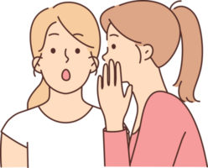
a-_I play video games.  b-_I play board games. | a-_He walks slowly.  b-_He runs quickly. | a-_She likes vlogging.  b-_She likes texting. | a-_She talks loudly.  b-_She talks quietly.

  - Match the opposites:
    - quickly a- inside
    - loudly b- quietly
    - outside c- difficult
    - easy d- slowly

- Grammar:
  - Choose the correct answer:
1-He (go – goes – went) shopping yesterday. | 6-(Does – Did) he make a model last week?
2-He didn’t (go – goes – went) shopping. | 7-I can speak Arabic (and – but – so) English.
3-He (sleeps – slept) late last night. | 8-I am hungry, (and – but – so) I order a burger.
4-She (didn’t see – didn’t saw) a movie. | 9-I go to the hospital (because – and) I am sick.
5-Did you (take – took) photos in the park? | 10-I like soccer, (and – but) I don’t like tennis.

- Vocabulary:
  - Write the words under the pictures:
present – seeds – vegetables – piano – dominoes – graduation

 |  |  |  | 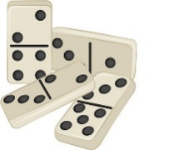 | 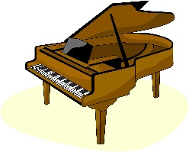

- Orthography:
  - Fill in the missing letters:
 | 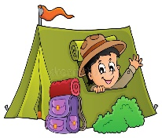 | 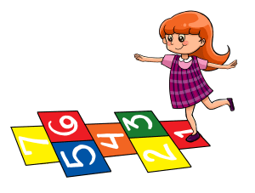 | 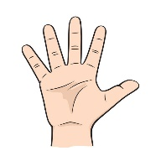 | 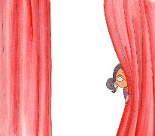 |  | 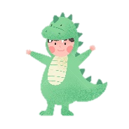
mu__ic | i__side | ho__scotch | fin__ers | h__de | te__ting | d__ess up

