Name: ................................... Ms. Tahani
Class: 3rd Elementary / ........
Revision Sheet _ Unit ( 1 ): It’s Nice to Meet You!
- General Questions:
  - Match the questions with the correct answers:
- What is your name? |  | I live in Al-Lith
- How old are you? |  | I go to school by bus
- Where do you live? |  | My name is Ali
- Do you have brothers or sisters? |  | Yes, I can
- How do you go to school? |  | I am 9 years old
 |  | Yes, I have 2 sisters and 1 brother

- Controlled Writing:
  - Rearrange the words to form sentences:
    - to – you – meet – Nice
……………………………………………..
    - bicycle – have – a – I
……………………………………………..
    - shoes – are – my – They
……………………………………………..
  - Fill in the missing words:
live – mother – nine – name – father

Hello, my ...................... is Sara. I am ..................... years old, and I ......................in Al-Lith. This is my .................... Her name is Fatima. This is my ...................... His name is Ali. I love my family.


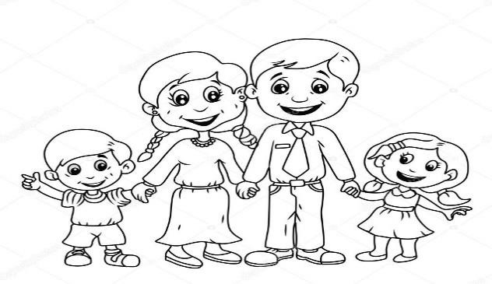
- Reading Short Sentence:

Hello. My name is
Sara
.

1
-

This is my father.

2
-

This is my
sister
.

3
-

This is my
mother
.

4
-

This is my brother.

  - Read then write the correct number:

- Grammar:
  - Choose the correct answer:
    - He ( am – is – are ) my father.
    - They ( am – is – are ) my friends.
    - This is ( I – my – mine ) coat.
    - This hat is ( I – my – mine ).
    - This shirt is ( she – her – hers ).
    - These are ( she – her – hers ) sandals.
    - This is ( you – your – yours ) dress.
    - These shoes are ( you – your – yours ).
    - She ( has – have – are ) a computer.
    - We ( has – have – is ) bicycles.

  - Do as shown between brackets:
    - (Complete the sentences using “can” or “can’t”):
 |  | 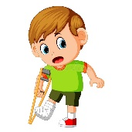 | 
He ………. swim. | The bird …… fly. | He ………. run. | The baby ….…. walk.

- Vocabulary:
  - Write the words under the correct pictures:
coat – sandals – dress – computer – hat – bicycle – shirt


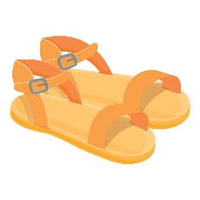
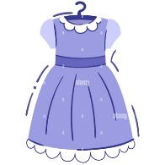

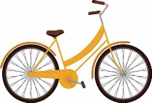


……………… ……………… ……………… …………… ……………… ………………
- Orthography:
  - Fill in the missing letters:
ea – ee – ie – ai – ay



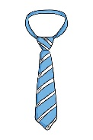
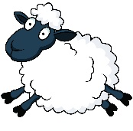
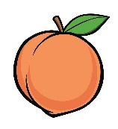

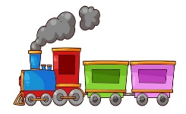

t __ __ sh__ __p tr__ __n pl__ __ m__ __t ch__ __se p__ __ch

Name: ................................... Ms. Tahani
Class: 3rd Elementary / ........
Revision Sheet _ Unit ( 2 ): Sea Animals
- General Questions:
  - Match the questions with the correct answers:
- What is that?  |  | An octopus
- Which animal looks like a star?  |  | I think they are fast
- Which animal has 8 legs?  |  | It is a shark.
- What do you think about dolphins?  |  | I like walrus
 |  | A starfish

- Controlled Writing:
  - Rearrange the words to form sentences:
    - big – Whales – are
……………………………………………..
    - change – A squid – color – can
……………………………………………..
    - has – teeth – A shark – big
……………………………………………..

- Reading Short Sentence:
  - Read then match sentences and animals:
          - It is as white as snow and as strong as a lion.
          - It is as scary as a tiger and as quiet as a fish.
          - It is beautiful and as fast as the wind.
          - It is very quiet and as slow as a snail.
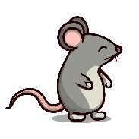
          - It is smaller than a cat and as gray as an elephant.
 | 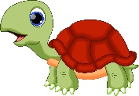 | 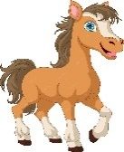 | 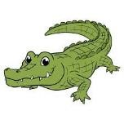 | 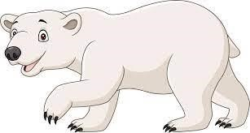

- Grammar:
  - Choose the correct answer:
    - Ali is ( tall – taller – tallest ) than Ahmed.
    - This elephant is the ( big – bigger – biggest ).
    - Baby seals are as ( cute – cuter – cutest ) as cats.

- Vocabulary:
  - Write the words under the correct pictures:
eel – seagull – starfish – jellyfish – squid – crab – walrus

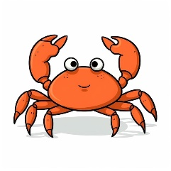

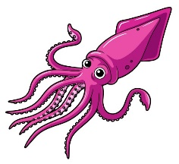
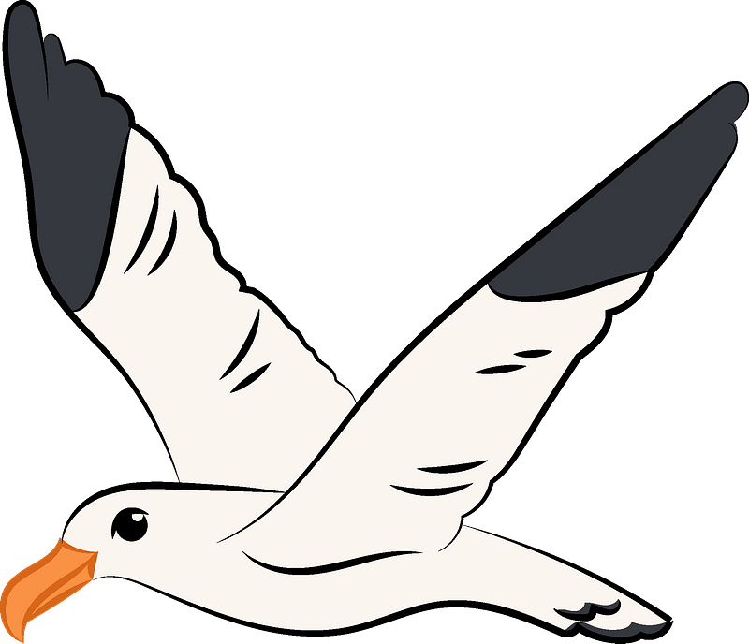
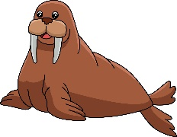
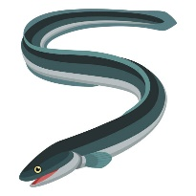

……………… ……………… ……………… …………… ……………… ………………
- Orthography:
  - Fill in the missing letters:
ow – oa – ou


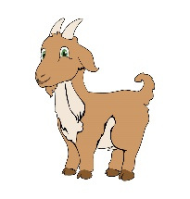
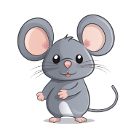
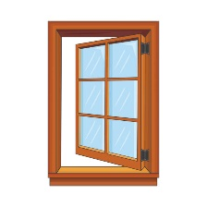
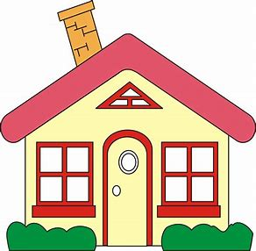



h__ __se b__ __t c__ __ cl__ __n m__ __se g__ __t wind__ __

Name: ................................... Ms. Tahani
Class: 3rd Elementary / ........
Revision Sheet _ Unit ( 3 ): Sports and Activities
- General Questions:
  - Match the questions with the correct answers:
- What sport does he like? |  | No, I don’t.
- Do you play basketball? |  | I’d like to try cooking.
- Can you ride a horse? |  | He likes tennis.
- Does your father do karate? |  | Yes, I can.
- What activities do you want to try? |  | Yes, he does.

- Controlled Writing:
  - Rearrange the words to form sentences:
    - is – dangerous – Scuba diving – sport – a
……………………………………………..
    - like – football – I
……………………………………………..
    - plays – games – He – computer
……………………………………………..

  - Do as shown between brackets:
    - (Complete the answers)
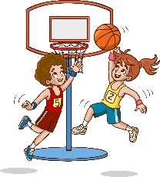
        - Do you like basketball?
Yes, ……………………………
        - Do you like basketball?
No, ……………………………

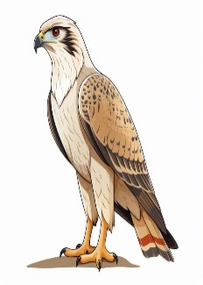
  - Fill in the missing words:
fly – talons – strong – see – prey

Falcons are very ..................... birds. They can ..................... fast. They can .....................very far. They have very sharp ..................... that they use to attack and catch their ......................

- Reading Short Sentence:
  - Read the sentences then choose the correct sentence for each picture:
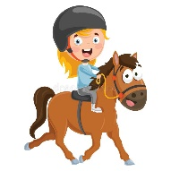 |  | 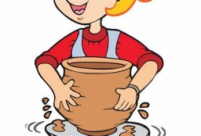 | 
a. He likes riding horse.  b. He likes volleyball. | a. She likes rock climbing.  b. She likes bungee jumping. | a. I do pottery.  b. I do painting. | a. He likes jogging.  b. He likes skiing.

- Grammar:
  - Choose the correct answer:
    - (Do – Does) you play word games?
    - (Do – Does) she play golf?
    - (Do – Does) they play football?
    - (Do – Does) he like snowboarding?
    - Horse riding is (exciting – more exciting – most exciting) than cycling.
    - Sky diving is the (exciting – more exciting – most exciting) sport.

- Vocabulary:
  - Write the words under the correct pictures:
rock climbing – hang gliding – snowboard – falconry – roller skating – racket

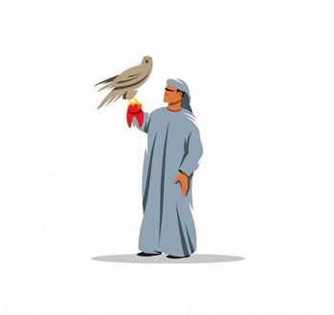
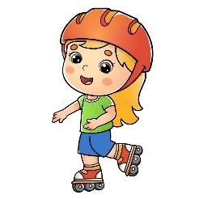
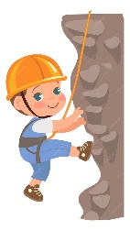
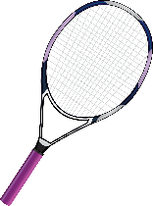
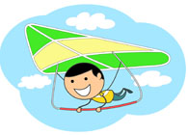
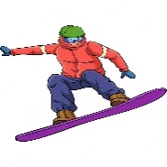

……………… ……………… ……………… ……...……… ……………… ………………

- Orthography:
  - Fill in the missing letters:
ear – air – ere – oi – oy

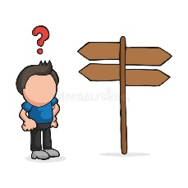
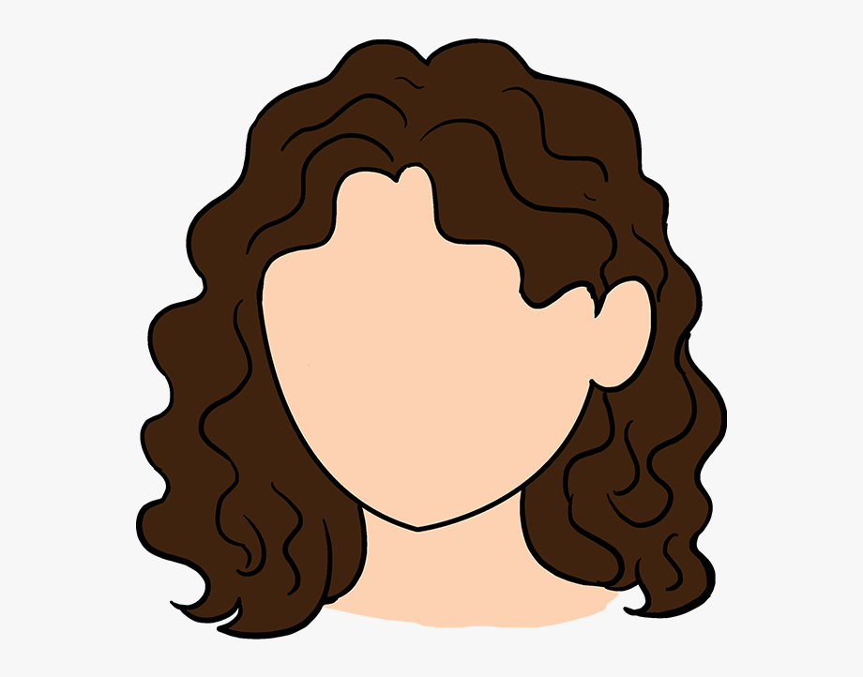

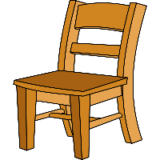

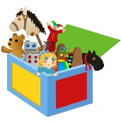


t __ __ c__ __n h__ __ __ p__ __ __ ch__ __ __ b__ __ wh__ __ __

Name: ................................... Ms. Tahani
Class: 3rd Elementary / ........
Revision Sheet _ Unit ( 4 ): Chores
- General Questions:
  - Match the questions with the correct answers:
- What chores do you do? |  | Yes, I do.
- Do you clean up your room? |  | t – e – a – c – h – e – r
- What is he doing now? |  | She folds the laundry.
- How do you spell teacher? |  | He is watching TV.
- What chores does she do? |  | I wash the dishes.

- Controlled Writing:
  - Rearrange the words to form sentences:
    - takes – trash – He – the – out
……………………………………………..
    - the – feed – I – fish
……………………………………………..
  - Fill in the missing words:
smile – clean – drink – dishes – bread
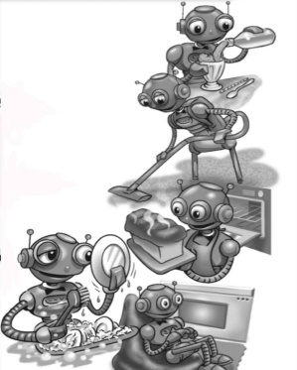
I have a little robot. He washes my ......................, and keeps the house ...................... He bakes my ....................., and makes me a ...................... He sits by the fire and gives me a ......................

- Reading Short Sentence:
  - Read the sentences then choose the correct sentence for each picture:
 | 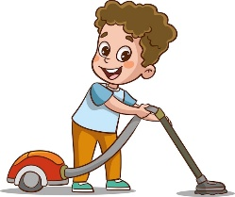 | 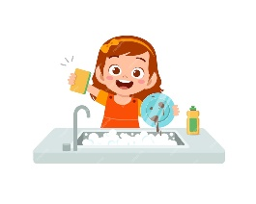 | 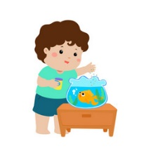
a. I go shopping.  b. I fold the laundry. | a. He cleans up the room.  b. He vacuums the floor. | a. I wash the dishes.  b. I set the table. | a. He feeds the fish.  b. He goes shopping.

- Grammar:
  - Choose the correct answer:
    - You (wash – washes) the dishes.
    - She (wash – washes) the dishes.
    - They (set – sets) the table.
    - He (set – sets) the table.

  - Do as shown between brackets:
    - (Write the missing form of the verbs)
        - clean ……………
        - ……………. washes
        - vacuum ……………
        - …………… goes

- Vocabulary:
  - Write the words under the correct pictures:
robot – dishes – bread – smile – fire – house

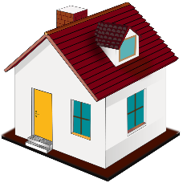


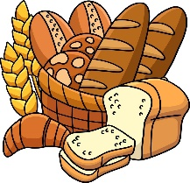



……………… ……………… ……………… ……...……… ……………… ………………

- Orthography:
  - Fill in the missing letters:
er – ar – or

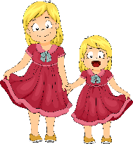


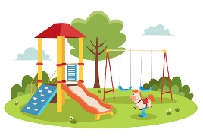

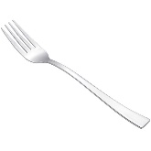


c__ __ f__ __k doct__ __ p__ __k broth__ __s f__ __m sist__ __

Name: ................................... Ms. Tahani
Class: 3rd Elementary / ........
Revision Sheet _ Unit ( 5 ): Yesterday and Today
- General Questions:
  - Match the questions with the correct answers:
- What time do you go to bed? |  | Yesterday, I went to bed at 10 o’clock.
- What time did you go to bed yesterday? |  | Yes, I do.
- What time is it? |  | I usually go to bed at 9 o’clock.
- Do you like cheese? |  | No, it isn’t.
- Can you call me on the phone? |  | It is half past four.
- Is an elephant green? |  | Okay.

- Controlled Writing:
  - Rearrange the words to form sentences:
    - brush – I – teeth – my
……………………………………………..
    - my – did – I – homework
……………………………………………..
  - Fill in the missing words:
home – bath – homework – lunch – bed
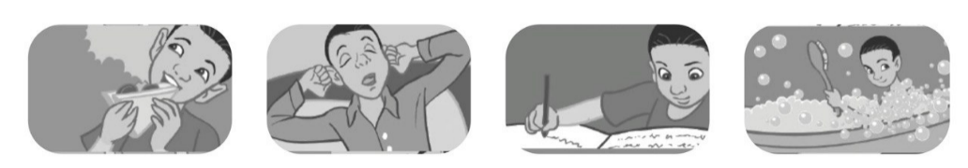

I usually eat ...................... at 12 o’clock. I usually come ...................... at 3 o’clock. I usually do my ...................... at 5:30. I usually take a ...................... at 8 o’clock. I usually go to ...................... at 9:30.

- Reading Short Sentence:
  - Read the sentences then choose the correct sentence for each picture:
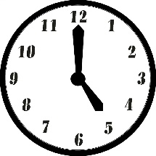 | 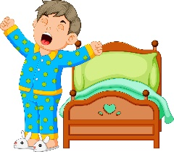 |  | 
a. It is five o’clock.  b. It is five thirty. | a. He did his homework.  b. He got up. | a. I ride the bus home.  b. I jump into bed. | a. I meet my friend.  b. I brush my teeth.

- Grammar:
  - Choose the correct answer:
    - Yesterday, I (get up – got up) at 6 o’clock.
    - I ususlly (get up – got up) at 5:30.
    - Yesterday, I (go – went) to bed at 10 o’clock.
    - I ususlly (go – went) to bed at 9:30.

  - Do as shown between brackets:
- Write the sentence in the past tense:
        - I take a bath.
Yesterday, ……………………………………
        - I do my homework.
Yesterday, ……………………………………

- Vocabulary:
  - Write the words under the correct pictures:
dream – teeth – bus – bed – bike – take a bath

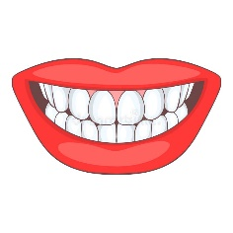

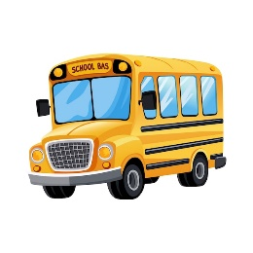

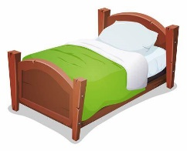
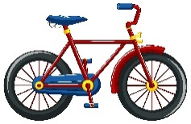

……………… ……………… ……………… ……...……… ……………… ………………
- Orthography:
  - Fill in the missing letters:
ng – nk – ck


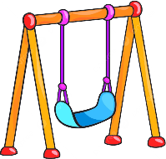
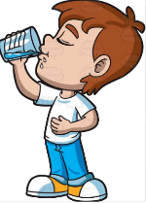
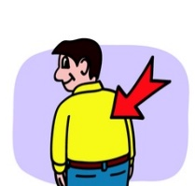
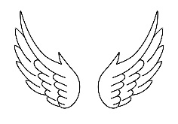
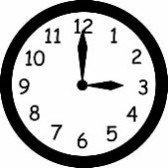


clo__ __ i__ __ ba__ __ wi__ __ spri__ __ dri__ __ swi__ __
  - Choose the correct letter:
- __ __ ip | - ch  - sh |   - __ __ erry | a- ch  b- ssh
  - __ __ one | - ph  - wh | 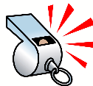  - __ __ istle | a-p ph  b-wwh

Name: ................................... Ms. Tahani
Class: 3rd Elementary / ........
Revision Sheet _ Unit ( 6 ): Jobs
- General Questions:
  - Match the questions with the correct answers:
- What is your dad’s name? |  | Yes, I do.
- What does your mom do? |  | She is a housewife.
- Where do they work? |  | I want to be a computer technician.
- Do you want to learn many languages? |  | My dad’s name is Ali.
- What do you want to be when you grow up? |  | It is 9 o’clock.
 |  | In the restaurant.

- Controlled Writing:
  - Rearrange the words to form sentences:
    - put – Firefighters – fires – out
……………………………………………..
    - brother – is – My – a lawyer
……………………………………………..
  - Fill in the missing words:
pilot – hospital – airport – helps – doctor – flies
He is a …………………..
He works in the …………………
He …………….. sick people.
He is a …………………..
He works in the ……………………
He …………….. airplanes.



- Reading Short Sentence:
  - Read the sentences then choose the correct sentence for each picture:
 |  |  | 
a. He is a businessman.  b. He is a cook. | a. He works in a laboratory.  b. He works in an office. | a. She is a nurse.  b. She is a writer. | a. I design buildings.  b. I teach English.

- Grammar:
  - Choose the correct answer:
    - A: (Who – Where – What) is she?
B: She is my sister.
    - A: (Who – Where – What) does she do?
B: She is a teacher.
    - A: (Who – Where – What) does she work?
B: She works in a school.

- Vocabulary:
  - Write the words under the correct pictures:
astronaut – diver – engineer – baker – hundred – thousand – reporter



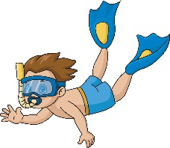


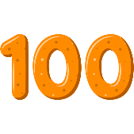

…………… …………… …………… ……...…… …………… …………… ……………
- Orthography:
  - Fill in the missing letters:
kn- gh




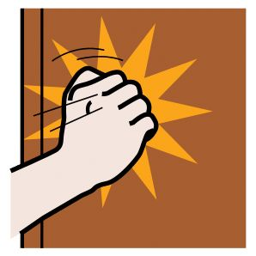
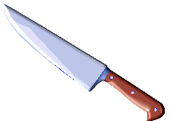
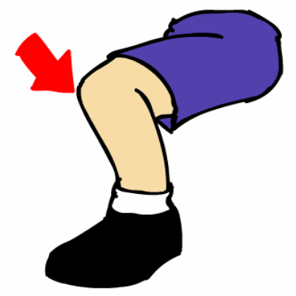

ri__ __t __ __ob __ __ee __ __ock li__ __t __ __ife
  - Check the right box:
 | 1 /z/  reads | 2 /s/  walks | 3 /iz/  teaches
eats
brushes
cleans
plays
sleeps
watches

