Name: ................................... Ms. Tahani
Class: 5th + 6th Elementary / ........
Revision Sheet: Welcome!
- General Questions:
  - Match the questions with the correct answers:
- Who is the tallest students in the class? |  | It is in September.
- In which month is the Saudi National Day holiday? |  | My birthday is in October.
- How long is the lunch break? |  | I think it’s one hundred fifty.
- What is one hundred thirty plus twenty? |  | I have six classes on Tuesday.
- Which month is your birthday in? |  | I think Ali is the tallest student.
6. How many classes do you have on Tuesday? |  | About thirty minutes.
- Controlled Writing:
B- Write the opposite of the following words:
1- early ≠ ………………. 2- difficult ≠ ………………. 3- small ≠ ……………….

  - Rearrange the words to form sentences:
    - long / was / your vacation? / How
……………………………………………..
    - December / My favourite / is / month
……………………………………………..
    - the biggest / is / This / classroom
……………………………………………..
C- Do as shown between brackets:
    - (Write the months of the year in the correct order):
August – November – March – June – April
1- January | 2- February | 3- ………… | 4- …………. | 5- May | 6- ……………
7- July | 8- ………… | 9- September | 10- October | 11- ………… | 12- December
    - (Complete the chart)
verb | Past form | Verb | Past form | Verb | Past form
buy |  | wake up |  |  | made
 | went | take |  |  | was/were
- Reading Short Sentence:

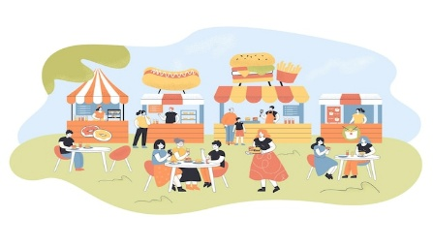

  - Read the sentences then match them with the correct pictures:
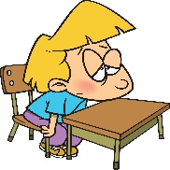
a-_He is a tall boy.  b-_He is a tired boy. | a-_It is one hundred.  b-_It is one thousand. | a-_It is a rainbow.  b-_It is a mountain. | a-_They go to food festival.  b-_They go to school.
  - Read and complete. Use the words in the box:
comic book – calendar – lion – snail

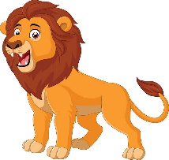  It is the king of the jungle.  ………………. | 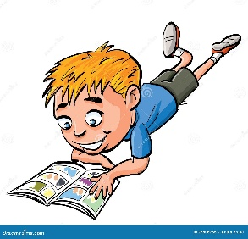  He likes to read a  ……………… | 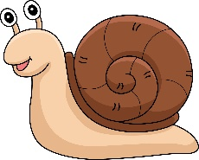  It moves slowly.  ……………… | 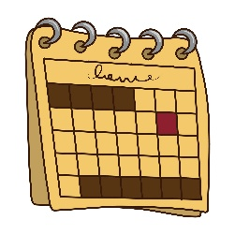  I marked my party on the ……………….

- Grammar:
  - Choose the correct answer:
    - (How many – How long) is the lunch break?
    - (How many – How long) students are in your class?
    - (How many – How long) was your vacation?
    - (How many – How long) classes do you have on Sunday?
    - I (eat – ate - eating) fruit with yogurt yesterday.
    - They (met – meet – meeting) their friends last weekend.
    - He is the (tall – taller – tallest) student.
    - This is the (difficult – more difficult – most difficult) class for me.

- Vocabulary:
  - Write the words under the correct pictures:
months – late – date – plus – classroom
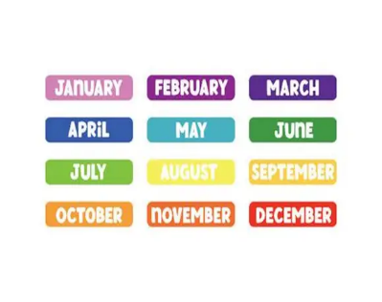


 | 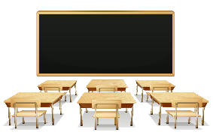 |  |  | 

- Orthography:
  - Fill in the missing letters:
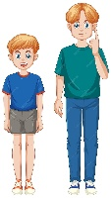 |  |   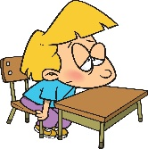 |  |  | 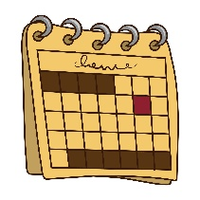 | 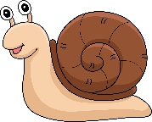
t__ll | rain__ow | t__red | moun__ain | hund__ed | __alendar | s__ail

Name: ................................... Ms. Tahani
Class: 5th + 6th Elementary / ........
Revision Sheet _ Unit (1): Personal Interests
- General Questions:
  - Match the questions with the correct answers:
- What is your favourite interest? |  | I started three years ago.
- When did you start your interest? |  | Voyaging because it is boring.
- Why do you like your interest? |  | My favourite interest is playing the guitar.
- Which activity do you not want to try? Why? |  | I like it because it is fun.
- Controlled Writing:
B- Write the opposite of the following words:
1- happy ≠ ………………. 2- usual ≠ ………………. 3- kind ≠ ………………. 4- lucky ≠ ……………..

  - Rearrange the words to form sentences:
    - prefers – She – days – sunny
……………………………………………..
    - sports – do – What – you play?
……………………………………………..
    - pasta – She – last night – cooked
……………………………………………..
C- Do as shown between brackets:
    - (Fill in the blank with the word that has the same meaning):
special – enormous – noisy – frightening – tidy – friendly
1- …………….. : make a lot of noise. | 4- …………….. : nice and kind to everyone.
2- …………….. : clean and organized. | 5- …………….. : scary.
3- …………..… : very big. | 6- …………….. :something unique.

    - (Rewrite the sentences in their negative form):
      - He plays tennis every Monday.
………………………………………………………….
      - He played tennis last Monday.
………………………………………………………….
    - (Classify the verbs in the correct column. Use the words from the box)
cook – love – know – write – understand – eat

Action Verbs | State Verbs

- Reading Short Sentence:
  - Read the sentences then match them with the correct pictures:
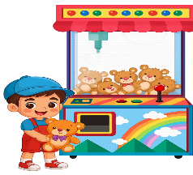 | 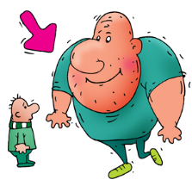 |  | 
a-_He is lucky.  b-_He is popular. | a-_He is upset.  b-_He is enormous. | a-_It is frightening.  b-_It is amazing. | a-_He is a musician.  b-_He is a reporter.
  - Read and complete. Use the words in the box:
tidy – popular – fairs - messy

  The woman has a  ………… hair. |   I love ……………. .I want to go again! | It is a ……………… closet. | 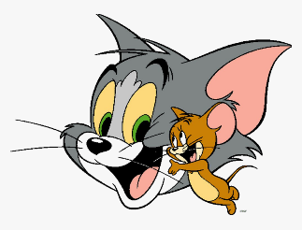  Tom and Jerry is a ……………… cartoon.
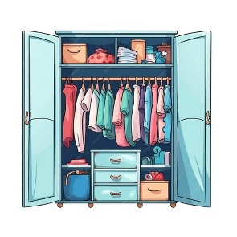
- Grammar:
  - Choose the correct answer:
    - He (swim – swims – swam) in the ocean last summer.
    - They (eat – eats – ate) pizza every Friday.
    - She (play – plays – played) board games on Thursdays.
    - She didn’t (go – goes – went) to a party yesterday.
    - He doesn’t (watch – watches – watched) horror movie.
    - He (write – is writing) in his notebook.
    - We (want – are wanting) to have a picnic.
- Vocabulary:
  - Write the words under the correct pictures:
origami – ride – untidy – horrible – excited

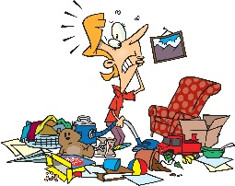 |    |  |  | 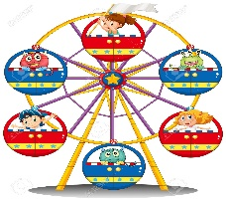
- Orthography:


  - Fill in the missing letters:
 |  |  | 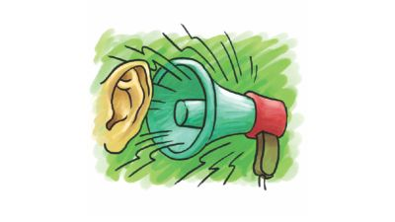  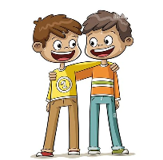 |  |  | 
pr__ze | imp__rtant | en__oy | frien__ly | noi__y | ex__ellent | un__ind

Name: ................................... Ms. Tahani
Class: 5th + 6th Elementary / ........
Revision Sheet _ Unit (2): House Designs
- General Questions:
  - Match the questions with the correct answers:
- Who designs houses? |  | Big and has a garden.
- What does your ideal home look like? |  | Concrete, and steel.
- What materials will the builders use? |  | No, I don’t.
- Do you think houses will be designed in the same way in the future? |  | An architect.
- Controlled Writing:
B- Write the opposite of the following words:
1- new ≠ ………………. 2- small ≠ ………………. 3- empty ≠ ………………. 4- different ≠ ……………..

  - Rearrange the words to form sentences:
    - has – basement – a – My house
……………………………………………..
    - the key – will – I – look for
……………………………………………..
    - going to – a book – I am – read
……………………………………………..

C- Do as shown between brackets:
    - (Fill in the blanks with the words from the box):
key – architect – entrance – measurements – materials
1- …………….. : You go through this to enter a place or building.
2- …………….. : You use them to build houses.
3- …………..… : You need this to unlock the door to your house.
4- …………..… : This professional designs houses and buildings.
5- …………..… : These are numbers that express the size of a room.

    - (Analyze the underlined words then write V for verbs and N for nouns):
      - You can call me. ( )
      - You can give me a call. ( )
      - He is going to design his dream bedroom. ( )
      - He draws the design he wants. ( )

- Reading Short Sentence:
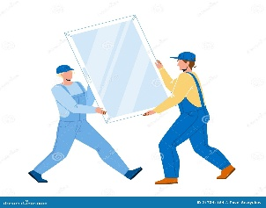
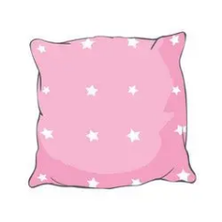
  - Read the sentences then match them with the correct pictures:
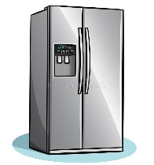 | 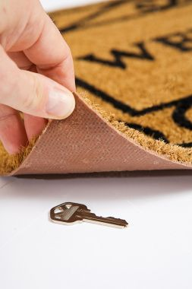
a-_It is an oven.  b-_It is a fridge. | a-_The key is under the mat.  b-_The key is under the bed. | a-_It is a shelf.  b-_It is a cushion. | a-_The builders need wood.  b-_The builders need glass.
  - Read and complete. Use the words in the box:
empty – take – later – basement

  It’ll ………… about 30 minutes to cook. | 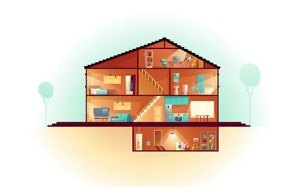  My house has a …………….. | 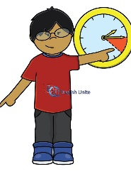  I’ll do my homework ……………. | There are no cookies in the bowl. It’s completely ……………….


- Grammar:
  - Choose the correct answer:
    - I will (order – orders – ordered) a pizza.
    - She is going to (comes – come – came) to my house after school.
    - I (am going to – will) take you to the hospital right now.
    - He (is going to – will) play basketball tomorrow.
- Vocabulary:
  - Write the words under the correct pictures:
stadium – stairs – Wi-Fi – haunted – racoon
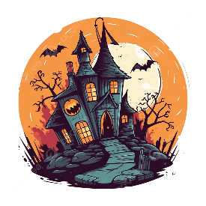

 | 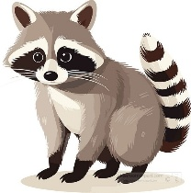 | 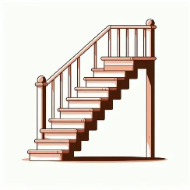
- Orthography:

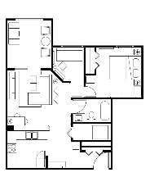
  - Fill in the missing letters:
 |  | 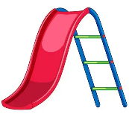 | 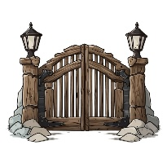 | 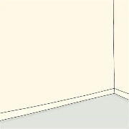 |  | 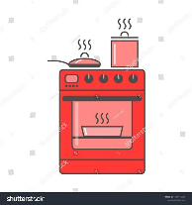
s__reen | la__out | sli__e | g__te | co__ner | she__f | o__en

Name: ................................... Ms. Tahani
Class: 5th + 6th Elementary / ........
Revision Sheet _ Unit (3): Job Paths
- General Questions:
  - Match the questions with the correct answers:
- What jobs do people in your community do? |  | Yes, he is.
- Where do you work? |  | I work in an office.
- He is a flight attendant, isn’t he? |  | I’m going to be a pilot.
- What are you going to do in the future? |  | Teachers, doctors and engineers.
- Controlled Writing:
B- Write the opposite of the following words:
1- happy ≠ ………………. 2- rich ≠ ………………. 3- difficult ≠ ………………. 4- older ≠ ……………..

  - Rearrange the words to form sentences:
    - am – mechanic – a – I
……………………………………………..
    - a scientist – going to – I’m – be
……………………………………………..
    - works – My dad – a factory – in
……………………………………………..
C- Do as shown between brackets:
    - (Write the suitable job from the box for each description):
receptionist – mechanic – driver – journalist
1- …………….. : This person writes news or gives news reports on TV.
2- …………….. : This person helps you when your car doesn’t work well.
3- …………..… : This person takes people to different places by buses or cars.
4- …………..… : This person works in the reception at a hotel or office.
    - (Complete the chart):
Base Word | Noun with -ist | Base Word | Noun with -ist
special |  | tour
psychology |  | cycle
- Reading Short Sentence:



  - Read the sentences then match them with the correct pictures:

a-_A waiter serves food.  b-_An actor acts in films. | a-He works in a factory.  b-He works in an office. | a- He’s an artist.  b- He’s a pharmacist. | a-_She’s a fashion designer.  b-_She’s a businesswoman.

  - Read and complete. Use the words in the box:
stage – meetings – flight attendant - manager

A …………………… helps the passengers. | A businessman has many ……………... every day. | A ……………... has leadership skills. |   Actors act on a ……………….


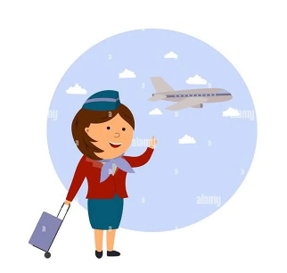

- Grammar:
  - Choose the correct answer:
    - I (am going to – is going to – are going to) be a scientist.
    - She (am going to – is going to – are going to) be a novelist.
    - He might (be – being – been) an engineer.
    - It’s possible that we (may – might – are going to) study acting in the future.
    - He (may – might – is going to) work as a waiter, but he is not sure.
    - This is the theater, (is it – isn’t it – it isn’t)?
    - You aren’t a doctor, (are you – aren’t you – you are)?
    - She enjoys taking photos, (does she – doesn’t she – she doesn’t)?
    - They can’t be businessmen, (can they – can’t they – they can)?

- Vocabulary:
  - Write the words under the correct pictures:
gallery – therapist – singer – photographer – news studio

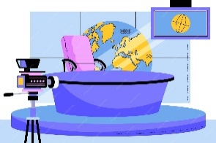 |  | 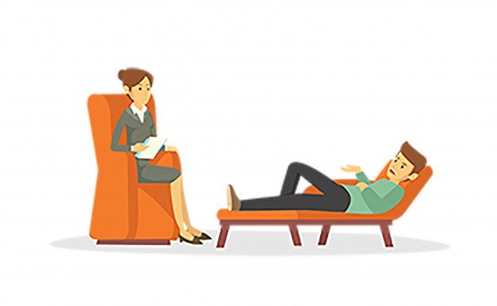 |  | 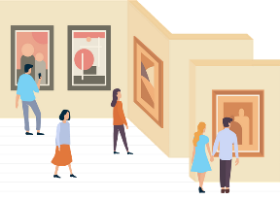
- Orthography:

  - Fill in the missing letters:
 |  | 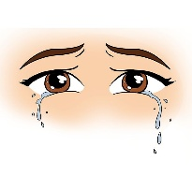 |  |  |  | 
air__ort | offi__e | tea__s | dri__er | tour__st | pi__ot | r__bot

Name: ................................... Ms. Tahani
Class: 5th + 6th Elementary / ........
Revision Sheet _ Unit (4): Glorious Food
- General Questions:
  - Match the questions with the correct answers:
- What is your favorite dish? |  | Flour, butter, sugar & chocolate.
- What ingredients do you need to make cookies? |  | Vegetables &fruit, starches and proteins.
- How can you improve your eating habits? |  | My favorite dish is pizza.
- What are the three most important food types? |  | Eat fruit & vegetables and drink water.
- Controlled Writing:
B- Write the opposite of the following words:
1- buy ≠ ………………. 2- good ≠ ………………. 3- quickly ≠ ………………. 4- healthy ≠ ……………..

  - Rearrange the words to form sentences:
    - shouldn’t – You – meals – skip
……………………………………………..
    - your hands – had better – You – wash
……………………………………………..
    - dish – My favorite – mutabbaq – is
……………………………………………..
C- Do as shown between brackets:
    - (Write the suitable job from the box for each description):
recipe – smell – bake – snack
1- …………….. : You use your nose to do this.
2- …………….. : It is a small meal between regular meals.
3- …………..… : To do this, you cook something in a hot oven.
4- …………..… : It gives instructions to prepare food.
    - (Look at the words in bold and write verb or noun):
a. I don’t like the taste of coffee. ( )
b. Mmm! The cake tastes delicious! ( )
c. People shouldn’t snack between meals. ( )
d.You should take a snack to school. ( )
- Reading Short Sentence:
  - Read the sentences then match them with the correct pictures:
 |  | 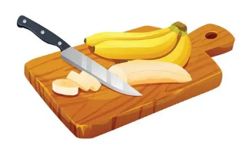 | 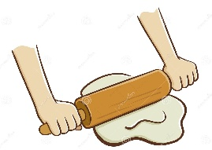
a- Stir the eggs quickly.  b- Measure 500g of flour. | a- Pour enough milk.  b- Taste the sauce. | a- Mix the ingredients.  b- Cut the bananas. | a-_Fetch the ingredients.  b-_Roll the dough.
  - Read and complete. Use the words in the box:
melt – honey – preheat – mix – knife

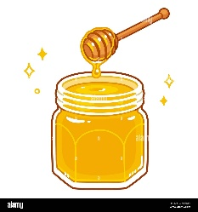  Add ……………………  to make a sweet snack. | 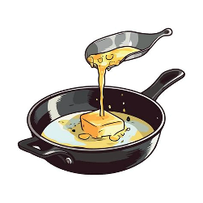  ……………... the butter in a pan. | Cut the vegetables with a …………….... | 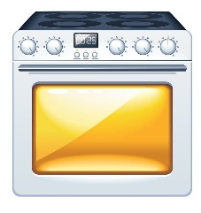  ………………. the oven to 175ºC.
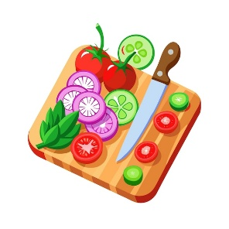

  - Read and choose the word that doesn’t belong in each group:
    - butter – countertop – honey
    - topping – recipe – ingredients
    - milk – pasta – cheese
    - rice – fish – meat
    - lunch – carrot – dinner

- Grammar:
  - Choose the correct answer:
    - You should (turn – turns – turned) on the oven before making the cookies.
    - You had better (washing – washed – wash) your hands before you start.
    - This milk smells bad. You (had better – had better not) drink it.
    - You (should – shouldn’t) drink lots of water.
    - If you (eat – eats – eating) a good breakfast, you have lots of energy.

- Vocabulary:
  - Write the words under the correct pictures:
dough – pour – measure – garlic – broccoli – dairy – starches

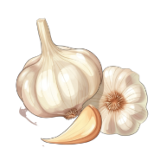 |  | 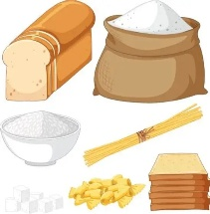 | 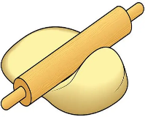 |  | 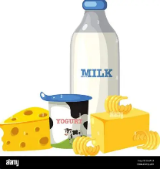 | 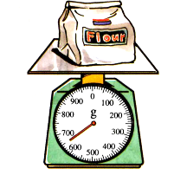
- Orthography:
  - Fill in the missing letters:
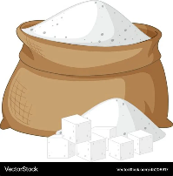 | 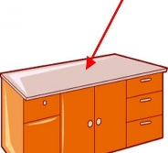 |  | 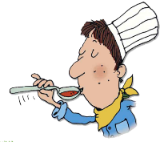 | 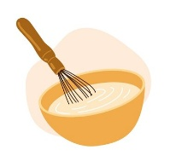 | 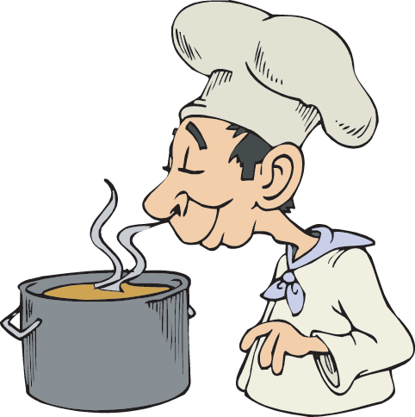 | 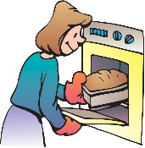
su__ar | coun__ertop | yog__rt | ta__te | m__x | s__ell | ba__e

