1
1– What kind of stories do you like?
I. CHOOSE
A. I like stories about animals. B. I like English.
2– What after-school activity do you do ?

A. No, I am not . B. I play computer games.
المملكة العربية السعودية |  |  | اسم الطالب/ ......................................
وزارة التعليم
إدارة التعليم بمنطقة |  |  | المادة : انجليزي
مدرسة : |  |  | الزمن :
 |  |  | الصف : فصل ( )
شفهي | تحريري |  |  | المجموع
10 / | 10 / |  |  | 20 /
Top goal1 اختبار الفترة الثانية للفصل الأول - للعام الدراسي 1447– لغة انجليزية –– للصف الرابع
اسم الطالب / هـ الفصل /

2. CHOOSE OR
1.5

She is reading a book.
They are in the classroom.
He planted flowers.




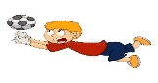

3. DO AS SHOWN BETWEEN BRACKETS
1.5

1 played / Carta / a soccer / yesterday. ( rearrange ) …………………………………………………
quietly | quickly | loudly | 2 - He is walking ________. (choose )
4. CHOOSE
1

scoring | scored | scores | 1- She _____ a goal yesterday.
so | and | but | 2- I go swimming _____ play tennis.

3
4. CHOOSE
jump - plant - vlogging

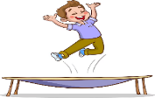 | 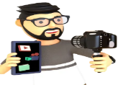 | 


2

Choose the correct letter:

 | 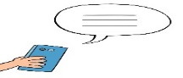 | 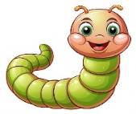 | 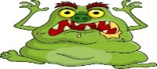
Vi_eo games | ting_te | _rom | ter_mon
n | c | n | k
d | x | w | s

___________________________________________________________________________________________________________________________________________________________________________________________________________________________________
Controlled writing

4

Good luck T.


Kingdom of Saudi Arabia
Ministry of Education
……..Education Directorate
………………… School
English Language
elementary Grade 4th
2nd period Exam
…………….\20
الاسم: الصف:

……\ 4 marks

General questions

A.Answer the questions
Yes, I did. |  | What do you like to do for fun? | 1
I like to read a storybook |  | Did you like the movie? | 2
Yes, I can. |  | Did she finish the story? | 3
No, she didn't. |  | Can you run quickly? | 4

Controlled Writing
……\ 1 marks
A-reorder.
1-1-homework / Did / do / you / your / ?
a-Did you do your homework? b-homework you Did your do ?

……\ 4 marks

Reading short sentence
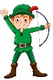 | 1- Nasser loves dressing up ( )
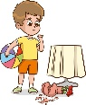 | 2- The boy is in trouble because he broke the vase. ( )
A-Put ( ✔ ) or ( X )
B. Choose the correct answer
c-writes | b-reads | a-takes | 1- He ……………photos of the train
c-climb | b-shout | a-drop | 2- Omar …………….the big tree.

……\ 4 marks

Grammar
A-Choose the correct answer.
c- plants | b- plant | a- planted | 1-We ……… flowers last weekend
c- watching | b- watched | a- watch | 2-She didn’t ………….. TV.
c- fixes | b- fixed | a- fix | 3-My dad …. my computer last week.
c-see | b- saw | a-seeing | 4- Did he ……..a movie last night. ?

Vocabulary

A.Choose the correct word under each picture
……\ 5 marks

 |  | 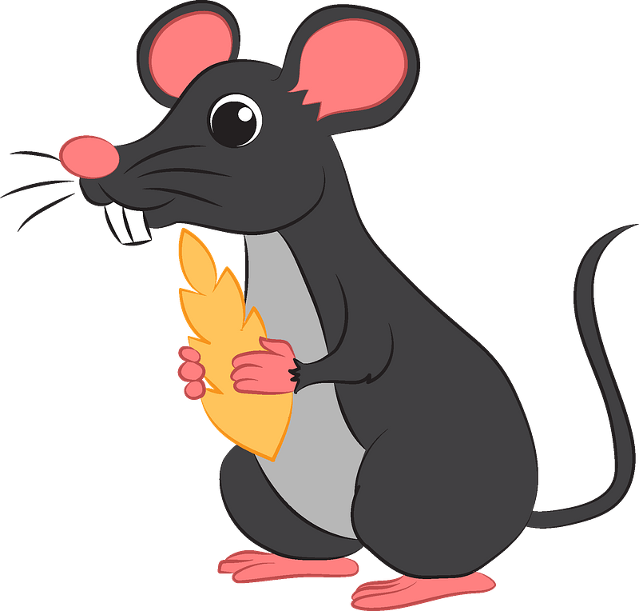 | 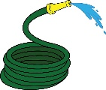 | 
cry | writer | cat | hose | texting
lough | doctor | mouse | book | playing
……\ 2 marks

Orthography
A. Fill in the missing letters
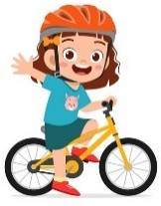
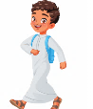
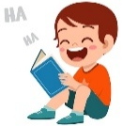


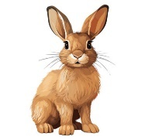
1-slo…ly
( t – w - k )
4- ….ream
( o – d – s )
3- fun…y
( x – p - n )

2- ro…..
( j – r – b )

( s – t - o)


Your teacher:

Your teacher …..:…………………………….


Kingdom of Saudi Arabia 4th Elementary Grade
Ministry of Education First Term

10
………….Elementary School . . Second Exam 1447 AH
Name: ………………………………………………………….………………. Class: …………..
- General Questions:
- Match the questions with the correct answers:
- What do you like to do for fun? a- At 6 o’clock
- What time do you get up in the morning? b- It was great.
c- I like to jump rope.

- Controlled Writing:
- Rearrange the words to form sentences or questions:
- waited – the bus – I – for
………………………………………………………

- Reading Short Sentence:
- Read the sentences then match them with the correct pictures:
 | 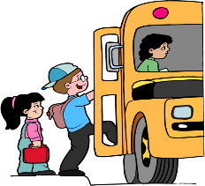 | 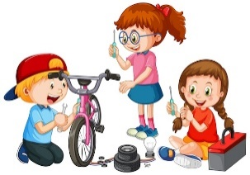 | 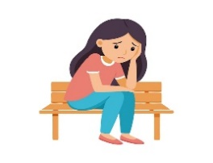
a-_I feed the animals.  b-_I get dressed. | a-_I get on the bus.  b-_I get off the bus. | a-- They fix the bike.  b-- They water the trees. | a-_She looks sad.  b-_She looks happy.

- Grammar:
- Choose the correct answer:
- He ………… at my joke last night.
- laugh | - laughs | - laughed
- Hind …………… a story now.
- read | - reads | - is reading

- Vocabulary:
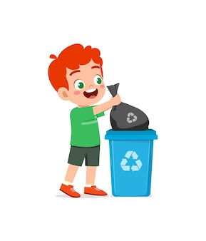
- Choose the correct answer:
 | 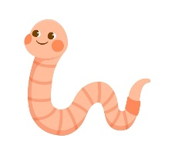 | 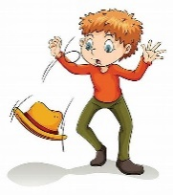 | 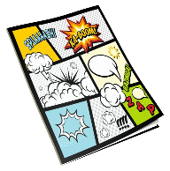 | 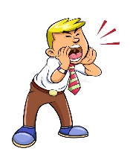
- dishes  - trash | - story  - worm | - rob  - drop | - notebook  - comic book | - shout  - read

- Orthography:
- Choose the correct missing letter:

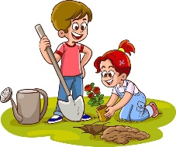  pl__nt |  | 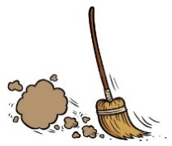  du__t |  |   lea__es |  | 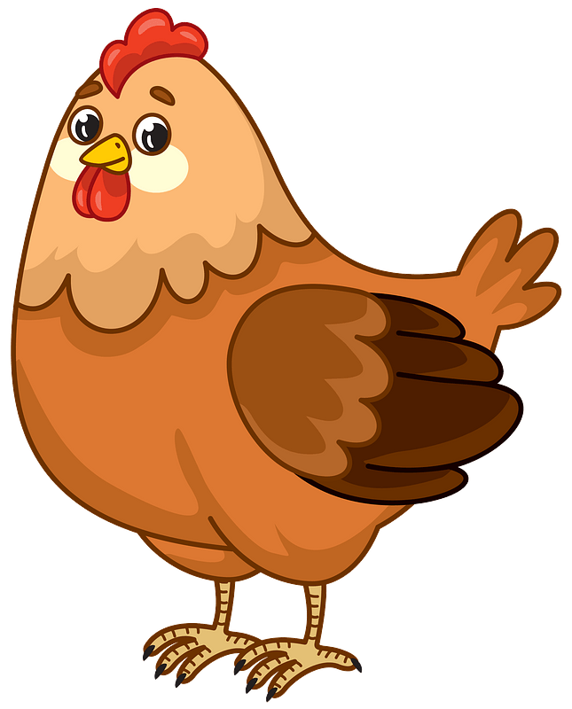  chicke__ |  | 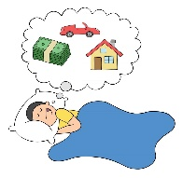  d__eam
a | o | s | c | f | v | n | m | f | r

BEST OF LUCK
Ms. Tahani Al-Ghamdi



Second Period Exam – Top Goal1

مدرسة :
الاسم | الفصل | شفهي | تحريري | المجموع
 | / | 10 / | 10 / | 20 /
Choose the correct answer:
/ 1

1– What kind of stories do you like?

A. I like stories about animals. B. I like English.
1– What after-school activity do you do ?

A. No, I am not . B. I play computer games.
____________________________________________________________________________________________________
/ 1.5
Choose or :
She is reading a book. | They are in the classroom. | He planted flowers.
 |  | 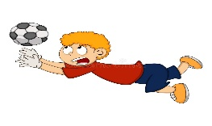
___________________________________________________________________________________________
/ 1.5
1- played / Carta / a soccer / yesterday. ( Rearrange) ………………………………………………………………………………………
quietly | quickly | loudly | 2 - He is walking ________. (choose )
Do as shown between brackets :
Choose the correct word:
/ 1.5
scoring | scored | scores | 1- She _____ a goal yesterday.
shout | shouting | shouted | 2- He didn't _______.
so | and | but | 3- I go swimming _____ play tennis.

Choose the correct word:
/ 3

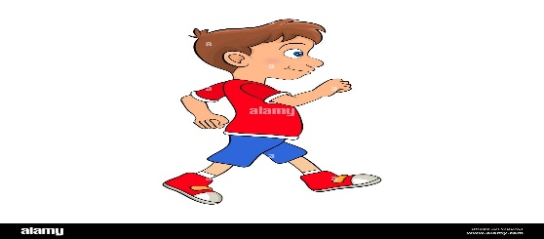 |  | 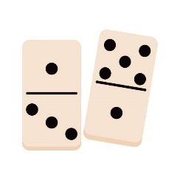 |  | 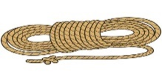 | 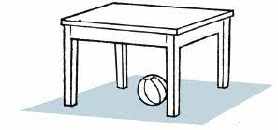
sleeping | vlogging | Dominos | hose | rope | shout
walking | running | Piano | plant | Leave | Jump
Choose the correct letter to fill in the blank:
/ 1.5
ting_te | _rom | ter_mon
c | n | k
x | w | s

Good luck T.
Controlled writing

4

