

English Language
Intermediate Grade 1st
1st period Exam
……….\20
Kingdom of Saudi Arabia
Ministry of Education
………………… School

Student's Name : class:

……\ 5 marks
1-Read the following passage and answer the questions below:
Ahmad and his friend Ali love spending time together. On Tuesday, they went to the zoo. On Thursday, they played football in the park. On Saturday, they visited the library and read stories. They had a lot of fun every day they were together.
c- cousins | b- brothers | a- friends | 1- Ahmad and Ali are ……..
c-Wednesday | b-Friday | a- Tuesday | 2- What day did Ahmad and Ali go to the zoo?
c-went shopping | b-played football | a-studied | 3- What did they do on Thursday?
c- library | b-gym | a-restaurant | 4- Where did Ahmad and Ali go on Saturday?
c-Mohammad | b-Ali | a-Sami | 5- Who did Ahmad spend time with?
A.Choose the correct answer.

2-Choose the correct answer.
……\ 5 marks

c-are | b-am | a-is | 1- Omar ………………a student.
c-Why | b-Where | a-What | 2-………day is today?
c-opening | b-opens | a-open | 3- Please …………..your book.
c-am | b-is | a-are | 4- You ………a doctor.
c-Our | b-Her | a-My | 5-…………names are Yahya and Adel.
c-How | b-What | a-When | 6-……………are you?
c-their | b-we | a- she | 7-They are excited about ……graduation day.
c-at | b-on | a-in | 8- The exam is ………..Monday.
c-His | b-My | a-Her | 9- I’m a student. …………..name is Alan.
c- is | b-are | a-am | 10- This is my friend .She ……. a teacher.

3-Do as shown between brackets.
……\ 2 marks
1- This is the teacher. My name is Mr. Ahmed. ………………… ( correct)
2- close the door…………………………………………………………. (write the negative)

……\ 4 marks
4- write the correct word under each picture ( eraser – horse – dolphin - paints )



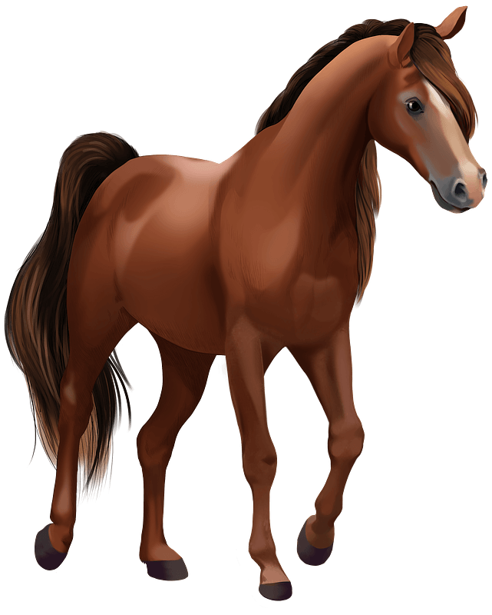
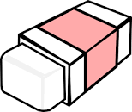

………………………
………………………
………………………
………………………

……\ 2 marks
5- Choose the correct answer.
1- We( cut – color – read ) with scissors.
2-(Life span - Turtle – Baby) is the number of years an animal can live.
.

……\ 2 marks
6.Choose the missing letter.
1- I'm star….ing . I hvaen't eaten anything all day .( v - d - w )
2- My dad has a ….eeting today. ( c – m – g )

7- write the missing letter

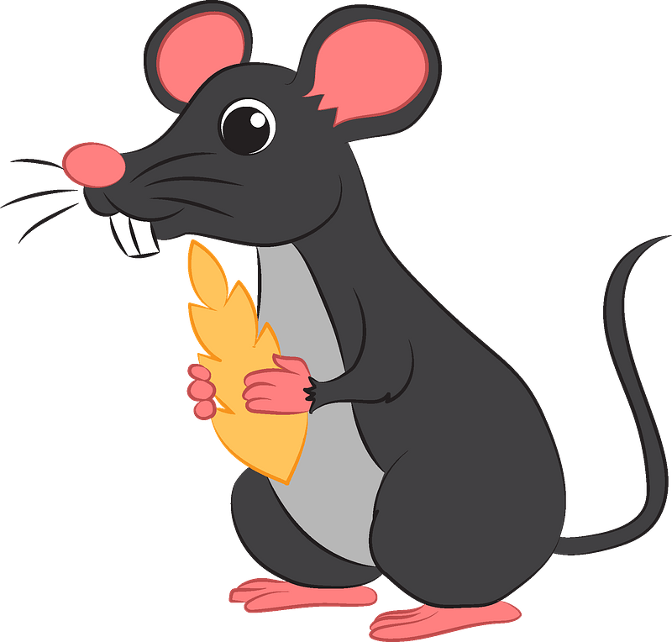
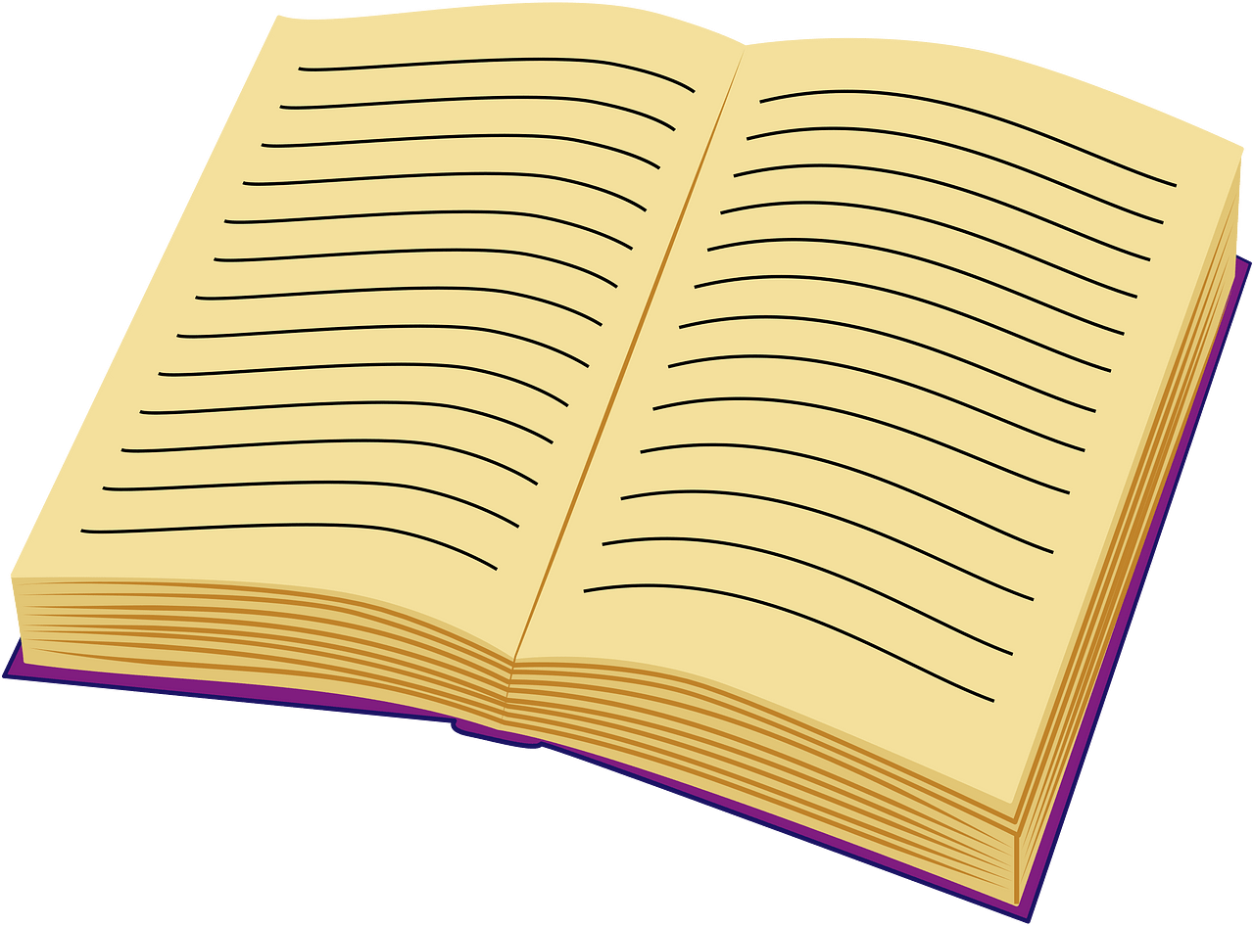

Boo….
….ouse

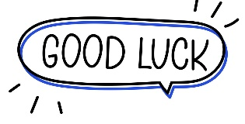

Your teacher:


Kingdom of Saudi Arabia Name: ……………………………
Ministry of education Class: 1st Intermediate Grade
10 /
………. Intermediate School First Exam - 1447 First Term
- Grammar:
- Choose:
- Huda (am – is – are) a smart student.
- I am Nora. This is (my – her – his) little sister.
- The Saudi National Day is (in – on – at) September.
- (How old – When – What) is your name?

- Do as shown between brackets:
- doctors / We / . / are (Rearrange)
…………………………………………………………
- This is a car. (Change to the plural)
…………………………………………………………

- Vocabulary:
- Write the words under the pictures:

crayons – coffee – horse – rabbit – sculpture
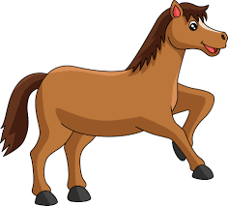
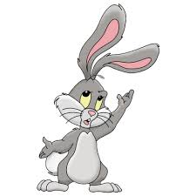


_____________ _______________ ________________ ______________

- Classify the words:
meteor – November – dolphin – pen

Animal | Museums items | School Supply | Month of the year

- Orthography:
- Fill in the missing letters:
- The child lost his t__y.
- Rawan didn’t sleep early last n__ght.
- A__ril is the fourth month of the year.
- My final test is on Th__rsday.

Good Luck
Ms. Tahani Al-Ghamdi


Kingdom of Saudi Arabia
Ministry of Education
………… Education Directorate............
…………..……………….. Intermediate School

Total
المجموع | تحريري | شفهي
20 | 10 | 10

First Period Exam
First Intermediate Grade

Name ………………………………… Class ………………………………
__________________________________________________________________________________________
/ 2
Comprehension

Read the following then answer the questions:

Ali gets up at five o'clock every morning. He performs morning prayer. For breakfast, he likes to eat eggs and bread. He drinks milk. Ali always goes to school by bus. He reaches school at seven o’clock. Later, he has lunch at half past two with her family. In the afternoon, he starts doing his homework at four o’clock. He goes to bed at ten o’clock
A- Put (√ ) for true or ( ᵡ ) for false :

( ) | 1. Ali drinks coffee in the morning.
( ) | 2. He always go to school by bus .

B- Choose the right answer:

Tabuk | Abha | Jeddah | Riyadh | 1-He was born in ______.
driver | student | teacher | doctor | 2-Abdullah is a _______.
_________________________________________________________________
/ 2.5
Grammar

Choose the right answer:

1- You _______ my best friend. .
A. is B. am C. are D. do
2 - _______ is the date tomorrow?
A. When B. What C. Where D. Where
3 - Our vacation is ____ May.
A. on B. in C. at D. under
4 - ______ old are you? I’m fifteen .
A. Where B. How C. When D. which
5 - Look at _____ bird in the sky!
A. those B. these C. this D. that

/ 2
Vocabulary

A- Choose the best answer to fill in the blank:
1. I need a pair of ________ to cut this paper.
D. pen | C. pencil | B. scissors | A. book
2. Good night, Fatima. __________ , Mona
D. Good afternoon | C. Good night | B. Good bye | A. Good morning
3- January is the first _____ of the year.
D. hour | C. day | B. week | A. month
4- _____ your books. Look at page 12.
D. cut | C. open | B. write | A. help
B- Put the right word under its picture:
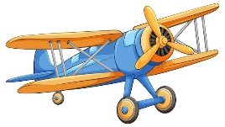 |  | 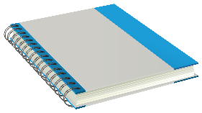 | 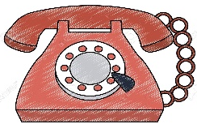 | 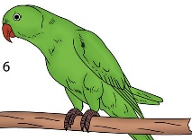
/ 2.5
Parrot - telephone - crayon - notebook - airplane

_______________________________________________________________________________
/ 1
Orthography

Choose the correct letter:
k | h | l | 1. The food on planes is terrib_e.
b | w | t | 2. Put your bags a_ay.

Good luck T.


Name:……………………………………………………
Seat: ………………………………………………………

Comprehension
Today, we went on a fun visit to the museum! We saw amazing sculptures and an old poster of a dinosaur. There were also cool fossils and a big skeleton of a human body.
We saw many old things, like toys and old cameras. I found some colorful key chains and tote bags in the gift shop. The guide told us, "Don't touch!" We looked at the old radio, camera, and washing machine. It was a great day of fun!
A/Choose the correct answer:
1. What did they see at the big at the museum?
a) a small toy b) a big skeleton c) a bus
2. What did the guide tell them not to do?
a) run b) play c) touch
3. Where did they see the colorful items?
a) in the sculpture room b) in the gift shop c) home
4. Which animal was on the poster?
a) elephant b) dinosaur c) bird
B/ Fill in the blanks:
5. They saw amazing _________ at the museum. (sculptures/cat/bus)
6. They looked at the old_________. (radio/apple/fish)
7. They went on a fun visit to the _______. (park/zoo/museum)
C/Put (T) for true or ( F )for false:
8. They went on a visit to the zoo. ( )
9. It was a great day. ( )
10. saw many old things.( )

English language
1st grade intermediate
1st term

Kingdom of Saudi Arabia
Ministry of Education
intermediate School

/20
Mark:

/5

Grammar
A-Choose the correct answer.
- I __ student. (am - are - is)
- She is a teacher, _____ name is Miss Mona. (his - her – they)
- I eat ___ apple. (a - the - an)
- My birthday is ___ January 1st 2013 (in - on - at)
- I play football. ___ Mondays. (at– on – in)
- You _____ my best friend. (are – am – is)
- _____ old, are you? (How – What – When)
- ___________ is your first name? (What- Where – How)
B- correct the errors.
- This is me friend, his name is Ali. _____
- Sara and Mona is teachers. ______
C-Fill in the blanks with the correct preposition (on / in).
- My vacation _______ the summer.
- Our final test is __________ September 21st.

A-Choose the correct answer:
- Hi, how are you? _____ a) I’m ok. b) goodbye c) thanks
- We cut with _______. a) scissors b) pen c) book
- We _____with crayons. a) write b) read c) color
B- Fill in the blanks from the box
- I have a surprise for you,________
- Put your bags _________
- Please sit ________
C/ Write the correct word under the picture

A./ Choose the correct letter to fill in the blank.
- I’m sorr__, Hi Ahmed {y / i / e}
- There are twelve __onths in a year. {n/e/m}

/4

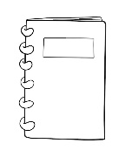
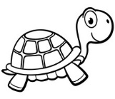
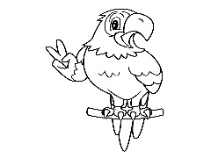

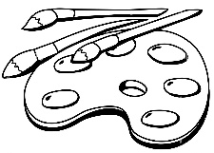
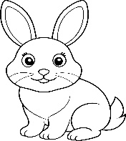
away / guess what! / down
Best wishes
By: Manal Al-Shareef
/2
/5
B/ Write the missing letter

1.Tu__tle (r/l /j) 2. not__book(i/y/e)
Orthography
Parrot / Scissors/Paints/ Rabbit
Vocabulary
/4

Name :…………………………………………………………………… Class:…….……….
Super Goal 1 - Test unit 1 & 2

Reading
2 Marks
- Read the text and answer the questions. Write T or F at the end of each question/statement.
My name is Mariam. I am 13 years old. My birth date is in the ninth month of the year. It is on September 4th. My best friends’ names are Carla and Jane. They are 14 years old. Carla’s birth date is on June 3rd. Jane’s birth date is on March 31st. We are students in Mrs. Jenkin’s English class. Our class is on Mondays, Tuesdays, and Wednesdays.
- Mariam, Carla, and Jane are teenagers. ( )
- Mariam is a student, but Carla and Jane are not students. ( )
- Jane’s birth date is in the 11th month of the year. ( )
- Mariam’s birth date is in the 9th month of the year. ( )
Grammar
5 Marks
- Choose the best answer to fill in the blank in each question.
- Mr. Smith _____ a teacher.
a. am b. is c. his d. are
- _____ students.
a. I’m b. He’s c. Are d. They’re
- Asma and Nura are _____.
a. friend b. friends c. is friend d. are friend
- Their final test is __________ April 14th.
a. in b. on c. am d. are
- His driving test is __________ November.
a. on b. are c. in d. am

- Complete the sentences with possessive adjectives.
1.5 Marks
- He is a student. __________ name is Ahmad Saleh .
- I am a teacher, ____________ name is Rashed Alsulami .
- He`s the director. __________ name is Mr. Abdulaziz Alshehri

- Complete the question, use ( What – When – How old ).
1.5 Marks
- ________________ is your vacation? - our vacation is in May .
- __________________ are you ? - I'm fifteen .
- _________________ is the date tomorrow ? - It's 20th September .

Vocabulary
- Choose the best answer to fill in the blank in each question.
5 Marks
- See you _____, Faisal.
a. bye b. later c. night d. goodbye
- Good _____, Mr. Ali.
a. days b. meet c. hello d. evening
- Nice to _____ you, Mona.
a. meet b. name c. friend d. call
- June is the __________ month of the year.
a. Second b. first c. twelfth d. sixth
- Today is Tuesday. __________ is Wednesday.
a. Tomorrow b. Today c. Yesterday d. Month

- Write the correct word under the picture.
3 Marks
Pencil – Turtle – Calendar

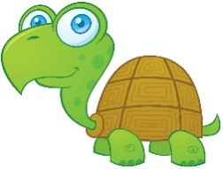
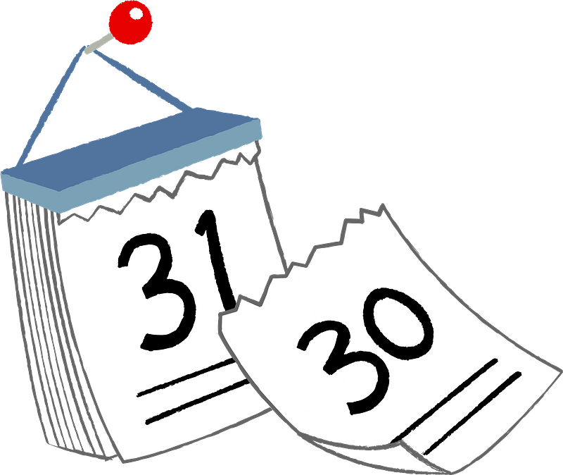
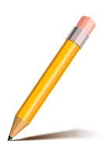

…………………………..…………………….

…………………………..…………………….

…………………………..…………………….

- Choose the correct letter.
2 Marks
- Nice to meet …ou ( v – y – r )
- He is so c….te ! ( y – u – c )


Kingdom of Saudi Arabia
Ministry of Education
………… Education Directorate............
…………..……………….. Intermediate School

20
Total

Midterm Test units 1 & 2
First Intermediate Grade

Name ………………………………… Class ………………………………
__________________________________________________________________________________________
/ 4
Comprehension

Read the following then answer the questions:

My name is Abdullah, I was born in Jeddah. I am from Saudi Arabia and I am 22 years old.
I am a student at the Business Administration College. I have got one brother and one sister.
In my free time, I watch TV and play computer games. And I also play basketball every weekend. I like to have a good time with my friends, but I hate shopping for clothes.
A- Put (√ ) for true or ( ᵡ ) for false :

( ) | 1. He has got two sisters.
( ) | 2. In his free time, he watches TV.

B- Choose the right answer:

Tabuk | Abha | Jeddah | Riyadh | 1-He was born in ______.
driver | student | teacher | doctor | 2-Abdullah is a _______.
_________________________________________________________________
/ 5
Grammar

Choose the right answer:

1- You _______ my best friend. .
A. is B. am C. are D. do
2 - I’m a student. _______ name is Aisha
A. his B. my C. your D. she
3 - Our vacation is ____ May.
A. on B. in C. at D. under
4 - ______ old are you? I’m fifteen .
A. Where B. How C. When D. which
5 - Sara ____ a nurse .
A. am B. are C. is D. she

/ 4
Vocabulary

A- Choose the best answer to fill in the blank:
1. I need a pair of ________ to cut this paper.
D. pen | C. pencil | B. scissors | A. book
2. Good night, Fatima. __________ , Mona
D. Good afternoon | C. Good night | B. Good bye | A. Good morning
3- January is the first _____ of the year.
D. hour | C. day | B. week | A. month
4- _____ your books. Look at page 12.
D. cut | C. open | B. write | A. help
B- Put the right word under its picture:
 | 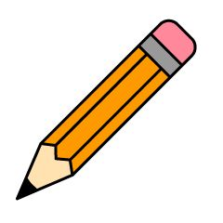 | 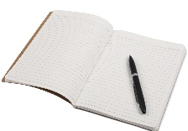 | 
Parrot , dolphin , pencil , notebook , listen
/ 5

_______________________________________________________________________________
/ 2
Orthography

Choose the correct letter:
k | h | l | 1. The food on planes is terrib_e.
b | d | t | 2. Our visit is on Thurs_ay.

Good luck T.

English Language
Intermediate Grade 1st
period Exam
Kingdom of Saudi Arabia
Ministry of Education
………..Education Directorate
………………… Intermediate School

Student's Name : class:

Reading comprehension ✦
……\ 5 marks
1-Read the following passage and answer the questions below:
Ali gets up at five o'clock every morning. He performs morning prayer. For breakfast, he likes to eat eggs and bread. He drinks milk. Ali always goes to school by bus. He reaches school at seven o’clock. Later, he has lunch at half past two with her family. In the afternoon, he starts doing his homework at four o’clock. He goes to bed at ten o’clock.

1- Ali gets up at ………… o'clock every morning.
c- ten | b- three | a- five
2- For breakfast, he likes to eat …………. and bread
c- cheese | b- cereal | a- eggs
3- Ali drinks ………………
c- juice | b- milk | a- coffee
4-. Ali always goes to school by ……………..
c-train | b-bus | a-car
5- He goes to bed at ………. o’clock.
c- ten | b- nine | a- one

Grammar ✦
……\ 4 marks
A. Choose the correct answer.
1- You ( is – are – am ) a doctor.
2-(Where – What – Why ) day is today?
3-( What – How – when ) are you?
4- Omar (is – are – am) a student.
5- Please ( open – opening – opens ) your book.
6- I’m a student. (Her – My – His )name is Alan.
7-This is my friend .She (is – are -am) a teacher.
8- The exam is ( in – on – at )Monday.



B. Do as shown between brackets.
1-( Correct)
a-What is you name? ………………
b- Our vacation is on the winter. ………..
2-Write the negative.
a-Close the door…………………………………………………………………………….
3-Write the following dates.
a-2/15 ………………………………………………………………………………………..

……\ 4 marks

✦ Vocabulary
A-choose the correct answer.
1-We( read – cut - swim) books.
2- Open your books. Look at ( page – pencil – read ) twelve.
B- Write the correct word under each picture

……\ 5 marks

cat pencil scissors dolphin

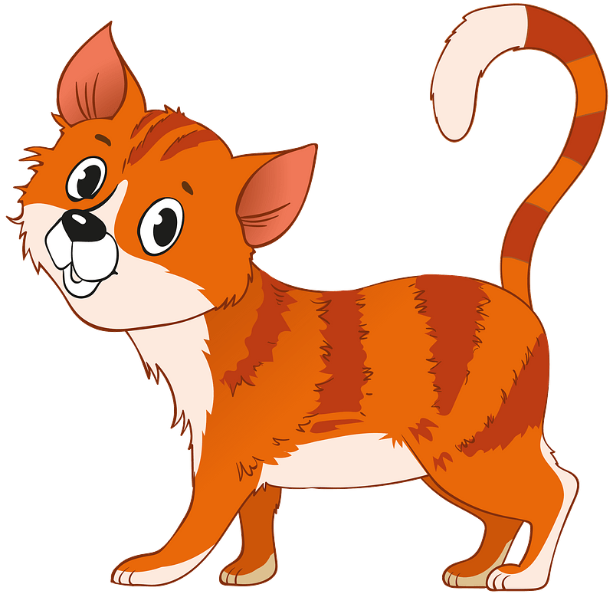
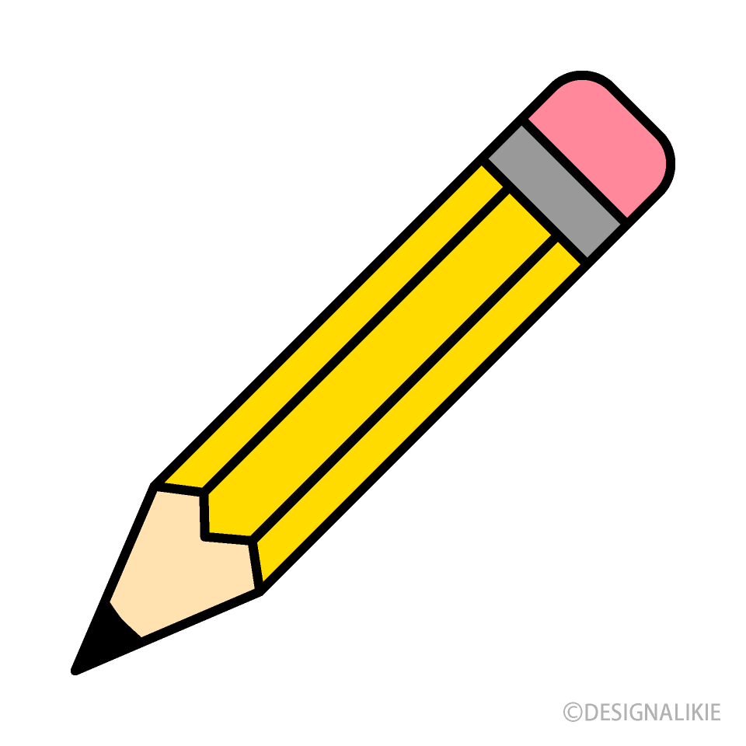
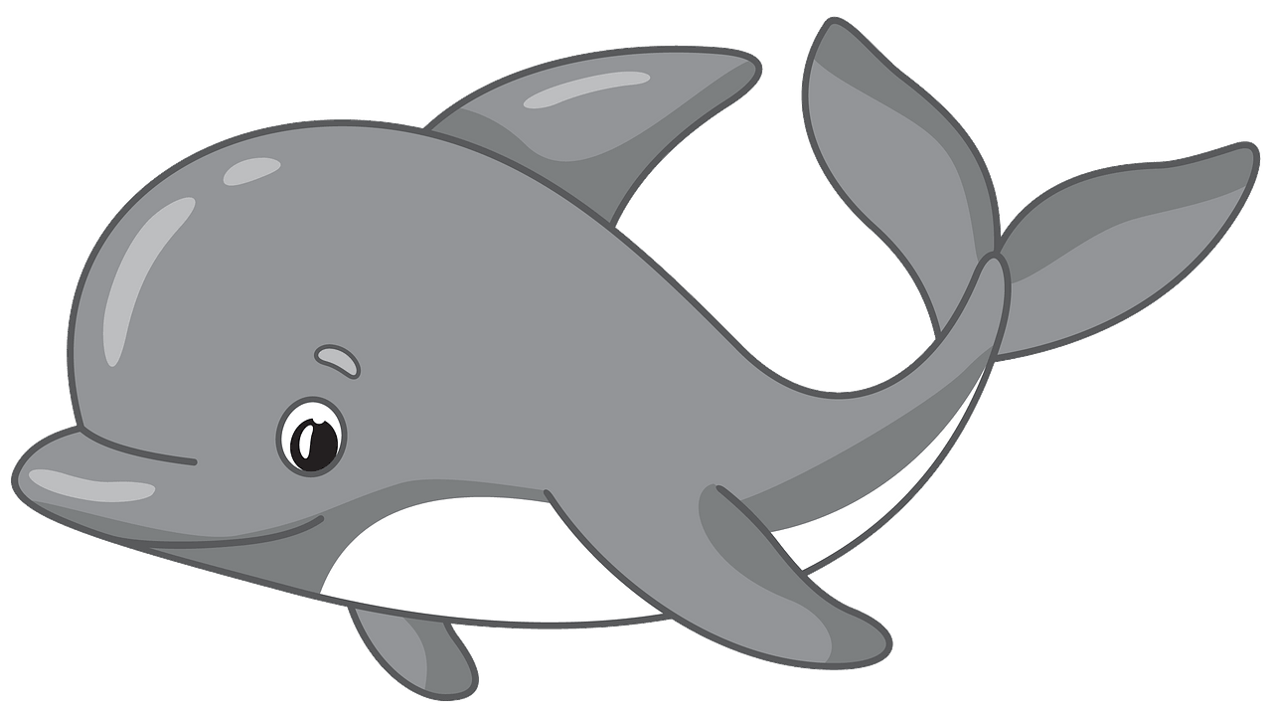


…………………………
…………………………
…………………………
…………………………
✦ Orthography
Choose the corre

……\ 2 marks
A. Choose the missing letter.

1- We’re going sailing on Mo….day. ( n – u – q ).
2- Ni….e to meet you. I'm Fahad. ( p – c – z )

B. Write the missing letter.
Your teacher:

2- ….ouse ( h – m – p )
1-Boo…… ( k – j – a )
The end of the questions
Good luck
Your teacher ………………………

