[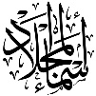](https://t.me/Asmaworld)

Kingdom of Saudi Arabia

Ministry of Education

……..Education Directorate

………………… School

English Language

elementary Grade 3rd

period Exam

…………….\20

الاسم: الصف:

……\ 4 marks

General questions

**A.Answer the questions**

|  |  |  |  |
| --- | --- | --- | --- |
| I think whale is fast. |  | **Where do you live?** | 1 |
| My name is Ali. |  | **How old are you?** | 2 |
| I am eleven years old. |  | **What's your name?** | 3 |
| I live in Jeddah. |  | **What do you think about whale ?** | 4 |

Controlled Writing

……\ 1 marks

**A-reorder.**

!- **a – It's - walrus**

a- It‘s a walrus. b- walrus it's a .

……\ 4 marks

Reading short sentence

|  |  |  |
| --- | --- | --- |
| Young Boy Reads a Book | 1- I am eating cheese.( ) | |
| Cap | 2- This is my T-shirt.( |
| Red Octopus clipart | 3- I think sharks are scary. ( ) |
| Seahorse clipart | 4- It's a seahorse ( ) |

**A-Put (** ✔ **) or (**  X  **)**

[](https://t.me/Asmaworld)

……\ 4 marks

Grammar

**A-Choose the correct answer.**

|  |  |  |  |
| --- | --- | --- | --- |
| c-fastest | b-faster | a-fast | 1- Sharks are ………..than whales. |
| c-his | b-her | a-our | 2- Omar and …….family live in Riyadh. |
| c- has | b-have | a- are | 3- She ……….. a new bag. |
| c- quietest | b- quieter | a- quiet | 4- A polar bear is as ………. as a fish. |

Vocabulary

**A.Choose the correct word under each picture**

……\ 5 marks

|  |  |  |  |  |
| --- | --- | --- | --- | --- |
| Seagull clipart | Pie clip art Images - Free Download on Freepik | Road Bicycle | Crab clipart | Squid cuttlefish clipart |
| **octopus** | **rice** | **bicycle** | **dolphin** | **squid** |
| **seagull** | **pie** | **computer** | **crab** | **starfish** |

……\ 2 marks

Orthography

**A. Fill in the missing letters**

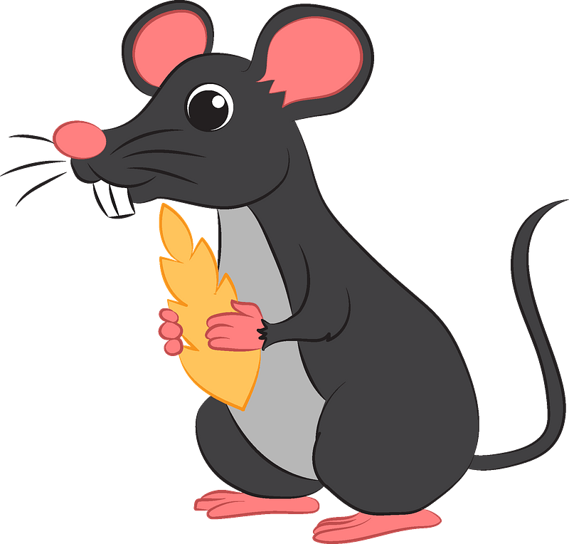

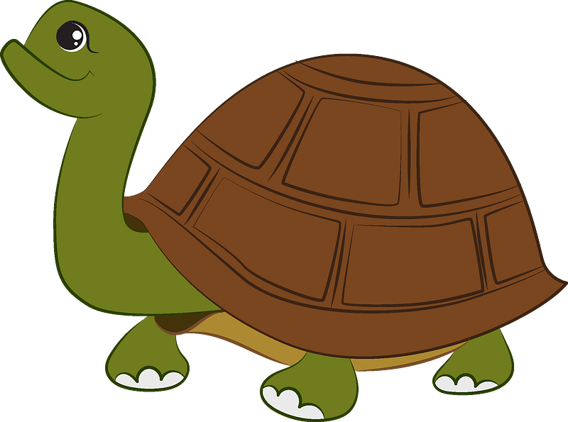

**1-m……..se**

**( bl – kn – ou )**

**4-r……..n**

**(bl - ee – ai)**

**3-t…..…**

**(kn – ie – cl)**

**2-….urtle**

**(f - b - t )**

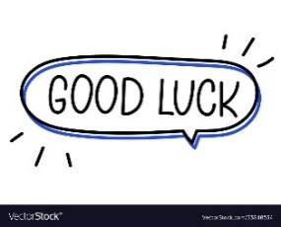

Your teacher:

Your teacher …..:…………………………….

|  |
| --- |
|  |
| 1 |

**I. CHOOSE**

|  |  |  |  |  |
| --- | --- | --- | --- | --- |
| **المملكة العربية السعودية** | |  | **اسم الطالب/ ......................................** | |
| **وزارة التعليم** | |
| **إدارة التعليم بمنطقة** | | **المادة : انجليزي** | |
| **مدرسة :** | | **الزمن :** | |
| **الصف : فصل ( )** | |
| **شفهي** | **تحريري** | | | **المجموع** |
| **10 /** | **10 /** | | | **20 /** |
| **اختبار الفترة الأولى للفصل الأول - للعام الدراسي 1447– لغة انجليزية –– للصف الثالث الابتدائي** | | | | |
| **اسم الطالب / هـ الفصل /** | | | | |

|  |
| --- |
| Funny Seal Cartoon Royalty Free SVG, Cliparts, Vectors, And Stock  Illustration. Image 13281545.**1 – What is that?**  **A** . **It's a seahorse.** **B** . **It's a seal.** |
| **2 – where do you live ?**  **A**. **I like some juice.** **B**. **I live in Riyadh .** |

**2. CHOOSE 🗸 OR 🗴**

|  |
| --- |
|  |
| 1.5 |

|  |  |  |
| --- | --- | --- |
| **1. He can swim.** | 🗸 | 🗴 |
| **This is a computer. .2** | 🗸 | 🗴 |
| **3. The whale is small.** | 🗸 | 🗴 |

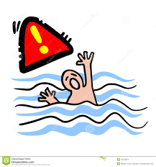





**3. DO AS SHOWN BETWEEN BRACKETS**

|  |
| --- |
|  |
| 1.5 |

|  |  |  |  |
| --- | --- | --- | --- |
| **\_\_\_\_\_\_\_\_\_\_\_\_\_\_\_\_\_\_\_** | | | **1– to - nice – you – meet . ( rearrange )** |
| **where** | **whose** | **who** | **2- \_\_\_\_\_\_ skirt is this? It's mine. ( choose )** |

**4. CHOOSE**

|  |
| --- |
|  |
| 1 |

|  |  |  |  |
| --- | --- | --- | --- |
| **your** | **my** | **his** | **1 – I am a teacher , \_\_\_\_\_ name is Nora .** |
| **has** | **as** | **is** | **. As fast \_\_\_ a dolphin .2** |

|  |
| --- |
|  |
| 3 |

**4. CHOOSE**

**starfish - cap - crab**

|  |  |  |
| --- | --- | --- |
| Starfish cartoon hi-res stock photography and images - Alamy | Cartoon Crab Stock Illustrations – 19,883 Cartoon Crab Stock Illustrations,  Vectors & Clipart - Dreamstime | C:\Users\Danae\Desktop\WC5\WC5_unit1\p5_Cap.jpg |
|  |  |  |



|  |
| --- |
|  |
| 2 |

Choose the correct letter: **( ai - ea - ow - ee - oa - ou ) )**

|  |  |  |  |
| --- | --- | --- | --- |
| C:\Users\PC\AppData\Local\Microsoft\Windows\Temporary Internet Files\Content.IE5\X799EHP1\Manga_meat[1].png | C:\Users\PC\AppData\Local\Microsoft\Windows\Temporary Internet Files\Content.IE5\X799EHP1\sheep[1].jpg | Cartoon Mouse Vector Art, Icons, and Graphics for Free Download | cartoon illustration cool cow 6655953 Vector Art at Vecteezy |
| **m\_ \_t** | **sh\_ \_ p** | **m\_ \_se** | **c\_ \_** |

\_\_\_\_\_\_\_\_\_\_\_\_\_\_\_\_\_\_\_\_\_\_\_\_\_\_\_\_\_\_\_\_\_\_\_\_\_\_\_\_\_\_\_\_\_\_\_\_\_\_\_\_\_\_\_\_\_\_\_\_\_\_\_\_\_\_\_\_\_\_\_\_\_\_\_\_\_\_\_\_\_\_\_\_\_\_\_\_\_\_\_\_\_\_\_\_\_\_\_\_\_\_\_\_\_\_\_\_\_\_\_\_\_\_\_\_\_\_\_\_\_\_\_\_\_\_\_\_\_\_\_\_\_\_\_\_\_\_\_\_\_\_\_\_\_\_\_\_\_\_\_\_\_\_\_\_\_\_\_\_\_\_\_\_\_\_\_\_\_\_\_\_\_\_\_\_\_\_\_\_\_\_\_\_\_\_\_\_\_\_\_\_\_\_\_\_\_\_\_\_\_\_\_\_\_\_\_\_\_\_\_\_\_\_\_\_\_\_\_\_\_\_\_\_\_\_\_

Controlled writing

**Good luck**

**III. DO AS SHOWN BETWEEN BRACKETS**

Kingdom of Saudi Arabia Third Elementary Grade

Ministry of Education First Term

**20**

3rd Elementary School . . Mid-Term Exam 1447 AH

**Name:** ………………………………………………………….………………. **Class : …………..**

|  |  |  |  |  |  |  |  |  |  |  |  |  |
| --- | --- | --- | --- | --- | --- | --- | --- | --- | --- | --- | --- | --- |
| 1. **General Questions:** | | | | | | | | | | | | |
| 1. **Choose the correct answer:** | | | | | | | | | | | | |
| 1- **What is your name?** | | | | | | | | | | | | |
| a- My name is Ali. | | | | | | b- It is a dolphin. | | | | | | |
| 2- **How old are you?** | | | | | | | | | | | | |
| a- I am Rana. | | | | | | b- I am 9 years old. | | | | | | |
| 8 Number PNG Images Transparent Background | PNG Play3- **Which animal has 8 legs?** | | | | | | | | | | | | |
| a- It is a cat. | | | | | | b- It is an octopus. | | | | | | |
| Clipart Of Sharks4- **What is this?** | | | | | | | | | | | | |
| a- It is a dog. | | | | | | b- It is a shark. | | | | | | |
| 1. **Controlled Writing:** | | | | | | | | | | | | |
| 1. **Rearrange the words to form a sentence:** | | | | | | | | | | | | |
| to | | | You | | | meet | | | | Nice | | |
|  | | | | | | | | | | | | |
| 1. **Reading short sentence:** | | | | | | | | | | | | |
| 1. **Read then write the correct number:** | | | | | | | | | | | | |
| **Hello. My name is**  **Sara**  **.**    **1**  **-**    **This is my father.**    **2**  **-**    **This is my**  **sister**  **.**    **3**  **-**    **This is my**  **mother**  **.**    **4**  **-**      **This is my brother.** | | | | | | | | | | | | |
| 1. **Grammar:** | | | | | | | | | | | | |
| 1. **Choose the correct answer:** | | | | | | | | | | | | |
| 1. They ……… my friends. | | | | | | | | | | | | |
| 1. Am | | | | 1. is | | | | | 1. are | | | |
| 1. This hat is ………… | | | | | | | | | | | | |
| 1. I | | | | 1. my | | | | | 1. mine | | | |
| 1. Ali is ………… **than** Ahmed. | | | | | | | | | | | | |
| 1. Tall | | | | 1. tall**er** | | | | | 1. tall**est** | | | |
| 1. **Vocabulary:** | | | | | | | | | | | | |
| 1. Trendy sandals icon, cartoon style 14282289 Vector Art at VecteezyPremium AI Image | Clip art of crab**Choose the correct answer:** | | | | | | | | | | | | |
| Free Cute Starfish Cliparts, Download Free Cute Starfish Cliparts png ... | |  | | | | |  | | | | Clipart bike racing bicycle, Clipart bike racing bicycle Transparent ... | |
| 1. starfish 2. book | | 1. sandals 2. coat | | | | | 1. hat 2. crab | | | | 1. computer 2. bicycle | |
| 1. **Orthography:** | | | | | | | | | | | | |
| 1. Days of the week | Baamboozle - Baamboozle | The Most Fun Classroom Games!**Choose the correct missing letters:** | | | | | | | | | | | | |
| **pl \_\_ \_\_** | | Cheese png graphic clipart design 19614416 PNG  **ch \_\_ \_\_ se** | | | | | Free Free Cow, Download Free Free Cow png images, Free ClipArts on ...  **c \_\_ \_\_** | | | | Image result for boat clipart  **b \_\_ \_\_ t** | |
| **ay** | **ow** | **oo** | | | **ee** | | **ow** | **ie** | | | **ay** | **oa** |

**BEST OF LUCK ☺**

**Ms. Tahani Al-Ghamdi**

### **اختبار** فتري – الصف الثالث /



|  |  |  |  |  |
| --- | --- | --- | --- | --- |
| **الاسم** | **الفصل** | **شفهي** | **تحريري** | **المجموع** |
|  | **/** | **10 /** | **10 /** | **20 /** |

First Period Exam

|  |  |  |  |  |  |  |  |  |  |  |  |  |
| --- | --- | --- | --- | --- | --- | --- | --- | --- | --- | --- | --- | --- |
| |  | | --- | |  | | **1** |   **1. CHOOSE**   |  |  | | --- | --- | | 1. **What is your name ?** | | | 1. **I am 13 .** | 1. **My name is Ali .** | |      |  |  | | --- | --- | | 1. **What is that?** | | | 1. **It's a seal.** | 1. **It's a whale.** | | |
| |  | | --- | |  | | **1.5** |   222  **2. CHOOSE 🗸 OR 🗴**   |  |  |  | | --- | --- | --- | | **This is a computer.** | **The whale is small.** | **This is a dolphin.** | |  |  |  | | **🗸 🗴** | **🗸 🗴** | **🗸 🗴** | |
| |  | | --- | |  | | **1** |   **3. DO AS SHOWN BETWEEN BRACKETS**     |  |  |  |  | | --- | --- | --- | --- | | **where** | **whose** | **who** | **1- \_\_\_\_\_\_ skirt is this? It's mine . ( Choose )** | | **slow** | **scary** | **fast** | **2. Seahorse is \_\_\_\_\_\_\_\_\_\_\_ . ( choose)** | |
| |  |  |  |  | | --- | --- | --- | --- | | **your** | **my** | **his** | **1 – I am a teacher , \_\_\_\_\_ name is Nora .** | | **have** | **has** | **is** | **2. I \_\_\_\_\_ a box** |   **4. CHOOSE**   |  | | --- | |  | | **1** | |
| **5. CHOOSE**   |  | | --- | |  | | **3** |        |  |  |  |  |  |  | | --- | --- | --- | --- | --- | --- | |  |  |  |  |  |  | | **sandals** | **Thobe** | **T-shirts** | **starfish** | **fish** | **Seahorse** | | **jacket** | **cap** | **Hat** | **cat** | **crab** | **whale** | |
| |  |  |  |  |  | | --- | --- | --- | --- | --- | | **sh\_ \_ p** | **m\_ \_t** | **Pl\_ \_** | **c\_ \_** | **m\_ \_se** | | **ea** | **ea** | **ay** | **ow** | **ow** | | **ee** | **ee** | **ea** | **ou** | **ou** |   **6. CHOOSE THE CORRECT LTTER**   |  | | --- | |  | | **2.5** | |
| **TEACHER :** |



English Language

elementary Grade …..

1st period Exam

…………….\20

Kingdom of Saudi Arabia

Ministry of Education

………………… School

Student's Name : class:

|  |
| --- |
|  |
| 5 |

**A-Choose the correct answer.**

|  |  |  |  |  |
| --- | --- | --- | --- | --- |
| her | my | his | This is our little brother. ……..name is Ahmad. | 1 |
| she | I | mine | Whose shoes are these? - They're ………….. | 2 |
| has | are | have | He …………. a new bag. | 3 |
| cutest | cuter | cute | A dolphin is ………………………... | 4 |
| slowest | slower | slow | A snail is the …………………… | 5 |

|  |
| --- |
|  |
| 2 |

[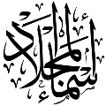](https://t.me/Asmaworld)

**B- reorder.**

1- cook \ you \ Can \ ?

………………………………………………………………………………………….………

2- have \ Thay \ a car.

……………………………………………….………………………………………………….

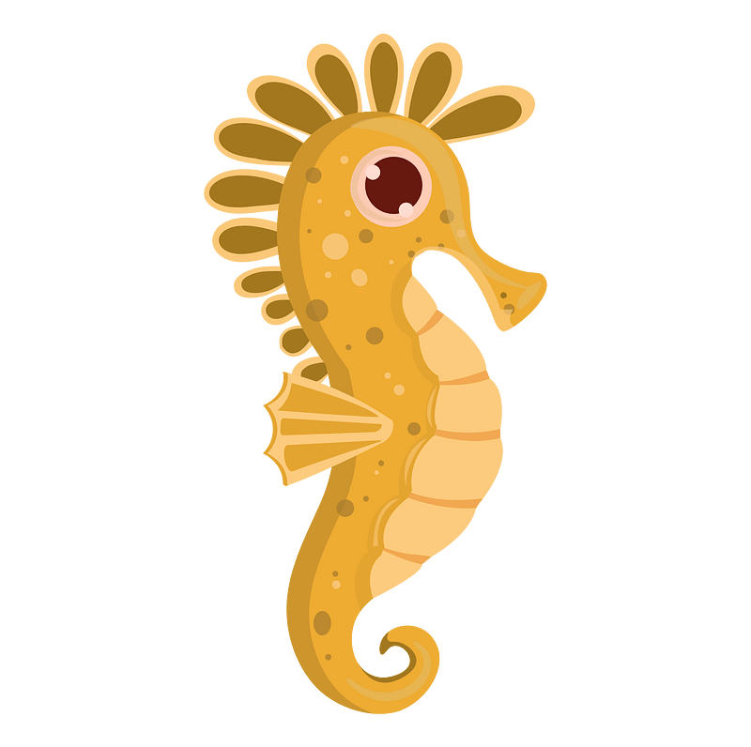**C-Answer the question.**

1-what's that ?

|  |
| --- |
|  |
| 3 |

It's a ( seahorse - fish - sharks ).

2-What are those?

Those are ( crocodile – seagull - baby seals).

3-What‘s that?

it's a ( squid – crab – Jellyfish ).

|  |
| --- |
|  |
| 2 |

**D.Match**

|  |  |  |  |
| --- | --- | --- | --- |
| Nice to meet you, too . |  | What's your name? | 1 |
| My name is Ali. |  | Nice to meet you . | 2 |

|  |
| --- |
|  |
| 4 |

**E. Write the correct words under each picture**

Sleep goat rice turtle



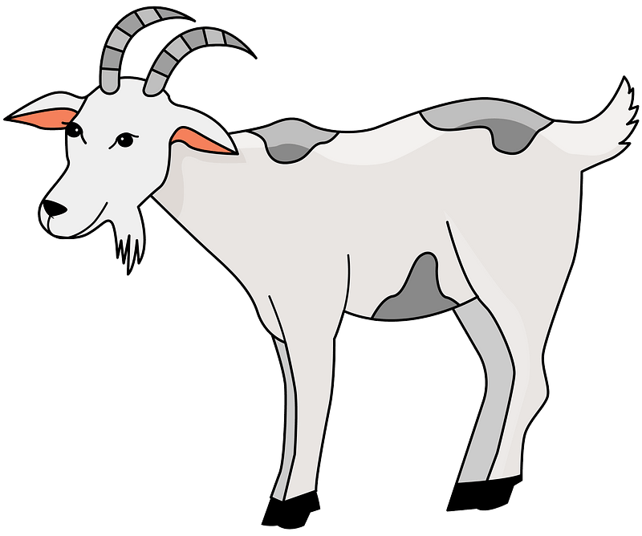

……………………….ر

……………………….ر

……………………….ر

……………………….ر

**F.Complete the missing letters.**

ee ay ou oa

|  |
| --- |
|  |
| 4 |



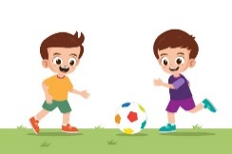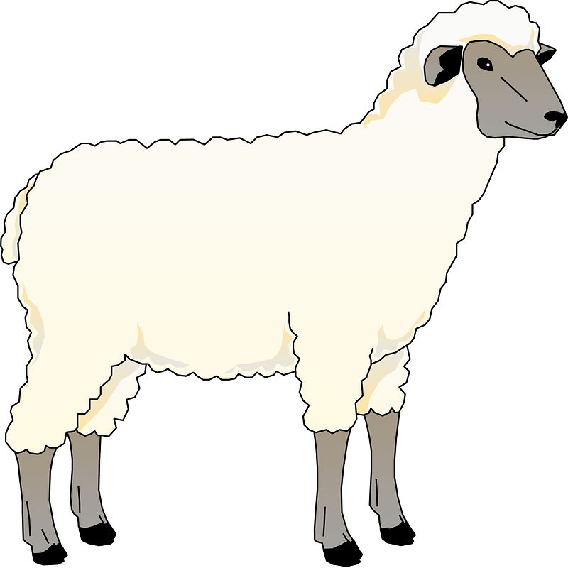



H…….se

Pl………

Sh……..p

C…….t

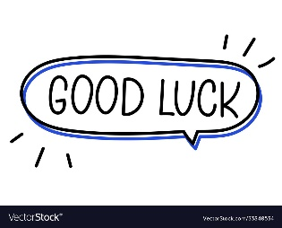

Your teacher: