**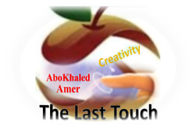****المملكة العربية السعودية**

**Kingdom of Saudi Arabia**

**Ministry of Education**

**------- Educational Directorate**

**------- Future Educational Schools**

**2nd Grade High School 2025**

**3rd Term – Final Exam**

**وزارة التعليم**

**الإدارة العامة للتعليم بن**

**مدارس م ن التعليمية**

**الصف الثاني الثانوي**

**الاختبار النهائي للفصل الدراسي الثالث 1446**

|  |  |  |  |  |  |  |  |
| --- | --- | --- | --- | --- | --- | --- | --- |
| **Total**  **written** | **5**  **Vocabulary** | **4**  **Grammar** | **3**  **Free Composition** | **2**  **Guided Composition** | | **1 Comprehension** | **Q. NO.** |
|  |  |  |  |  | |  | **Mark Given** |
| **30** | **6** | **6** | **6** | **6** | | **6** | **Mark** |
| **6** | | | **Reviser** | |  | | **Corrector** |
|  | |

**زمن الاختبار: 3 ساعات**

**اسم الطالب: ------------------------------------ رقم الجلوس: ------------- الصف الثاني الثانوي**

**1)** **Comprehension**

**Read the following passage then answer the questions**

**Water**

**Water is life and the lack of water means death. Any living thing cannot go on living without water. Plants need water to grow. Animals need water to drink. People need water to drink and to use in cleaning, cooking, farming and irrigating their lands. We can get water from rivers and lakes. But the main source of water is the rain.  In the desert, people dig deep wells to get water. For keeping water from being wasted, people build dams for storing water in reservoirs that form behind the dams. Water is stored in water towers that supply all the houses with pure water. Our government has set up desalination plants for treating seawater and removing the salt. Thanks be to God, the Merciful, who has created water for us. We don't need to pay for it as it is neither sold nor bought.**

***A)* Answer the following questions*:*  
1. What does the lack of water mean?-------------------------------------------------------.**

**2. Why do people need water? -----------------------------------------------------------.**

**3. What is the main source of water? ----------------------------------------------------------.**

**4. Who has created water for us?  --------------------------------------------------------------.**

***B)* Put ( √ ) or ( X ):  
5. Any living thing can go on living without water. ( )**

**6 Plants and animals need water to grow and drink. ( )**

**7. In the mountains, people dig deep wells to get water. ( )**

**8. We don't need to pay for water. ( )  
*C)* Complete*:*  
9. Our government has set up desalination plants for --------------------------------.  
10. We can get water from -----------------------------------.**

**D) Choose the correct answer:**

**11. Farmers need water for farming and irrigating their (**houses – lands – rooms**)**

**12. To restore water, people build (**dams – schools – farms**)**

**2) Guided Composition**

**6**

**You read a book about some life threating situations that man can hardly survive. Write about a situation you passed or heard about.**

**(**Write not less than 150 word **(**

**Guiding words:**

(fire – smoke – burning – collapsed – call fire department – fire engines – rescue …)

-------------------------------------------------------

--------------------------------------------------------------------------------------------------------------------------------------------------------------------------------------------------------------------------------------------------------------------------------------------------------------------------------------------------------------------------------------------------------------------------------------------------------------------------------------------------------------------------------------------------------------------------------------------------------------------------------------------------------------------------------------------------------------------------------------------------------------------------------------------------------------------------------------------------------------------------------------------------------------------------------------------------------------------------------------------------------------------------------------------------------------------------------------------------------------------------------------------------------------------------------------------------------------------------------------------------------------------------------------------------------------------------------------

**3) Free Composition**

**6**

**Choose one topic from the following to write about.**

**1. Imagine that you are going to buy a new house for your new family. Write a short paragraph describing your new home.**

**2. Sports are spread around the world. All nations have their favorite sport. Write about your favorite sport.**

**(**Write not less than 100 word**).**

-------------------------------------------------------

--------------------------------------------------------------------------------------------------------------------------------------------------------------------------------------------------------------------------------------------------------------------------------------------------------------------------------------------------------------------------------------------------------------------------------------------------------------------------------------------------------------------------------------------------------------------------------------------------------------------------------------------------------------------------------------------------------------------------------------------------------------------------------------------------------------------------------------------------------------------------------------------------------------------------------------------------------------------------------------------------------------------------------------------------------------------------------------------------------------------------------------------------------------------------------------------------------------------------------------------------------------------------------------------------------------------------------------

**4) Grammar**

**6**

**A: Choose the correct answer:**

**1. You are not well (too – so – enough – just) to work today.**

**2. (Watching – Watched – Watches – Watch) sports is my favorite hobby.**

**3. My grandfather's stories about his childhood are (amuse – amusing – amused).**

**4. I take off my shoes. I (take them off – take off them – take it off – take off it).**

**5. The tiger will be (releasing – releases – release – released) into the wild.**

**6. If they had slept early, they would have (be – been – bees – are) on time.**

**Do as shown between brackets:**

**1. If Hassan (visit) me, I would have told him the whole story. (**Correct**)**

-------------------------------------------------------------------------------------------------.

**2. You should clean the bird's cage weekly. (**Make Passive**)**

-------------------------------------------------------------------------------------------------.

**3. I never tire of chocolate. (**Decide if it is Separable or Nonseparable**)**

-------------------------------------------------------------------------------------------------.

**4. Hassan was (disgust) by the news report. (**Correct**)**

-------------------------------------------------------------------------------------------------.

**5. Nora is the (beautiful) girl I have ever seen. (**Correct the adjective**)**

-------------------------------------------------------------------------------------------------.

**6. Ali is wearing a ( white , beautiful , linen , small ) jacket. (**Reorder the adj.)

-------------------------------------------------------------------------------------------------.

**5) vocabulary:**

**6**

**A- Match the words with the pictures:**

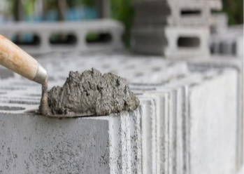**parrot – groundhog – mortar - chocolate – torch – lifeboat**

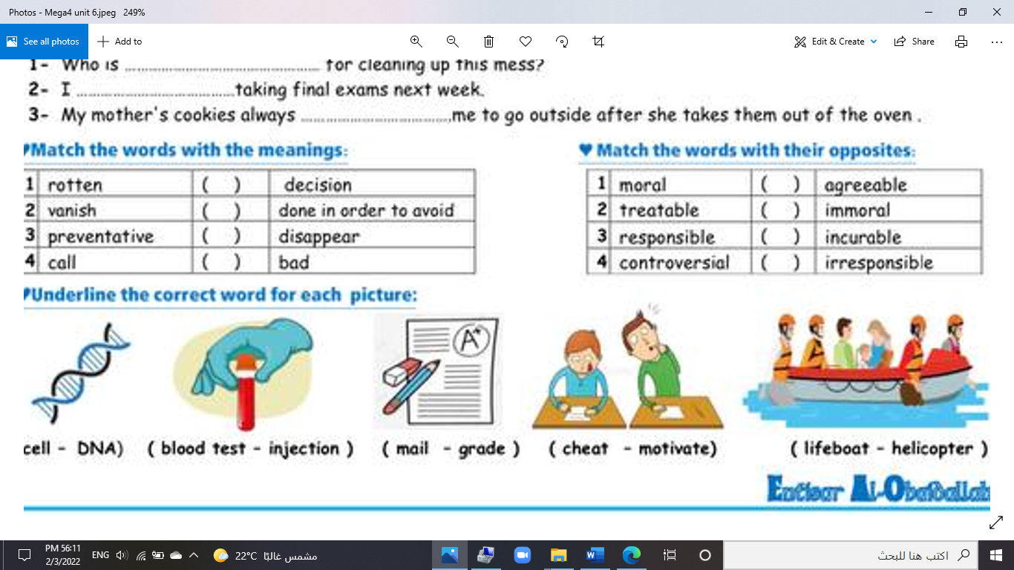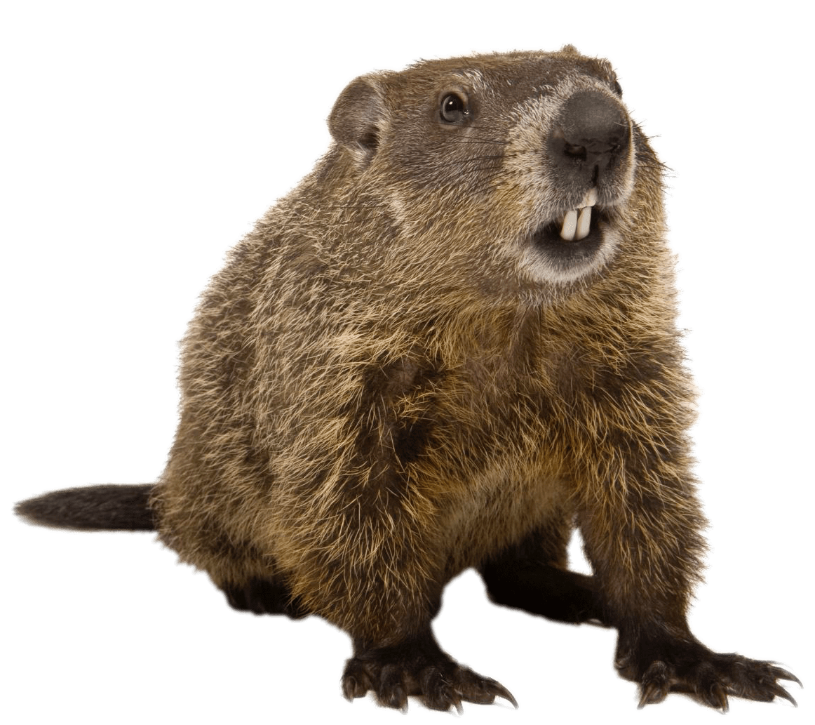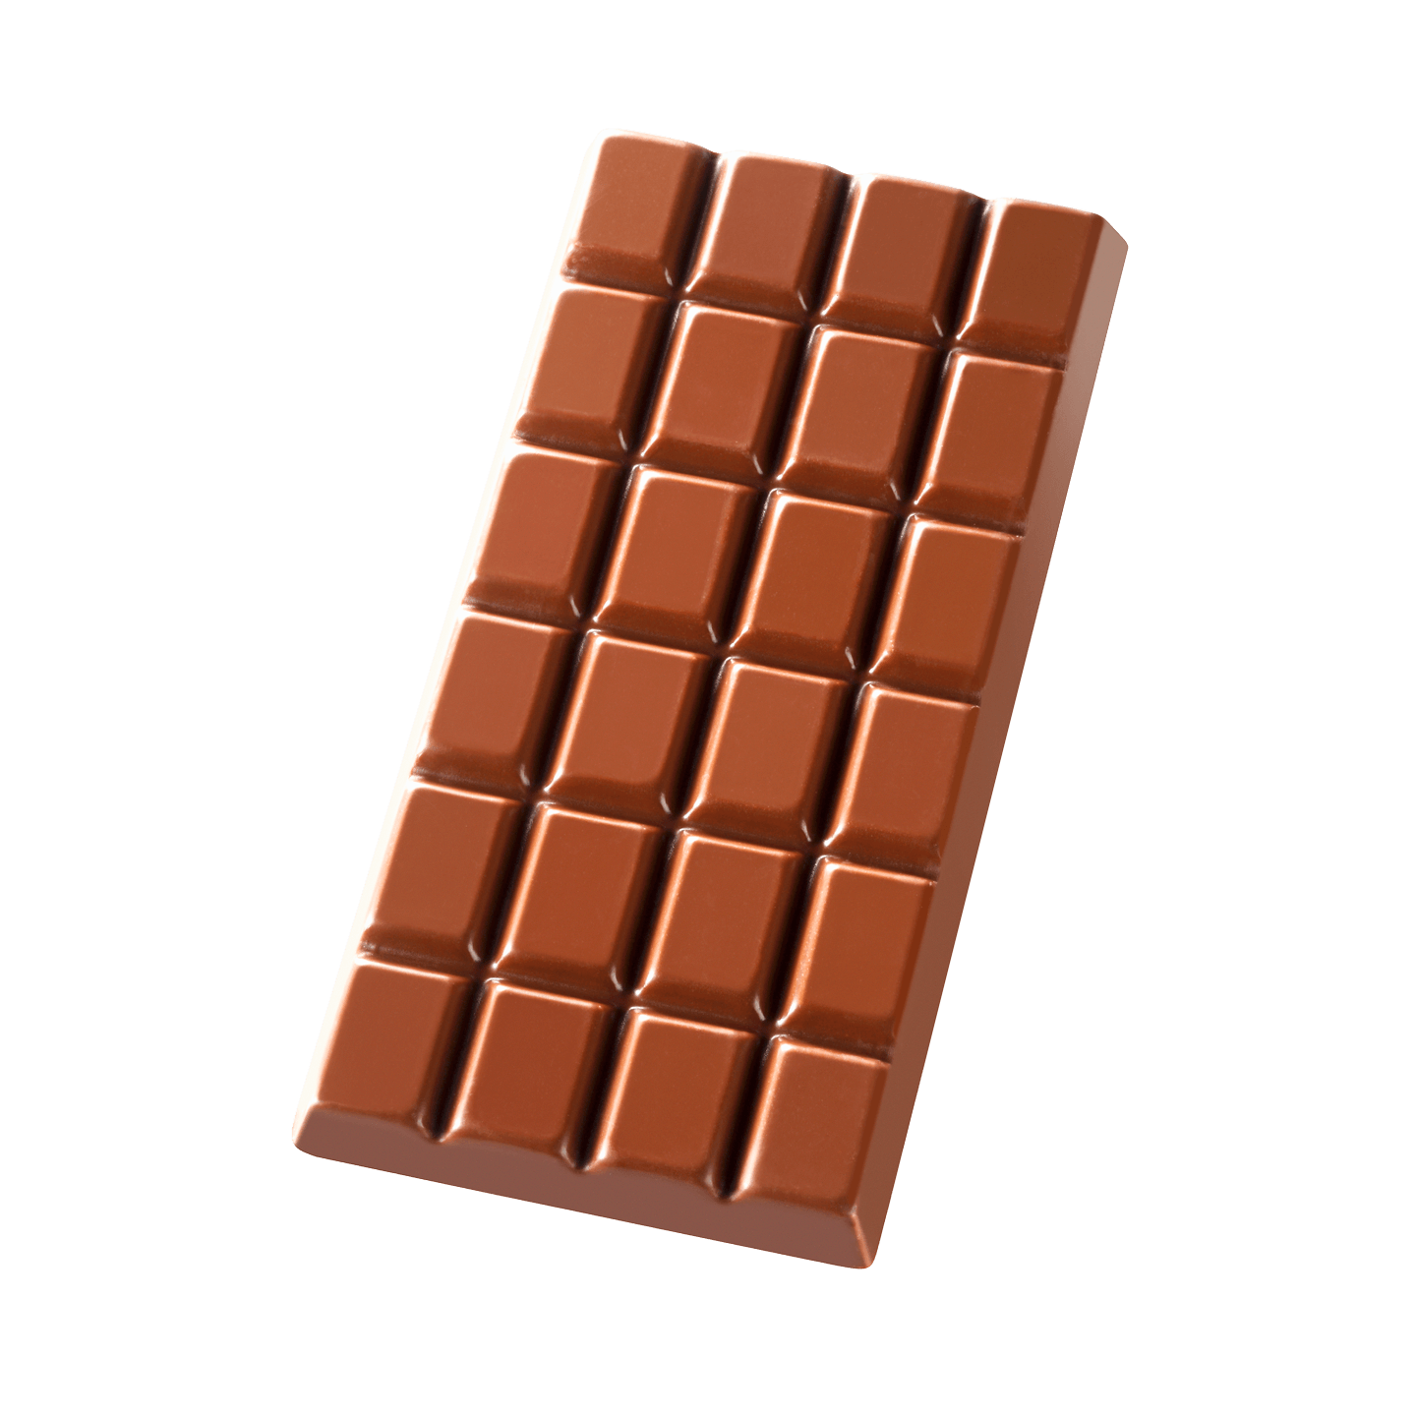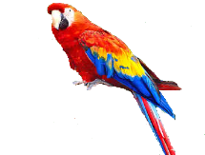

**--------- ------- -------- --------- -------- -----------**

**A) Match to form new words or expressions:**

**1. killer ---- a. very quickly**

**2. genuine ---- b. great**

**3. alert ---- c. real**

**4. bond ---- d. aware**

**5. call ---- e. connection**

**6. in no time ---- f. decision**

**End of Questions**

**Best of Luck** [**https://t.me/mnhaji2t**](https://t.me/mnhaji2t)

******المملكة العربية السعودية**

**Kingdom of Saudi Arabia**

**Ministry of Education**

**------- Educational Directorate**

**------- Future Educational Schools**

**2nd Grade High School 2025**

**3rd Term – Final Exam**

**وزارة التعليم**

**الإدارة العامة للتعليم بن**

**مدارس م ن التعليمية**

**الصف الثاني الثانوي**

**الاختبار النهائي للفصل الدراسي الثالث 1446**

|  |  |  |  |  |  |  |  |
| --- | --- | --- | --- | --- | --- | --- | --- |
| **Total**  **written** | **5**  **Vocabulary** | **4**  **Grammar** | **3**  **Free Composition** | **2**  **Guided Composition** | | **1 Comprehension** | **Q. NO.** |
|  |  |  |  |  | |  | **Mark Given** |
| **30** | **6** | **6** | **6** | **6** | | **6** | **Mark** |
| **6** | | | **Reviser** | |  | | **Corrector** |
|  | |

**زمن الاختبار: 3 ساعات**

**اسم الطالب: ------------------------------------ رقم الجلوس: ------------- الصف الثاني الثانوي**

**1)** **Comprehension**

**Read the following passage then answer the questions**

**Water**

**Water is life and the lack of water means death. Any living thing cannot go on living without water. Plants need water to grow. Animals need water to drink. People need water to drink and to use in cleaning, cooking, farming and irrigating their lands. We can get water from rivers and lakes. But the main source of water is the rain.  In the desert, people dig deep wells to get water. For keeping water from being wasted, people build dams for storing water in reservoirs that form behind the dams. Water is stored in water towers that supply all the houses with pure water. Our government has set up desalination plants for treating seawater and removing the salt. Thanks be to God, the Merciful, who has created water for us. We don't need to pay for it as it is neither sold nor bought.**

***A)* Answer the following questions*:*  
1. What does the lack of water mean?-------------------------------------------------------.**

**2. Why do people need water? -----------------------------------------------------------.**

**3. What is the main source of water? ----------------------------------------------------------.**

**4. Who has created water for us?  --------------------------------------------------------------.**

***B)* Put ( √ ) or ( X ):  
5. Any living thing can go on living without water. ( )**

**6 Plants and animals need water to grow and drink. ( )**

**7. In the mountains, people dig deep wells to get water. ( )**

**8. We don't need to pay for water. ( )  
*C)* Complete*:*  
9. Our government has set up desalination plants for --------------------------------.  
10. We can get water from -----------------------------------.**

**D) Choose the correct answer:**

**11. Farmers need water for farming and irrigating their (**houses – lands – rooms**)**

**12. To restore water, people build (**dams – schools – farms**)**

**2) Guided Composition**

**6**

**You read a book about some life threating situations that man can hardly survive. Write about a situation you passed or heard about.**

**(**Write not less than 150 word **(**

**Guiding words:**

(fire – smoke – burning – collapsed – call fire department – fire engines – rescue …)

-------------------------------------------------------

--------------------------------------------------------------------------------------------------------------------------------------------------------------------------------------------------------------------------------------------------------------------------------------------------------------------------------------------------------------------------------------------------------------------------------------------------------------------------------------------------------------------------------------------------------------------------------------------------------------------------------------------------------------------------------------------------------------------------------------------------------------------------------------------------------------------------------------------------------------------------------------------------------------------------------------------------------------------------------------------------------------------------------------------------------------------------------------------------------------------------------------------------------------------------------------------------------------------------------------------------------------------------------------------------------------------------------------

**3) Free Composition**

**6**

**Choose one topic from the following to write about.**

**1. Imagine that you are going to buy a new house for your new family. Write a short paragraph describing your new home.**

**2. Sports are spread around the world. All nations have their favorite sport. Write about your favorite sport.**

**(**Write not less than 100 word**).**

-------------------------------------------------------

--------------------------------------------------------------------------------------------------------------------------------------------------------------------------------------------------------------------------------------------------------------------------------------------------------------------------------------------------------------------------------------------------------------------------------------------------------------------------------------------------------------------------------------------------------------------------------------------------------------------------------------------------------------------------------------------------------------------------------------------------------------------------------------------------------------------------------------------------------------------------------------------------------------------------------------------------------------------------------------------------------------------------------------------------------------------------------------------------------------------------------------------------------------------------------------------------------------------------------------------------------------------------------------------------------------------------------------

**4) Grammar**

**6**

**A: Choose the correct answer:**

**1. You are not well (too – so – enough – just) to work today.**

**2. (Watching – Watched – Watches – Watch) sports is my favorite hobby.**

**3. My grandfather's stories about his childhood are (amuse – amusing – amused).**

**4. I take off my shoes. I (take them off – take off them – take it off – take off it).**

**5. The tiger will be (releasing – releases – release – released) into the wild.**

**6. If they had slept early, they would have (be – been – bees – are) on time.**

**Do as shown between brackets:**

**1. If Hassan (visit) me, I would have told him the whole story. (**Correct**)**

-------------------------------------------------------------------------------------------------.

**2. You should clean the bird's cage weekly. (**Make Passive**)**

-------------------------------------------------------------------------------------------------.

**3. I never tire of chocolate. (**Decide if it is Separable or Nonseparable**)**

-------------------------------------------------------------------------------------------------.

**4. Hassan was (disgust) by the news report. (**Correct**)**

-------------------------------------------------------------------------------------------------.

**5. Nora is the (beautiful) girl I have ever seen. (**Correct the adjective**)**

-------------------------------------------------------------------------------------------------.

**6. Ali is wearing a ( white , beautiful , linen , small ) jacket. (**Reorder the adj.)

-------------------------------------------------------------------------------------------------.

**5) vocabulary:**

**6**

**A- Match the words with the pictures:**

**parrot – groundhog – mortar - chocolate – torch – lifeboat**

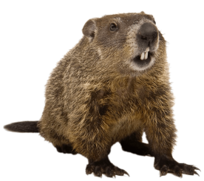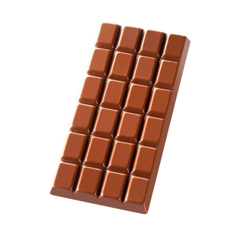

**--------- ------- -------- --------- -------- -----------**

**A) Match to form new words or expressions:**

**1. killer ---- a. very quickly**

**2. genuine ---- b. great**

**3. alert ---- c. real**

**4. bond ---- d. aware**

**5. call ---- e. connection**

**6. in no time ---- f. decision**

**End of Questions**

**Best of Luck** [**https://t.me/aikhtibart**](https://t.me/aikhtibart)

******المملكة العربية السعودية**

**Kingdom of Saudi Arabia**

**Ministry of Education**

**------- Educational Directorate**

**------- Future Educational Schools**

**2nd Grade High School 2025**

**3rd Term – Final Exam**

**وزارة التعليم**

**الإدارة العامة للتعليم بن**

**مدارس م ن التعليمية**

**الصف الثاني الثانوي**

**الاختبار النهائي للفصل الدراسي الثالث 1446**

|  |  |  |  |  |  |  |  |
| --- | --- | --- | --- | --- | --- | --- | --- |
| **Total**  **written** | **5**  **Vocabulary** | **4**  **Grammar** | **3**  **Free Composition** | **2**  **Guided Composition** | | **1 Comprehension** | **Q. NO.** |
|  |  |  |  |  | |  | **Mark Given** |
| **30** | **6** | **6** | **6** | **6** | | **6** | **Mark** |
| **6** | | | **Reviser** | |  | | **Corrector** |
|  | |

**زمن الاختبار: 3 ساعات**

**اسم الطالب: ------------------------------------ رقم الجلوس: ------------- الصف الثاني الثانوي**

**1)** **Comprehension**

**Read the following passage then answer the questions**

**One night, Pilar was in a deep sleep when she was woken by her cat Inti. Inti was meowing wildly outside Pilar's bedroom and throwing himself against the closed bedroom door. When Pilar opened her eyes, she saw that her bedroom was filling with smoke. As she escaped her house with Inti in her arms, she saw that a fire was blazing in her kitchen. Pilar could easily have lost consciousness from breathing in the smoke, but Inti wouldn't let that happen. Even though Inti could have escaped the house through a cat door, he wouldn't leave Pilar. A fireman at the scene said, " Without question, that cat is responsible for saving his owner's life.  He should be honored as a hero."**

***A)* Answer the following questions*:*  
1. How could Pilar have lost consciousness?-----------------------------------------------------.**

**2. When was he in a deep sleep? ----------------------------------------------------------.**

**3. Where was Pilar sleeping? ----------------------------------------------------------.**

**4. Who put out the fire?  -----------------------------------------------------------.**

***B)* Put ( √ ) or ( X ):  
5. Inti was meowing wildly outside Pilar's bedroom.  ( )**

**6. Even though Inti could have escaped the house, he wouldn't leave Pilar. ( )**

**7. Pilar left Inti inside the house and escaped. ( )**

**8. The cat is responsible for saving his owner's life. ( )  
*C)* Complete*:*  
9. Pilar saw that her bedroom was filling with --------------------------------.  
10. The cat should be honored as a -----------------------------------.**

**D) Choose the correct answer:**

**11. The best title for the paragraph is: (**Animal Hero – Firemen – The Kitchen**)**

**12. The cat could have escaped the house through a (**window – balcony – cat door**).**

**2) Guided Composition**

**6**

**Studying online and studying face to face are two ways of learning**

**Write an essay about the two kinds, using the following guide words:**

**Guiding words:**

**inside class – contact – expression – active – go anywhere – computer – internet – limit – time – age (**Write not less than 150 word **(**

-------------------------------------------------------

--------------------------------------------------------------------------------------------------------------------------------------------------------------------------------------------------------------------------------------------------------------------------------------------------------------------------------------------------------------------------------------------------------------------------------------------------------------------------------------------------------------------------------------------------------------------------------------------------------------------------------------------------------------------------------------------------------------------------------------------------------------------------------------------------------------------------------------------------------------------------------------------------------------------------------------------------------------------------------------------------------------------------------------------------------------------------------------------------------------------------------------------------------------------------------------------------------------------------------------------------------------------------------------------------------------------------------------

**3) Free Composition**

**6**

**Choose one topic from the following to write about.**

**1. Imagine that you are invited to a famous restaurant in your city.**

**Writ a paragraph about "Your Favorite Dish".**

**2. Write a paragraph about "Your Dream House" in which you describe which kind of you want to live in, where, who live with, …**

**(**Write not less than 100 word**).**

-------------------------------------------------------

--------------------------------------------------------------------------------------------------------------------------------------------------------------------------------------------------------------------------------------------------------------------------------------------------------------------------------------------------------------------------------------------------------------------------------------------------------------------------------------------------------------------------------------------------------------------------------------------------------------------------------------------------------------------------------------------------------------------------------------------------------------------------------------------------------------------------------------------------------------------------------------------------------------------------------------------------------------------------------------------------------------------------------------------------------------------------------------------------------------------------------------------------------------------------------------------------------------------------------------------------------------------------------------------------------------------------------------

**4) Grammar**

**6**

**A: Choose the correct answer:**

**1. If we (played – had played – play – playing) well, we would have won.**

**2. My car (has – is – will – does) be repaired tomorrow.**

**3. I turn off the TV. I (turn off it – turn it off – it turn off – off it turn).**

**4. Nora is (interest – interesting – interests – interested) in watching TV.**

**5. (Not Warming – Not warm – Not warms – Not warmed) up is bad.**

**6. She is not (enough tall – tall enough – tall too – tall so) to reach the shelf.**

**Do as shown between brackets:**

**1. I bought (yellow – big – Japanese – expensive) car. (**Reorder the adjectives)

-------------------------------------------------------------------------------------------------.

**2. Ali is the tallest boy I (see). (Correct the adjective)**

-------------------------------------------------------------------------------------------------.

**3. The book was very (bore). I didn’t enjoy it. (**Correct**)**

-------------------------------------------------------------------------------------------------.

**4. The chef cut the steak up into small pieces. (Decide if it is** Separable or Nonseparable**)**

-------------------------------------------------------------------------------------------------.

**5. Ali can help the boys. (**Make Passive**)**

-------------------------------------------------------------------------------------------------.

**6. If she had had time, she (visit) her friends. (**Correct**)**

-------------------------------------------------------------------------------------------------.

**5) vocabulary:**

**6**

**A- Match the words with the pictures:**

**medal – popscile – gorilla – dilemma – centipede – canyon**

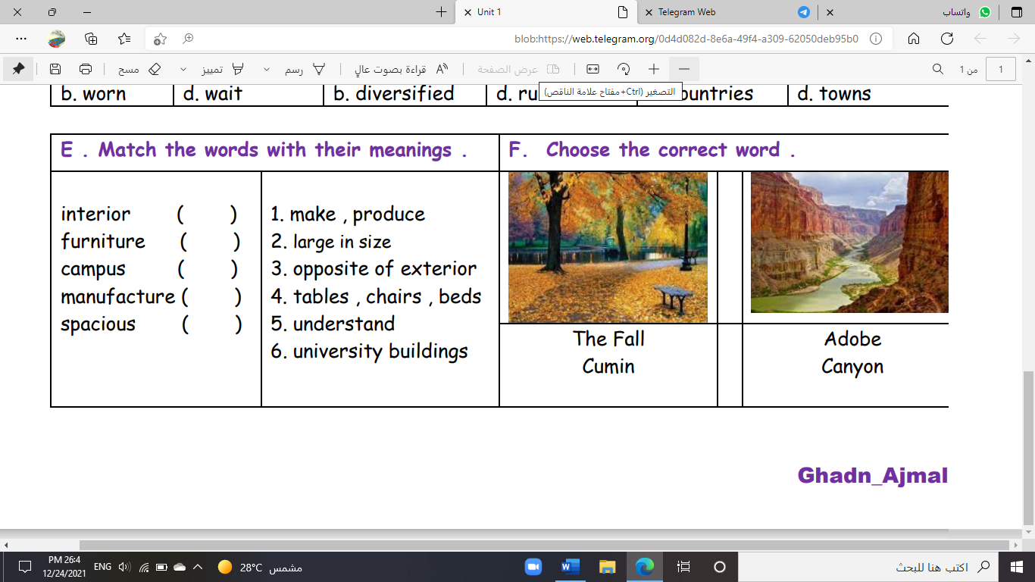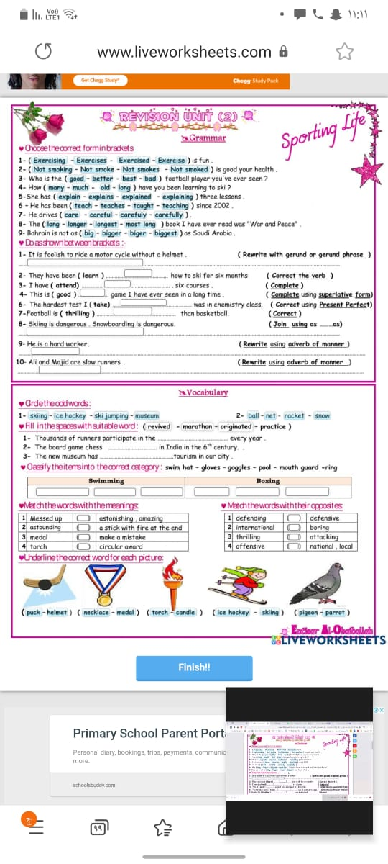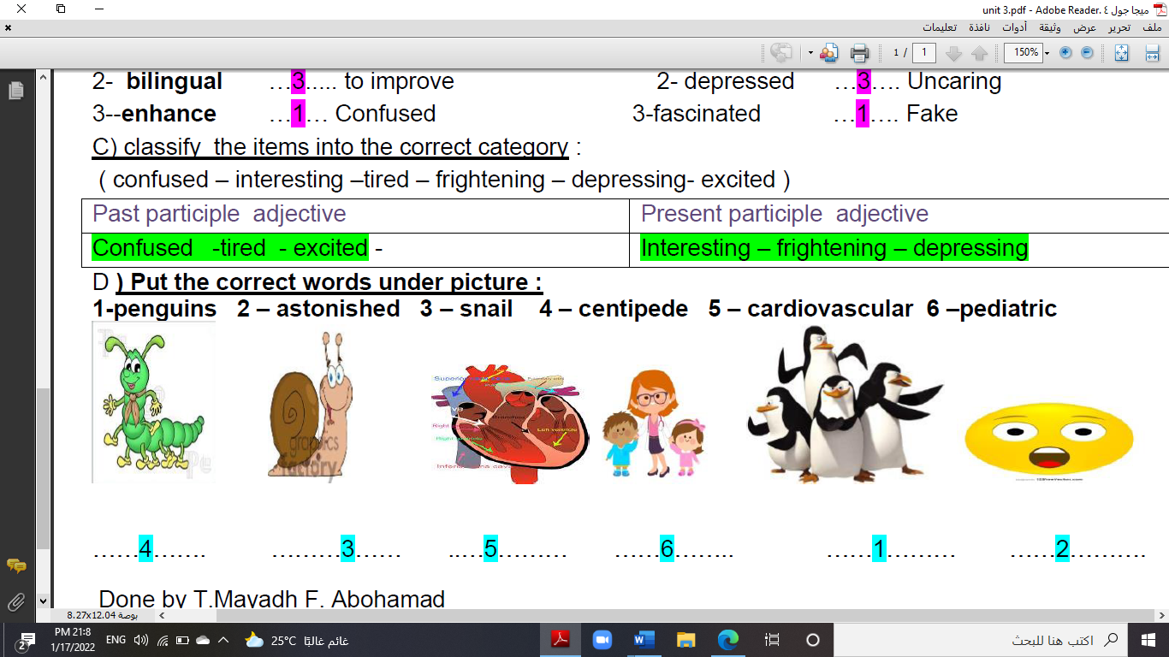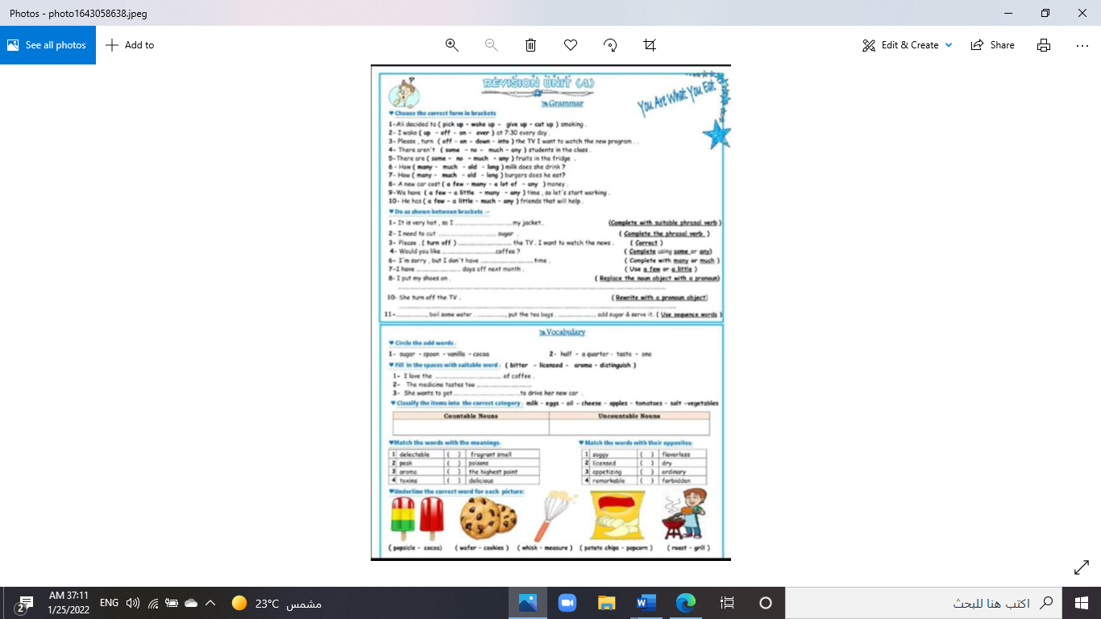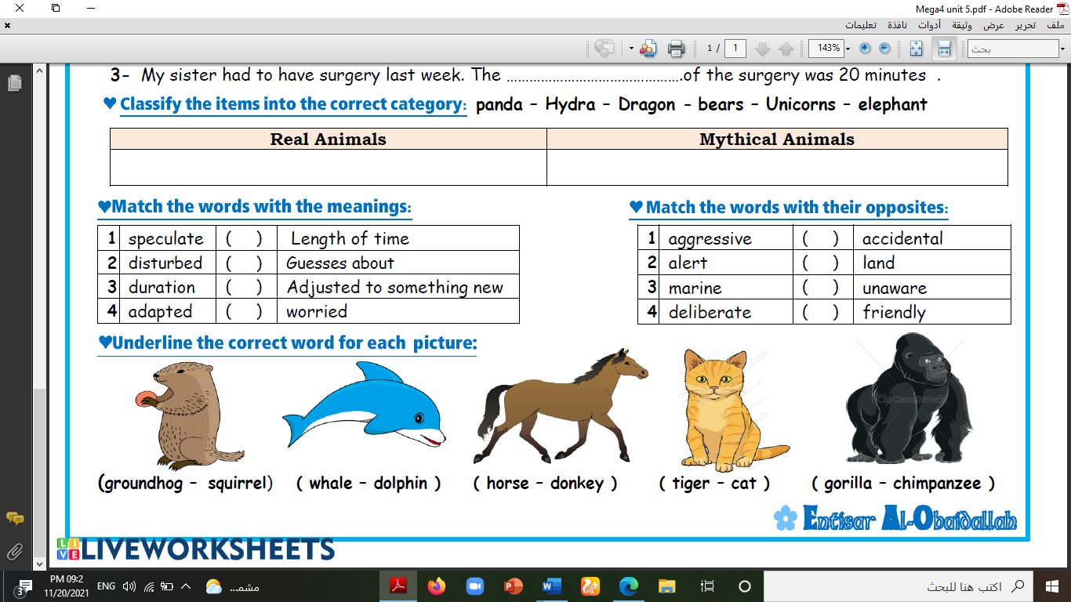

**--------- ------- -------- --------- -------- -----------**

**A) Match to form new words or expressions:**

**1. rotten ---- a. very good**

**2. pampered ---- b. bad**

**3. Hang in there ---- c. indulged**

**4. quite the ---- d. someone who sells something**

**5. vendor ---- e. annoying or bothering**

**6. getting to ---- f. Don't give up**

**End of Questions**

**Best of Luck** [**www.mnhaji.com/?p=10006**](https://www.mnhaji.com/?p=10006)

**Kingdom of Saudi Arabia 1446 . H**

**Ministry of Education**

**The First session- The third Term**

**……………… Secondary School**

**Time : 3 hours**

**Final Exam of English for Second Grade Secondary**

**أسم الطالبة /.................................................................... الصف/............................... رقم الجلوس /............................**

**انتظام ( ) انتساب ( ) التاريخ / / 1446 هـ**

ختم المدرسة

عزيزتي الطالبة؛

تأكدي أن عدد الأوراق ( 3 )

بدون الغلاف

|  |  |  |  |  |
| --- | --- | --- | --- | --- |
| **Items** | **Marks in numbers** | **The deserved**  **mark** | **Teacher's Sign** | **Reviser's Sign** |
| Free Composition | **6** |  |  |  |
| Guided Composition | **6** |  |
| Reading Comprehension | **6** |  |
| Grammar | **6** |  |
| Vocabulary | **6** |  | **Auditor’s sign** |
| Total | **30** |  |  |
| Listening | **5** |  |
| Speaking | **5** |  |
| Final mark | **40** |  |
|  |  |  |

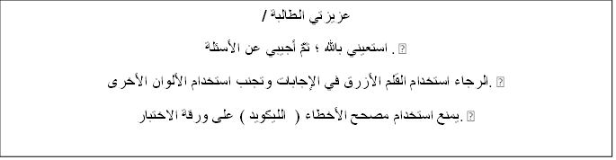

عزيزتي الطالبة /

استعيني بالله ؛ ثمَّ أجيبي عن الأسئلة . •

الرجاء استخدام القلم الأزرق في الإجابات وتجنب استخدام الألوان الأخرى. •

يمنع استخدام مصحح الأخطاء ( الليكويد ) على ورقة الاختبار. •

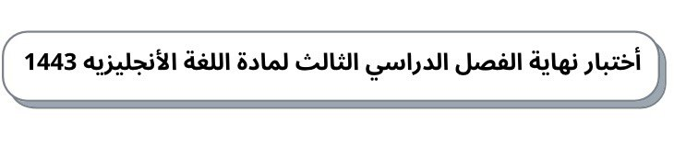

30

ثانوية ومتوسطة ............... الصف/ ثاني ثانوي الدور الأول          الزمن/ثلاث ساعات

**A -Free Composition**  **6 /**

**write an essay about Yourself**

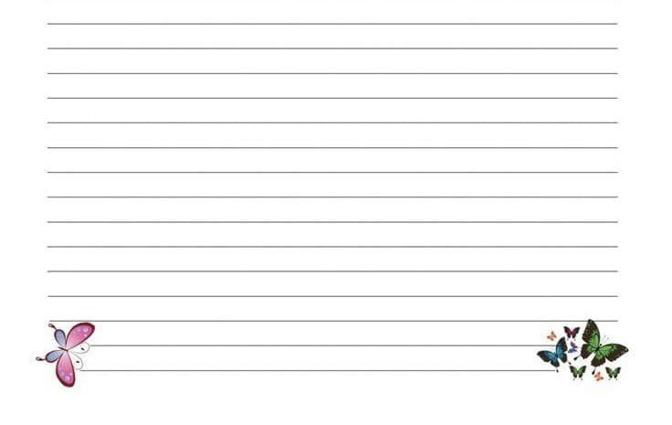

**B -** **Guided Composition** **6 /**

**Write an essay about: (a situation you wouldn’t forget)**

**Helping words:( prepare – agreed - suddenly - discovered - instead – embarrassing )**





**B -Reading Comprehension 6 /**

.**Read the following passage and answer the questions:**

**One day in 1969, John Rendall and Anthony Burke saw a real live lion cub in a London department store window. Feeling that a lion should not be kept this way, they bought him and took him home to live in Rendall’s basement. The lion, which they named Kristian, is said to have been an affectionate and extremely cooperative cat that even used a giant kitty litter box. Kristian was pampered. He was brought on drives, strolls through the neighborhood, and even to restaurants. But when Kristian grew to almost 200 pounds (90 kilograms), it was decided that he should be released into the wild. Kristian was brought to Africa where he adapted to life in the wild and became the leader of a group of lions. A year later, Rendall and Burke travelled to Africa to say goodbye. They were warned that Kristian would not remember them. However, when Kristian saw his old friends, he ran towards them, stood on his back legs, and joyfully gave each of them a long and loving embrace..**

**1-** **Where did John and Antony see a real live lion cub??**

**2. What is the trouble that Marcia’s dad says ?**

**3. they bought him and took him zoo.**

**True**



**False**



**4- A ………… later, Rendall and Burke travelled to Africa to say goodbye**

**year**



**ten year**



**5- Kristian is said to be an affectionate and extremely cooperative cat**

**True**



**False**



**6- Rendall and Burke travelled to ……………….. to say goodbye.**

**Africa**



**London**



**C-Grammar 6/**

1. **I did see the TV comedian**.                                               ( **Make it negative**  )

2. **The ( beautiful – old – stone ) house has been put up for sale**                    (**rewrite adjective order)**

3**- The mice were …………………………… of the cat**

frightened



frightening



4**- The funnier the joke , the ………………… the audience laughs.**

harder



hard



5 – **The new TV sitcom is ………………. A funny show that everyone watch it.**

such



so



6-  **There is ……………. juice .**

some



any



**D- Vocabulary** **6 /**

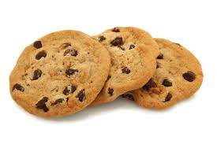1 -.**This is**

hair dryer



cookies



2-.**the odd word is**

parrot



penguins



truck



3- **Hold on. Means**:

stop for a moment.



this has gone too far.



4- **Match the word with the picture**

**[ Parrot – Penguins -snail -centipede]**

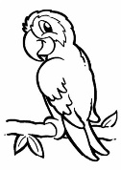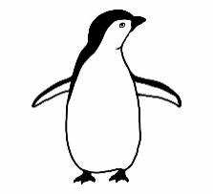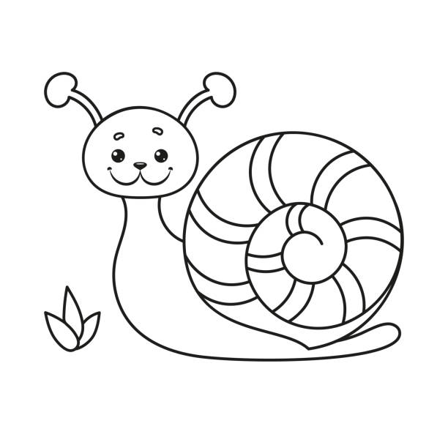

1. ……………………….. 2 ……………………………….. 3-………………….

**End of questions**

**T.Nora ALenzy**



المادة : لغة انجليزية الدور : الأول

الصف : ثاني ثانوي الزمن : ساعتان

الدرجة:

المملكة العربية السعودية

وزارة التعليم

الإدارة العامة للتعليم بمنطقة القويعية

### متوسطة وثانوية حلبان

### أسئلة اختبار نهاية الفصل الدراسي الثالث للعام الدراسي 1446هـ

1429 - 1430

بسم الله الرحمن الرحيم

30

### 

### : ..............

اسم الطالبة / ............................................ رقم الجلوس : _____________

|  |  |  |  |  |
| --- | --- | --- | --- | --- |
| **Number** | **Question** | | **Student’s Mark Number** | **Student’s Mark Written** |
| **Question** | **Mark** |
| **Q1** | **Reading Comprehension** | **12** |  |  |
| **Q2** | **Grammar** | **10** |  |  |
| **Q3** | **Vocabulary** | **8** |  |  |
| **Total Written Tasks** | | **30** |  |  |

**(A)Read the following passage, then answer the questions that follow:**

**I brush my teeth three times a day. That's the way I stay healthy. I wash my hands and face to keep them clean. That's the way I stay healthy . I sleep every night and wake up early. That's the way I stay healthy . I do exercise everyday to be strong and have strong body . That's the way I stay healthy .Fruits and vegetables, meat and bread , I eat them every day. I feel great because I am healthy. I am proud to stay healthy. Remember ! that " health is wealth."**

------

**12**

**A- Choose:-**

|  |  |  |
| --- | --- | --- |
| **1- I feel great because I am ______** | **a. healthy** | **b. sleaping** |
| **2- I brush my teath _____ times a day** | **a. one** | **b. three** |
| **3- The opposite** ≠ **of (Remember) is :___** | **a. play** | **b. forget** |
| **4- " Health is ______ "** | **a. wealth** | **b. nothing** |
| **5- To have healthy body you should do____** | **a. cooking** | **b. excercise** |
| **6- The word (them) in line 2 refers to:** | **a.fruits** | **b. hands and face** |

------

10

**(B) Grammar: Choose the correct answer:**

|  |  |  |
| --- | --- | --- |
| **1- A …………………… family lives next door.** | **a. nice large American** | **b. American nice large** |
| **2- Snowboarding is ………………………skiing.** | **a. easier than** | **b. easy** |
| **3- You are driving quickly………………** | **a. too** | **b. enough** |
| **4- New Delhi turned out to be an ………..city.** | **a. excited** | **b. exciting** |
| **5- I was very ……………………..** | **a. frustrated** | **b. frustrating** |
| **6- I am going to send this food back.** | **a. separable ( S )** | **b. nonseparable ( NS)** |
| **7- Sorry, we don’t have……..juice.** | **a. some** | **b. any** |
| **8- Milk is………….** | **a. countable(C)** | **b. noncountable(NC)** |
| **9-Banana is ………………** | **a. countable(C)** | **b. noncountable(NC)** |
| **10- My sister has gone ……too many crazy diets.** | **a. on** | **b. up** |

يتبع

8

**(C) VOCABULARY & ORTHOGRAPHY,Choose the correct answer:**

|  |  |  |
| --- | --- | --- |
| **1- Hold on means :** | **. a stop for a moment** | **b. pray for a moment** |
| **2- up for means:** | **a. ready for** | **b. down for** |
| **3-blow me away means:** | **a.really impress me** | **b.really annoy me** |
| **4. in no time means:** | **a. Very quickly.** | **b. Very slowly**  **too far.** |
| **5- have a sweet tooth means:** | **a.loves desserts**  **and candy** | **b. hates desserts**  **and candy** |
| **6-atmosp…..ere** | **1. k** | **2. h** |
| **7 –** **sor..ow** | **1. g** | **2. r** |
| **8– s….elter** | **1-n** | **2. h** |

……………………………………………………

- انتهت الأسئلة -

مع تمنياتنا للجميع بالتوفيق والنجاح