Kingdom of Saudi Arabia 2nd Intermediate Grade

Ministry of Education Time: An hour and a half

Hefar Intermediate & Secondary School Number of papers: 3

Final Exam – Third Term - 1446 AH

1. **Guided Composition:**

**6**

Complete the following paragraph about ***Your Next Vacation*** with the following

words in the box.

car – climb – family – stay – travel – visit

My Next Vacation

Next vacation, I am going to (1) ………………….. to Abha. I am going with my (2) ………………….. . We are going to travel by (3) ………………….. . We are going to (4) ………………….. there for two weeks. We are going to (5) ………………….. museums, go to the parks and (6) ………………….. the mountains.

1. **Reading Comprehension:**

**6**

***Read the passage and answer the questions below:***

My name is Adam. I live with my family in a big house. I have two sisters and one brother. We share many chores with our parents. My brother and I take the garbage out. We also wash our father’s car twice a week. Every Friday, I weed the garden and my brother waters the plants. I also make my bed in the morning. My sister, Emily, sweeps the floor every evening and washes the dishes after dinner. **She** also helps Mom with shopping every Thursday. My mother cooks for us and washes our clothes. My father fixes anything broken at home.

Hi my name is Adam. I live with my family in a

big house. I have two sisters and one brother.

We share many chores with our parents. My

brother and I take the garbage out.

We also wash our father’s car twice a week. Every Friday, I

weed the garden and my brother waters the plants. I also

make my bed in the morning. My sister, Emily, sweeps the

floor every evening and washes the dishes after dinner. She

also helps Mom with shopping every Thursday. My mother

cooks for us and washes our clothes. My father fixes

anything broken at home.

Hi my name is Adam. I live with my family in a

big house. I have two sisters and one brother.

We share many chores with our parents. My

brother and I take the garbage out.

We also wash our father’s car twice a week. Every Friday, I

weed the garden and my brother waters the plants. I also

make my bed in the morning. My sister, Emily, sweeps the

floor every evening and washes the dishes after dinner. She

also helps Mom with shopping every Thursday. My mother

cooks for us and washes our clothes. My father fixes

anything broken at home.

1. **Choose the correct answer:**
2. Adam washes his father’s car …… times in the week.

|  |  |  |  |
| --- | --- | --- | --- |
| 1. 1 | 1. 2 | 1. 3 | 1. 4 |

1. Adam’s …………. helps him to take out the rubbish.

|  |  |  |  |
| --- | --- | --- | --- |
| 1. brother | 1. sister | 1. uncle | 1. father |

1. There are ……… members in Adam’s family.

|  |  |  |  |
| --- | --- | --- | --- |
| 1. 3 | 1. 4 | 1. 5 | 1. 6 |

1. Adam weeds the garden on ……………..

|  |  |  |  |
| --- | --- | --- | --- |
| 1. Sunday | 1. Tuesday | 1. Thursday | 1. Friday |

1. Emily washes the dishes after …………..

|  |  |  |  |
| --- | --- | --- | --- |
| 1. breakfast | 1. lunch | 1. dinner | 1. school |

1. **She** in line **5** refers to Adam’s ………….

|  |  |  |  |
| --- | --- | --- | --- |
| 1. sister | 1. aunt | 1. grandmother | 1. cousin |

1. **Grammar:**

**7**

1. **Choose the correct answer:**
2. Yasser is going to ………pizza.

|  |  |  |  |
| --- | --- | --- | --- |
| 1. eat | 1. eats | 1. ate | 1. eating |

1. If it …………., they won’t play tennis.

|  |  |  |  |
| --- | --- | --- | --- |
| 1. rain | 1. rains | 1. will rain | 1. raining |

1. Would you ……… me the salt?

|  |  |  |  |
| --- | --- | --- | --- |
| 1. pass | 1. passes | 1. passed | 1. passing |

1. Mr. Ali wants me …….. in this form.

|  |  |  |  |
| --- | --- | --- | --- |
| 1. fill | 1. fills | 1. filled | 1. to fill |

1. You were ………. Chemistry all day yesterday.

|  |  |  |  |
| --- | --- | --- | --- |
| 1. study | 1. studies | 1. studying | 1. studied |

1. When the phone …………, she was writing a letter.

|  |  |  |  |
| --- | --- | --- | --- |
| 1. ring | 1. rings | 1. rang | 1. ringing |

1. They haven’t ……….. the lunch yet.

|  |  |  |  |
| --- | --- | --- | --- |
| 1. eat | 1. eats | 1. ate | 1. eaten |

1. The students …………. a test last week.

|  |  |  |  |
| --- | --- | --- | --- |
| 1. write | 1. are writing | 1. wrote | 1. have written |

1. **Do as shown between brackets:**
2. **(Rewrite the sentence using adverbs of manner)**
3. Nasser is a good player.

…………………………………………..…….

1. **(Unscramble the words to make a sentence)**
2. her room / tell / to clean / your sister

……………………………………………..

1. Nada couldn’t speak when she was one year and a half. **(Use ‘be able to’)**

………………………………………………….

1. **Vocabulary**:

**7**

1. **Write the words under the pictures:**

**scream – cage – napkin – mosquito – hurricane**

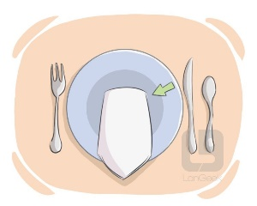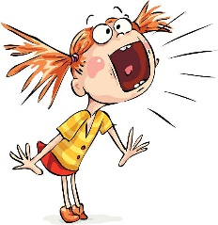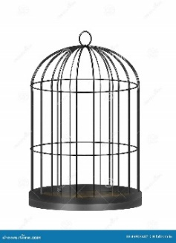

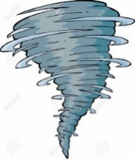

_____________ ______________ _____________ ______________

1. **Choose the correct answer to fill in the blank in each question:**
2. The child was …………….. by the snake.

|  |  |  |  |
| --- | --- | --- | --- |
| 1. happy | 1. frightening | 1. smart | 1. tired |

1. The opposite of ‘**empty’**:

|  |  |  |  |
| --- | --- | --- | --- |
| 1. weak | 1. fast | 1. proper | 1. full |

1. Will you …………… me your camera?

|  |  |  |  |
| --- | --- | --- | --- |
| 1. lend | 1. eat | 1. play | 1. read |

**4**

1. **Orthography:**
2. **Choose the correct missing letters:**
3. Columbus discovered America but he didn’t **e__plore** the new continent.

|  |  |  |  |
| --- | --- | --- | --- |
| 1. s | 1. x | 1. k | 1. g |

1. The color of **lea__es** is green in summer.

|  |  |  |  |
| --- | --- | --- | --- |
| 1. f | 1. b | 1. d | 1. v |

1. I had a huge lunch, so I’ll only need a **sn__ck** for dinner.

|  |  |  |  |
| --- | --- | --- | --- |
| 1. a | 1. e | 1. i | 1. u |

1. Could you **lo__er** your voice?

|  |  |  |  |
| --- | --- | --- | --- |
| 1. a | 1. e | 1. o | 1. w |

1. He was sitting on a bench and listening to a music through his **hea__phones**.

|  |  |  |  |
| --- | --- | --- | --- |
| 1. b | 1. d | 1. p | 1. q |

1. She got **st__ck** in an elevator.

|  |  |  |  |
| --- | --- | --- | --- |
| 1. a | 1. e | 1. i | 1. u |

1. Some types of **ca__el** have two humps and others have one.

|  |  |  |  |
| --- | --- | --- | --- |
| 1. m | 1. n | 1. w | 1. f |

1. This game has **wei__d** rules.

|  |  |  |  |
| --- | --- | --- | --- |
| 1. p | 1. r | 1. s | 1. t |

**END OF QUESTIONS**

**BEST OF LUCK**

**Ms. Tahani AlGhamdi ☺**

# نتيجة بحث الصور عن شعار الوزارة شفاف

Super Goal 2 - English Language

**Second Intermediate Grade**

Third Term Final Exam 1446-2025

**First Round** | Time: 1.5 hour

Kingdom of Saudi Arabia

Ministry of Education

………. Education Directorate

……………Intermediate School

**المراجع**

**checker**

**أ /..........**

**الدرجة كتابه**

**Written**

**المجموع**

**Total / 30**

**المصحح**

**corrector**

**أ / راشد السلمي**

**Q16**

**Q26**

**Q37**

**Q4**

**4**

**Q57**

اسم الطالب

رقم الجلوس

Composition

**اللهّم لا سَهلَ إلا ما جعلتُه سَهلاً فإنكَ تَجعَلُ الحزنَ إذا شِئتَ سَهلاَ " "**

**Write about things you have to do at home ?**

* What chores do you do?
* When do you do them?
* What do you like to do?
* What don’t you like to do?

..................................................................................................................................................................................................................

..................................................................................................................................................................................................................

..................................................................................................................................................................................................................

..................................................................................................................................................................................................................

..................................................................................................................................................................................................................

..................................................................................................................................................................................................................

..................................................................................................................................................................................................................

..................................................................................................................................................................................................................

..................................................................................................................................................................................................................

..................................................................................................................................................................................................................

**6**

**اقلب الصفحة**



Comprehension

**6**

* **Read the following passage and answer the questions below:**

What’s the strangest food you have ever eaten? People in the U.S. and Europe think that bugs are a strange thing to eat. But many people around the world eat bugs every day.

Bugs are eaten in 36 African countries, 29 Asian countries, and 23 Central and South American countries.

Bugs that live on land are not very different from bugs that live in the sea. Many people think that shrimp, crab, and lobster are really just "sea bugs." And like sea bugs, land bugs are good for you. Many contain protein, iron, and calcium- nutrients your body needs to stay healthy.

Dave Gordon is a famous chef in the United States. He is called "The Bug Chef." He has written many books about why everyone should eat bugs. He says that grasshoppers, for example, have a lot more protein than chicken or beef. Also, bugs are an inexpensive food. They are everywhere! He wants Americans to eat more bugs. He travels to different places and shows people how to cook with them. Many people are surprised to find out that they can be delicious!

**A. Choose the correct answer:**

1. A nutrient your body needs to stay healthy is ____.

**a**. grasshopper  **b**. calcium **c**. chicken **d.** beef

1. Many people call shrimp, crab, and lobster ____.

**a**. sea bugs **b** land bugs **c** fish **d.** vegetables

1. Bugs are eaten in _____ Asian countries.

**a**. 36  **b**. 23 **c**. 12 **d.** 29

**B. Write (T) for True or (F) for False:**

|  |  |
| --- | --- |
| **4.**  Bugs are a healthy food to eat. |  |
| **5.** Many people around the world eat bugs every day. |  |
| **6.** Dave Gordon is a famous doctor. |  |

**اقلب الصفحة**



**7**

Grammar

* **Choose the correct answer**

1. **Karl:** What are you going to do tomorrow? **Larry:** _____

**a**. I go to study. **b**. I going to study. **c**. I’m going to study. **d.** I’m going studying

1. Riyadh is _______.

**a**. a beautiful city **b**. a city beautiful  **c**. a beautiful  **d.** beautiful a city

1. They _________ going to go by plane.

**a**. isn’t  **b**. are  **c**. is  **d.** am

1. **Jane:** Will it be sunny tomorrow? **Amira:** No, ______.

**a**. it won’t **b**. it will  **c**. won’t it **d.** will it

1. **Jim:** _____ on vacation? **Gordon:** We’ll probably go in the spring.

**a**. Where will you go **b**. Where you will go  **c**. When you will go **d.** When will you go

1. If the lake ___, the children will probably go ice-skating.

**a**. frozen **b**. freezes  **c**. freeze  **d.** will freeze

1. _____ he understand what you were talking about?.

**a**. Could **b**. cans  **c**. will can **d.** can not

1. My brother _____ play tennis now. He is in the field.

**a**. will not can **b**. can not  **c**. will can **d.** can

1. _________ carry that for you thank you.

**a**. can  **b**. let me  **c**. could  **d.** will

1. He was so surprised that he _____ speak.

**a**. was almost able to **b**. couldn’t hardly **c**. was able just to **d.** could hardly

1. There was so much traffic that I was _____ for work.

**a**. almost late **b**. just late  **c**. absolutely late **d.** hardly late

1. The injured runner didn’t win, but he_____ the race..

**a**. wasn’t able to finish **b**. could finish  **c**. was able to finish **d.** couldn’t finish

1. I _____ Italy last year.

**a**. has visited **b**. have visited  **c**. visited **d.** visit

1. **Max:** Have you ever seen snake? **Tom:** Yes, ____.

**a**. I has **b**. I have  **c**. I have seen **d.** I has seen

Orthography

**4**

* **Choose the correct letters :**

1. Are you going on va…..ation ? ( c – o – r )
2. Scuba di…ing in The Red Sea ( q – o – v )
3. Spring is usually c….ol ( v – o – r )
4. It gets very cold in win…er ( q – t – x )
5. Children Please put away your to….s ( v – o – y )
6. Can I borrow your cell p….one? ( q – h – x )
7. The ele….ator wasn’t working. ( v – o – y )
8. Have You Had an Exciting Li…e? ( x – o – f )

**اقلب الصفحة**



Vocabulary

* **Choose the correct answer:**

**7**

1. This quiet beach is ____.

**a**. noisy **b**. relaxing **c**. adventurous **d.** expensive

1. This hiking vacation in the mountains is ____.

**a**. adventurous **b**. luxurious  **c**. expensive  **d.** relaxing

1. It’s _______________ today. Hold on to your hat!

**a**. windy  **b**. sunny **c**. cloudy **d.** snows

1. Don’t forget your sunglasses. It’s very _____________.

**a**. cloudy **b**. rainy  **c**. sunny  **d.** windy

1. I have no idea mean ____________ .

**a**. I don't know **b**. I have no problem **c**. He knows  **d.** I have to say

1. I will bring some snacks from the_________.

**a**. bathroom **b**. the roof  **c**. Kitchen  **d.** garage

1. I _____ when I saw the snake. I was so surprised!

**a**. fired **b**. shrieked **c**. lightning  **d.** wounds

1. Did you see the storm last night? The _____ was amazing!

**a**. lightning **b**. wounds  **c**. fired  **d.** risk

1. A zorse is half zebra, half _________.

**a**. horse **b**. fish **c**. Elephant  **d.** Tiger

1. Which of the following sports are unusual:

**a**. Dennis **b**. Football  **c**. Basketball **d.** Hang gliding

1. **Definitely** means: _____________.

**a**. not sure **b**. certainty **c**. very frightened **d.** You’re crazy!

* **Write the correct word under the picture.**

Hospital – Desert – Scuba diving

**صورة تحتوي على داكن

تم إنشاء الوصف تلقائياً**صورة تحتوي على تلبيس, رجل, رسوم متحركة, الأحذية

تم إنشاء الوصف تلقائياً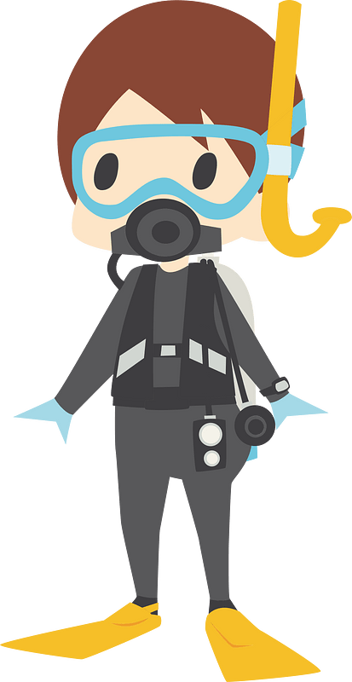

**14.**

**13.**

**12.**

………………………………….

………………………………….

………………………………….

**انتهت الأسئلة .. ..**

**وبالله التوفيق والنجاح ..**

**الأستاذ / راشد السلمي**

**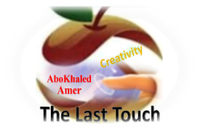****المملكة العربية السعودية**

**6**

**وزارة التعليم**

**الإدارة العامة للتعليم بن**

**مدارس م ن التعليمية**

**الصف الثاني المتوسط**

**الاختبار النهائي للفصل الدراسي الثالث1446**

|  |  |  |  |  |  |  |  |
| --- | --- | --- | --- | --- | --- | --- | --- |
| **Total**  **written** | **5 spelling** | **4 Vocabulary** | **3 Grammar** | **2 Comprehension** | | **1 Composition** | **Q. NO.** |
|  |  |  |  |  | |  | **Mark Given** |
| **30** | **4** | **7** | **7** | **6** | | **6** | **Mark** |
|  | | | **Reviser** | |  | | **Corrector** |
|  | |

**زمن الاختبار: ساعتان**

**اسم الطالب: ------------------------------------ رقم الجلوس: ------------- الصف الثاني المتوسط**

car – climb – family – stay – travel – visit

1) **Composition**

**1- Write a paragraph about “How the Weather Affects you "**

**You may talk about the following words: Feel – rainy – window – spend – trouble**

**6**

**2) Comprehension**

**7**

**2- Read the following passage then answer the questions:**

**Wonderful Vacation**

**Last vacation I went with my family to Egypt. At the beginning, we went on a cruise on the River Nile. We left Cairo on Friday morning and got back on Monday evening. It was a wonderful experience. Then we stayed in Cairo for five days. We went sightseeing and we visited the Egyptian Museum, too. There were so many interesting things to see there. We also visited the Pyramids in Giza and took lots of pictures. They were amazing! My parents and I also tried camel riding. It was lots of fun. I really want to visit Egypt again. It’s beautiful and there are many things to see and do there!**

**A- Put ( ) or ( x ):**

**1.Last vacation, they went on vacation to Egypt. ( )**

**2.They stayed in Cairo for seven days. ( )**

**3.They visited the pyramids and the museum. ( )**

**4.They all tried horse riding in the pyramids. ( )**

**5. They really want visit Egypt again. ( )**

**B- Choose the correct answer:**

**1. The family left Cairo on (**Monday – Sunday – Friday**) morning.**

**2. They went (**sightseeing – hang gliding – scuba diving**) in Egypt.**

**3. The vacation to Egypt was lots of (**fan – fat – fun**).**

**4. There were (**few – many – lot**) things to see and do in Egypt.**

**C- Answer the following questions:**

**1. Where did the family go last summer?.........................**

**2. Did they enjoy their stay there?...........................**

**3. What is the river they went on a cruise on? ..................**

**3) Grammar**

**A: Choose the correct answer:**

**7**

**1. He is (**go to – goes to – going to**) spend happy time.**

**2. (**What – Where – When**) are they going to leave for London?**

**3. Maybe, she (**will – am going to – have**) visit us next holiday.**

**4. What is the weather like today? (**He is – She is – It is**) sunny.**

**5. Can you (**clear – clears – clearing**) my way, please?**

**6. (**Let – Tell – Lets**) me help you with this box.**

**7. They (**waiting – were waiting – wait**) for the bus when it started raining.**

**8. We have (used – use – uses) all the toothpaste.**

**B: Chang into Negative:**

**1. We are going to brush our teeth.**

…………………………………………………………………………………………………………………………………………………………………………………………………………………

**2. He was feeding the fish.**

……………………………………………………………………………………………………………………………………

3. **She has spoiled all the nail polish.**

……………………………………………………………………………………………………………………………………

**C: Make Yes/No question:**

**1. They will set the table.**

……………………………………………………………………..……………………………………………………………

**2. They were washing the dishes.**

……………………………………………………………………………………………………………………………………

**3. I have finished all the cooking.**

……………………………………………………………………………………………………………………………………

**4) vocabulary:**

**scream – cage – napkin – mosquito – hurricane**

**A- Match the words with the pictures:**

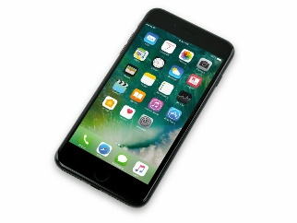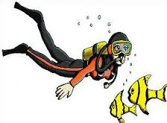**anaconda – cellphone – relaxing – snowy – scuba diving – safari**

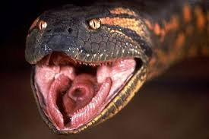****

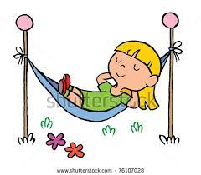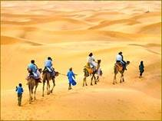

**……………. ……………. ……..……. ………..…… …………… …………..**

**B- Match the answers:**

|  |  |
| --- | --- |
| a. introduce news | **1. We went to the mountains for -------** |
| b. very cold | **2. Wild animals usually live in the --------** |
| c. cliff hanging | **3. How many months are there in a year? ---------** |
| d. jungle | **4. We say, " I hear " when we ---------** |
| e. twelve months | **5. The temperature is "below zero" means it is ---------** |

**C- Circle the correct spelling:**

**1. windy - widny – winyd**

**2. parot – parrat - parrot**

**3. wierd – weird – weired**

**5) Orthography**:

**4**

**A- Fill in the missing letters:**

**1- des__rt**

Super Goal 2 - English Language

**Second Intermediate Grade**

Third Term Final Exam 1446-2025

**First Round** | Time: 1.5 hour

**2- zookee__er**

**3- ho__pital**

**4- pop__lar**

**B- Choose the odd one out:**

**1. can could will Ali**

**2. helped cleaned worked sleep**

**3. stormy parrot foggy snowy**

**4. scuba diving hang gliding cliff hanging doctor**

**End of Questions**

**Best of Luck** [**https://t.me/mnhaji2m**](https://t.me/mnhaji2m)

******المملكة العربية السعودية**

Kingdom of Saudi Arabia

Ministry of Education

………. Education Directorate

……………Intermediate School

**وزارة التعليم**

**الإدارة العامة للتعليم بن**

**مدارس م ن التعليمية**

**الصف الثاني المتوسط**

**الاختبار النهائي للفصل الدراسي الثالث1446**

|  |  |  |  |  |  |  |  |
| --- | --- | --- | --- | --- | --- | --- | --- |
| **Total**  **written** | **5 spelling** | **4 Vocabulary** | **3 Grammar** | **2 Comprehension** | | **1 Composition** | **Q. NO.** |
|  |  |  |  |  | |  | **Mark Given** |
| **30** | **4** | **7** | **7** | **6** | | **6** | **Mark** |
|  | | | **Reviser** | |  | | **Corrector** |
|  | |

**زمن الاختبار: ساعتان**

**اسم الطالب: ------------------------------------ رقم الجلوس: ------------- الصف الثاني المتوسط**

1) **Composition**

**1- Write a paragraph about “Your Best Friend "**

**You may talk about the following words: His name – His age – His favorite color – His father job – His favorite subject – His favorite sport – His future job**

**المراجع**

**checker**

**2) Comprehension**

**أ /..........**

**2- Read the following passage then answer the questions:**

**Bill's Family**

**My name’s Bill. I’m 12 years old. I have two brothers and one sister. My father is a doctor, and my mother is an English teacher. I live in a flat with my family. Our flat is on the second floor and there are three bedrooms and one kitchen. We also have a beautiful balcony. Our favorite day of the week is Saturday. We all get up at about 10 o’clock and have breakfast. Then I play computer games with my sister. After lunch, I go to the park to play football with my brothers. In the evening, I often play basketball with my friends. I like it but my brothers love football.**

**A- Put ( ) or ( x ):**

**1.In this passage, the boy's name is Billa. ( )**

**2.His father is a doctor. ( )**

**3.His flat is on the fourth floor. ( )**

**4.On Sunday, they have breakfast at 10 o'clock. ( )**

**5. He plays computer games with his brothers. ( )**

**B- Choose the correct answer:**

**1. Bill's mother is an (**science – math - English**) teacher.**

**2. In his flat, they have a beautiful (**horse – yard – balcony**).**

**3. He plays (**tennis – football – computer games**) with his brothers.**

**4. Bill's family are (**six – seven – eight**) members.**

**C- Answer the following questions:**

**1. How old is Bill?.............................**

**2. How many brothers does Bill have?...........................**

**3. Where does he go after lunch? ..............................**

**3) Grammar**

**A: Choose the correct answer:**

**الدرجة كتابه**

**Written**

**1. They (am – is – are) going to visit their uncle.**

**2. (What – Where – Who) is he going to spend the weekend?**

**3. I (will – am going to – have) probably travel to Abha next summer.**

**4. (Why – When – What) is the weather like today?**

**5. (Could – Have – Are) you help me with this bag?**

**6. Let me (carry – carrying – carries) this box for you.**

**7. Hans (walk – was walking – walking) to college when he saw Samir.**

**8. She has (cleans – cleaning – cleaned) her own room.**

**B: Chang into Negative:**

**1. He is going to wash the car.**

…………………………………………………………………………………………………………………………………………………………………………………………………………………

**2. They were cooking lunch at home.**

……………………………………………………………………………………………………………………………………

3. **They have watched TV with their kids.**

……………………………………………………………………………………………………………………………………

**C: Make Yes/No question:**

**1. He will do his homework.**

……………………………………………………………………..……………………………………………………………

**2. Ali was helping his mom in the kitchen.**

……………………………………………………………………………………………………………………………………

**3. We have brushed our teeth.**

……………………………………………………………………………………………………………………………………

**4) vocabulary:**

**المجموع**

**Total / 30**

**A- Match the words with the pictures:**

****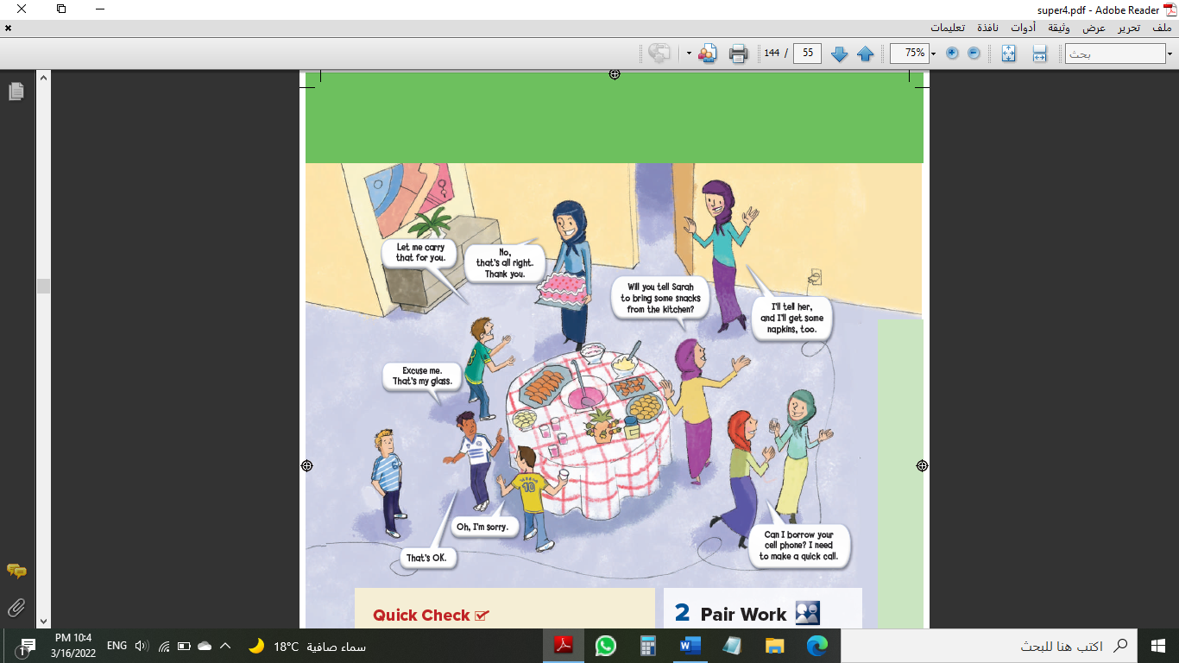**cake – parrot – pyramids – cliff hanging – graduation – rainy**

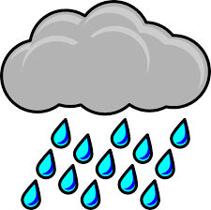

**……………. ……………. ……..……. ………..…… …………… …………..**

**B- Match the answers:**

|  |  |
| --- | --- |
| a. not certain | **1. We go the sea for ------** |
| b. No problem | **2. We say: "It depends" when we are ------** |
| c. scuba diving | **3. How many seasons are there in a year? ------** |
| d. Lost his job | **4. Can you open the door for me, Please? ------** |
| e. Four seasons | **5. He was "fired" means that he -------** |

**C- Circle the correct spelling:**

**1. awesome - awosome – owesome**

**2. snaek – snake - sanke**

**3. emergancy – emargency – emergency**

**5) Orthography**:

**المصحح**

**corrector**

**A- Fill in the missing letters:**

**1- saf__ri**

**أ / راشد السلمي**

**2- wor__d**

**3- fav__r**

**4- atta__k**

**B- Choose the odd one out:**

**1. written taken seen eat**

**2. going reading sing working**

**3. sunny cloudy year snowy**

**4. zebra doctor turtle zorse**

**End of Questions**

**Best of Luck** [**https://t.me/aikhtibart**](https://t.me/aikhtibart)

**المملكة العربيةالسعودية الصف: ثاني متوسط**

**وزارة التعليم مادة : اللغة الإنجليزية**

**المتوسطة الزمن: ساعة ونصف**

**أسئلة اختبار الفصل الدراسي الثالث للعام 1446هـ**

**عدد الصفحات: 3 عدد الأسئلة :5**

++++++++++++++++++++++++++++++++++++++++++++++++++++++++

|  |  |  |
| --- | --- | --- |
|  |  |  |
| **I-Composition:** |  | **6** |

‘’ **I think extreme sports are really good for relieving stress**. “

**\*Write a paragraph about Your Extreme Sport and Activity . Give your opinion about it. Use the questions below to guide you :**

1.What are your extreme sport ?

2. How often do you do this extreme sport or activity?

3. What extreme sport is popular in your country?

4. Why do you like this extreme sport?

**__________________________________________________________________**

**__________________________________________________________________**

**__________________________________________________________________**

**__________________________________________________________________**

**__________________________________________________________________**

**__________________________________________________________________**

**__________________________________________________________________**

**__________________________________________________________________**

**__________________________________________________________________**

**__________________________________________________________________**

6

**II-Comprehension:**

6

**Read the passage and answer the questions below:**

Rana is eighteen years old. She is from Saudi Arabia. She loves traveling with her friend Sabah. Rana is planning to travel to Al Ula in Madinah. **She** is going to travel next Friday, and she is going to stay in Madinah for three weeks. She is going to visit Mada'in Saleh and the museum there. She likes the Nabataeans culture, and she is going to visit Al Ula oasis. She is going to buy some souvenirs for her mom. Rana has friends in Madinah, so after visiting the Elephant Mountain, she is going to visit her friends Mona and Lana. Mona and Lana are going to prepare a big welcome party for Rana. They love her a lot and they are going to buy a lot of presents for her.

|  |  |  |  |  |
| --- | --- | --- | --- | --- |
| **Multiple Choice ( 1- 35 )** | | | | |
| **Comprehension (1-4)** | | | | |
| **A*Choose the correct answer:** | | | | |
| **1**- The **main idea** of the passage is … ……………. | | | | |
| d. Picnic in the park | | c- Reading a book | b- Travelling to Madinah | a- White sharks |
| **2**-In line 7 (small) is the opposite of.. | | | | |
| d. long | | c- ill | b- cute | a- big |
| 3-In line 2 (She) refers to…. | | | | |
| d- Rana | | c-Mona | b- Sabah | a-Lana |
| **4**- Rana is …………. years old | | | | |
| d. 15 | | c- 18 | b- 17 | a- 16 |
| **F**alse**\T**rue | **B*Put ( T√) or ( Fx ) (1-2)** | | | |
|  | 1- Rana is going to buy some souvenirs for her sister. | | | |
|  | 2- Rana is going to travel to Madinah next Friday. | | | |

|  |  |  |
| --- | --- | --- |
| **III-Grammar:/Multiple Choice: ( 5 to 11 )** |  |  |
| **Choose the correct words:** |  | **7** |

|  |  |  |  |
| --- | --- | --- | --- |
| **5**- I have ……………………. at the pet shop. | | | |
| d- are | c- been | b- is | a- be |
| **6**- We ………………… dinner when it started to rain. | | | |
| d-was having | c-are having | b- is having | 1. were having |
| **7**- If I ……………….. your ring, I will give it back to you | | | |
| d-finding | c- found | 1. find | 1. finds |
| **8**- ………………… are the boys going to ride? Their bikes | | | |
| d- Who | 1. How | 1. Where | 1. What |
| **9**- Let me ……………… my own decisions. | | | |
| d- make | c-makes | b- made | 1. making |
| **10**- They ………………….. handball next Saturday | | | |
| d- to play | c- will play | 1. playing | 1. played |
| **11**- He plays tennis ……………………. | | | |
| d-well | c- as good as | b-better than | 1. the best |

**77**76

|  |
| --- |
| **Vocabulary: ( 1 to 6 )** |
| **Pairing Question:** |

|  |  |  |  |  |
| --- | --- | --- | --- | --- |
| 1 | This bracelet is very **inexpensive**. |  | A | to tell a person of a danger |
| 2 | The monkey is in the **cage**. |  | B | the synonym of cheap |
| 3 | The storm didn't do much **damage**. |  | C | a wire net for keeping animals |
| 4 | This is my favorite holiday **resort**. |  | D | harm or injury |
| 5 | I tried to **warn** you. |  | E | a meeting of a group of people |
| 6 | I am at the family **gathering**. |  | F | a place where many people go for rest |
|  | | | G | to make you feel afraid |

|  |
| --- |
| **IV-Vocabulary:/Multiple Choice: ( 12 to 19 )** |
| **Choose the correct words:** |

|  |  |  |  |
| --- | --- | --- | --- |
| **12-** Mountains of FIFA is one of the initial ……………. | | | |
| d- ecosystem | c- habitat | b- wildlife | a- ecotourism |
| **13**- Do you like ……………… history? | | | |
| d- ancient | c- modern | b- dry | a- empty |
| **14**- A ………….. of horses had strayed into the road. | | | |
| d- swarm | c- pride | b- pod | a- herd |
| **15**. Cactus is a plant that lives in …………………. Places. | | | |
| d- windy | c- dry | b- cloudy | a- snowy |
| **16**- I have my ………………………..on to listen to the music. | | | |
| d- headphones | c- keyboards | b- cameras | a- screens |
| **17**- The …………….. may erupt at any moment. | | | |
| d- volcano | c- tsunamis | b- earthquake | a- tornado |
| **18**- …………………… is a measure of moisture in the atmosphere. | | | |
| d- Hurricane | c- Rain | b- Humidity | a- Weather |
| **19**- Clean your lips with the ………………………….. | | | |
| d- fork | c- plate | b- spoon | a- napkin |

**4**76

|  |
| --- |
| **V-Orthography (Spelling): ( 20 to 35 )** |

|  |  |  |  |  |  |  |  |  |  |  |  |  |
| --- | --- | --- | --- | --- | --- | --- | --- | --- | --- | --- | --- | --- |
| 20 | I ce__tainly did not like the place. | | | | | | | 28 | She's learning about Japanese cul__ure. | | | |
| a. m | b. r | | c. g | | d.q | | a. t | b. v | c. x | d. l |
| 21 | It has lower t__xes. | | | | | | | 29 | There are many mos__uitoes in the shops. | | | |
| a. e | | b. o | | c. i | | d. a | a. y | b. k | c. q | d. f |
| 22 | The anaco__da has eyes high on its head. | | | | | | | 30 | I like exot__c fruit, like papayas. | | | |
| a. x | | b. n | | c. t | | d. l | a. u | b. o | c. e | d. i |
| 23 | She keeps a parr__t as a pet. | | | | | | | 31 | The bar__meter was down to twenty eight. | | | |
| a. e | | b. i | | c. a | | d. o | a. o | b. a | c. i | d. u |
| 24 | He is a s__rong man. | | | | | | | 32 | There is a g__lf between the two cities. | | | |
| a. t | | b. f | | c. x | | d. n | a. i | b. u | c. o | d. e |
| 25 | The z__bra fell prey to the lion. | | | | | | | 33 | It was 36 d__grees in Boston today | | | |
| a. i | | b. a | | c. e | | d. u | a. i | b. a | c. e | d. u |
| 26 | They thr__w rubbish into rivers. | | | | | | | 34 | The weather foreca__t is good . | | | |
| a. u | | b. o | | c. i | | d. e | a. s | b. v | c. p | d. n |
| 27 | You s__ared me to death. | | | | | | | 35 | There's one pro__lem. | | | |
| a. c | | b. j | | c. d | | d. v | a. t | b. b | c. g | d. z |

**End of Questions**

**Best OF Luck !**

**Tr.**

|  |  |  |
| --- | --- | --- |
| English Language Final Exam | شعار وزارة التعليم بدون خلفية بيضاء الجديد مفرغ وشفاف - موقع محتويات | Kingdom of Saudi Arabia |
| The third Trimester, 1st Session, 1446 | Ministry of Education |
| The second Intermediate Grade | General Directorate of Education in Bisha |
| Time: 2 hours | East Education Office |
| No. of pages: 3 | Rabbah Intermediate School |
| **مستعينة بالله أجيبي عن الأسئلة التالية:** | | |

**I- Guided Composition:**

6

Write a paragraph about yourself:

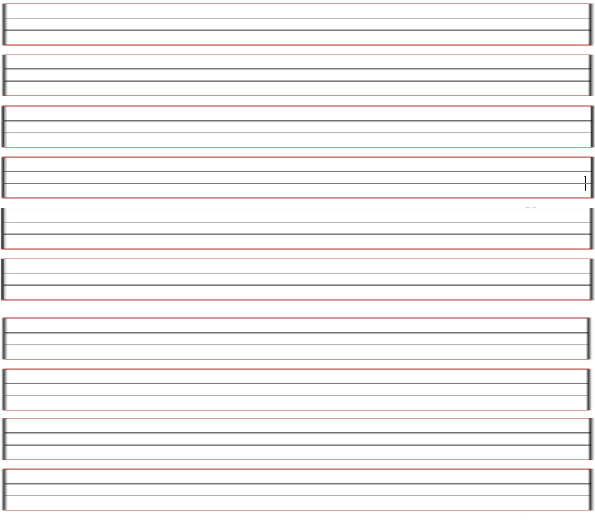

**II- Reading Comprehension**

6

**Read the passage carefully and answer the questions below:**

Noura and her family were in London last week. It was very expensive. They stayed in a hotel for three days. Then they took an apartment. Noura stayed there until Friday. She flew home last night. Her father is still there. Her mother is with her father. Next week Noura is going somewhere else.

Choose the correct word:-1

1. Mohammad and his family were in London last ( day - week – month)

2. They took an ( apartment – hotel – taxi ) .

3. He stayed there ( after – before - until ) Friday.

4. Next ( week – month - holiday ) Mohammad is going somewhere else .

B)Put ( 🗵 ) or ( ☑ ):-1

1- Mohammad and his family went to Paris. ( )

2-lt was very expensive in London. ( )

**-------------------------------------------------------------**

**III- Grammar:**

**A- Choose the correct answer:1**

7

1. Omar drives ( slow – slows – slowly )
2. I will ( travel – traveling _ travels ) to Jeddah
3. Could you ( give – gives – giving ) me a pen?

4. I ( was – were – is ) sleeping

5. Omar ( read – reads – reading ) the book.

**B- correct the mistake: 1**

1. Sara was able to finishing all housework yesterday ( reorder).

…………………………………………………………………………………………………………..…………………………..

1. Omar has eat chocolate. (correct the mistake)

…………………………………………………………………………………………………….………………………………

**-------------------------------------------------------------**

**IV- Vocabulary:**

7

A**) Write the correct number under each picture:1**

**1**- relaxing **2**- rainy **3**- graduation **4**-carseat phone

|  |  |  |  |
| --- | --- | --- | --- |
|  |  |  |  |
|  |  |  |  |

[هذه الصورة](https://collection.maas.museum/object/580836) بواسطة كاتب غير معروف مرخصة بالاسم [CC BY-NC-ND](https://creativecommons.org/licenses/by-nc-nd/3.0/)

**B) Find the odd words. 1**

1. winter August summer
2. thanks sorry not now
3. football hang gliding basketball

**-------------------------------------------------------------**

**V- Orthography:**

4

**Choose the correct letter:1**

1. o__erpower 3- __umidity
2. mo__quito 4- desert sa__ari

**------------------------------------------------------------**

**The End of the Questions**

Good Luck😊 Latifa Alyousef ♥



**Kingdom of Saudi Arabia**

**Ministry of Education**

**Al-……..**

**Final Exam**

**Term: third**

**Grade: 2nd**

**Time: 1 and half h**

**اختبار مادة اللغة الإنجليزية للصف الثاني المتوسط الفصل الدراسي الثالث - الدور الأول - للعام الدراسي 1446**

**اسم الطالبة: ....................................................................... رقم الجلوس: .........................**

|  |  |  |  |  |  |  |
| --- | --- | --- | --- | --- | --- | --- |
| **Scanner's name and signature** | **Reviser's name and signature** | تنزيل**Marker's name and signature** | **Given mark in letters** | **Student's mark** | **mark** | **Que.** |
|  |  |  |  |  | **6** | **1** |
|  |  | **6** | **2** |
|  |  | **7** | **3** |
|  |  | **7** | **4** |
|  |  | **4** | **5** |
|  |  | **30** | **Total** |

**1- WRITING**

**- Write a paragraph about** **your favorite sport**

**Write a paragraph about your favorite sport. What is your favorite sport? Why do you like it? End the text by writing your feelings**

…………………………………………………………………………………………..………………………………………………………………………………..…………………………………………………………………………………………………………………………………………………………………………………………………………………………………………………………………………………………………………………………………………………………………………………………………………………………………………………………

……………………………………………………………………………………………..………………………………………………………………………………

**2- Reading Comprehension**

**Read the following passage, then answer the questions:**

**Continue to page 2**

Butterflies are beautiful flying insects with two large wings and six legs. They have three body parts and compound eyes. Butterflies often have brightly coloured wings with unique shapes made up of tiny scales. Butterflies attach their eggs to leaves with a special glue.

A butterfly lifecycle is made up of four parts: egg, caterpillar, chrysalis and adult. A tiny butterfly egg hatches into a caterpillar. Most caterpillars are plant

eaters. The butterflies taste with their feet. Most butterflies feed on nectar from flowers. They are amazing insects.

---------------------------------------------------------------------------

**2**

**A/ Complete the following sentences from the passage:** (1/2 mark each)

1. Butterflies are beautiful flying insects with ……….……………

and ………….

1. Butterflies attach their ……..…. to …………… with a special glue.

--------------------------------------------------------------------------

**B/ Write (T) for True or (F) for False:**  (1 mark each)

**4**

1- Butterflies have 3 body parts. ( )

2- A butterfly lifecycle is made up of four parts. ( )

3- The butterflies taste with their wings. ( )

4- Most butterflies feed on honey from flowers. ( )

\*\***\*\*\*\*\*\*\*\*\*\*\*\*\*\*\*\*\*\*\*\*\*\*\*\*\*\*\*\*\*\*\*\*\*\*\*\*\*\*\*\*\*\*\*\*\*\*\*\*\*\*\*\*\*\*\*\*\*\*\*\*\*\*\*\*\*\*\***

**3/ Grammar**

**A/ Correct the following mistakes:**  (1/2 mark each)

1. They haven’t **write** any texts yet. …................
2. He couldn’t **played** tennis. ...............……

**2**

1. If I am sick, I may **stayed** at home. .…..................
2. Ali will **is** ten next year. …….................

**Continue to page 3**

**B/ Choose the correct answer:** (1/2 mark each)

**5**

|  |  |  |  |  |  |  |  |
| --- | --- | --- | --- | --- | --- | --- | --- |
| **1-** | I …………… sleeping when you called. | | | | | | |
| **a-** | **was** | **b-** | **is** | **c-** | **are** | **d-** | **were** |
| **2-** | He was able to ……… fast when he was younger. | | | | | | |
| **a-** | **ran** | **b-** | **run** | **c-** | **running** | **d-** | **runs** |
| **3-** | She ……… her horse almost every day. | | | | | | |
| a- | **Is ridding** | **b-** | **rode** | **c-** | **rides** | **d-** | **has ridden** |
| **4-** | He has …………. his task early. | | | | | | |
| **a-** | **finish** | **b-** | **finishing** | **c-** | **finishes** | **d-** | **Finished** |
| **5-** | We ……....taken any orders. | | | | | | |
| **a-** | **Haven’t** | **b-** | **have** | **c-** | **has** | **d-** | **hasn’t** |
| **6-** | Let me ………. you a joke. | | | | | | |
| **a-** | **told** | **b-** | **tell** | **c-** | **tells** | **d-** | **telling** |
| **7-** | 8- Sara won’t………. to her brother. | | | | | | |
| **a-** | **listens** | **b-** | **listening** | **c-** | **listen** | **d-** | **listened** |
| **8** | Ali drives ……… | | | | | |  |
| **a-** | **slow** | **b-** | **slows** | **c-** | **The slowest** | **d-** | **slowly** |
| **9-** | Nora is a ………. Speaker. | | | | | | |
| **a.** | **loud** | **b.** | **louder** | **c.** | **loudly** | **d.** | **louds** |
| **10** | If the lake………..., the children will probably go ice skating. | | | | | | |
| **a.** | **freeze** | **b.** | **freezes** | **c.** | **froze** | **d.** | **frozen** |

**4/Vocabulary**

**A/ Choose the correct answer:** (1/2 mark each)

1. Where are my sunglasses? It’s really …….. today.

**a. sunny b. snowy c. windy d. rainy**

**3**

2. It will be 40 degrees Celsius today. That’s ……….

**a. cold b. hot c. fine d. cool**

3. It will be ……… this afternoon. You should bring your umbrella!

**a. sunny b. windy c. rainy d. cloudy**

4. This quiet beach is…….…..

**a. noisy b. adventurous c. expensive d. relaxing**

5. He has …….. on his body from the car accident.

**a. wounds b. points c. risk d. sneezing**

6. He was …….. from his last job. He always arrived late.

**Continue to page 4**

**a. risk b. fired c. screamed d. shocked**

**\*\*\*\*\*\*\*\*\*\*\*\*\*\*\*\*\*\*\*\*\*\*\*\*\*\*\*\*\*\*\*\*\*\*\*\*\*\***

**B/ Cross out the odd word:** (1/2 mark each)

**2**

1. **a/ Shark b/ dolphins c/ camels**
2. **a/ Basketball b/ volleyball c/ biking**

**3. a/ bike b/ spring. c/ winter**

**4. a/ bungee jumping b/ swimming c/ water skiing**

**\*\*\*\*\*\*\*\*\*\*\*\*\*\*\*\*\*\*\*\*\*\*\*\*\*\*\*\*\*\*\*\*\*\*\*\*\*\***

**C/ Write the suitable word under each picture:** (1/2 mark each)

**( 1- snake / 2- parrot / 3- rainforest / 4- fall / 5- bear)**

|  |  |  |  |
| --- | --- | --- | --- |
| **2** |  |  |  |
|  |  |  |  |

**\*\*\*\*\*\*\*\*\*\*\*\*\*\*\*\*\*\*\*\*\*\*\*\*\*\*\*\*\*\*\*\*\*\*\*\*\*\***

**5/ Orthography**

**A/ Choose the correct letter:** (1/2 mark each)

1. Children Please put away your to....s ( **r – o – y** )
2. Can I borrow your cell p....one? ( **q – x – h**)
3. Let me ca.....ry that for you. ( **o– u – r**)

4. The ele....ator wasn’t working. ( **v – o – y** )

5. The guests arrived ea...ly. ( **r – d – x** )

6. Stay tuned for brea...ing news ! ( **k – u – g)**

7. Are you going on va.....ation ? ( **o – c – r** )

8. Scuba di...ing in The Red Sea ( **q – v – k )**

**\*\*\*\*\*\*\*\*\*\*\*\*\*\*\*\*\*\*\*\*****\*\*\*\*\*\*\*\*\*\*\*\*\*\*\*\*\*\*\*\*\*\*\*\*\*\*\*\*\*\*\*\*\*\*\*\*\*\***

**End of Questions / Good Luck ☺/ ET. …..**

**Kingdom of Saudi Arabia**

**Ministry of Education**

**intermediate School**

Super Goal 2 - English Language

**Second Intermediate Grade**

Third Term Final Exam 1446-2025

**Time: 1.5**

|  |  |  |  |  |  |  |
| --- | --- | --- | --- | --- | --- | --- |
| **Question No.** | Q1 | Q2 | Q3 | Q4 | Q5 | **Total** |
| **Question’s mark** | 6 | 6 | 7 | 7 | 4 | **30** |
| **Student’s mark** |  |  |  |  |  |  |

**Corrector: …………………………**

**Checker: ……………………………**

**Student’s name: ……………………………………………………………………. Seat No. ………………………… Class No. ……………………**

🏵Composition🏵

6 marks

**Describe the activities you do and how you feel in certain weather conditions**

1. How do you feel when the weather is **warm and sunny**
2. How do you feel when the weather is **cloudy and rainy**
3. How do you feel when the weather is **hot and sunny**

……………………………………………………………………………………………………………………………………………………………………………………….

……………………………………………………………………………………………………………………………………………………………………………………….

………………………………………………………………………………………………………………………………………………………………………………………

……………………………………………………………………………………………………………………………………………………………………………………….

……………………………………………………………………………………………………………………………………………………………………………………….

……………………………………………………………………………………………………………………………………………………………………………………….

……………………………………………………………………………………………………………………………………………………………………………………….

……………………………………………………………………………………………………………………………………………………………………………………….

……………………………………………………………………………………………………………………………………………………………………………………..

………………………………………………………………………………………………………………………………………………………………………………………



Focus with Manal

**Turn the page/ أقلب الصفحة**

6 marks



Focus with Manal

**Turn the page/ أقلب الصفحة**

**🏵Reading comprehension🏵**

**Read the following passage and answer the questions below:**

Adel writes from their hotel in **Al-Ula** after a long bus journey from **Madinah**. Adel went on a school trip. Adel and his friends will explore the historical site of **Mada'in Saleh**, which is a very old town, and the climate there is very hot and dry. They are going to visit the museum of **Al-Ula** oasis, and the old city of **Al-Deerah,** Adel promises to take many pictures to share the experience with his family and friends.

**➀. Fill in the Blank: Fill in the blank with the correct words.**

|  |  |  |
| --- | --- | --- |
| **1. Where did Adel travel from?** | | |
| a. Riyadh | b. Madinah | c. Jeddah |
| **2.** **What is the name of the historical site Adel will explore?** | | |
| a. Mada’in Saleh | b. Al-Ula | c. Al-Ula Hotel |
| **3. What is the weather like in Al-Ula?** | | |
| a. cold and rainy | b. cold and snowy | c. hot and dry |

**➁. Choose( ✓) or (🗶)**

1) Adel promises not to take many pictures. ( )

2) Adel writes from their hotel in Al-Ula. ( )

7

**🏵Grammar🏵**

**➀. Choose the correct answer.**

|  |  |  |  |  |
| --- | --- | --- | --- | --- |
| 1. We are _________ to visit Oman. | go | goes | going | went |
| 2. She has just ______ her homework. | finish | finished | finishing | finishes |
| 3. It will ______ tomorrow. | rain | rains | rained | Is rain |
| 4. If you heat ice, it_______. | melt | melts | melted | melting |
| 5. __________’s your name? my name is Ali. | Where | which | What | Who |
| 6. He was playing soccer when he _____ his leg. | Has hurt | hurt | hurting | hurts |
| 7.John was _______a cake. | baking | bake | baked | bakes |
| 8. I _______ run fast when I was young. | may | can | could | will |

**➁. Correct the following errors.**

1. I’m **go** to visit you next vacation. _______
2. The students have already **finish** their homework ________

**➂. Form a question.**

1. She has visited New York. _________________________________?

**➃. Answer the question.**

1. Was it raining outside? **Yes**, ________. **No**, ________.

**➄** **Put the words in the correct order.**

1. going to / visit / I’m / Abha /

_____________________________________.

1. me / can / call / you /? / later

_____________________________________.

**vocabulary**

**1/Match the following:**

|  |  |  |
| --- | --- | --- |
| 1. People come here to watch a football game. |  | Where two roads across |
| 2. intersection |  | headache |
| 3. My head hurts. I have a |  | museum |

**2-Choose the correct answer:** angry **/** museum of natural history /

1) Where can you see dinosaurs?

2) I was _______ because I lost my phone.

**Orthography**

H



**Turn the page/ أقلب الصفحة**

Focus with Manal

**🏵Vocabulary🏵**

7

**➀Choose the correct answer.**

1. Jazan is a ________city on the Red Sea.

|  |  |  |  |
| --- | --- | --- | --- |
| **exotic** | **costal** | **dangerous** | **cozy** |

1. I got a small_______ when I fell down

|  |  |  |  |
| --- | --- | --- | --- |
| **wound** | **shriek** | **scream** | **knife** |

|  |  |  |  |
| --- | --- | --- | --- |
| **cold** | **hot** | **windy** | **Snowy** |

1. On _______ day, trees and flags move back.
2. The ________ lit up the sky during the storm.

|  |  |  |  |
| --- | --- | --- | --- |
| **lightning** | **sun** | **cloud** | **moon** |

**➁Circle the word that doesn’t belong.**

1. fish shark lobster camel
2. relaxing noisy peaceful quiet
3. hot cold snow snowy

**➂Match the following.**

|  |  |  |  |
| --- | --- | --- | --- |
| 1 | I have no idea |  | injury |
| 2 | wound |  | Will you help me |
| 3 | Will you do me a favor? |  | I don’t know |

**➃Write the correct words under each picture.**

durian fruit / hurricane / wound / coral reefs

🏵With my best wishes🏵

Focus with Manal

Teacher/……………………………………

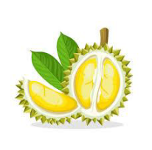





Focus with Manal

**Turn the page/ أقلب الصفحة**

4

**🏵Orthography🏵**

**➀Choose the correct letter.**

1. We are going on a **vac_tion** (**e/a/i)**
2. My favorite season is **s_mmer** (**u / o/w)**
3. My brother was **_tuck** in the elevator yesterday (**s/c/x)**
4. The **weathe_** is very hot in May (**r/l/i)**
5. I want to be a **_ookeeper (s/f/z)**
6. I saw the **thie_** who stole my father’s car (**v/f/t)**
7. It’s going to rai__ today. You need your umbrella. **(l/n/r)**
8. I have ridden a **ca_el** last year. **(n/m/l)**



With my best wishes

Focus With Manal

By/Manal Al-Shareef