Kingdom of Saudi Arabia 1st Intermediate Grade

Ministry of Education Time: An hour and a half

Hefar Intermediate & Secondary School Number of papers: 3

Final Exam – Third Term - 1446 AH

1. **Guided Composition:**

**6**

Complete the following paragraph about ***Saudi National Day*** with the following

words in the box.

flag – September – cultural – celebrates – fireworks – Families

Saudi National Day

Everyone in Saudi Arabia (1) …………………………. the National Day on 23rd of (2) …………………………. . (3) ……..…………… celebrate together by flying the national (4) …………………………. and joining the celebrations in the streets. Many people attend performances and (5) …………………………. events. At night, everyone is excited to watch the (6) …………………………. light up the sky.

**6**

1. **Reading Comprehension:**

***Read the passage and answer the questions below:***

My name is Helen and I'm nine years old. I am a student. I've got blond hair. I get up at seven o'clock every morning. I take off my pyjamas, I wash my face and I **put on** my clothes. I like my pink T-shirt, my yellow trousers and my blue shoes and my red hat. Then I have breakfast: I eat biscuits, I drink milk with cocoa and a glass of orange juice. I brush my teeth and I go to school by bus. At school I read and write. I have lunch at the school canteen. I go home at four o'clock. I play basketball with my friends, and I do my homework. I have dinner with my family in the evening. I watch TV with my family, then I put on my pyjamas, and I go to bed.

1. **Choose the correct answer:**
2. Helen is …… years old.

|  |  |  |  |
| --- | --- | --- | --- |
| 1. 7 | 1. 8 | 1. 9 | 1. 10 |

1. ‘put on’ means ………….

|  |  |  |  |
| --- | --- | --- | --- |
| 1. play | 1. wear | 1. go | 1. visit |

1. How does she get to school?

|  |  |  |  |
| --- | --- | --- | --- |
| 1. by bus | 1. by car | 1. by bike | 1. on foot |

1. She has hunch at the ………...

|  |  |  |  |
| --- | --- | --- | --- |
| 1. restaurant | 1. home | 1. canteen | 1. cafeteria |

1. She watches TV with her ………….

|  |  |  |  |
| --- | --- | --- | --- |
| 1. friends | 1. family | 1. cousins | 1. grandparents |

1. Which sport does she like to play with her friends?

|  |  |  |  |
| --- | --- | --- | --- |
| 1. football | 1. tennis | 1. basketball | 1. volleyball |

1. **Grammar:**

**7**

1. **Choose the correct answer:**
2. I **can** ……... English fluently.

|  |  |  |  |
| --- | --- | --- | --- |
| 1. speak | 1. speaks | 1. spoke | 1. speaking |

1. He ……….. his uncle **next** week.

|  |  |  |  |
| --- | --- | --- | --- |
| 1. visit | 1. visit | c--is going to visit | d-- visiting |

1. She **wants** ………… a smartphone.

|  |  |  |  |
| --- | --- | --- | --- |
| 1. buy | 1. buys | 1. to buy | 1. bought |

1. There ………… **a** party in my uncle’s house **last night**.

|  |  |  |  |
| --- | --- | --- | --- |
| 1. was | 1. were | 1. is | 1. are |

1. …………. he sleep early **yesterday**?

|  |  |  |  |
| --- | --- | --- | --- |
| 1. Do | 1. Does | 1. Doing | 1. Did |

1. He **usually** ………… pizza.

|  |  |  |  |
| --- | --- | --- | --- |
| 1. eat | 1. eats | 1. eating | 1. ate |

1. **Do as shown between brackets:**
2. Sara watched TV last night.  **(Change into negative)**

…………………………………….

1. There was a tree in the park. **(Change to the plural form)**

…………………………………….

1. **(Complete the sentences using must or mustn’t)**
2. We ……………… drive too fast.
3. We ……………… listen to the teacher.
4. **Vocabulary**:

**7**

1. **Write the words under the pictures:**



**race – vendor – sneakers – rollerblade – donate**

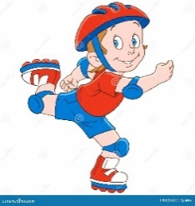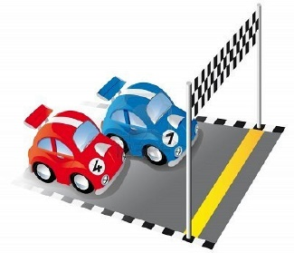

_____________ ______________ _____________ ______________

1. **Choose the correct answer to fill in the blank in each question:**
2. I will ………….. my cousins for Eid.

|  |  |  |  |
| --- | --- | --- | --- |
| 1. invite | 1. study | 1. hit | 1. borrow |

1. Omar was the best boxer in the ………………..

|  |  |  |  |
| --- | --- | --- | --- |
| 1. rice | 1. tournament | 1. drive | 1. boss |

1. **‘looking for’** means:

|  |  |  |  |
| --- | --- | --- | --- |
| 1. assignment | 1. homework | 1. playing | 1. searching |

**4**

1. **Orthography:**
2. **Choose the correct missing letters:**
3. An **air__ort** is a place where airplanes can land or take off.

|  |  |  |  |
| --- | --- | --- | --- |
| 1. b | 1. d | 1. p | 1. t |

1. Samar went to the **s__permarket** to buy some eggs and milk.

|  |  |  |  |
| --- | --- | --- | --- |
| 1. a | 1. o | 1. u | 1. y |

1. My father wore a new pair of **glo__es** yesterday.

|  |  |  |  |
| --- | --- | --- | --- |
| 1. b | 1. f | 1. d | 1. v |

1. I have a small **g__ft** for you.

|  |  |  |  |
| --- | --- | --- | --- |
| 1. a | 1. e | 1. i | 1. o |

1. Today, some **s__yscrapers** have 100 floors or more.

|  |  |  |  |
| --- | --- | --- | --- |
| 1. c | 1. k | 1. j | 1. g |

1. We need to **pro__ect** Earth because it is our home.

|  |  |  |  |
| --- | --- | --- | --- |
| 1. t | 1. r | 1. u | 1. l |

1. A **co__sole** is an equipment for video game.

|  |  |  |  |
| --- | --- | --- | --- |
| 1. m | 1. n | 1. o | 1. j |

1. If you warm ice, it will **me__t** into water.

|  |  |  |  |
| --- | --- | --- | --- |
| 1. r | 1. l | 1. i | 1. h |

**END OF QUESTIONS**

**BEST OF LUCK**

**Ms. Tahani AlGhamdi ☺**

|  |  |  |
| --- | --- | --- |
| **Kingdom of Saudi Arabia**  **Ministry of Education**  **Education Directorate**  **Intermediate Schoo**l | نتيجة بحث الصور عن شعار الوزارة شفاف | **Super goal 2. - English Language**  **1st Intermediate Grade**  **Super goal 1 Time: 3hours** |

**اختبار نهاية الفصل الدراسي الثالث الدور الاول لصف الاول المتوسط 1446 هـ -2025م**

**اللهّم لا سَهلَ إلا ما جعلتُه سَهلاً فإنكَ تَجعَلُ الحزنَ إذا شِئتَ سَهلاَ "**

اسـم الطالبة: .......................... رقم الجلوس...............................

***30***

**لدرجة النهائية رقما**: **الدرجة النهائية كتابة: ................................................**

|  |  |  |  |  |  |
| --- | --- | --- | --- | --- | --- |
| **السؤال** | **الدرجة** | **الدرجة كتابة** | **المصححة** | **المراجعة** | **المدققة** |
| **الأول** |  | فقط |  |  |  |
| **الثاني** |  | فقط |  |  |  |
| **الثالث** |  | فقط |  |  |  |
| **الرابع** |  | فقط |  |  |  |
| **الخامس** |  | فقط |  |  |  |

1) **Composition**

**6**

**1- Write a paragraph about “Your Favorite Place"**

**You may use 50 words:**

…………………………………………

……………………………………………………………………………………………………………………………………………………………………………………………………………………………………………………………………………………………………………………………………………………………………………………………………………………………………………………………………………………………………………………………………………………………………………………………………………………………………………………………………………………………………………………………………………………………………………………………………………………………………………………………………………………………………………………………………………………………………………………………………………………………………………….

**2) Comprehension**

**6**

**2- Read the following passage then answer the questions:**

**The Sports Center**

I like to go to the sports center. I go there every weekend. At the sports center, you can do many things. For example, you can play golf or tennis. There is a pool, so you can also swim or relax by the pool. There is a beach next to the sports center. You can swim, water-ski, or windsurf in the ocean. You can also sail on windy days. There aren’t any fish near the beach, so you can’t snorkel. When I go to the sports center, I like to play volleyball on the beach. I also like to jog on the beach. I can’t swim well, so I don’t like to water-ski or windsurf.

**A- Put ( ) or ( x ):**

1. The writer likes the sports center. ( )

2. You can swim in the pool or in the ocean. ( )

3. People can windsurf in the pool. ( )

4. You can’t use a boat in the ocean. ( )

5. In the sports center, there aren't many things. ( )

B- Choose the correct answer:

1. There is a (peach – beach – fetch) next to the sports center.

2. There aren’t any (fish – meat – fruit) near the beach

3. He doesn’t like to water-ski or (windows – doors – windsurf).

4. You can also sail on (rainy – snowy – windy) days.

C- Answer the following questions:

1. Where does the writer like to go?.............................

2. When does he go?...........................

3. What does he play on the beach? ..............................

**3) Grammar**

**A: Choose the correct answer:**

**7**

1. We like to ( goes – going - go - went ) shopping .
2. ( Are -Am - Is ) you going to go to Dubai ?
3. Amal is ( book – books – booking – booked ) the restaurant tonight .
4. Sami answers ( he - his – him - her ) homework everyday .
5. Where ( was - were - is – am ) you born ?
6. I can ( play - plays – playing - played ) chess .
7. Last week ,we ( travel -travels - travelled – travelling ) to Jeddah .
8. We must ( followed - follow – following ) the rule .
9. There ( are - were - was - is ) many fountains in this park 20 years.
10. They enjoy ( swim - swimming - swims - swimed ) in the summer .

**B: Do as shown between brackets ;**

1. Ahmad is going to wear sandals to the beach. **(Chang into Negative )**

……………………………………………………………………………………………………………………………………

2. She was tired .( **Make Yes/No question )**

……………………………………………………………………………………………………………………………………

3..Snacks / to buy / you / Do / need / ? ( **Reorder )**

……………………………………………………………………………………………………………………………………

4- Ahmad can't **writes** stories ………………………………. **( correct the verb )**

**4) vocabulary:**

**7**

**A- Match the words with the pictures:**

- basketball – Socks - Tie - fireworks- Calender –Suchi

 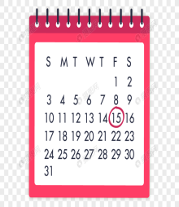  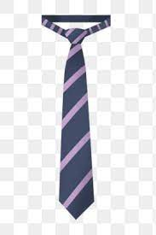 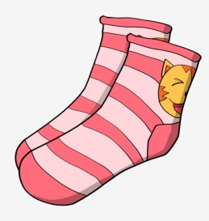 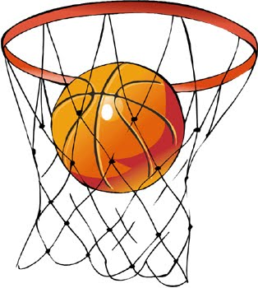

**……………... ……………. ……..………. ……..…… ………… …………..**

**B- Match the answers:**

|  |  |
| --- | --- |
| a. hotel | 1. a place you can shopping and meet friends |
| b. bank | 2. a place you can fly to places |
| c. airport | 3. a place you can open an account |
| d. mall | 4. a place visitors can sleep there |

**c- Find the odd words ;**

1. Dress jeans abaya skirt ……………
2. Shirt hats sandals shoes ……………
3. T-shirt shirt gloves blouse ……………
4. Watch school help eat …………..

**5) Orthography**:

**4**

1. **Fill in the missing letters:**

**k- m– d – r – c – s - t- n**

1- restaura……t 2- boo….s

3- bu….inessman 4- Sa..rifice

5- celeb__ation 6-Gra……..uation

7- gy…… 8-Stri…..er

**B- Circle the correct spelling:**

1.musuem - museum – meusum

2. house – huoes - hosue

3. snack - sncak - scnak

4- spicy - sbicy - sipcy

**C-Write the correct missing letters under each picture ;**

**( z - s - n - t )**

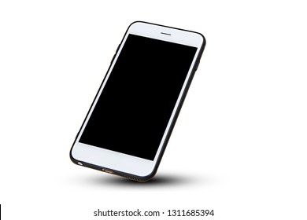 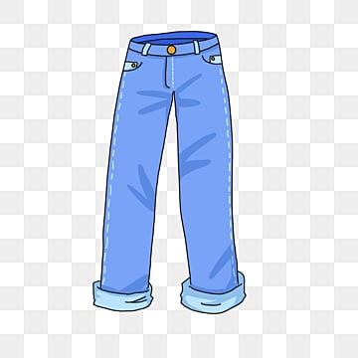 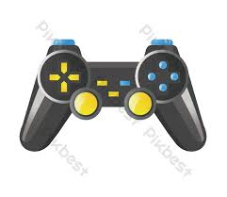 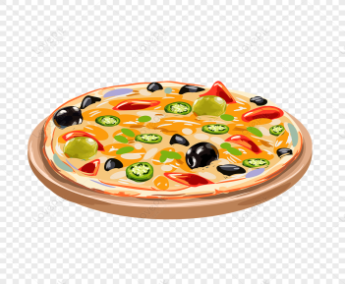

Smar…phone Pa…… ts Con……ole Piz…….a

**Best of Luck**

# نتيجة بحث الصور عن شعار الوزارة شفاف

Super Goal 1 - English Language

**First Intermediate Grade**

Third Term Final Exam 1446-2025

**First Round** | Time: 1.5 hour

Kingdom of Saudi Arabia

Ministry of Education

………. Education Directorate

……………Intermediate School

**المراجع**

**checker**

**أ /..........**

**الدرجة كتابه**

**Written**

**المجموع**

**Total / 30**

**المصحح**

**corrector**

**أ / راشد السلمي**

**Q16**

**Q26**

**Q37**

**Q4**

**4**

**Q57**

اسم الطالب

رقم الجلوس

Composition

**اللهّم لا سَهلَ إلا ما جعلتُه سَهلاً فإنكَ تَجعَلُ الحزنَ إذا شِئتَ سَهلاَ " "**

**Write about what you are going to do on your next vacation.**

Guide words:

**( enjoy – exploring – new food – activities – the weather – the place – language – relaxing – city – trip )**

..................................................................................................................................................................................................................

..................................................................................................................................................................................................................

..................................................................................................................................................................................................................

..................................................................................................................................................................................................................

..................................................................................................................................................................................................................

..................................................................................................................................................................................................................

..................................................................................................................................................................................................................

..................................................................................................................................................................................................................

..................................................................................................................................................................................................................

..................................................................................................................................................................................................................

**6**

**اقلب الصفحة**



Comprehension

**6**

* **Read the following passage and answer the questions below:**

Ali usually has a relaxing Saturday. He doesn’t have work, so he always wakes up late on Saturdays—usually at 10 A.M. Then he has a cup of coffee and makes a big breakfast. He eats breakfast and then reads the news online. Sometimes he goes to visit his cousin on Saturday afternoons, and sometimes he goes for a long walk with his brother. He usually watches a football game on Saturday evenings. Sometimes he meets his family at a restaurant to have dinner. He watches TV at night, and then goes to bed at 10 P.M. so that he’s ready for work on Sunday.

**A. Choose the correct answer:**

1. The text is about Ali’s ____________ .

**a**. Saturdays  **b**. Sundays **c**. weekends **d.** Mondays

1. Ali _____________ wakes up late on Saturdays.

**a**. never **b** sometimes **c** usually **d.** always

1. Ali usually eats a big _____________ on Saturdays.

**a**. food  **b**. breakfast **c**. lunch **d.** dinner

**B. Write (T) for True or (F) for False:**

|  |  |
| --- | --- |
| **4.**  Ali sometimes goes for a long walk with his brother . |  |
| **5.** Ali usually watches a football game on Saturday mornings . |  |
| **6.** Ali goes to bed at 10 P.M |  |

**اقلب الصفحة**



**7**

Grammar

* **Choose the correct answer**

1. He can’t surf, but he _____ water-ski.

**a**. can’t **b**. can  **c**. not can **d.** don’t can

1. **Aisha:** Do they like to relax on the beach? **Lucy:** Yes, _____.

**a**. they do **b**. do they  **c**. not they  **d.** they don’t

1. I _____ play volleyball, but I can play tennis.

**a**. can **b**. am can  **c**. can’t  **d.** am can’t

1. I’m not going to buy jeans. ____________ pants.

**a**. I’m going to buy **b**. I buying  **c**. I’m going buying **d.** I going to buy

1. Susan ____________ a dress. She’s going to wear a skirt and blouse.

**a**. isn’t wear **b**. not wearing  **c**. isn’t going to wear **d.** isn’t going to wearing

1. They ____________ suits. They’re going to wear jeans.

**a**. not wearing **b**. not going to wearing **c**. aren’t going wear **d.** aren’t going to wear

1. _____ Bob to our house!

**a**. We invite **b**. Let invite  **c**. Let’s invite **d.** Let’s us invite

1. Do you _____ a film on TV tonight?

**a**. want to watch **b**. want watch  **c**. want watching **d.** want to watching

1. You _____ the street when the light is red.

**a**. mustn’t cross **b**. should cross not **c**. must not to cross **d.** should cross

1. My grandfather _____ a car salesman.

**a**. was **b**. were  **c**. not **d.** be

1. Majed Ahmed Abdullah _____ in Jeddah.

**a**. is born **b**. are born  **c**. was born **d.** were born

1. When I was a child, I _____ a good student.

**a**. wasn’t be **b**. not **c**. wasn’t **d.** weren’t

1. We didn’t go to the football game yesterday. We_____ to the museum.

**a**. go **b**. went  **c**. are **d.** going

1. Sally didn’t drink coffee. She _____ water.

**a**. is drink **b**. drinking  **c**. drink **d.** drank

Orthography

**4**

* **Choose the correct letters :**

1. You can go sho…..ping and meet friends. ( v – p – r )
2. You can fly to pla…..es. ( n – o – c )
3. Nawal is going to buy aba…..a ( y – o – r )
4. You need warm clothes it’s …..old in Abha ( n – o – c )
5. I don’t have an in…itation to the party ( y – v – r )
6. Let’s get some ca…ds for the National Day ( r – o – c )
7. Balad, the old pa…t of Jeddah ( y – v – r )
8. Ahmed was pleased with his prese…tation ( o – t – n )

**اقلب الصفحة**



Vocabulary

* **Choose the correct answer:**

**7**

1. You can _____ at the pool.

**a**. swim **b**. surf  **c**. rollerblade **d.** sail

1. My friends like to _____. They enjoy looking at underwater attractions.

**a**. swim **b**. sail  **c**. surf  **d.** snorkel

1. He’s going to wear a shirt and a ____________.

**a**. shoes **b**. tie  **c**. shorts **d.** white

1. Do you need to buy new ____________ to play basketball?

**a**. suit **b**. shirt  **c**. sneakers  **d.** blouses

1. On December 2nd, they _____ Federation of the Emirates in the UAE.

**a**. parades **b**. decorate  **c**. celebrate **d.** share

1. In Saudi Arabia, people fly _____ on September 23rd.

**a**. flags **b**. streets  **c**. fireworks  **d.** celebrations

1. In old Riyadh, many houses were made from ____ bricks.

**a**. ruins **b**. town  **c**. mud **d.** city

1. In modern Riyadh, you can see many ______.

**a**. skyscrapers **b**. walls  **c**. population  **d.** areas

1. **Adel:** What did you do last night? **Ali:** I went to a friend’s house and watched _____.

**a**. a car race **b**. the zoo  **c**. a computer club **d.** home

1. **Peter:** Do you have any clean clothes? **Andy:** Yes, I do. I did my _____ yesterday.

**a**. closet **b**. laundry  **c**. home  **d.** house

1. **Chang:** What did you do yesterday? **Todd:** I went to the _____ and played volleyball.

**a**. car race **b**. beach  **c**. museum  **d.** zoo

1. **Sabah:** What did you do yesterday? **Aisha:** I went to a _____. I love history.

**a**. restaurant **b**. closet **c**. mall **d.** museum

* **Write the correct word under the picture.**



Graduation day – Gym – calendar

صورة تحتوي على نص, نافذة, مبنى

تم إنشاء الوصف تلقائياً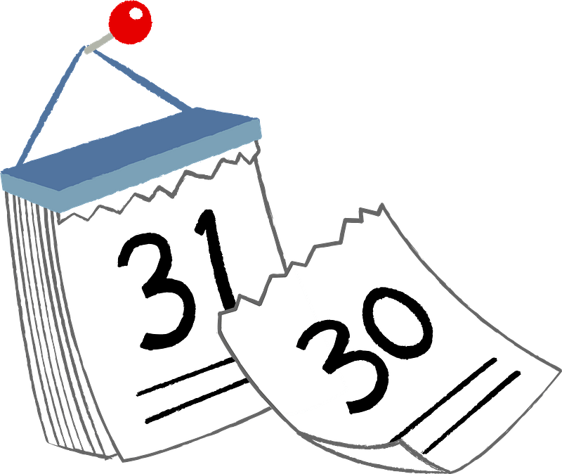

**14.**

**13.**

**12.**

………………………….…

………………………….…

………………………….…

**انتهت الأسئلة .. ..**

**وبالله التوفيق والنجاح ..**

**الأستاذ / راشد السلمي**

**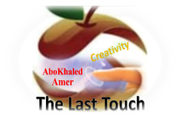****المملكة العربية السعودية**

**6**

**وزارة التعليم**

**الإدارة العامة للتعليم بن**

**مدارس م ن التعليمية**

**الصف الاول المتوسط**

**الاختبار النهائي للفصل الدراسي الثالث1446**

|  |  |  |  |  |  |  |  |
| --- | --- | --- | --- | --- | --- | --- | --- |
| **Total**  **written** | **5 spelling** | **4 Vocabulary** | **3 Grammar** | **2 Comprehension** | | **1 Composition** | **Q. NO.** |
|  |  |  |  |  | |  | **Mark Given** |
| **30** | **4** | **7** | **7** | **6** | | **6** | **Mark** |
|  | | | **Reviser** | |  | | **Corrector** |
|  | |

**زمن الاختبار: ساعتان**

**اسم الطالب: ------------------------------------ رقم الجلوس: ------------- الصف الأول المتوسط**

flag – September – cultural – celebrates – fireworks – Families

1) **Composition**

**1- Write a paragraph about “Your Favorite Clothes"**

**You may use the following words: favorite – cool – wear – home - weather- school-…**

**6**

**2) Comprehension**

**7**

**2- Read the following passage then answer the questions:**

**Janadriyah Festival**

**Every year in Saudi Arabia, many people from all over the country and from abroad attend the Janadriyah national heritage and culture festival. The festival takes place in a village near Riyadh, and it is normally held between November and March when the heat is less extreme. The festival celebrates symbols of Saudi identity. There are camel races and horse races, displays of regional costumes, cuisines, and crafts such a carpet-weaving, and pottery. There are donkey rides, which are very popular with children. The festival lasts for two weeks.**

**A- Put ( ) or ( x ):**

**1.The text is about camel racing in Saudi Arabia. ( )**

**2.Only people who live in Saudi Arabia can attend the festival. ( )**

**3.The festival is usually held when the temperatures are cooler. ( )**

**4.Children like the donkey rides. ( )**

**5. The festival lasts for two weeks. ( )**

**B- Choose the correct answer:**

**1. Janadriyah is Every (**month – season – year**) in Saudi Arabia.**

**2. There are camel races and horse (**eating – races – graces**).**

**3. The festival celebrates symbols of Saudi (**flag – people – identity**)**

**4. The festival is between November and (**April – March – May**).**

**C- Answer the following questions:**

**1. What is the name of the festival?.............................**

**2. Where does Janadriyah take place?...........................**

**3. How long does the festival last? ..............................**

**3) Grammar**

**A: Choose the correct answer:**

**7**

**1. She is good at English. She (**can – can't – is**) speak it well**

**2. He (**don't like – doesn't like – isn't like**) to cook food.**

**3. They (**am – is – are**) going to sleep early.**

**4. I want to meet my neighbors. I don’t know (**them – him – her**)**

**5. We need (**to buy – buy – buying**) some snacks.**

**6. He (**was – were – are**) at home.**

**7. They (**went – goes – going**) to the beach last summer.**

**8. Did he play football? Yes, he (**is – did – didn't**).**

**B: Chang into Negative:**

**1. I can clean my room.**

…………………………………………………………………………………………………………………………………………………………………………………………………………………

**2. She is going to help her mom.**

……………………………………………………………………………………………………………………………………

3. **They watched TV at home.**

……………………………………………………………………………………………………………………………………

**C: Make Yes/No question:**

**1. She can cook lunch.**

……………………………………………………………………..……………………………………………………………

**2. They are going to study English.**

……………………………………………………………………………………………………………………………………

**3. He worked hard.**

……………………………………………………………………………………………………………………………………

**4) vocabulary:**

**race – vendor – sneakers – rollerblade – donate**

**A- Match the words with the pictures :**

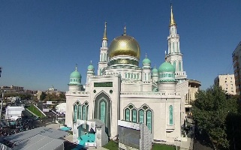**pizza 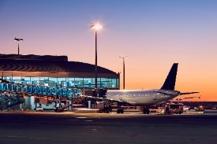– shoes – graduation – mosque – airport – exercise**



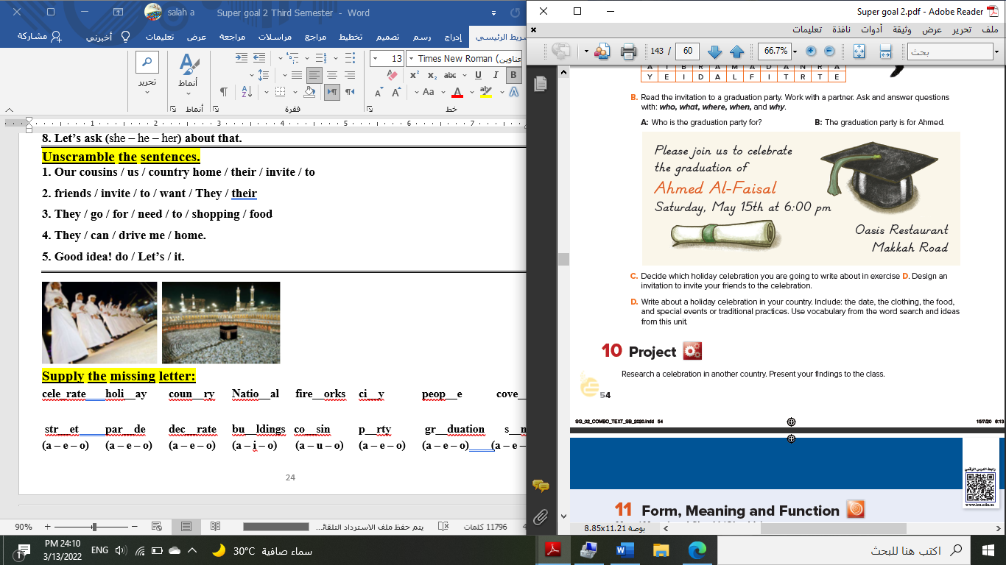****

**……………... ……………. ……..………. ………… …………… …………..**

**B- Match the answers:**

|  |  |
| --- | --- |
| a. National Day | **1. Visitors can sleep there. --------** |
| b. Vacation | **2. Women wear these formal clothes.** -------- |
| c. hotel | **3. In Saudi Arabia, people celebrate the -**------ |
| d. abayas | **4. Majed Ahmed Abdullah was a famous** ------- |
| e. footballer | **5. We traveled to Egypt during the summer ---------** |

**C- Circle the correct spelling:**

**1. moring - morning – marning**

**2. skyscraper – skyskraper - ckyscraper**

**3. celebote – celeprate – celebrate**

**5) Orthography**:

**4**

**A- Fill in the missing letters:**

**1- cl__thes**

**اختبار نهاية الفصل الدراسي الثالث الدور الاول لصف الاول المتوسط 1446 هـ -2025م**

**2- book__tore**

**3- par__de**

**4- pop__lation**

**B- Choose the odd one out:**

**1. shorts jeans pants TV**

**2. school restaurant gym eat**

**3. watched TV Played tennis helped Ali eat fish**

**4. footballer doctor scientist car**

**End of Questions**

**Best of Luck** [**https://t.me/mnhaji1m**](https://t.me/mnhaji1m)

******المملكة العربية السعودية**

اسـم الطالبة: .......................... رقم الجلوس...............................

**وزارة التعليم**

**الإدارة العامة للتعليم بن**

**مدارس م ن التعليمية**

**الصف الاول المتوسط**

**الاختبار النهائي للفصل الدراسي الثالث1446**

|  |  |  |  |  |  |  |  |
| --- | --- | --- | --- | --- | --- | --- | --- |
| **Total**  **written** | **5 spelling** | **4 Vocabulary** | **3 Grammar** | **2 Comprehension** | | **1 Composition** | **Q. NO.** |
|  |  |  |  |  | |  | **Mark Given** |
| **30** | **4** | **7** | **7** | **6** | | **6** | **Mark** |
|  | | | **Reviser** | |  | | **Corrector** |
|  | |

**زمن الاختبار: ساعتان**

**اسم الطالب: ------------------------------------ رقم الجلوس: ------------- الصف الأول المتوسط**

***30***

1) **Composition**

**1- Write a paragraph about “Your Favorite Place"**

**You may use 50 words:**

**6**

**2) Comprehension**

…………………………………………

……………………………………………………………………………………………………………………………………………………………………………………………………………………………………………………………………………………………………………………………………………………………………………………………………………………………………………………………………………………………………………………………………………………………………………………………………………………………………………………………………………………………………………………………………………………………………………………………………………………………………………………………………………………………………………………………………………………………………………………………………………………………………………….

**2- Read the following passage then answer the questions:**

**The Sports Center**

**I like to go to the sports center. I go there every weekend. At the sports center, you can do many things. For example, you can play golf or tennis. There is a pool, so you can also swim or relax by the pool. There is a beach next to the sports center. You can swim, water-ski, or windsurf in the ocean. You can also sail on windy days. There aren’t any fish near the beach, so you can’t snorkel. When I go to the sports center, I like to play volleyball on the beach. I also like to jog on the beach. I can’t swim well, so I don’t like to water-ski or windsurf.**

**A- Put ( ) or ( x ):**

**1. The writer likes the sports center. ( )**

**2. You can swim in the pool or in the ocean. ( )**

**3. People can windsurf in the pool. ( )**

**4. You can’t use a boat in the ocean. ( )**

**5. In the sports center, there aren't many things. ( )**

**B- Choose the correct answer:**

**1. There is a (**peach – beach – fetch**) next to the sports center.**

**2. There aren’t any (**fish – meat – fruit**) near the beach**

**3. He doesn’t like to water-ski or (**windows – doors – windsurf**).**

**4. You can also sail on (**rainy – snowy – windy**) days.**

**C- Answer the following questions:**

**1. Where does the writer like to go?.............................**

**2. When does he go?...........................**

**3. What does he play on the beach? ..............................**

**3) Grammar**

**A: Choose the correct answer:**

**6**

**1. She (**can – can't – does**) cook well. She is bad at cooking.**

**2. We (**don't like – doesn't like – isn't like**) to stay up for late hours.**

**3. She (**am – is – are**) going to visit her friends.**

**4. Ali is a nice guy. I want you to meet (**them – him – her**)**

**5. He wants (**to reads – to read – to read**) some books.**

**6. We (**was – were – are**) at home, waiting for you.**

**7. They (**eat – eating – ate**) a delicious meal last weekend.**

**8. Did you do your homework? No, I (**is – did – didn't**).**

**B: Chang into Negative:**

**1. They can play football.**

…………………………………………………………………………………………………………………………………………………………………………………………………………………

**2. He is going to dust his room.**

……………………………………………………………………………………………………………………………………

3. **We stopped at the supermarket to buy ice cream.**

……………………………………………………………………………………………………………………………………

**C: Make Yes/No question:**

**1. He can read English well.**

……………………………………………………………………..……………………………………………………………

**2. She is going to call her friend.**

……………………………………………………………………………………………………………………………………

**3. We visited our friends in Najran.**

……………………………………………………………………………………………………………………………………

**4) vocabulary:**

**7**

**A- Match the words with the pictures:**

****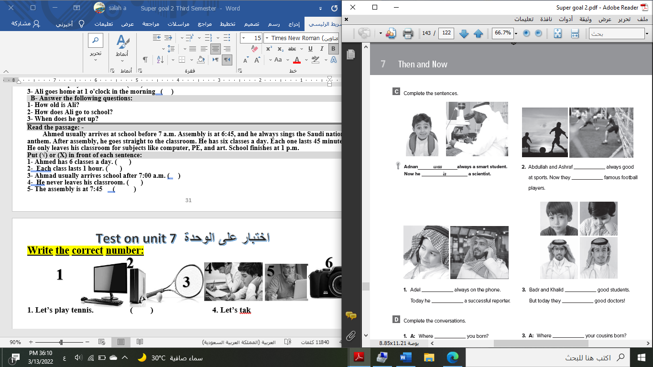**doctor - meal – shirt – bus stop – fireworks – beach**

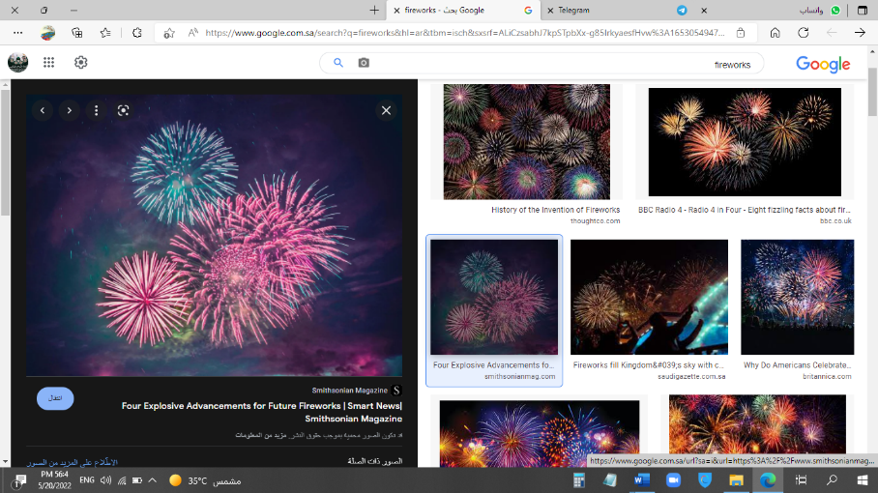

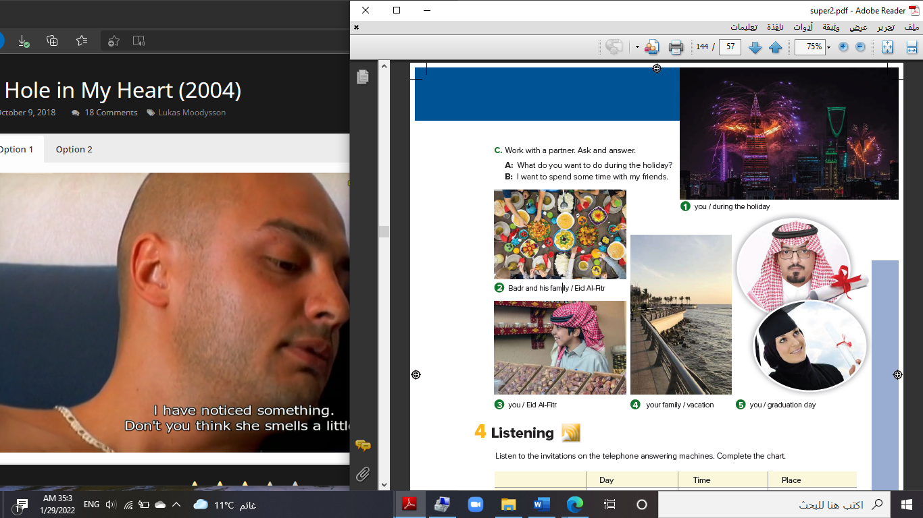****

**……………... ……………. ……..………. ……..…… ………… …………..**

**B- Match the answers:**

|  |  |
| --- | --- |
| a. green color | **1. You can open an account. ------** |
| b. Riyadh | **2. Men wear it for work. ------** |
| c. bank | **3. In Saudi Arabia, people decorate houses in ------** |
| d. thobe | **4. The King of Saudi Arabia is ------** |
| e. King Salman | **5. It was a traditional place then i**t **became the capital ------** |

**C- Circle the correct spelling:**

**1. natonial - nashional – national**

**2. house – huoes - hosue**

**3. yesteday – yesterday – yetserday**

**5) Orthography**:

**7**

**A- Fill in the missing letters:**

**1- buil__ing**

**4**

**2- cons__le**

**3- celeb__ation**

**4- air__ort**

**B- Choose the odd one out:**

**1. suit jeans tie abaya**

**2. watch school help eat**

**3. Emirates Kuwait under Oman**

**4. teacher morning afternoon evening**

**End of Questions**

**Best of Luck**  [**https://t.me/aikhtibart**](https://t.me/aikhtibart)

**المملكة العربيةالسعودية الصف: الأول متوسط**

**وزارة التعليم مادة : اللغة الإنجليزية**

**المتوسطة __ الزمن: ساعة ونصف**

**أسئلة اختبار الفصل الدراسي الثالث للعام 1446هـ**

**عدد الصفحات: 4 عدد الأسئلة :5**

++++++++++++++++++++++++++++++++++++++++++++++++++++++++

|  |  |  |
| --- | --- | --- |
|  |  |  |
| **I-Composition:** | SG1 T3 Us 12 to 16 | **6** |

‘’ **Tell me what you eat, and I will tell you who you are** “

**\*Write a paragraph about Your Favorite Food. Give your opinion about it. Use the questions below to guide you :**

1-How many meals a day do you eat?

2.What food can you cook?

3. How often do you eat out?

4.What is your favorite food? Why

any suitable paragraph

**__________________________________________________________________**

**__________________________________________________________________**

**__________________________________________________________________**

**__________________________________________________________________**

2 marks structure

2 marks ideas

1 punctuation

1 on-off composition- related to the subject.

**__________________________________________________________________**

**__________________________________________________________________**

**__________________________________________________________________**

**__________________________________________________________________**

**__________________________________________________________________**

**__________________________________________________________________**

**__________________________________________________________________**

**__________________________________________________________________**

**__________________________________________________________________**

**_______________________________________________________**

6

**II-Comprehension:**

6

**Read the passage and answer the questions below:**

Sara is fifteen years old. She lives in Riyadh. She is in the 9th grade. She usually likes casual clothes, like a pair of jeans, a t-shirt, and trainers. She also likes to wear a tracksuit; it is so comfortable for her. Sara rarely wear skirts or dresses and high heels; it is not her style. But she can wear them when she goes to s special event like wedding or a party. When Sara goes to the restaurant with her friend Nawal, she wears trousers and a blouse. In summer, Sara wears skirt and a tank top. In spring, she likes wearing a blue jacket. In winter, Sara wears coats, gloves, and boots.

|  |  |  |  |  |
| --- | --- | --- | --- | --- |
| **Multiple Choice ( 1- 35 )** | | | | |
| **Comprehension (1-4)** | | | | |
| **A*Choose the correct answer :** | | | | |
| **1**- The **main idea** of the passage is … ……………. | | | | |
| d. the weather | | c- a celebrity | b- Sara's clothes | a- the museum |
| **2**-In line 1 (casual) is the opposite of….. | | | | |
| d. formal | | c- big | b- nice | a- single |
| 3-In line 6 (she) refers to…. | | | | |
| d-Lana | | c- Huda | b- Nawal | a- Sara |
| **4**- Sara likes to wear a ………………. jacket in spring. | | | | |
| d. yellow | | c- blue | b- red | a- green |
| **F**alse**\T**rue | **B*Put ( T√) or ( Fx ) (1-2)** | | | |
| **T** | 1- Sara lives in Riyadh. | | | |
| **F** | 2- Sara goes to the restaurant with her mom. | | | |

|  |  |  |
| --- | --- | --- |
| **III-Grammar:/Multiple Choice: ( 5 to 11 )** |  |  |
| **Choose the correct words:** |  | **7** |

|  |  |  |  |
| --- | --- | --- | --- |
| **5**- I can't stand ……………. in that small house. | | | |
| d-live | c- living | b- lived | a- lives |
| **6**- She ……………….. home now. | | | |
| d- went | c- to go | b- is going | 1. goes |
| **7**- They are going to ………… a new computer. | | | |
| d-get | c- gets | 1. got | 1. getting |
| **8**- She …………….. fire yesterday. | | | |
| d- sees | c- seeing | 1. see | 1. saw |
| **9**- We are hungry. The rice is for ……………... | | | |
| d- me | c-her | b- us | 1. him |
| **10**- She ……… in Abha last month | | | |
| d- were | c- be | 1. been | 1. was |
| **11**- He can ……………. the piano. | | | |
| d- play | c- plays | b- playing | 1. played |

**77**76

|  |
| --- |
| **Vocabulary: ( 1 to 6 )** |
| **Pairing Question:** |

|  |  |  |  |  |
| --- | --- | --- | --- | --- |
| 1 | She'll go **snorkeling** with her sister. | **F** | A | the condition of the atmosphere |
| 2 | He usually wears **casual** clothes. | **D** | B | to travel on the water |
| 3 | I'd like to **invite** you to the party. | **G** | C | someone who is visiting you |
| 4 | A **skyscraper** has been built. | **E** | D | the opposite of formal |
| 5 | Our **guest** is arriving. | **C** | E | a very tall building in a city. |
| 6 | We'll **sail** on Monday. | **B** | F | swimming with a diving mask |
|  | | | G | to ask someone to go to an event |

|  |
| --- |
| **IV-Vocabulary:/Multiple Choice: ( 12 to 19 )** |
| **Choose the correct words:** |

|  |  |  |  |
| --- | --- | --- | --- |
| **12-** Many people …………………….at this mall. | | | |
| d- study | c- read | b- shop | a- play |
| **13**- Tom's ………………….. were muddy. | | | |
| d- tie | c- boots | b- suit | a- shomagh |
| **14**- He had to ………….. another animal. | | | |
| d- know | c- cover | b- donate | a- sacrifice |
| **15**. The ……….. signal had turned to green. | | | |
| d- pedestrian | c- consultant | b-boss | a- businessman |
| **16**- I couldn't find a seat because the train was very ……...,. | | | |
| d- comfortable | c- beautiful | b- crowded | a- good |
| **17**- I love Indian cooking, because it is hot and …………... | | | |
| d- fresh | c- spicy | b- sweet | a- salty |
| **18**- We attended our school to have our ………………………….. party | | | |
| d- garden | c- birthday | b- wedding | a- graduation |
| **19**- I should have a ………………………….. account to keep your money. | | | |
| d- hospital | c- bus station | b- bank | a- school |

**4**76

|  |
| --- |
| **V-Orthography (Spelling): ( 20 to 35 )** |

|  |  |  |  |  |  |  |  |  |  |  |  |  |
| --- | --- | --- | --- | --- | --- | --- | --- | --- | --- | --- | --- | --- |
| 20 | Long s__irts are in fashion. | | | | | | | 28 | She went to the muse__m. | | | |
| a. d | b. h | | c. k | | d.q | | a. o | b. i | c. e | d. u |
| 21 | I forgot my sc__rf. | | | | | | | 29 | These are wond__rful. | | | |
| a. e | | b. a | | c. i | | d. u | a. i | b. e | c. o | d. a |
| 22 | The old man gave the child sh__lter. | | | | | | | 30 | Kimchi is a tradition__al Korean dish. | | | |
| a. i | | b. o | | c. u | | d. e | a. j | b. k | c. h | d. n |
| 23 | I prefer m__dern furniture. | | | | | | | 31 | I'll see you at the re__taurant. | | | |
| a. e | | b. a | | c. o | | d. i | a. s | b. g | c. v | d. r |
| 24 | I tried to pr__tect you. | | | | | | | 32 | We have a hol__day today. | | | |
| a. i | | b. o | | c. a | | d. e | a. e | b. i | c. o | d. u |
| 25 | I found that restaurant by accide__t. | | | | | | | 33 | I'll sha__e them with you. | | | |
| a. n | | b. j | | c. k | | d. z | a. f | b. g | c. r | d. b |
| 26 | I often play v__lleyball. | | | | | | | 34 | The tr__nsportation system is quite good. | | | |
| a. u | | b. e | | c. o | | d. a | a. e | b. o | c. i | d. a |
| 27 | I was impr__ssed by his music. | | | | | | | 35 | We were playing gol__. | | | |
| a. o | | b. u | | c. i | | d. e | a. v | b. m | c. f | d. p |

**End of Questions**

**Best OF Luck !**

**Tr.Noureyah Alghamdi**