

English Language

elementary Grade …..

period Exam

…………….\20

Kingdom of Saudi Arabia

Ministry of Education

……..Education Directorate

………………… School

Student's Name : class:

[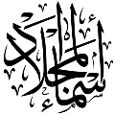](https://t.me/Asmaworld)

……\ 4 marks

General questions

**A. Answer the questions**

|  |  |  |  |
| --- | --- | --- | --- |
| **Yes, I do.** |  | **What’s your favorite animal?** | 1 |
| **He has a stomachache.** |  | **How is the tortoise moving?** | 2 |
| **My favorite animal is panda.** |  | **What is the matter?** | 3 |
| **The tortoise is moving slowly.** |  | **Do you need a doctor?** | 4 |

Controlled Writing

……\ 1 marks

**A-reorder.**

1- are \Lions \dangerous

………………………………………………………………………………………………..

Reading short sentence

……\ 4 marks

|  |  |
| --- | --- |
| Snail | **1-Snail can’t run or walk fast. ( )** |
|  | **2-You should sleep for ten hours every night ( )** |

**A-Put (** ✔ **) or (**  X  **)**

**B. Choose the correct answer**

|  |  |  |  |
| --- | --- | --- | --- |
| c-cut | b-stomachache | a-cough | 1-Mona has a bad …….. she is coughing a lot. |
| c-tall | b-carefully | a-smart | 2- My cat is …………… It can do tricks |

……\ 4 marks

Grammar

**A-Choose the correct answer.**

|  |  |  |  |  |
| --- | --- | --- | --- | --- |
| c- shouted | b- shouting | a- shout | I mustn't ……… in the hospital. | 1 |
| c-when | b-who | a- where | The jungle is………. tiger live. | 2 |
| c-something | b-no one | a- someone | There’s ……… in my eye. I can’t see at all! | 3 |
| c-most brave | b-braver | a-brave | The tiger is ………..than the mouse. | 4 |

Vocabulary

……\ 5 marks

**A.write the correct word under each picture**

**( brave - take off - earache - vet - lion )**

**)**

|  |  |  |  |  |
| --- | --- | --- | --- | --- |
| Brave Boy Vector Art, Icons, and Graphics for Free Download | Vector Illustration Of Kids Abstract Background SVG, Cliparty, ilustracje  stockowe oraz ilustracje wektorowe Royalty Free. Image 101672709 | Lion | Vet Vector Art, Icons, and Graphics for Free Download | Ear Ache Vector Art, Icons, and Graphics for Free Download |
|  |  |  |  |  |

Orthography

……\ 2 marks

**A. Fill in the missing letters.**

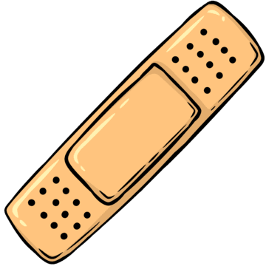

**1- band ai…**

**( h – u - d )**

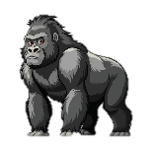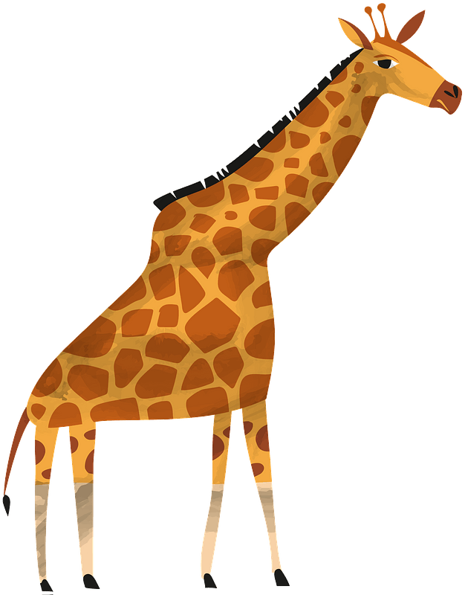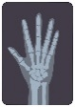

**2- …orilla**

**( z– r – g )**

**( s – t - o)**

**4- X-…ay**

**( g– o – r )**

**( s – t - o)**

**3-giraf…e**

**( o – q – f )**

**( s – t - o)**

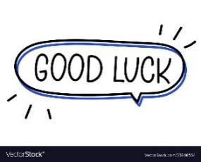

Your teacher …..:…………………………….

**المملكة العربية السعودية المادة: لغة انجليزية**

**وزارة التعليم اختبار فتري للفصل الثالث 1446هـ**

**إدارة التعليم بمنطقة مدرسة :**

|  |  |  |
| --- | --- | --- |
| **المجموع: 20 /** | **الصف:** | **الاسم:** |

**Choose the right answer:**

______________________________________________________________________________

|  |  |  |
| --- | --- | --- |
| **I have a headache.** | **I am going shopping.** | 1- What is the matter? |
| **It is asleep.** | **It is cat.** | 2- What's your favorite animal? |

**Read then circle (✔) or (✖):**

|  |  |  |  |
| --- | --- | --- | --- |
| 1- She has a toothache. | 60+ Free Stomach Clipart Images | ✔ | ✖ |
| 2- The bird is in the cage. | Bird Cage Images - Free Download on Freepik | ✔ | ✖ |
| 3- They are in the zoo. | صورة تحتوي على رسوم متحركة, تلبيس, الأحذية, شخص | ✔ | ✖ |

______________________________________________________________________________

**Do as shown between brackets:**

|  |  |  |
| --- | --- | --- |
| 1- cats / the quietest / are / pets (**Rearrange)**  ……………………………………………………………… | | |
| **interest** | **interesting** | 2- **Interest** is (noun) ( **Choose the adjective**) |
| ........................................ | | 3- The tall giraffe lives in Africa. (**Write the verb**) |

______________________________________________________________________________

**Choose the right answer:**

|  |  |  |
| --- | --- | --- |
| **mustn't** | **should** | 1-You______ drink a lot of water. It is good for your health**.** |
| **strongest** | **stronger** | 2- The lion is the ………………animal in the jungle. |
| **whose** | **who** | 3- The man ______ car is blue is my brother. |

______________________________________________________________________________

|  |  |  |  |  |
| --- | --- | --- | --- | --- |
| صورة تحتوي على رسوم متحركة, قصاصة فنية, توضيح, رسم | couch clipart |  |  | صورة تحتوي على شخص, الوجه الإنساني, بشرة, حائط  قد يكون المحتوى المعد بواسطة الذكاء الاصطناعي غير صحيح. |
| Shelter | couch | X-ray | Polar bear | headache |
| Vet | cough | back | Lion | stomachache |

______________________________________________________________________________

**Fill in the missing letters:**

|  |  |  |  |
| --- | --- | --- | --- |
| 1,100+ Giant Panda Stock Illustrations, Royalty-Free Vector Graphics & Clip  Art - iStock | Giant panda cub, Giant panda snow, Giant panda china | صورة تحتوي على بدة, فرس, حصان, الفحل | owattaphotos 사진, 이미지, 에셋 | Adobe Stock | صورة تحتوي على تعبيرات, مبتسم, الأصفر, دائرة  قد يكون المحتوى المعد بواسطة الذكاء الاصطناعي غير صحيح. |
| _anda | ho_se | Ca_le | __nhappy |
| b | r | b | O |
| p | n | f | U |

Kingdom of Saudi Arabia 4th, 5th & 6th Elementary Grade

Ministry of Education Third Term

**20**

………….. Elementary School . . Mid-Term Exam 1446 AH

**Name:** ………………………………………………………….………………. **Class: …………..**

|  |  |  |  |  |  |  |  |  |  |  |  |
| --- | --- | --- | --- | --- | --- | --- | --- | --- | --- | --- | --- |
| 1. **General Questions:** | | | | | | | | | | | |
| 1. **Choose the correct answer:** | | | | | | | | | | | |
| 1- **What’s the matter?** | | | | | | | | | | | |
| a- I have a stomachache. | | | | | b- I should go to the hospital. | | | | | | |
| 2- **What do you do?** | | | | | | | | | | | |
| a- I like rabbits. | | | | | b- I am a vet. | | | | | | |
| 1. **Controlled Writing:** | | | | | | | | | | | |
| 1. **Rearrange the words to form a sentence:** | | | | | | | | | | | |
| you eat – Wash – before – your hands | | | | | | | | | | | |
|  | | | | | | | | | | | |
| 1. **Reading short sentence:** | | | | | | | | | | | |
| 1. **Read the sentences then match them with the correct pictures:** | | | | | | | | | | | |
| |  |  | | --- | --- | | Match Opposites Stock Illustrations – 200 Match Opposites Stock ... | a-_I put on my clothes.  b-_I take off my clothes. | | Pet Store Or Animal Shelter Concept | EPS PNG Images Free Download ...  What's the matter with you? | Baamboozle - Baamboozle | The Most Fun ... | a-_ They’re at the zoo.  b-_ They’re at the animal shelter. | |  | a-_ He has an earache.  b-_ He has a cough. | | | | | | | | | | | | |
| 1. **Grammar:** | | | | | | | | | | | |
| 1. **Choose the correct answer:** | | | | | | | | | | | |
| 1. I want to ride my bike. You …………. wear a helmet. | | | | | | | | | | | |
| 1. must | | | | 1. mustn’t | | | | 1. don’t have to | | | |
| 1. Is there …………. to eat**?** I’m very hungry. | | | | | | | | | | | |
| 1. someone | | | | 1. nothing | | | | 1. anything | | | |
| 1. It was October …………… I visited Jeddah. | | | | | | | | | | | |
| 1. where | | | | 1. when | | | | 1. whose | | | |
| 1. The mouse is…………… than the frog. | | | | | | | | | | | |
| 1. fast | | | | 1. faster | | | | 1. fastest | | | |
| 1. **Vocabulary:** | | | | | | | | | | | |
| 1. **Choose the correct answer:** | | | | | | | | | | | |
| 31,300+ Face Mask Clipart Illustrations, Royalty-Free Vector Graphics ... | | bandaids clipart 20 free Cliparts | Download images on Clipground 2024 | | | Computer Mouse Electrical Wires & Cable Clip Art - Technology - Pc ... | | Friendship Clip art - friends png download - 2071*1902 - Free ... | | | Polar Bear Cartoon Illustration, Bear Clipart, Cartoon Clipart, Bear ... | |
| 1. towel 2. mask | | 1. band aid 2. first aid | | | 1. cables 2. toys | | 1. pretty 2. friendly | | | 1. polar bear 2. lion | |
| 1. **Orthography:** | | | | | | | | | | | |
| 1. **Choose the correct missing letters:** | | | | | | | | | | | |
| Stumble Stock Illustrations – 2,239 Stumble Stock Illustrations ...  **f__ll** | | hurt clip art 10 free Cliparts | Download images on Clipground 2024  **hu__t** | | | smart kid clipart 10 free Cliparts | Download images on Clipground 2024  **s__art** | | brave clip art 19 free Cliparts | Download images on Clipground 2025  **bra__e** | | | Panda Clipart Vector | Premium AI-generated vector  **pan__a** | |
| **a** | **o** | **r** | **n** | | **t** | **m** | **v** | | **f** | **b** | **d** |

**BEST OF LUCK ☺**

**Ms. Tahani Al-Ghamdi**



**المملكة العربية السعودية**

**اختبار منتصف الفصل**

**مدرسة الابتدائية**

**وزارة التعليم**

**الفصل الدراسي الثالث 1446 هـ**

**الصف الابتدائي**

**الدرجة: 20 /**

**إسم الطالب :**

**الصف:**

**Choose the correct answer :**

|  |  |  |
| --- | --- | --- |
| 1. He needs to get an _____….. | | |
| a. x-ray | b. office | c. doctor |
| 2. The ball hit his ______ | | |
| a. finger | b. hand | c. stomach |
| 3. He feels______ | | |
| a. good | b. sick | c. happy |
| 4. Choose the correct word : | | |
| a. band aid | b. cut | c. take off |
| 5. Choose the correct word : | | |
| a. food | b. medicine | c. hands |
| 6. Choose the correct word : | | |
| a. put on | b. downstairs | c. play |
| 7. Choose the correct word | | |
| a. go | b. product | c. fall |
| 8. Choose the correct letter : ( li_n ) | | |
| a. ( o ) | b. ( s ) | c. ( i ) |
| 9. Choose the correct letter : ( cr__ ) | | |
| a. ( n ) | b. ( a ) | c. ( y ) |
| 10. Choose the correct letter : ( scre__n ) | | |
| a. ( w ) | b. ( e ) | c. ( s ) |
| 11. This is the school ______the students can learn. | | |
| a. who | b. where | c. when |
| 12. She ______ shout in the hospital. | | |
| a. should | b. must | c. mustn't |
| 13. He is coughing. | | |
| a. He has a headache | b. He has an earache | c. He has a cough |
| 14. You should wear a mask in the ______ | | |
| a. office | b. hospital | c. yard |
| 15. I didn’t say ________ | | |
| a. anything | b. nothing | c. something |
| 16. Choose the correct halve : up**___** | | |
| a. body | b. stairs | c. ache |
| 17. You should wear a _____ when you go cycling. | | |
| a. jacket | b. jeans | c. helmet |
| 18. If the cut is on your head, you should see the ____ . | | |
| a. doctor | b. student | c. store |
| 19. Which animal is black and white ? | | |
| a. The parrot | b. The panda | c. The tortoise |
| 20. There’s _________ in my eye. I can’t see at all. | | |
| a. someone | b. something | c. somebody |

**اختبار منتصف الفصل الثالث**

الاسم/................................................................................... الصف ..................

**Match the questions to their answers:ضع أرقام الأسئلة أمام الإجابات الصحيحة**

1- I have a stomachache. Hot drinks will help your throat.

2- I have a cough. Stop eating ice cream.

3- I have an earache. You should go to an ear doctor.

4- I have a headache. Stay in a dark room.

5- I have a toothache. Don’t eat sweets and chocolate.

**Put (****)or(****):ضع علامة (صح) أمام الجملة الصحيحة وعلامة (خطأ) أمام الجملة الخاطئة**

1. Be quiet in the hospital.
2. Candy is good for teeth.
3. Wash your hands before you eat.
4. Kangaroos are fast.
5. Parrots can talk.

|  |  |
| --- | --- |
| must | mustn’t |
| should | shouldn’t |
| must | mustn’t |
| have to | don’t have to |
| Do | Don’t |

**Choose the correct words:ضع دائرة على الإجابة الصحيحة**

1. You ………… run in the hospital.
2. I ……… drink 8 cups of water a day.
3. You ……... take your medicine every day.
4. I …...wear a helmet to ride a bike.
5. …………touch cables with electricity

**Circle the correct word: ضع دائرة على الكلمة الصحيحة**

|  |  |  |  |  |
| --- | --- | --- | --- | --- |
| tiger  panda | happy  headache | earache  parrot | lion  dog | asleep  stomachache |

|  |  |  |  |  |
| --- | --- | --- | --- | --- |
| شعار **المملكة العربية السعودية المادة : اللغة الإنجليزية**  **وزارة التعليم الصف: ابتدائي**  **إدارة التعليم ب**      **ابتدائية :** | | | | |
| اختبار الفترة للصف ابتدائي الفصل الدراسي (الثالث) للعام الدراسي 1446ه | | | | |
| **الدرجة كتابة** | **المصحح** |  |  |  |
|  | **التوقيع** |  |  |  |

|  |  |  |  |  |  |  |
| --- | --- | --- | --- | --- | --- | --- |
| **Total** | **Reading** | **Orthography** | **Vocabulary** | **Grammar** | **Controlled writing** | **General Questions** |
|  |  |  |  |  |  |  |
| **20** | **3** | **4** | **5** | **3** | **3** | **2** |

|  |
| --- |
|  |
| **2** |

1.General Questions

|  |  |
| --- | --- |
| **اسم الطالب/:** | **رقم الجلوس:** |



**Choose the correct answer:**

**1:**  What is the matter?

|  |  |  |  |  |  |
| --- | --- | --- | --- | --- | --- |
| **A** | **I have a headache.** | **B** | **I have a cough.** | **C** | **I am happy.** |

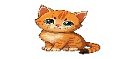

**2:**  What is your favorite animal?

|  |  |  |  |  |  |
| --- | --- | --- | --- | --- | --- |
| **A** | **Yes, I am** | **B** | **It is cat** | **C** | **No, I am not.** |

|  |
| --- |
|  |
| **3** |

____________________________________________________________________________________________________________________________

2.Controlled writing

**Choose the correct word:**

|  |  |  |  |  |  |
| --- | --- | --- | --- | --- | --- |
| **3** – The top part of building is __________ . | | | | | |
| **A** | **upstairs** | **B** | **downstairs** | **C** | **garden** |
| **4** – Interest is (noun) . The **adjective** is _______ | | | | | |
| **A** | **interest** | **B** | **interesting** | **C** | **interests** |
| **5** - The same meaning as [ sick ] _______________ | | | | | |
| **A** | **well** | **B** | **all right** | **C** | **ill** |

____________________________________________________________________________________________

|  |
| --- |
|  |
| **3** |

3.Grammar

**Choose the correct word:**

|  |  |  |  |  |  |
| --- | --- | --- | --- | --- | --- |
| **6** - You______ drink a lot of water. It is good for your health. | | | | | |
| **A** | **should** | **B** | **mustn't** | **C** | **Shouldn't** |
| **7** - The lion is the ………………animal in the jungle. | | | | | |
| **A** | **strong** | **B** | **strongest** | **C** | **Stronger** |
| **8** - The man ______ car is blue is my brother. | | | | | |
| **A** | **when** | **B** | **who** | **C** | **whose** |

__________________________________________________________________________________

4.Vocabulary

|  |
| --- |
|  |
| **5** |

**Choose the correct word for each picture:**

|  |  |  |  |  |  |
| --- | --- | --- | --- | --- | --- |
| **9** - | | | | | |
| **A** | **Polar bear** | **B** | **lion** | **C** | **tiger** |
| **10** - | | | | | |
| **A** | **cage** | **B** | **X-ray** | **C** | **sky** |
| couch clipart  **11** - | | | | | |
| **A** | **chair** | **B** | **table** | **C** | **couch** |
| صورة تحتوي على رسوم متحركة, قصاصة فنية, توضيح, رسم  **12** - | | | | | |
| **A** | **vet** | **B** | **teacher** | **C** | **shelter** |
| 2,200+ Clip Art Of Bare Feet Stock ...  **13** - | | | | | |
| **A** | **hand** | **B** | **foot** | **C** | **head** |

_________________________________________________________________________________________________________________________________________

5.Orthography

|  |
| --- |
|  |
| **4** |

**Choose the correct letters to fill in the blank:**

|  |  |  |  |  |  |  |  |
| --- | --- | --- | --- | --- | --- | --- | --- |
| owattaphotos 사진, 이미지, 에셋 | Adobe Stock  **14** - ca_le | | | | | | | |
| **A** | **b** | **B** | **d** | **C** | **f** | **D** | **m** |
| صورة تحتوي على تعبيرات, مبتسم, الأصفر, دائرة  قد يكون المحتوى المعد بواسطة الذكاء الاصطناعي غير صحيح.  **15** - _nhappy | | | | | | | |
| **A** | **t** | **B** | **u** | **C** | **e** | **D** | **r** |
| 1,100+ Giant Panda Stock Illustrations, Royalty-Free Vector Graphics & Clip  Art - iStock | Giant panda cub, Giant panda snow, Giant panda china  **16** - _ anda | | | | | | | |
| **A** | **b** | **B** | **q** | **C** | **p** | **D** | **j** |
| صورة تحتوي على بدة, فرس, حصان, الفحل  **17** - ho_ se | | | | | | | |
| **A** | **c** | **B** | **n** | **C** | **s** | **D** | **r** |

|  |
| --- |
|  |
| **3** |

6.Reading short sentences

**Read then choose T ( 🗸 ) or F ( 🗴 )**

|  |  |  |  |
| --- | --- | --- | --- |
| 60+ Free Stomach Clipart Images**1** -  **She has a toothache.** | | | |
| **T** | **🗸** | **F** | **🗴** |
| Bird Cage Images - Free Download on Freepik  **2** - **The bird is in the cage.** | | | |
| **T** | صورة تحتوي على رسوم متحركة, تلبيس, الأحذية, شخص **🗸** | **F** | **🗴** |
| **3** -  **They are in the zoo.** | | | |
| **T** | **🗸** | **F** | **🗴** |

Good luck T.