|  |  |  |
| --- | --- | --- |
| المملكة العربية السعودية  وزارة التعليم  إدارة تعليم  مكتب تعليم  مدرسة |  | اختبار مادة اللغة الإنجليزية  الصف الثالث المتوسط  الفصل الدراسي الثاني  التاريخ  الزمن |

|  |  |  |  |
| --- | --- | --- | --- |
| المعلم/ة | التوقيع | المراجعـ/ة | التوقيع |
|  |  |  |  |

|  |  |  |  |  |  |  |
| --- | --- | --- | --- | --- | --- | --- |
| السؤال الأول | السؤال الثاني | السؤال الثالث | السؤال الرابع | السؤال الخامس | المجموع كتابة | المجموع رقما |
| 6 | 6 | 7 | 7 | 4 |  |  |
|  |  |  |  |  |  |  |

|  |  |  |  |  |  |
| --- | --- | --- | --- | --- | --- |
| اسم الطالب : |  | الصف : |  | رقم الجلوس : |  |

استعن بالله

**Total : 6 /**

**1. Composition**

**Write about your city/town , and what you think the aims should be to improve it**

…………………………………………………………………………………………………………………………………………………………………………………………………………………………………………………………………………………………………………………………………………………………………………………………………………………………………………………………………………………………………………………………………………………………………………………………………………………………………………………………………………………………………………………………………………………………………………

**2. Comprehension**

**Read the text and answer the questions. Choose the best answer to each question.**

**The Ballpoint Pen**

Ballpoint pens have not been around for very long. John Loud invented the first ballpoint pen in 1888. Before the invention of ballpoint pens, people had to dip their pens into ink when they were writing. This made writing slow. Also, sometimes too much ink made the writing messy. Ballpoint pens were the first pens that did not need to be dipped in ink. Laud’s invention was wonderful, but the design was still not perfect. Sometimes the pen did not get enough ink, and sometimes it got too much ink. Other inventors continued to work on the design of the ballpoint pen to improve it. For the next 30 years, inventors created over 350 kinds of ballpoint pens. But still the pens did not work very well, and people did not buy them. It wasn’t until 1935 that Ladislaw Biro and his brother developed an improved ballpoint pen in Hungary. Today, in the U.K. and Australia, some people call ballpoint pens biros after their inventor.

**PTO**

**A. Choose the correct answer :**

**1. Ballpoint pens have been around since _____.**

A. 1800 B. 1888 C. 1910 D. 1935

**2. _______ invented the first ballpoint pen**

A. John Loud B. John Lowie C. Luke James D. Dan Loud

**3. Before ballpoint pens, writers had to _____.**

A. use their fingers B. dip pens into water C. dip pens into ink D. use pencils

**4. Ldislaw Biro and his brother developed an improved ballpoint pen in _____.**

A. Hungary B. Spain C. Australia D. America

**5. Some British people call ballpoint pens _____.**

A. louds B. pencils C. inks D. biros

**6. People have been using ballpoint pens for _____.**

A. over 100 years B. less than 100 years C. 1888 D. 1935

**B. What were the problems with Loud’s invention ?**

- ……………………………………………………………………………………………

- ……………………………………………………………………………………………

**C. How many kinds of ballpoint pens were invented ?**

………………………………………………………………………

**D. When did Ldislaw Biro and his brother developed an improved ballpoint pen ?**

………………………………………………………………………

**Total : 6 /**

**3. Grammar**

**A. Choose the best answer to fill in the blank.**

**1. The newest laptops are _____.**

A. clumsy B. light C. huge D. conventional

**2. The first computer was _____.**

A. light B. fast C. conventional D. huge

**3. We _____ friends since first grade.**

A. has been B. have been C. been D. being

**4. They _____ on the phone for two weeks.**

A. not has talked B. not have talked C. hasn’t talked D. haven’t talked

**B. Write *for* or *since* to fill in the blank.**

1. I have had my new car …………… September.

2. He has been studying Arabic …………… six months.

3. They have played tennis together …………… five years.

4. We haven’t gone to the beach …………… last summer.

**PTO**

**C. Write the correct form of the adjective in parentheses to fill in the blank.**

1. Our town has the …………… water of all the towns in this area. (***clean***)

2. Traffic in big cities is …………… than it is in smaller towns. (***bad***)

**D. Complete the tag question.**

1. He bought a hammer, …………………. ?

6. She didn’t go to school, …………………. ?

**E. Write the adverb of manner to fill in the blank.**

1. Stan is a slow runner. He runs ……………

2. Ali is a good writer. He writes ……………

**4. Vocabulary**

**A. Match a term in Column 1 with a description in Column 2.**

|  |  |  |
| --- | --- | --- |
| ***Column 1*** | | ***Column 2*** |
| 1. digital |  | A. phone . |
| 2. cellular . |  | B. camera |
| 3. laptop . |  | C. printer . |
| 4. high-tech . |  | D. computer . |

**B. Choose the best answer to fill in the blank.**

**1. _____ are green areas.**

A. Buildings B. Roads C. Parking lots D. Parks

**2. An apartment is a type of _____.**

A. recreation B. transportation C. housing D. hospital

**3. dash _____**

A. shield B. sign C. wheel D. board

**4. road _____**

A. belt B. sign C. wheel D. mirror

**5. What do you use to climb a wall?**

A. a ladder B. a bike C. a hammer D. a stove

**6. What do you use to water the garden?**

A. a garage B. a plate C. a hose D. a spoon

**7. What do you use to clean the living room?**

A. a ladder B. a sofa C. a vacuum cleaner D. a hose

**8. What do you use to sweep the backyard?**

A. a spoon B. a broom C. a bike D. a fork

**PTO**

**C. Match :**

Stove – teapot – danger – camera

|  |  |  |  |
| --- | --- | --- | --- |
|  |  |  |  |
|  |  |  |  |

**Total : 7 /**

**5. Orthography**

**Complete the missing letters :**

**Total : 4 /**

c__mp__ters T__levi__ions



ce__l p__ones Tr__in

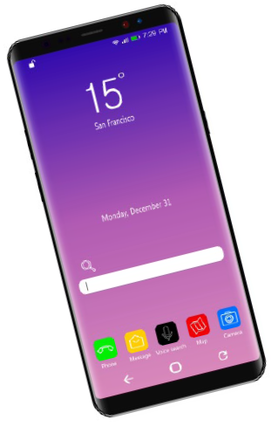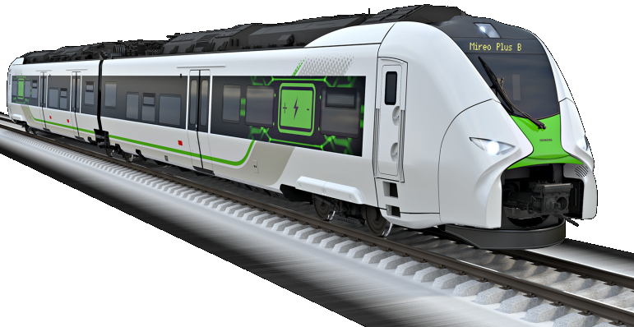

__nife Fo__k

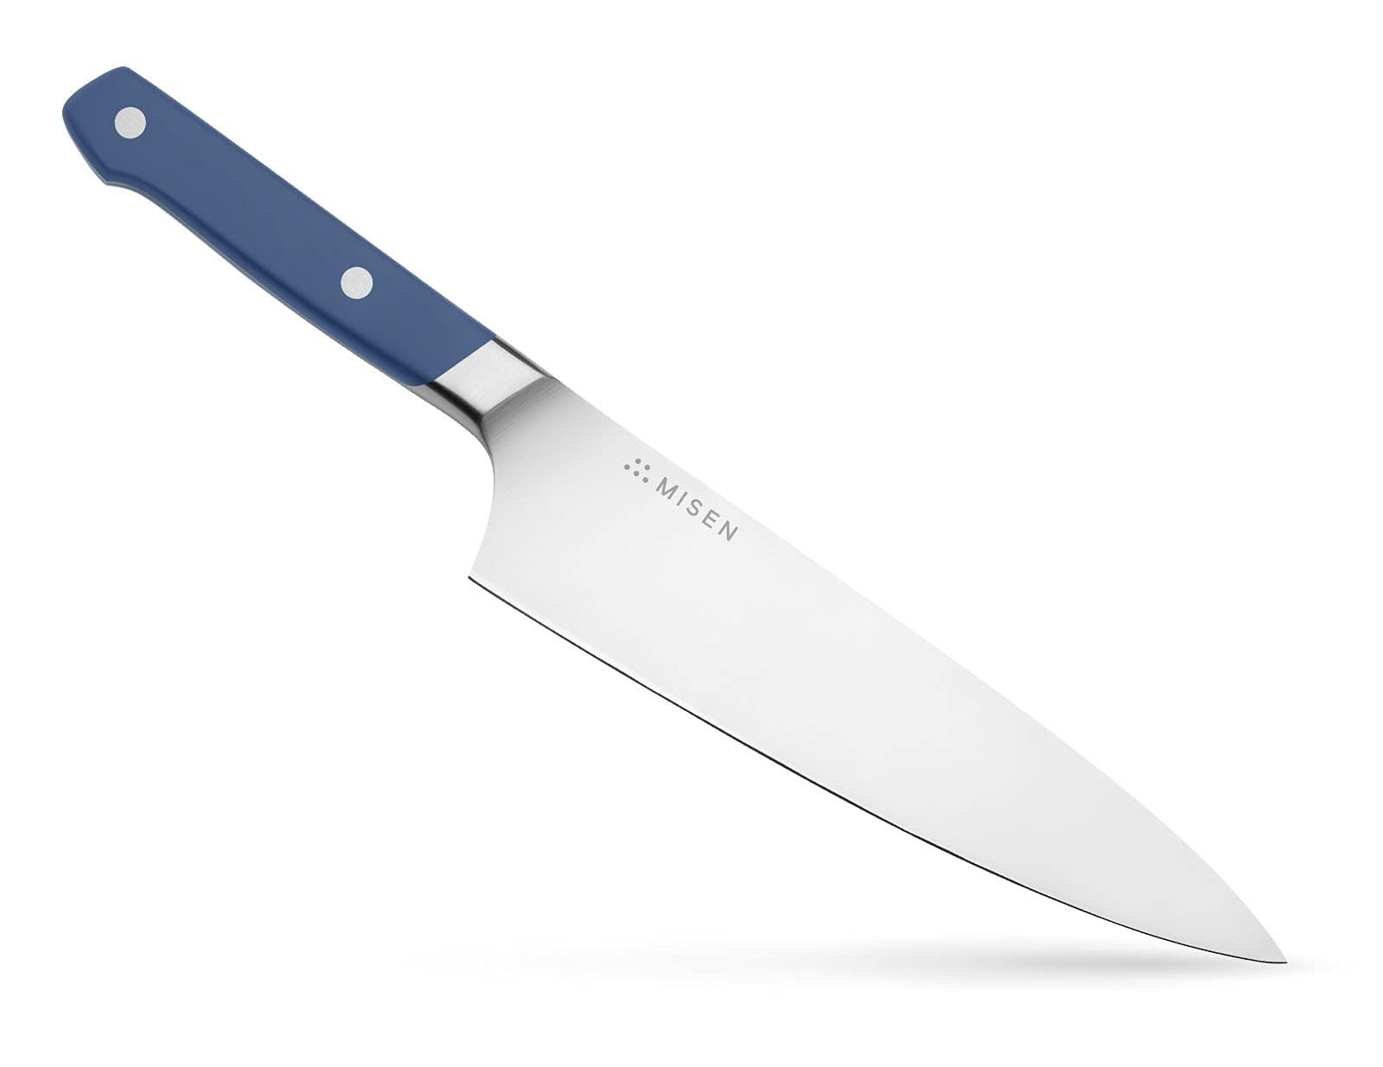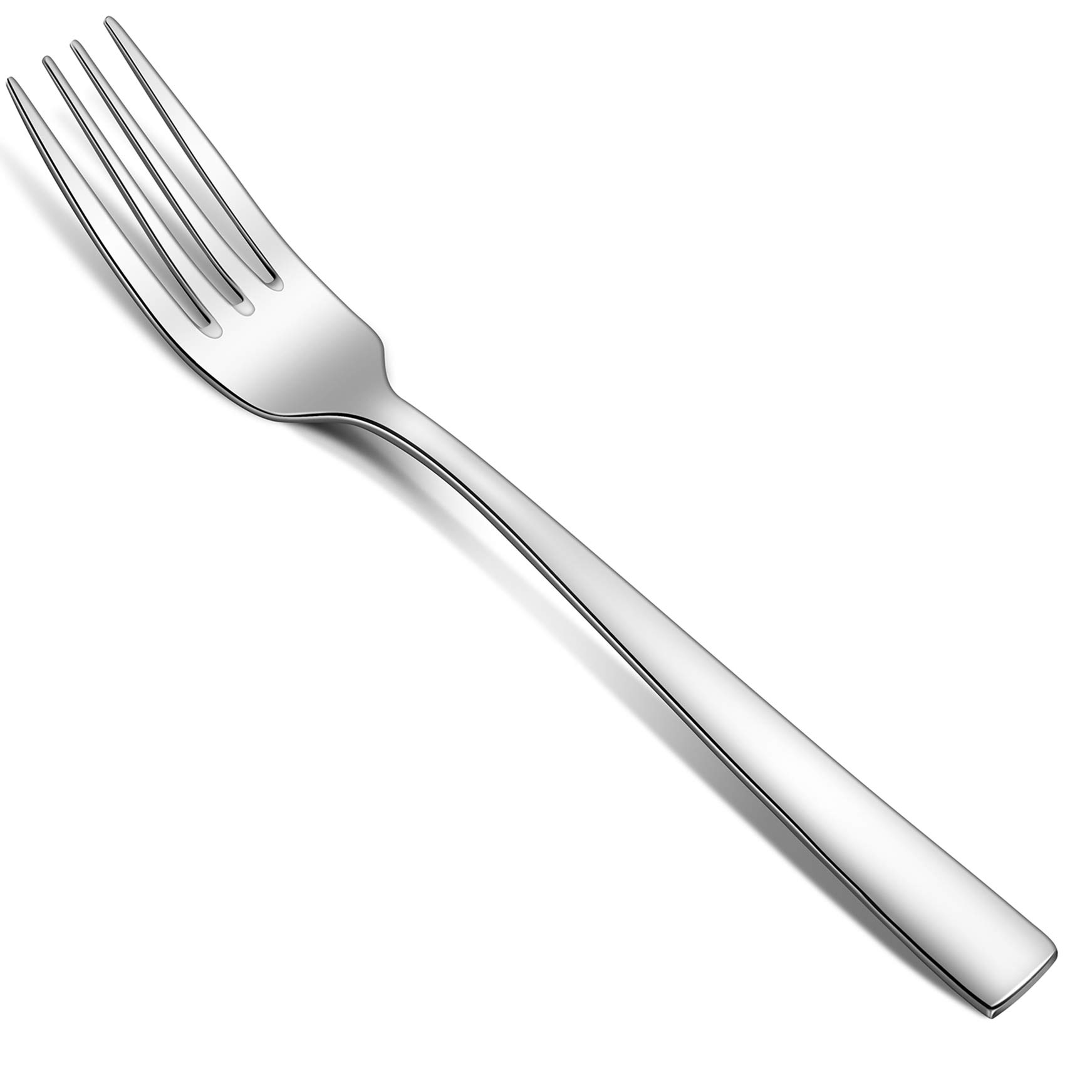

Sp__ed L__mit N__ pas__ing



Best of luck

   