اسم الطالب/ة : ................................................ الفصل: .......................

6

**I- General Questions:**

A- Match the questions in column (A) with the correct answers in column (B):

|  |  |
| --- | --- |
| B | A |
| ( ) He is a doctor.  ( ) I cooked breakfast.  ( ) I made a rocket  ( ) 2 cups of flour  ( )I want to be a teacher  ( ) I usually go to bed at 9:00 | 1- What did you do over the weekend?  2- How much flour do we need ?  3-What good things happened to you last year ?  4- What does your dad do ?  5- What time do you go to bed ?  6- What do you want to be when you grow up ? |

**II- Controlled Writing:**

5

A- Complete the sentences with the correct word:

**sick**

**fires**

**thirty**

1- Firefighter put out ______

2- Ten , twenty , ________ , forty.

3- Doctors help _________ people.

B- Rearrange the words to form a sentence:

1- game / We / a football / won

………………………………………………….

2- scary / How

………………………………………………….

**III- Grammar:**

5

A) Choose the correct word:

1- I usually ( take – took ) a bath in the morning.

2- Yesterday , I ( play – played ) computer games.

3- We don't have ( some – any ) oil.

B) Fill in the spaces with **much** or **many** :

1- How ________ oil do you need ?

2- How ________ apples do you eat ?

**IV- Reading Short Sentence:**

A- Read the sentences and match them with the correct pictures:

4

1- It's 10:30 2- a half past three 3- He is a baker

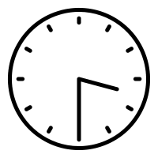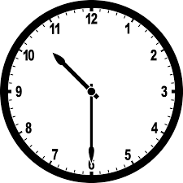

B- Read the question and choose the correct answer:

1- I broke my leg.

a) congratulations b) How nice c) sorry about that

6

**V- Vocabulary:**

A) Write the correct number under each picture:

**1**- pizza **2**- teacher **3**- boot **4**- diver **5**- bed **6**- reporter

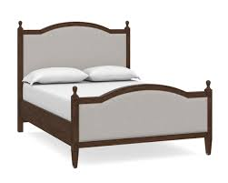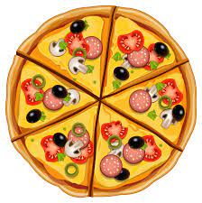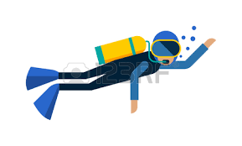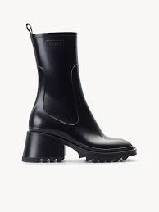

( ) ( ) ( ) ( ) ( ) ( )

**VI- Orthography:**

4

A) Choose the correct letter:

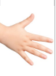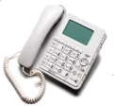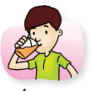

1- dri_ _ 2- _ _one 3- ha_ _ 4- lau_ _

( nk – sh – ch ) ( f – ph – kn ) ( gh – sh – nd ) ( gh – nt – nk )

***I General Question***

**6**

***A-Choose the corret sentence:***

|  |  |  |  |  |  |
| --- | --- | --- | --- | --- | --- |
| I usually go to bed at 9:00. | ß | He is a pilot. | **ą** | What time do you go to bed? | 1 |
| I want to be a teacher. | ß | I saw a rainbow | **ą** | What happened to you? | 2 |
| She is fine. | ß | He is a scientist. | **ą** | What does your dad do? | 3 |
| Yes, please. | ß | No, she doesn't | **ą** | Can I help you? | 4 |

*Match :*

|  |  |
| --- | --- |
| B | A |
| ( ) How nice. | 1-I won a football match 3 to 0 |
| ( ) congratulations. | 2-My friends were stuck in the train. |
| ( ) That's scary. |  |

***II Controlled Writing***

**5**

***A- Rearrange the words to form sentences:***

|  |
| --- |
| Math Clip Art--Digital Clock Faces--9:00 | Media4Math1- nine / It's /o'clock .  ……………………………………………………………………………………………………………. |
| Hotel Computer Icons Room Housekeeping, sweeping, text, logo png | PNGEgg2-cleaned /my /I / room .  ……………………………………………………………………………. |
| Runner Man On Podium First Place Stock Vector (Royalty Free) 1796318440 |  Shutterstock3- got /first place / I .  …………………………………………………………………………………………………………………… |
| Reporter running with mic flat vector illustration. Male journalist working  for sensational breaking news coverage cartoon character. Correspondent  holding microphone rushing to take interview 4305840 Vector Art at Vecteezy4- is /a reporter / she.  …………………………………………………………………………………… |
| School lunch clipart. Free download transparent .PNG | Creazilla5- eat / my / I / lunch.  …………………………………………………………………………….... |

***III Reading short Sentences***

**4**

***A- Match***

|  |  |  |
| --- | --- | --- |
| 59,900+ Seven Thirty Stock Photos, Pictures & Royalty-Free Images - iStock  | Clock |  | 1- He kicked the ball. |
| Food Black and White Outline Clipart - black-white-baker-black-white-clipart  - Classroom Clipart |  | 2- My dad is a firefighter. |
| Person Kicking a Soccer Ball - Free Clipart Images |  | 3- It's seven thirty. |
| 164 Firefighter clipart - Graphics Factory |  | 4- I want to be a baker. |

***IV Grammar***

**5**

***A – Choose:***

1- ( How much – How many ) apples are there?

2- We have ( some – any ) milk in the house.

3- ( How much – How many) sugar do you want.

4- Yesterday, I ( watched – watch ) a DVD about animals.

_____________________________________________________________

***B- Write the past form of the verb:***

1- play :………………………………. 2- eat:………………………….

3- take: ……………………………… 4- cook :……………………….

________________________________________________________________

***C- Choose a suitable comment:***

1- I made a rocket. ( sorry for that – How a nice).

2- I won a basketball game. ( congratulations – How scary).

________________________________________________________

***V Vocabulary***

**6**

***A-Write the suitable word:***

(butter _ boots _ chocolate _ teeth _ businessman _ train station )

|  |  |  |  |  |  |
| --- | --- | --- | --- | --- | --- |
| Black and white drawing of the business man clipart free image download | Funny Yummy Chocolate Filled Caramel Cartoon Stock Vector (Royalty Free)  2027221847 | Shutterstock | Suburban train station. Flat design style. Vector illustration Stock Vector  | Adobe Stock | Historical Clipart of Rain Boots - Black and White Outline by Picsburg -  #9408 | Clip Art: Teeth B&W I abcteach.com | Ketchup Computer Icons Food, ketchup transparent background PNG clipart |  HiClipart |
|  |  |  |  |  |  |

***B-Classify the words:***

( mangoes – doctor – How nice – oranges – nurse – that's fantastic)

|  |  |  |
| --- | --- | --- |
| **jobs** | **comments** | **fruits** |
|  |  |  |
|  |  |  |

***________________________________________________________***

***VI Orthography***

***Choose the correct missing letter:***

|  |  |  |  |  |  |  |  |
| --- | --- | --- | --- | --- | --- | --- | --- |
| Sand Castle Cartoon Vector Illustration Black Stock Vector (Royalty Free)  750809431 | Shutterstock | Phone clipart. Free download transparent .PNG | Creazilla | Plant Outline Clipart-rubber tree house plant printable cutout clip art | Free backaches, Download Free backaches png images, Free ClipArts on Clipart  Library | Army Knife Outline SVG, Knife SVG, Military Knife, Army Knife Clipart, Knife  Files for Cricut, Knife Cut Files for Silhouette, Png, Dxf - Etsy | 14,149 Laughing High Res Illustrations - Getty Images | Free Night Clipart Black And White, Download Free Night Clipart Black And  White png images, Free ClipArts on Clipart Library | Swing Black and White Free PNG Image｜Illustoon    **4** |
| Sa_ _  nd - nt | _ _one  gh - ph | Pla_ _  nt - nd | ba_ _  ck - nk | _ _ ife  kn - gh | Lau- -  gh - ph | n_ _t  gh - kn | swi_ _  ng - nk |

***The End***

With my best wishes / Tr. Abeer Nasser

|  |  |  |  |  |
| --- | --- | --- | --- | --- |
| **السؤال** | **الدرجة** | **كتابةً** | **المصحح** | **التوقيع** |
| **س1** |  |  |  |  |
| **س2** |  |  |  |  |
| **س3** |  |  |  |  |
| **س4** |  |  |  |  |
| **س5** |  |  |  |  |
| **س6** |  |  |  |  |
| المجموع : | | | | |

المراجع : التوقيع :

**الــمـملكة الـعربية السـعوديـة بسم الله الرحمن الرحيم**



**وزارة التعليم**

**الإدارة العامة للتعليم -------**

**مكتب تعليم ------**

**مدرسة -------- الابتدائية**

##### أسئلة اختبار نهاية الفصل الدراسي الثاني للعام الدراسي 1445هـ

##### ( الدور الأول )

**المادة: اللغة الإنجليزية الصف: الخامس الابتدائي الزمن: ساعة ونصف ( الفصل : / )**

**اسم الطالب /** ................................................................. **رقم الجلوس (** .........................)

**­­­­­­­­­­­­­­­­­­­­­­­­1.General Questions: A. Match "A" with "B":**

|  |
| --- |
| A |
| 1- How much flour do we need ? |
| 2- What does your dad do? |
| 3- What time do you go to bed ? |

|  |  |
| --- | --- |
| B | |
| I usually go to bed at 9:00 | ( ) |
| He is a doctor . | ( ) |
| 2 cups of flour . | ( ) |

**B. Choose the correct answer:**

|  |  |  |  |  |
| --- | --- | --- | --- | --- |
| 1 | What did you do over the weekend? | | | |
| a | I cooked breakfast. | b | She is a nurse. | | c | Here you go. |
| 2 | What good things happened to you last year? | | | |
| a | I lost a game. | b | I made a rocket. | | c | I stayed home. |
| 3 | What do you want to be when you grow up? | | | |
| a | I went to bed. | b | He is painting. | | c | I want to be a teacher. |

**2.Reading Short Sentence: Choose (** 🗸 **) or (** 🗴 **)**

|  |  |  |
| --- | --- | --- |
| 1. It's half past three. | 🗸 | 🗴 |
| 2. He wants to be a player. | 🗸 | 🗴 |
| 3. I broke my hand. | 🗸 | 🗴 |
| 4. I cleaned my room. | 🗸 | 🗴 |

**3.Orthography: Choose the missing letters:**

|  |  |  |  |
| --- | --- | --- | --- |
| nk - ck | ph - fe | nt - nd | sh - gh |
| dri__ __ | __ __ one | ha __ __ | lau__ __ |

**4.Grammar: Choose the correct answer:**

|  |  |  |  |  |
| --- | --- | --- | --- | --- |
| 1 | I usually …… a bath in the morning. | | | |
| a | take | b | took | | c | takes |
| 2 | Yesterday, I …… computer games. | | | |
| a | played | b | play | | c | playing |
| 3 | We don't have …… oil. | | | |
| a | some | b | any | | c | more |
| 4 | How …… apples do you eat? | | | |
| a | much | b | many | | c | any |
| 5 | I …… a cold. | | | |
| a | catching | b | Catched | | c | caught |

**5.Vocabulary: Write the correct word under the correct picture:**

1- pizza 2- teacher 3- boot 4- diver 5- bed 6- reporter

|  |  |  |  |  |  |
| --- | --- | --- | --- | --- | --- |
|  |  |  |  |  |  |
|  |  |  |  |  |  |

**6.Controlled Writing: A. Rearrange the words to make a correct sentence:**

game / We / a football / won .

______________________________________________.

**B. Unscramble the words:**

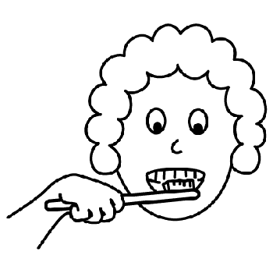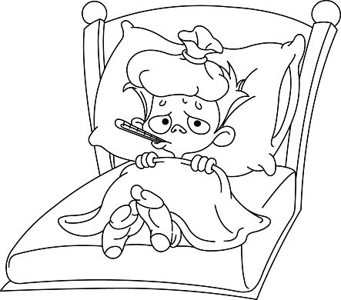

1. kcis = ____________ 2. burhs = ________

3. tyhrit = ___________ 30

**C. Copy:**

My dad had an operation.

_____________________________________________________________________________________



**GOOD LUCK** انتهت الأسئلة

المملكة العربية السعودية الصف السادس الابتدائي

وزارة التعليم الفصل الدراسي الثاني

الابتدائية .............. الزمن : ساعة ونصف ساعة

الاختبار النهائي لمادة اللغة الإنجليزية للصف السادس الابتدائي الفصل الدراسي الثاني للعام الدراسي **1445** هـ

_________________________________________________________________________________________________________________________________________________________________________

**General Questions**

6 /

**Match the sentence with the correct picture: ( 6 marks )**

1- I brush my teeth. 4 – I cleaned my room .

2 – You practiced on the trampoline. 5- I caught a cold .

3 – He watched a DVD about sharks. 6- I was a team captain

|  |  |  |  |  |  |
| --- | --- | --- | --- | --- | --- |
|  |  |  |  |  |  |
|  |  |  |  |  |  |

**_____________________________________________________________**

**Controlled Writing**

5 /

**Rearrange these sentences: ( 3 marks )**

**operation / dad / an / My / had**

|  |
| --- |
| **------------------------------------------------------------------------------------------------** |

**stayed -Nora - home.**

|  |
| --- |
| **------------------------------------------------------------------------------------------------** |

**ate – lunch – I**

|  |
| --- |
| **------------------------------------------------------------------------------------------------** |

**B) Choose the correct answer: ( 2 marks )**

1-What does he do? ( a- He is a cook. b- He’s Faisal )

2-Where does he work? ( a- He is a doctor . b- In a restaurant.)

**(2)**

**____________________________________________________________________**

**Reading**

4 /

**Read the following sentences then Put (✓ T ) or ( x F ): ( 4 marks )**

|  |  |  |
| --- | --- | --- |
| **1- We were stuck in an elevator .** |  | **( )** |
| **2- This is a ring .** |  | **( )** |
| **3- I got first place in a race .** |  | **( )** |
| **4- It's three o'clock .** |  | **( )** |

**Grammar**

5 /

**choose the correct answer : ( 5 marks )**

|  |  |
| --- | --- |
| 1. **She ……………………. the breakfast** | |
| 1. **cooked** | 1. **cleaned** | 1. **kicked** |
| 1. **How ………… flour do we need ?** | |
| 1. **many** | 1. **much** | 1. **some** |
| 1. **2- Yesterday I ……….up at five o'clock.** | |
| 1. **get** | 1. **gotten** | 1. **got** |
| 1. **I usually ………. my homework at 4 o'clock .** | |
| 1. **do** | 1. **did** | 1. **does** |
| 1. **I ……………… a big fish.** | |
| 1. **were** | 1. **caught** | 1. **was** |

**___________________________________________________________________**

**(3)**

**______________________________________________________________________**

**Vocabulary**

6 /

**Match the words to the correct picture : ( 6 marks )**

**hand– rock– knock – astronaut- firefighter – right**

|  |  |  |  |  |  |
| --- | --- | --- | --- | --- | --- |
|  |  |  |  |  |  |
|  |  |  |  |  |  |

**Orthography**

4 /

**Fill in the missing letters : ( 4 marks )**

|  |  |  |  |
| --- | --- | --- | --- |
|  |  |  |  |
| **C _ at** | **ba _ er** | **e_ephant** | **Rain_ow** |

**Good luck**

**(4)**