

المملكة العربية السعودية

وزارة التعليم

ادارة التعليم

مدرسة

|  |
| --- |
| عددالأوراق:4 |
| الزمن: ساعتان ونصف |
| الصف: ثاني ثانوي مسارات عام |

الاختبار النهائي لمادة اللغة الإنجليزية المرحلة الثانوية الفصل الدراسي الثاني الدور الأول للعام الدراسي 1445ه‍

**اسـم الطالبة: ................................................................................................... رقم الجلوس : ................................................................**

|  |  |  |  |  |  |  |
| --- | --- | --- | --- | --- | --- | --- |
| Question | **1**  **Guided composition** | **2**  **Free Composition** | **3**  **Comprehension** | **4 Grammar** | **5**  **Vocabulary** | Total written |
| Mark given |  |  |  |  |  |  |
| Mark | 6 | 6 | 6 | 6 | 6 | 30 |
| Corrector | |  | | | Reviser | |

**I-Composition:**

**A) Guided Composition:**

-Write an assay about ( **Sport** ) using the notes below Guided words:

**(**important - physical - strength – hearts- reduce -stress - diseases – managing – enjoying- significant.**)**

_____________________________________________________________________

_____________________________________________________________________

_____________________________________________________________________

_____________________________________________________________________

_____________________________________________________________________

_____________________________________________________________________

_____________________________________________________________________

**B ) Free Composition**

- Choose one topic from the following to write about:

**1- ( Your dream Job )**

**2- ( The internet in our life )**

_____________________________________________________________________

_____________________________________________________________________

_____________________________________________________________________

_____________________________________________________________________

**1 ) )**

**II-Reading Comprehension:**

**A-Read the following text, and then answer the questions below:**

French fries are one of the most common food around the world . French fries are long, thin pieces of potato fried in oil or fat . Vegetables oil is the best fat to make amazing fries . French fries are served hot, either soft or **crispy**, and are generally eaten as part of lunch or dinner or by themselves as a snack, and they commonly appear on the menus of diners and fast food restaurants. French Fries are usually salted and, depending on the country, may be served with ketchup, mayonnaise or tomato sauce. To achieve golden-brown perfection, you have to fry them twice: first at a low temperature, to poach them; then at a high heat, to crisp them up. Actually , French fries are better when cooked at restaurants .Some people got addicted to French Fries because they don't need a fork or spoon to eat them . They can eat French fries with their fingers . Many restaurants selling French fires frequently combine servings of fries with another food, for example, fried fish or beef burgers. In fact , French fries go with hot dogs, hamburgers, fish and all sorts of sandwiches. Many countries in every corner of the globe have their own way of eating this beloved dish.

**A-Answer the following questions :**

1- What are French fries ? …………………………………………………………………………………………………… 2- Why did some people get addicted to French Fries ? ……………………………………………………………………………………………………3- Do French fries go with all sorts of sandwiches ? ……………………………………………………………………………………………………**B-Choose the correct answer:**

1- The best fat to make amazing French fries is ( **vegetables – corn – olive - palm** ) oil.

2- To achieve golden-brown perfection, you have to (**grill - roast – boil - fry**) them twice

3- **crispy** in line **(3)** means (**crunchy – flexible – organic - neutral**)

4- The opposite of beloved is (**admired – popular – favorite - unloved** )

**( 2 )**

**C- Write ( True ) or ( False ) :**

1- French Fries are usually salted. ( )

2-French fries may be served without ketchup, mayonnaise or tomato sauce.( )

**III-Grammar**

**A-Circle the correct answers:**

|  |  |  |  |  |  |  |  |
| --- | --- | --- | --- | --- | --- | --- | --- |
| **1)** | The manager insisted that he …………………..late. | | | | | | |
| a- | **works** | b- | **Work** | c- | **Worked** | d- | **working** |
| **2)** | You ………….. stop at " STOP " sing. | | | | | | |
| a- | **must** | b- | **Had to** | c- | **Need to** | d- | **Have to** |
| **3)** | Our class enjoys………………………about ways to help the environment . | | | | | | |
| a- | **learn** | b- | **Learns** | c- | **Learning** | d- | **learned** |
| **4)** | The Saudi Riyal …………..the official currency of the kingdom of Saudi Arabia. | | | | | | |
| a- | **Am** | b- | **is** | c- | **Was** | d- | **Were** |
| **5)** | She can't reach the shelf. She is ……...short. | | | | | | |
| a- | **enough** | b- | **For** | c- | **How** | d- | **too** |
| **6)** | …………………………. uses more muscles of the body. | | | | | | |
| a- | **swimming** | b- | **Swim** | c- | **Swam** | d- | **swum** |
| **7)** | It was the night shift you wanted,………………..? | | | | | | |
| a- | **Was you** | b- | **Wasn't it** | c- | **Is it** | d- | **Weren't it** |
| **8)** | She has …………………three lessons. | | | | | | |
| a- | **explain** | b- | **explains** | c- | **explained** | d- | **explaining** |

**B- Do as shown between brackets:**

1- Could \ me \ you \ help \ ? **( reorder)**

………………………………………………………………

2- Skiing is dangerous. Snowboarding is dangerous. **(Join using as ……… as)** …………………………………………………………………………………

**( 3 )**

**IV –Vocabulary:**

1. **Fill the blanks with the correct words:**

**cooperate** - **loyalty** - **economy** - **furnish** - **marathon**

1. Thousands of runners participate in the ……………. every year..
2. They had no money to ……………… their house.
3. The people showed ……………… for the king by putting his face on the coins.
4. I ……………. well with others when I’m in a group.
5. **Match each phrase/expression with its meaning :**

|  |  |  |
| --- | --- | --- |
| **Phrase / Expression** |  | **Meaning** |
| 1. Take off |  | 1. Make a mistake |
| 1. A piece of cake |  | 1. Great! |
| 1. Cool! |  | 1. very easy |
| 1. mess up |  | 1. leave |
|  |  | 1. Really? |

1. **Write the correct word and its picture:**

**skiing** **- No parking** - **zoologist** - **medal** - **Recycling**

|  |  |  |  |
| --- | --- | --- | --- |
|  |  |  |  |
| ____________ | ____________ | ____________ | ____________ |

**Finished & Good Luck**

**Done by:**

**( 4 )**

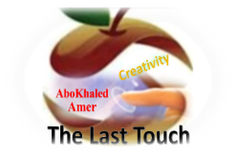**المملكة العربية السعودية**

**Kingdom of Saudi Arabia**

**Ministry of Education**

**------- Educational Directorate**

**------- Future Educational Schools**

**2nd Grade High School 2022**

**2nd Term – Final Exam**

**وزارة التعليم**

**الإدارة العامة للتعليم بن**

**مدارس م ن التعليمية**

**الصف الثاني الثانوي**

**الاختبار النهائي للفصل الدراسي الثاني1445هـ**

|  |  |  |  |  |  |  |  |
| --- | --- | --- | --- | --- | --- | --- | --- |
| **Total**  **written** | **5**  **Vocabulary** | **4**  **Grammar** | **3**  **Free Composition** | **2**  **Guided Composition** | | **1 Comprehension** | **Q. NO.** |
|  |  |  |  |  | |  | **Mark Given** |
| **30** | **6** | **6** | **6** | **6** | | **6** | **Mark** |
| **6** | | | **Reviser** | |  | | **Corrector** |
|  | |

**زمن الاختبار: 3 ساعات**

**اسم الطالب: ------------------------------------ رقم الجلوس: ------------- الصف الثاني الثانوي**

**1.Comprehension**

**Read the following passage then answer the questions**

**The Benefits of Exercise**

**Getting regular exercise is good for you. Everyone knows that. But, then why doesn't everyone exercise? Some people say they don't have enough time because they are busy with work, school, and family obligations. However, making time for some exercise should be a priority for everyone. The following are just a few of the reasons why:**

**1) Exercising makes you feel good. When you have a bad day, or you feel stressed or angry about something, a little exercise can help you relax and improve your mood. Also, getting regular exercise can help prevent depression.**

**2) Physical exercise helps prevent some diseases such as high blood pressure, diabetes, and certain types of cancer. A walk a day can help keep you healthy!**

**3) Exercising helps you maintain a healthy weight and keeps you strong.**

**4) Exercising gives you more energy. You will feel less tired during the day if you are physically stronger and more active.**

**5) Exercising helps you sleep better. If you have been active during the day, you sleep better. And when you have slept better at night, you feel better during the day.**

**6) Find an activity that you enjoy. You don't have to go to the gym. You can go for a walk or a hike. Whenever you are active, you are doing something good for both your physical and mental health.**

***A)* Answer the following questions*:*  
1. What is the passage about? ----------------------------------------------------------------------------.**

**2. Does exercising help you sleep better? -------------------------------------------------------------.**

**3. Why do some people say they don't have enough time? -------------------------------------------.**

**4. What can you do if you don’t go to the gym? -------------------------------------------------------.**

***B)* Put ( √ ) or ( X ):  
5. Exercising helps you to keep strong. ( )**

**6. Exercising is good for both your physical and mental health. ( )**

**7. Cancer is a kind of disease. ( )**

**8. Exercising doesn't make you feel good. ( )  
*C)* Complete*:*  
9. Exercising gives you more** -------------------------.

**10. Physical exercise helps prevent some** ------------------------------.

**D) Choose the correct answer:**

**11. Getting regular exercise can help prevent (**happiness **–** depression – devasted – drown**)**

**12. The underlined word “they" refers to: (** school – exercise – work – people )

**2) Guided Composition**

**6**

**Playing sports is a must to keep fit.**

**Write a paragraph about “ Your Favorite Sport”:**

**You many use the guiding words:**

Favorite – club – gym – friends – free time – build muscles – keep fit – feel happy

-------------------------------------------------------

-------------------------------------------------------------------------------------------------------------------------------------------------------------------------------------------------------------------------------------------------------------------------------------------------------------------------------------------------------------------------------------------------------------------------------------------------------------------------------------------------------------------------------------------------------------------------------------------------------------------------------------------------------------------------------------------------------------------------------------------------------------------------------------------------------------------------------------------------------------------------------------------------------------------------------------------------------------------------------------------------------------------------------------------------------------------------------------------------------------------------------------------------------------------------------------------------------------------------------------------------------------------------------------------

**3) Free Composition**

**6**

**Choose one topic from the following to write about.**

**1. Recycling is a must to keep our environment clean**

**2. Write a paragraph about "Your Dream House" in which you describe which kind of you want to live in, where, who live with, …**

-------------------------------------------------------

---------------------------------------------------------------------------------------------------------------------------------------------------------------------------------------------------------------------------------------------------------------------------------------------------------------------------------------------------------------------------------------------------------------------------------------------------------------------------------------------------------------------------------------------------------------------------------------------------------------------------------------------------------------------------------------------------------------------------------------------------------------------------------------------------------------------------------------------------------------------------------------------------------------------------------------------------------------------------------------------------------------------------------------------------------------------------------------------------------------------------------------------------------------------------------------------------------------------------------------------------------------------------------------------

**4) Grammar**

**6**

**A: Choose the correct answer:**

**1. The manager insisted that he (** worked – works – work – working **) late.**

**2. Quit (** using – to use – used – use **) disposable batteries.**

**3. She is not (** enough tall – tall enough – tall too – tall so **) to reach the shelf.**

**4. (** Not Warming – Not warm – Not warms – Not warmed **) up is bad.**

**5. This is the (** most – more – less – many **) exciting sporting event.**

**6. I want you (** opened – opening – open – to open **) the window.**

**B- Do as shown between brackets:**

**1. you / applying for the job / to consider / I’d like (**Unscramble**)**

-------------------------------------------------------------------------------.

**2. to buy – a hybrid – Do they – car? – intend (**Unscramble**)**

----------------------------------------------------------------------------.

**3. I bought (yellow – big – Japanese – expensive) car. (**Reorder the adjectives**)**

-------------------------------------------------------------------.

**4. She is short to play basketball. (**Use**: too)**

---------------------------------------------------------------------------.

**5. Ali is the nicest boy I (see). (**Correct in present perfect**)**

--------------------------------------------------------------------------------.

**6. (Swim) uses more muscles of the body. (**Correct**)**

---------------------------------------------------------------------------.

**5) vocabulary:**

**6**

**A- Match the words with the pictures:**

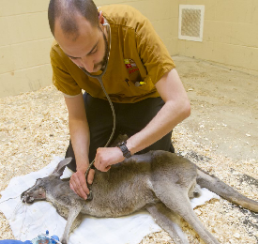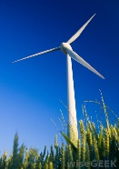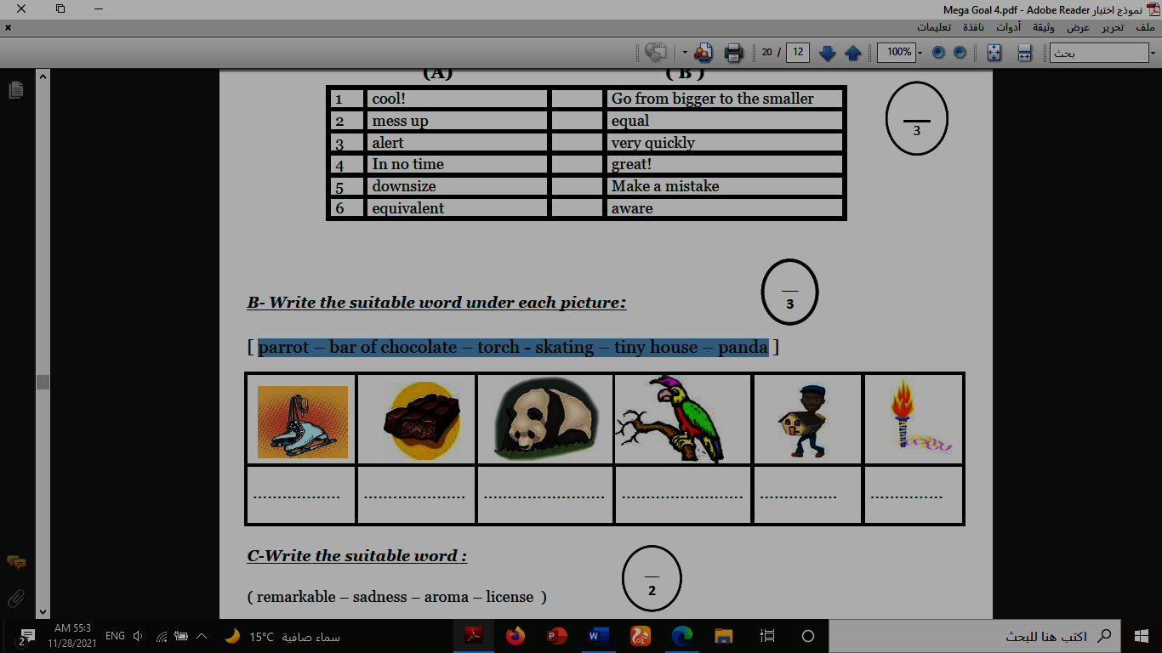**1.recycle 2.torch 3.zoologist 4.medal 5.canyon 6.windmill**

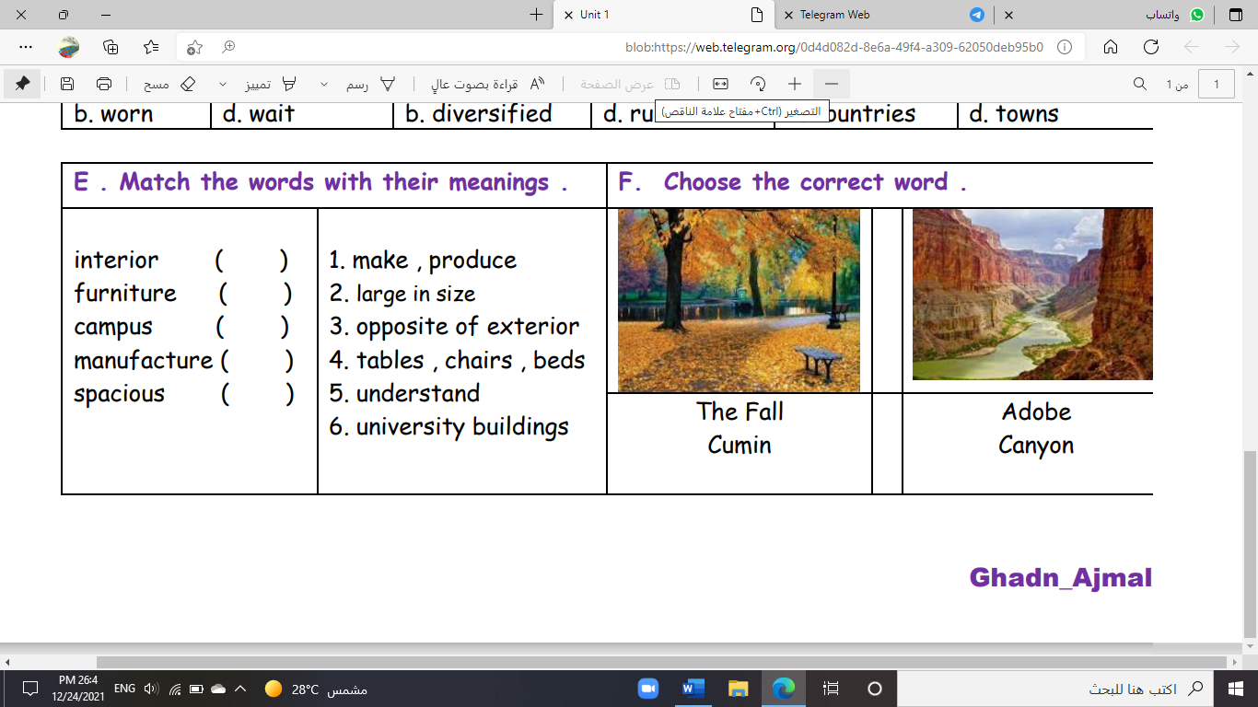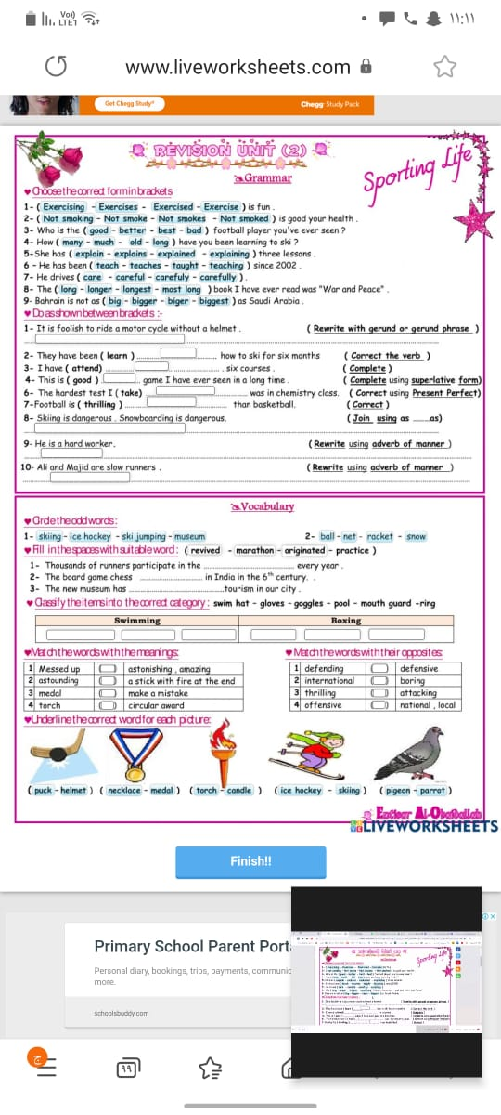

**( ) ( ) ( ) ( ) ( ) ( )**

**B- Match to form new words or expressions:**

**1. satisfaction ------ a. take one’s place, often in work**

**2. cover ------ b. feeling of contentment**

**3. a piece of cake ------ c. without a soul**

**4. cool ------ d. ready for**

**5. soulless ------ e. very easy**

**6. up for ------ f. great**

**End of Questions**

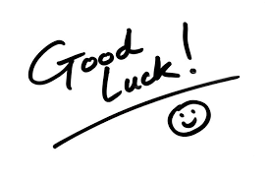**Best of Luck**