2nd الفصل الثاني

Summary مـلخـص

We Can 3

Units :5-6-7-8

Name: ………………………………………………….………………………………
الاسم: ………………………………………………….………………………………..
الصف: ………………………………………………….………………………………

Yesterday and Today page:34
المحادثات

1-What time is it? كم الساعة؟
It is 7 o’clock  الساعة السابعة تماما | 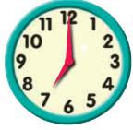
It is 12 o’clock  الساعة الثانية عشر تماما | 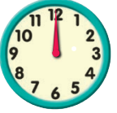
It is 3 o’clock  الساعة الثالثة تماما | 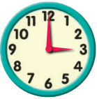
It is eight thirty.  It is 8:30  الساعة الثامنة والنصف | 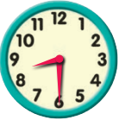
It is eleven thirty.  It is 11:30  الساعة الحادية عشر والنصف  الساعة الحادية عشر وثلاثون دقيقة | 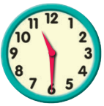
It is five forty-five.  It is 5:45  الساعة الخامسة وخمسة واربعون دقيقة | 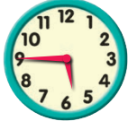
It is one – ten.  It is 1:10  الساعة وحده وعشر دقائق | 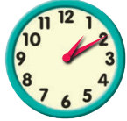
It is nine twenty.  It is 9:20  الساعة التاسعة وعشرون دقيقة | 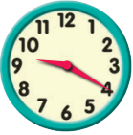
It is seven – forty.  It is 7:40  الساعة السابعة وأربعين دقيقة | 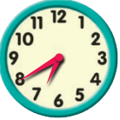

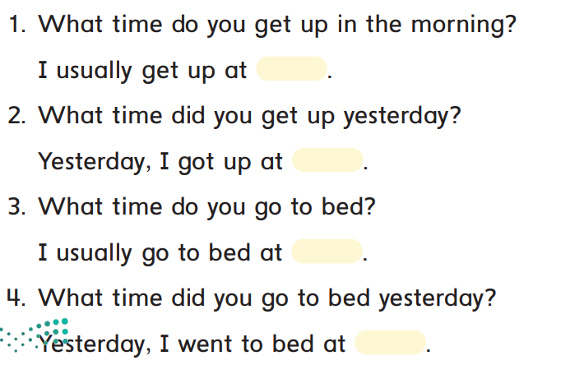
10:00
9:30
6:30
6:00
1-في أي وقت تستيقظ صباحا؟
عادة استيقظ الساعة السادسة تماما.
2-في أي وقت استيقظت بالأمس؟
استيقظت الساعة السادسة والنصف.
3-في أي وقت تذهب لسريرك؟
عادة اذهب للسرير الساعة التاسعة والنصف.
4-في اي وقت ذهبت لسريرك بالأمس؟
ذهبت للسرير الساعة العاشرة.

page:35
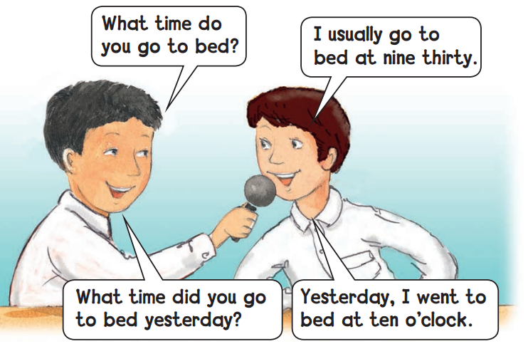
في أي وقت ذهبت للسرير بالأمس؟
بالأمس ذهبت للسرير الساعة العاشرة تماما
عادة اذهب للسرير الساعة التاسعة والنصف.
في أي وقت تذهب للسرير؟

Page:43
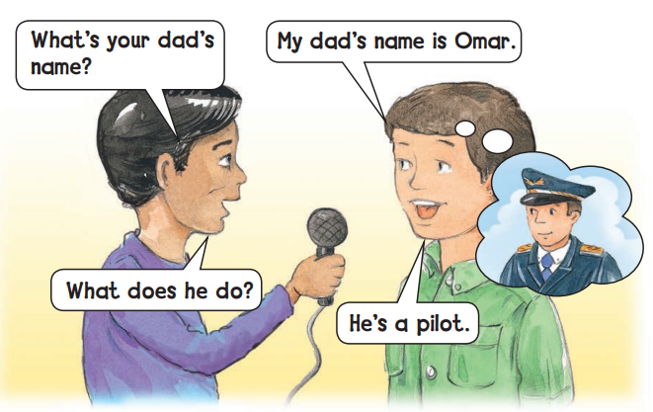
ما اسم والدك؟
اسم والدي عمر.

ماذا يعمل؟
كابتن طيار.

Page:51
طبخت فطورا بكمية كبيرة
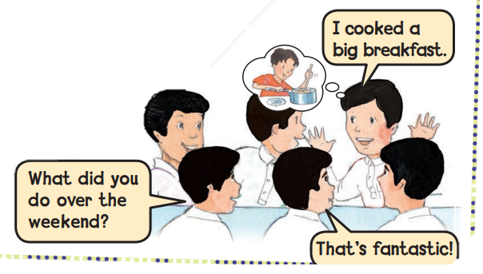
رائع
ماذا فعلت في إجازة نهاية الأسبوع؟

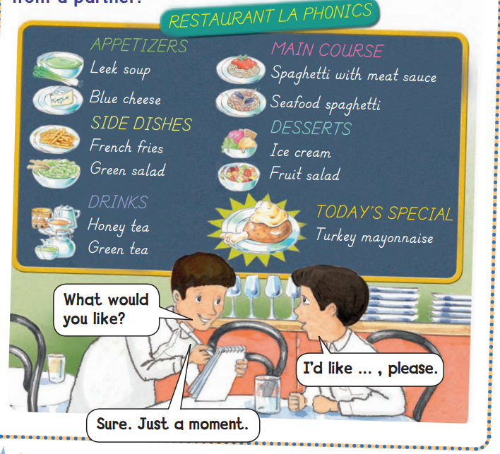
Page:55
بالتأكيد. لحظه من فضلك
ماذا تود ان تطلب؟
اود ان اطلب (يختار الطبق من القائمة) لو سمحت

page:57
هل يمكنني مساعدتك؟

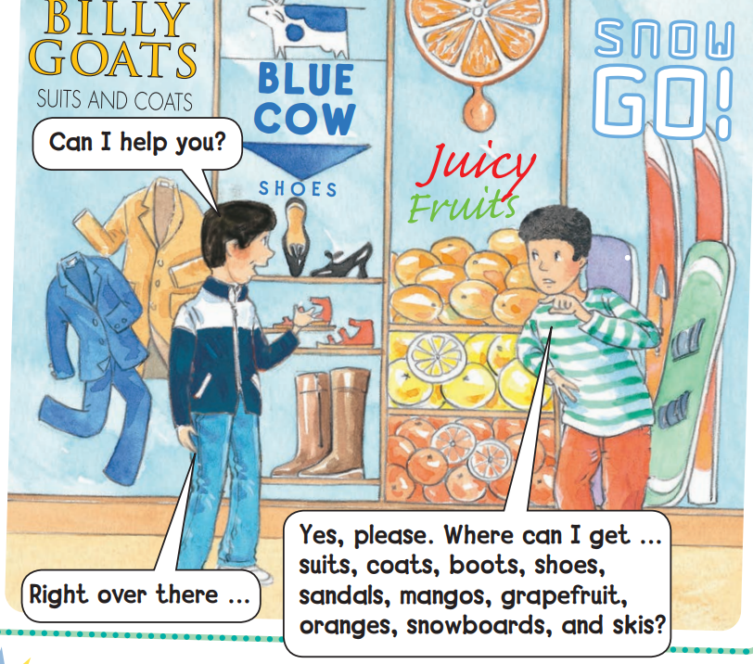

نعم رجاء، من اين احصل على ..... بدلة، معطف، احذية، صنادل، مانجو، فاكهة قريب فروت،برتقال،الواح التزلج؟
حسنا ، انها هناك
ما الذي حصل لك بالأمس؟ (يمكن استبدال (بالأمس) ب العبارات التالية: الأسبوع الماضي، الشهر الماضي ،العام الماضي)
Page:59
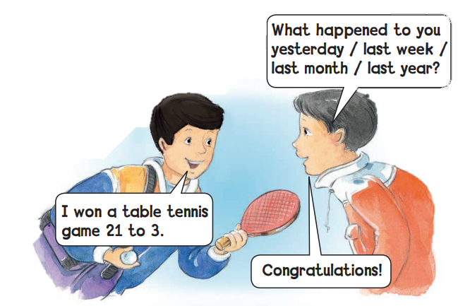
مبروك!
فزت في تنس الطاولة 21 مقابل 3

usually
يستخدم معها أفعال في زمن المضارع
Yesterday
يستخدم معها أفعال في زمن الماضي
الـقـواعــد
Yesterday and Today
Page:36
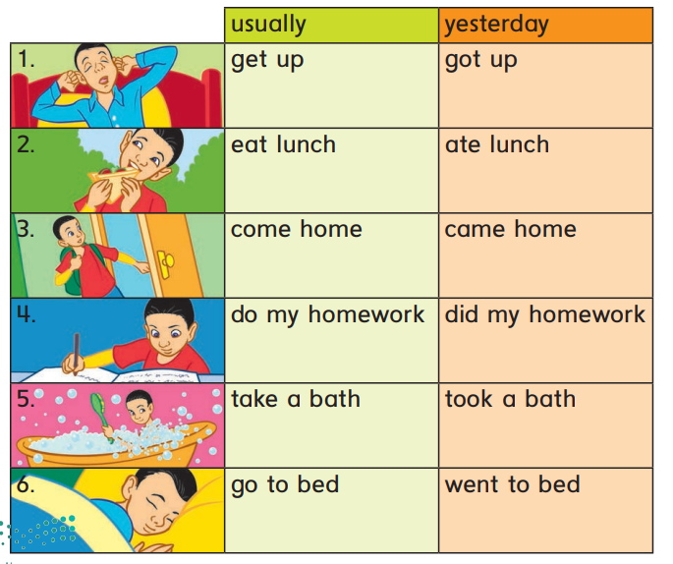
يخلد للنوم
خلد للنوم
اسـتـحـم
يـسـتـحـم
أدى واجباته المنزلية
يؤدي واجباته المنزلية
عاد للمنزل
يعود للمنزل
تناول الغداء
يتناول الغداء
يـستـيـقـظ
اسـتـيـقـظـ

مثال:
المضارع | الماضي
I usually get up at 6 o’clock. | Yesterday, I got up at 6 o’clock.
I usually go to bed at 9 o’clock. | Yesterday, I went to bed at 9 o’clock.
Page:44-45
التعرف على أسماء الوظائف وماذا يعملون وأين يعملون.
He / she تستخدم مع ضمائر المفرد DOES
( I ) وأيضا تستخدم مع They/ we/ you تستخدم مع ضمائر الجمع Do
 | 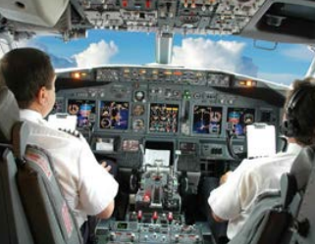 |  |  |  | 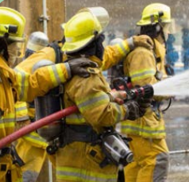
Who’s he/she?  من هذا- هذه؟ | He is Abdallah. | He is Faisal. | He is Ali. | She is Sara. | Who are they?  They are Ali and Saif.  من هؤلاء؟
What does he/she do?  ماذا يعمل-تعمل؟ | He is a pilot. | He is a doctor. | He is a chef. | She is a nurse. | What do they do?  They are fire fighters.  ماذا يعملون؟
Where does he/ she work?  اين يعمل- تعمل؟ | In airplanes. | In hospital. | In a restaurant. | In hospital. | Where do they work?  In fire station.  اين يعملون؟
What does he/she do?  ماذا يفعل في وظيفته؟ | He flies planes. | He helps sick people | He cooks dishes. | She helps sick people. | What do they do?  They put out fire.  ماذا يفعلون في وظيفتهم؟

Page:52-53
الأفعال في الزمن الماضي:
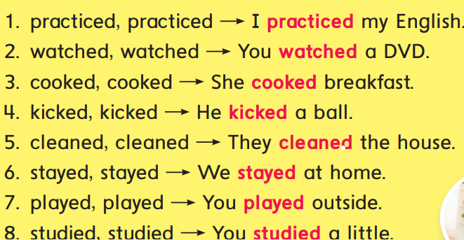
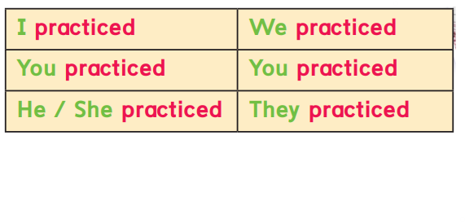
1- أفعال منتظمة: وهي الأفعال التي تبقى على شكلها الأصلي ويضاف لها في اخرها حرفي لتدل على ان الفعل في الزمن الماضي. أمثله:
ed

page:54
المعدود والغير معدود
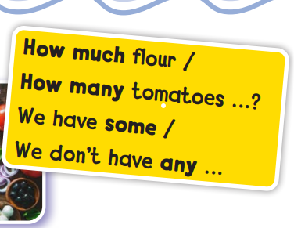

How much | How many | some | any
سؤال لغير المعدود مثل السائل مثل الماء، الدقيق، الرز الخ  مثال:  How much oil are there? | سؤال للمعدود مثل الفواكه والخضار الكراسي الأبواب السيارات الخ.  مثال:  How many eggs are there? | تستخدم للإثبات سواء معدود او غير معدود  مثال:  يوجد بعض الدقيق.  There are some flours. | تستخدم للنفي وللسؤال سواء معدود او غير معدود  مثال:  لا يوجد أي دقيق.  -There is not any flour.  -Is there any apple?
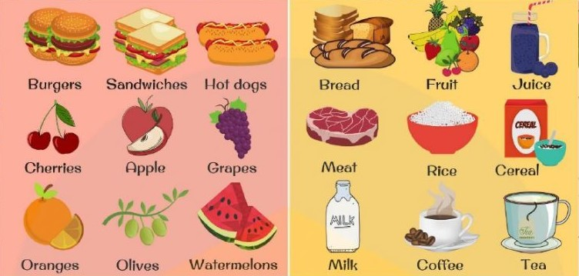

Page:60 -61
الأفعال في الزمن الماضي:
الأفعال الغير منتظمة: وهي الأفعال التي تتغير عند تحويلها للزمن الماضي وليس لها صيغة محدده.
win
أمثلة: نلاحظ ان الفعل في المضارع له حروف مختلفة وفي الجدول في حالة الماضي ونلاحظ اختلاف حروفه بتغير حرف الى حرف وأصبح في حالة الماضي.
i
o
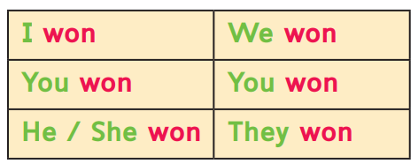

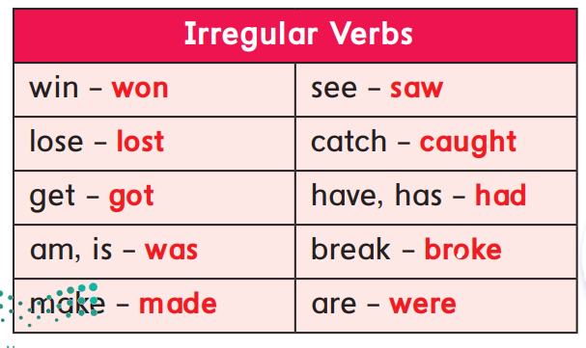

Yesterday and Today
المـفردات
get up يستيقظ | eat يأكل | 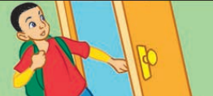  come home  يعود للمنزل | do homework  يحل واجباته المنزلية
take a bath  يتحمم | go to bed  الخلود للنوم | 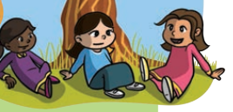  meet friends  اقابل الاصدقاء | 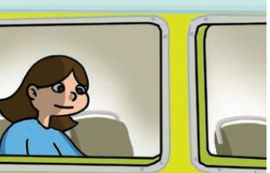  ride a bus  ركوب الباص
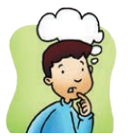  think  يفكر | 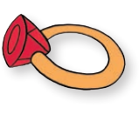  ring  خاتم | 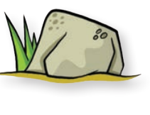  rock  صخره | 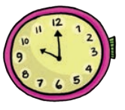  clock  ساعة
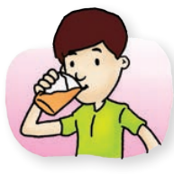  drink  يشرب | 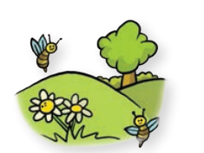  spring  ربيع | ink  حبر | 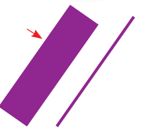  thick  عريض
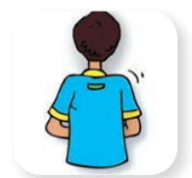  back  ظهر | 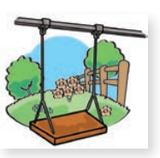  swing  ارجوحة | wing  جناح | 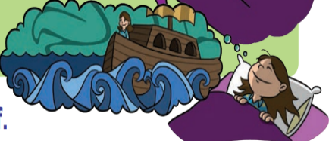  dream  تحلم
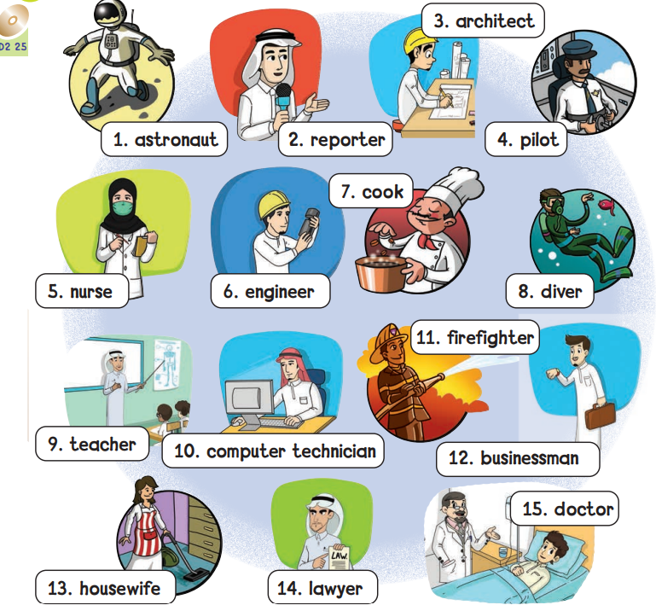
13-ربة منزل
3- معماري
10-تقني حاسب
15-طبيب
14-محامي
12-رجل اعمال
4-كابتن طيار
11-اطفائي
9- مــعــلــم
7-طــبــاخ
6- مهندس
8-رائد فضاء
5-ممرضة
2-مــذيــع
1-رائد فضاء
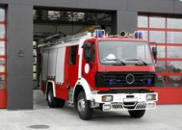  Fire station  محطة الاطفاء | Planes  طائرات | Hospital  مستشفى | Baker  خباز | Designer  مصمم
Tv reporter  مراسل تلفزيوني | Scientist  عالم | Writer  كاتب | Presenter  مقدم | 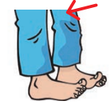  Knee  ركبة
Knob  مقبض الباب | Light  نور | Right  يمين | 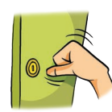  Knock  يطرق | Knife  سكين
Night  ليل | Teaches  يعلم- يدرس | 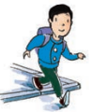  Walks  يسير | Reads  يقرأ | One thousand  ألف

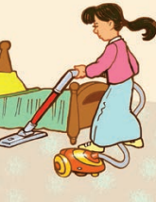  Clean  تنظف | Practice  يتدرب | 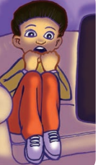  Scared  خائف | Kick  يركل | 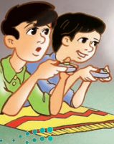  Play  يلعبون
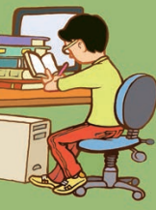  Study  يذاكر | 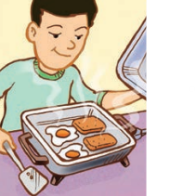  Cook  يطبخ | 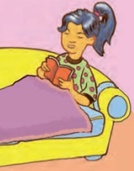  Stay at home  بقيت في المنزل | Sand  رمل | 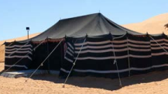  Tent  خيمة
Hand  كف اليد | Stand  يقف | Paint  يلون | Plant  نبته | 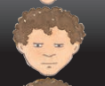  Bored  ممل
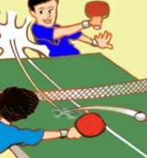  Tennis table  تنس الطاولة | Win  فوز | Captain  قائد | Rocket  صاروخ | See  يشاهد | 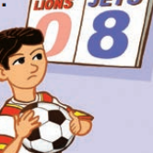  Lose  خسر
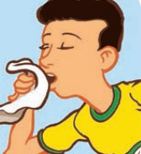  Sick  مريض | Operation  عملية | 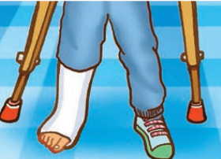  Break  كسر | 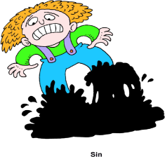  Stuck  عالق | Football  كرة القدم | Meat  لحم
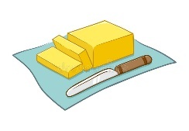  Butter  زبدة | 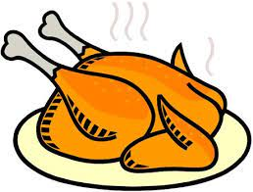  Chicken  دجاجه | 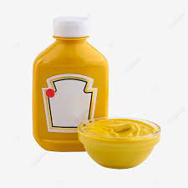  Mustard  خردل | Onion  بصل | Carrot  جزر | Flour  دقيق

الصوتيات
Yesterday and Today
Ng  صوت | Nk  صوت | Ck صوت (ك)
ring  spring  swing  wing | drink  think  ink | clock  thick  back  rock
صوت (ف) ph
telephone
صوت (ش) sh
ship
صوت (تش) ch
Cheese
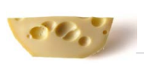
صوت (و) Wh
Whale

s
s
Kn  n لا ينطق عندما يتبع حرف k | gh  i  سبقت بحرف لذلك لا تنطق
Knob  Knock  Knife  Knee | Right  Light  Night
عندما تنتهي الكلمة بحرف فإن له عدة أصوات. الصوت الأول الصوت الطبيعي للحرف.
iz
z
الصوت الثاني نفس صوت حرف اما الصوت الثالث يكسر عند نطقه ويضاف له صوت (ز)
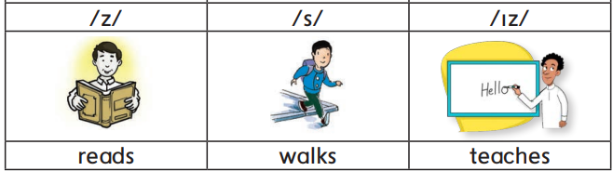

nd  صوت | nt  صوت
Sand  Stand  hand | Tent  Paint  Plant

جميع هذه الاحرف تنطق (ف)
gh  صوته في هذه الكلمات (ف) | F  صوته الأصلي (ف) | ph  صوته في هذه الكلمات (ف)
Laugh  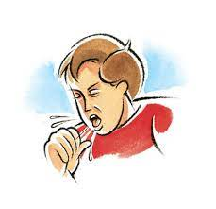  Cough | Friends  Frog | Elephant  Photos  photo

2nd term الفصل الثاني

Name : ………………………………………………….………………………………
الاسم: ………………………………………………….………………………………..
الصف: ………………………………………………….………………………………

Units : 5-6-7-8

for We Can 3

General Revision

General Questions
A. Match "A" with "B":
"A" |  | "B"
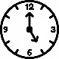  1.What time is it? |  |  | Nice to meet you, too.
2. What does your mom do? |  |  | I am 12 years old.
3.Nice to meet you Amal! |  |  | Yes, I do.
4.What time do you get up? |  |  | It’s five o’clock.
5.Do you like chocolate? |  |  | I get up at 6:30 in the morning.
6.I was a team captain. |  |  | He works in a school.
7. What did you do over the weekend? |  |  | She is a doctor.
8.How old are you? |  |  | That’s fantastic.
9. How many tomatoes do you need? |  |  | I played with my friends.
10.Where does the teacher work? |  |  | I need 3 tomatoes.
 |  |  | Good night!
B. Answer the following:
1- What’s your name?
………………………………………………………………………………………
2- How old are you?
………………………………………………………………………………………
3- What do you want to be when you grow up?
………………………………………………………………………………………
4- What does your dad do?
………………………………………………………………………………………
5. What did you do over the weekend?
………………………………………………………………………………………

C-Choose the correct answer:
1. Good morning!
c. Goodbye! | b. Good morning! | a. Goodnight
2. What do you want to be when you grow up?
c. I want to be a pilot. | b. We are students. | a. He works in a hospital.
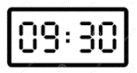
3. What time is it?
c. It’s quarter to nine. | b. It’s half past nine. | a. It is nine o’clock.
4.I cleaned my room on the weekend.
c. So did I. | b. How strange! | a. That’s scary!
5. My sister was sick.
c. Congratulations! | b. That’s fantastic! | a. Sorry for that!

Controlled Writing
A. Reorder to make a correct sentence or question:
1- 12;30 - I - a - bath – Yesterday – took – at - .
…………………………………………………………………………………………………………………………………………………………………………………………………
................................................................................................................................................................................................................
2- is - a - She - businesswoman.
…………………………………………………………………………………………………………………………………………………………………………………………………
................................................................................................................................................................................................................
3 - We - a - rainbow - saw - .
…………………………………………………………………………………………………………………………………………………………………………………………………
................................................................................................................................................................................................................

B. unscramble the words:
ocok: ________ ernus: ________
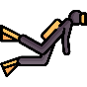
iplto: ________ irdev: ________
C. Fill the blanks with the correct word:
hospital - designer - TV - help - please
- Can I ____________ you ?
- A doctor works in a _______________ .
- We watched __________ last night.
- I want to be a fashion __________ when I grow up.
- I’d like coffee and cookies , _____________!

Reading Short Sentences:
A.Read and match:
1- He puts out fires. |  | 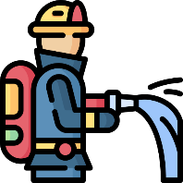
2- I cooked breakfast.
3- She caught a cold.
4- He fixes computers.
5- I went to school by bus.
6- We played a football match.

B. Circle or ×
1. They watched a scary movie on TV. |  | ×
2. I’d like sushi , please! |  | ×
3. I did my homework at 4:30 yesterday. 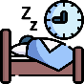 |  | ×
4. She works in a school . 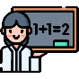 |  | ×

Grammar
A.Choose the correct answer:
1. I usually _______ to school at 7:00. | a. go | b. went | c. going
2. Yesterday, I _______ lunch at 3:30. | a. eat | b. ate | c. eating
3. What time ____ you usually come home? | a. do | b. did | c. does
4. What time ____ you go to bed yesterday? | a. do | b. did | c. does
5. I _____ in 5th grade last year. | a. is | b. are | c. was
6. We _____ tennis game last week. | a. lost | b. lose | c. losing
7. _______ does your dad do? | a. Who | b. Where | c. What
8. _______ are you? - I’m great, Thanks. | a. Where | b. How | c. Why
9. _______ do you work? - In a hospital. | a. Where | b. What | c. Who
10. How _______ milk do you have? | a. many | b. any | c. much
11. How _______ eggs do we need? | a. many | b. some | c. much
12. I don’t have _________ coffee. | a. some | b. any | c. many
13. There are ______ apples. | a. much | b. any | c. some
14. He is ____ engineer. | a. a | b. an | c. -
15. She is ____ police officer. | a. a | b. an | c. -
16. I have pens ____ pencils. | a. but | b. and | c. or
17. I like oranges ____ I don’t like bananas. | a. but | b. and | c. or
18. He is ______ dad. | a. he | b. my | c. they
19. She took me to ______ house. | a. her | b. his | c. their
20. I ______ a big fish last week. | a. catch | b.caught | c.catches
21. Last night, I _____ English for 2 hours. | a. practiced | b.practice | c.practicing
22. We _______ on the phone everyday. | a. talk | b. talked | c. talking
23. He is ____ police officer | a. an | b, a | c. --
24. I am ____ engineer. | a. an | b, a | c. --

Vocabulary
A.Write the correct answer under each picture:
do homework - go to bed - clock - clean the room - think

_____________ | _____________ | 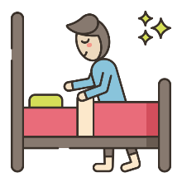_____________ | 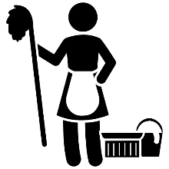_____________ | _____________
Housewife - astronaut - lawyer - pilot - scientist

_____________ | _____________ | _____________ | _____________ | _____________
trampoline - study - fantastic - boring - spaghetti

_____________ | _____________ | _____________ | _____________ | 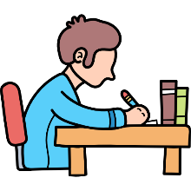_____________
race - rocket - table tennis - sick - salad

_____________ | _____________ | _____________ | _____________ | _____________
Orthography
A.Write ( ck – nk – ng ) in the suitable blanks:
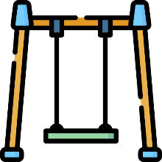 |  | 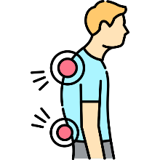
swi __ __ | i __ __ | ba __ __ | dri __ __ | wi __ __
B .Choose the correct answer :
__ __ ark |  |  |  |  |  | __ __ cocolate |  |  |  |  |  | __ __ ale |  |  |  |  |  | __ __ one
ch | sh |  | ph |  | wh | ch | sh |  | ph |  | wh | ch | sh |  | ph |  | wh | ch | sh | ph | wh
 |  |  |  |  |  | 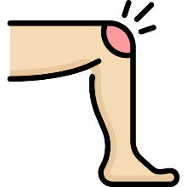
ni __ __ t |  |  |  |  |  | __ __ ee |  |  |  |  |  | pai __ __ |  |  |  |  |  | sta __ __
nt | gh |  | kn |  | nd | nt | gh |  | kn |  | nd | nt | gh |  | kn |  | nd | nt | gh | kn | nd
__ riends |  |  |  |  |  | ele __ __ ant |  |  |  |  |  | lau __ __
ph |  | gh |  | f |  | ph |  | gh |  | f |  | ph |  | gh |  | f

Done by: Hanadi Al Osaimi

