

Kingdom of Saudi Arabia

Ministry of Education

……..Education Directorate

………………… School

English Language

elementary Grade …..

period Exam

…………….\20

Student's Name : class:

……\ 4 marks

General questions

**A.Answer the questions**

[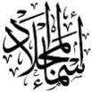](https://t.me/Asmaworld)**1-What does he do?**

a-Good afternoon b- He's a lawyer c- No. he isn't.

**2-What time did you get up yesterday?**

a-Yesterday, I got up at 5:30 b- I usually get up at 5:30 c- Yes, I did.

**3-What time do you take a bath?**

a- She plays basketball at 3:00 b-I usually take bath at 10:00 c- No , I can't.

**4-Where do they work?**

a-They work in airport. b-She works in hospital. c-I am work in school.

Controlled Writing

……\ 1 marks

**A-reorder.**

**grow up, - a firefighter – I want – When I – to be**

……………………………………………………………………………………

……\ 4 marks

Reading short sentence

|  |  |  |
| --- | --- | --- |
| Child brushes his teeth clipart | 1- I usually finish the school at 1:30 ( ) | |
| The clock in room in its mirror image showed as if the time is quarter past  seven . What is actual time - Brainly.in | 2- It's a quarter past seven ( ) |

**A-Put (** ✔ **) or (**  X  **)**

**B.Match**

|  |  |  |
| --- | --- | --- |
|  |  | 1-It's 5 o'clock. |
| Clock 5:00 | ClipArt ETC |  | 2-A doctor helps sick people and works in a hospital. |

[](https://t.me/Asmaworld)**A-Choose the correct answer.**

Grammar

……\ 4 marks

1- What does she ( do – does – doing ) ?

2- I usually ( eat – ate – eats ) lunch at 1:00.

3-Yesterday, I ( do – does – did ) my homework at ten o'clock.

4-Where do you ( work – works – working)?

……\ 5 marks

Vocabulary

**A.write the correct word under each picture**

**( cheese – ink - clock - baker - astronaut )**

**)**

|  |  |  |  |  |
| --- | --- | --- | --- | --- |
| Cheese png graphic clipart design 19614416 PNG | Ink clip art cartoon Royalty Free Vector Image |  | Bakers Clipart PNG, Vector, PSD, and Clipart With Transparent Background  for Free Download | Pngtree | Vintage alarm clock clipart |
|  |  |  |  |  |

Orthography

……\ 2 marks

**A. Fill in the missing letters**

Sh Kn ph gh

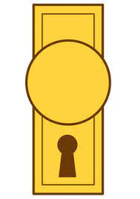

…..ob

….ip

Ni…..t

…..one

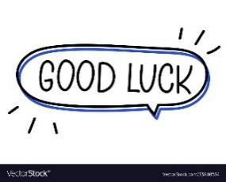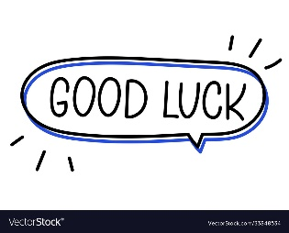

Your teacher …..:…………………………….

Your teacher:

__________________________________________________________________________________

**General Questions**

/ 3

Choose the correct answer:

|  |
| --- |
| **1 –** What does your dad do ?  **A . I am playing. B . He is a doctor.** |
| 2 – What does the firefighter do?  **A. He puts out fires . B. He flies plane .** |
| 3 – What is the time? 10:30  **A . It is ten o'clock. B. It is ten thirty.** |

________________________________________________________________________________________________________________________________________________________________________________________________________

/ 3

**Reading short sentences**

Read the sentence then choose**☑** or **🗵** :

|  |  |  |
| --- | --- | --- |
| **🗵** | **☑** | Using a digital clock  **1. It is seven o'clock.** |
| **🗵** | **☑** | Cartoon Little Girl Waking Up in the Morning Stock Vector - Illustration of  yawn, kids: 173059130  **2. I eat my lunch.** |
| **🗵** | **☑** | **3. He is a pilot.** |

______________________________________________________________________________________________________________________________________________________________________________________________________

/ 3

**Grammar**

|  |  |  |  |
| --- | --- | --- | --- |
| C**. got** | B**. get** | A**. go** | **1 –** I usually ____ up at 5:00 **.** |
| C**. go** | B**. came** | A**. come** | **2-** yesterday, I ____ home at 1:00 . |
| C**. where** | B**. what** | A**. who** | **3-** ____ does she do ? She is a nurse . |

Choose the correct answer:

Do as shown between brackets:

/ 2

**Controlled writing**

|  |  |  |  |
| --- | --- | --- | --- |
| **Thirty** | **Thousand** | **hundred** | One To Hundred | Numbers Song | 123 ABC | Learning Numbers For Toddlers by  Kids Tv - YouTube **2- One _______. ( choose )** |
| ..................................................... | | | **3– she - a – teacher – is. ( rearrange )** |

/ 5

**Vocabulary**

Put the right word under its picture:

**clock – doctor – firefighter – baker - get up**

|  |  |  |  |  |
| --- | --- | --- | --- | --- |
| Premium Vector | Baker cartoon character holding a bread. vector hand drawn  illustration | Cute doctor vector illustration isolated on white background. Doctor cartoon  illustration Stock Vector Image & Art - Alamy |  | Cartoon Little Girl Waking Up in the Morning Stock Vector - Illustration of  yawn, kids: 173059130 |  |
|  |  |  |  |  |

**Orthography**

/ 4

Fill in the missing letters:

**ng – kn – gh -nk**

|  |  |  |  |
| --- | --- | --- | --- |
| Quill Inkpot - Cartoon Vector Illustration Stock Vector Image by ©baavli  #29940217 |  |  | Ring Cartoon Diamond - Free vector graphic on Pixabay | Wedding ring  drawing, Engagement ring drawings, Clip art |
| **i_ _** | **ri_ _ t** | **_ _ ee** | **ri_ _** |

Good luck T.

**اختبار** فتري – الصف ..........



|  |  |  |  |  |  |
| --- | --- | --- | --- | --- | --- |
| **الاسم ثلاثي:** |  | **الفصل** | **/** | **الدرجة** | **/ 20** |

Midterm Exam

|  |  |  |  |  |  |  |  |  |  |  |  |  |
| --- | --- | --- | --- | --- | --- | --- | --- | --- | --- | --- | --- | --- |
| |  | | --- | |  | | **2** |   **I. Choose the right answer :**   |  |  | | --- | --- | | 1. What is the time ? | | | 1. **It is one o'clock.** | 1. **It is three o'clock.** | |      |  |  | | --- | --- | | 1. What does the firefighter do? | | | 1. **He puts out fires .** | 1. **He flies plane .** | | |
| |  | | --- | |  | | **3** |   222  **II. Choose 🗸 OR 🗴**   |  |  |  | | --- | --- | --- | | **It is seven o'clock.** | **He is a doctor.** | **I eat my lunch.** | |  |  |  | | **🗸 🗴** | **🗸 🗴** | **🗸 🗴** | |
| |  | | --- | |  | | **2** |   **III. Do as shown between brackets:**     |  |  |  |  | | --- | --- | --- | --- | | **thirty** | **thousand** | **hundred** | **1-one _______ . ( Choose )** | | **ززززززززززززززززززززززززززززززززززززززززززززززززززززززززززززززززززززززززززززززززززززززززززززززززززززززززززززززززززززززززززززززززززززززززززززززززززززززززز** | | | **2. is – a – she – teacher ( rearrange)** | |
| |  |  |  |  | | --- | --- | --- | --- | | **C. go** | B**. get** | A**. got** | **1 –** I usually ____ up at 5:00 **.** | | **C. Where** | B**. Who** | A**. What** | 2**.**  ____ does she do ? She is a nurse . |   **IV. Choose the correct word:**   |  | | --- | |  | | **2** | |
| **V. Choose the correct word:**   |  | | --- | |  | | **6** |        |  |  |  |  |  |  | | --- | --- | --- | --- | --- | --- | |  |  |  |  |  |  | | **Eat** | **Take a bath** | **Engineer** | **Baker** | **Teacher** | **Clock** | | **Brush** | **Get up** | **Firefighter** | **Nurse** | **Doctor** | **Ring** | |
| |  |  |  |  |  | | --- | --- | --- | --- | --- | | **_ ilot** | **dri_ _** | **ri_ _**t | **_ _**ee | **ri_ _** | | **b** | **nk** | **ph** | **gh** | **ng** | | **p** | **kn** | **gh** | **kn** | **nk** |   **VI. Choose the correct letter:**   |  | | --- | |  | | **5** | |
| **TEACHER :** |

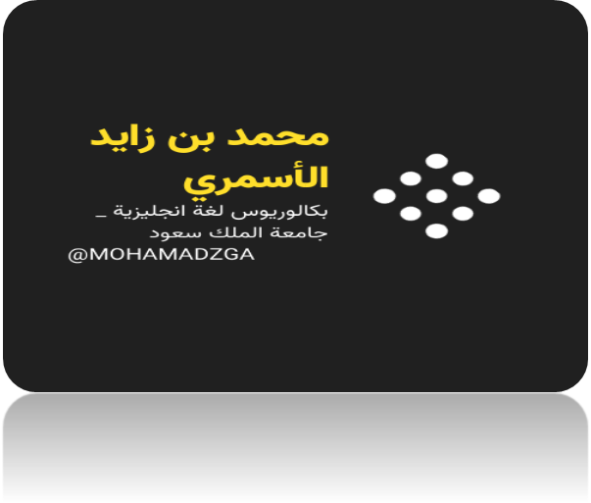

**لا تنسوني من صالح دعائكم**



M_zaid0