Kingdom of Saudi Arabia
Ministry of Education
………… Education Directorate
……………….. Intermediate School

Super Goal 2 - Test unit 6 & 7

Name :………………………………………………………………………… Class:…….……….

Comprehension
2 Marks
- Read the text and answer the questions. Write T or F at the end of each question/statement.
Police Department
Witness Report
Incident: Motor Vehicle Accident
Witness: Larry Johnson
There was an accident at the corner of Main Street and Oak Street last night. A car crashed into The Café. The accident happened around 6:30 P.M. I saw it happen. I was at the bus stop across the street. A car drove through the intersection very fast. Someone started to walk across the street. The driver couldn’t stop. He turned and crashed into the café. Fortunately, no one was hurt. I was scared and worried about the people in the café. But everyone was OK. It was the driver’s fault. He was driving too fast.
- The car drove too fast. ( )
- The driver turned and crashed into the café. ( )
- The driver was hurt. ( )
- It was the driver’s fault. ( )
Grammar
- Choose the best answer to fill in the blank in each question.
5 Marks
- How was the museum tour ? - it ______ good.
a. were b. is c. was d. none
- The museum exhibit was ____ interesting.
a. absolutely b. completely c. really d. totally
- The dinosaur skeleton at the Natural History Museum is ____.
a. completely big b. absolutely enormous c. quite a big d. very huge
- ______ are you Worried ? - Because I have a test tomorrow .
a. Why b. When c. What d. Where
- Why did the driver start to shout ? - ________ he was angry .
a. What b. Because c. There d. Have
1.5 Marks
- Find the mistake, underline it and write the correct word.
- Did you had fun at the weekend? - _______________ .
- What did you watched on TV yesterday? - _______________ .
- Do you write an email yesterday? - _______________ .

- Complete with there was – there were.
1.5 Marks
- _____________________ no clouds in the sky !
- _____________________________ two wolfs !
- _____________________ a picture in the room.

Vocabulary
- Choose the best answer to fill in the blank in each question.
5 Marks
- That _______________ shows wonderful modern art by a Spanish artist.
a. gallery b. exhibit c. history d. museums
- She is _______ of dogs, she can't buy one.
a. tired b. scared c. sleepy d. liked
- The word 'calligraphy' means:
a. creative writing b. beautiful writing c. bad writing d. big writing
- Lucy: Why is Jen so ____? -Ann: Because she stayed up late last night.
a. happy b. angry c. worried d. sleepy
- Bill: Why is Brian so ____? - Ali: Because his brother was in an accident this morning.
a. Happy b. tried c. surprised d. worried

- Write the correct word under the picture.
3 Marks

1 | Happy | 2 | Robot | 3 | Pizza
A | 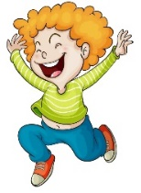 | B |  | C
……………………..…………….. |  | ……………………..…………….. |  | ……………………..……………..

Orthography
- Choose the correct letter.
2 Marks

- I like his…..ory museums best
a. ( p ) b. ( t ) c. ( m )
- I was slee…y and I didn't see the car coming.
a. ( p ) b. ( s ) c. ( c )
Good luck !
English Language
Intermediate Grade 2nd
1st period Exam
Kingdom of Saudi Arabia
Ministry of Education
………………… School

5
Student's Name : class:

1-Read the following passage and answer the questions below:
Last summer my family and I went to Egypt. At the beginning of our trip, we went on a cruise on the River Nile. Then we went sightseeing and of course, we went to the Egyptian Museum. We also visited the Pyramids of Giza and took lots of pictures. They were amazing! My parents and I also tried camel riding. My brother didn’t want to go anywhere near the animal. You see, he was afraid. I really want to visit Egypt again. It’s beautiful and there are many things to see there!
A) Choose the correct answer : -
1- We go to Egypt…………….
a) last week b) last summer c) last year
2- We went on a cruise on the ……………………………..
a) Red sea b) River Nile c) mall
3- My …………….. was afraid of the camel.
a) brother b) sister c) friend
B) Put (√ ) or (×):
1- The pyramids were amazing.( )
2- The writer doesn't want to visit Egypt again. ( )
5
2-choose the correct answer.
1- They ( was – were – do ) at school.
2- Do you want (someone – no one - anything )to eat?
3- where (was – were – am ) the football game?
4- Did you (watch – watched – watching ) T.V this morning?
5-She was scared (so – because – to ) he was driving too fast .
6-I don’t have a driver’s license. - ( Neither – So – more ) do I.
7- There (was – were - do )many stores around here.
8-I know(something – anything - someone) who gives yoga lessons.
9- The museum was ( very – too – X ) great .
10- Omar ( study – studied – studying ) Math yesterday.

5
3. Do as shown between brackets.
A-(Correct)
a.Ali didn’t eat something for dinner because he had a very big lunch…………….……
b. Noura win the game last moth. ……………..
B-( reorder)
a- was \ exciting \ the \ movie \ very
…………………………………………………………………………………
b- wrote \ Ahlam \ 2 days \ a test \ ago
…………………………………………………………………………………..
C-. (make a question)
a- Ali played football. ………………………………………………….?
D-( use very )
He is clever ………………………………………………………….
5
4- Match
Hurt from an accident |  | injury | 1
Payment for cost of an accident |  | witness | 2
Where tow road cross |  | intersection | 3
Someone who saw an event |  | insurance | 4

5- Choose the correct missing letters.
1-__icket ( H – T ) 2- Stadiu__ ( q – m ) 3- gui__e ( d – v)

6-write the correct word under each picture.
Sad happy scared sleepy

………………..
………………..
………………..

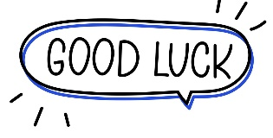

Your teacher:

Kingdom of Saudi Arabia
Ministry of Education
………… Education Directorate............
…………..……………….. Intermediate School

20
Total

Midterm Test
Second Intermediate Grade

Name ………………………………… Class ………………………………
__________________________________________________________________________________________
/ 5
Comprehension

Read the following then answer the questions:

My uncle has a small farm. He has a lot of chickens there. He sells eggs and chickens. Every summer, during the holiday I usually go to his farm to help him. I feed the chickens and collect the eggs. My uncle sometimes gives me chocolate
and money.

A- Put (√ ) for true or ( ᵡ ) for false :

( ) | 1. My uncle has a big farm.
( ) | 1. My uncle sells cows and milk.
( ) | 2. I help my uncle in his farm.

B- Choose the right answer:
cows | chickens | dogs | cats | - I feed the_________ in my uncle's farm.
holiday | eggs | milk | chocolate | 2- My uncle sometimes gives me _____ and money.

_____________________________________________________________________________________________________
/ 5
Grammar

A-Choose the right answer:
1. I ______ home yesterday.
A . stayed B. stay C. stays D. staying
2. What ___ you do last weekend?
A . do B. does C. did D. doing
3. There ____three accidents last week.
A . was B. is C. are D. were B-Do as shown between brackets:
1. I didn’t hear __________. I was asleep. ( Choose ) [nothing / anything] 2- A. I have some good news.
B. _____ do I . ( Choose ) [ Neither / So ]

/ 3
Vocabulary

A- Choose the best answer to fill in the blank:
1. The word calligraphy means__________________.
A. different writing B. beautiful writing C. good writing D. bad writing
2. I heard a _____ for help. “Over here! I’m stuck in the fence.
A. smile B. laugh C. love D. cry
3- Ahmed has a toothache. He should go to the _______ .
A. nurse B. teacher C. dentist D. doctor
B- Put the right word under its picture:
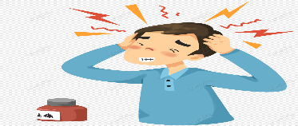 | 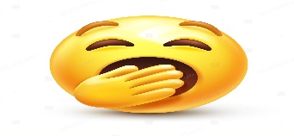 | 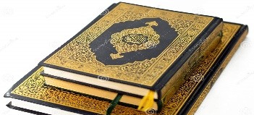 | 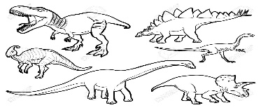
The holy Qur’an - Sleepy – Dinosaurs – Headache
/ 4

_______________________________________________________________________________
/ 3
Orthography

Choose the correct letter:
C. ( n ) | B. ( g ) | A. ( m ) | 1. There many people in the stadiu__.
C. ( c ) | B. ( s ) | A. ( t ) | 2. Don’t be __hy.
B. ( c ) C. ( l ) |  | A. ( s ) | 3. Doctor, I feel si__k.

Good luck T.

