KINGOM OF SAUDI ARABIA …………………………………. Education directorate
MINISTRY OF EDUCATION ……………………………. Elementary school

12/5 _ 16/5 1st week |  |  |  | Unit 1  Beautiful Nature
P4 | P3 | P2 | Talk Time,Rhythms & Listening
2nd week 19/5 _ 23/5
P7 | P6 | P5 | Rhythms & Sounds, Words
3rd week 26/5 _ 1/6
Evaluation unit1 | P9,34 | P8 | Phonics, Phonics Pr
Sunday 4th week 4/6 _ 8/6 |  |  |  | Unit 2  Friends, Actions, Things
P12 | P11 | P10 | Talk Time,Rhythms & Listening
11/6 _ 15/6 5th week
P15 | P14 | P13 | Rhythms & Sounds, Words
18/6 _ 22/6 6th week
Evaluation unit2 | P17 | P16 | Phonics
7th week 2/7 _ 6/7 |  |  |  | Unit 3  Wild Animals
P20,21 | P19 | P18 | Talk Time,Rhythms & Listening
8th week 9/7 _ 13/7
Evaluation unit3 | P24,25,36 | P22.23,35 | & Phonics, Phonics Pr Words
9th week 16/7 _ 20/7 Sunday |  |  |  | Unit 4  From Here to There
P28,29,37 | P27 | P26 | Talk Time,Rhythms & Ph pr
10th week 23/7 _ 27/7
Evaluation unit4 | P32,33,39 | P30.31,38 | & Phonics, Phonics Pr Words
11th week 1/8 _ 5/8

Remedial Plans
12th week 8/8 _ 12/8
Final Exams
Thursday
SYLLABUS DISTRIBUTION FOR 2nd ELEMENTARY GRADE (WE CAN 2)(SECOND TERM) 1445

إجازة مطولة يوم التأسيس

Teacher…………….… Headmaster………………. Supervisor ……………….

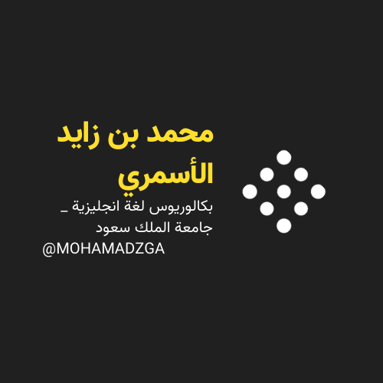

MOHAMADZGA M_zaid0

لا تنسوني من صالح دعائكم

