KINGOM OF SAUDI ARABIA …………………………………. Education directorate
MINISTRY OF EDUCATION ……………………………. Elementary school

12/5 _ 16/5 1st week |  |  |  |  |  | Unit 5  Since When?
listening + pronunciation | Language in Context | Grammar |  | Listening and discuss + pair work | L
2nd week 19/5 _ 23/5
Writing | Project | Reading |  | about you +Conversation | L
3rd week 26/5 _ 1/6 |  |  |  |  |  | Unit 5  Since When?  Unit 6  Do You Know where It Is?
Grammar | (U6) Listening and discuss + pair work | Provide tasks  (four skills) |  | Form, Meaning and Function | L
Sunday 4th week 4/6 _ 8/6
Reading | about you +Conversation | listening + pronunciation |  | Language in Context | L
11/6 _ 15/6 5th week |  |  |  |  |  | Unit 6  Do You Know where It Is?  Unit 7  IT’S A GOOD DEAL, ISN’T IT?
Provide tasks  (Vocabulary and grammar) | Form, Meaning  and Function | Writing |  | Project | L
18/6 _ 22/6 6th week
listening + pronunciation | Language in Context | Grammar |  | (U7) Listening and discuss + pair work | L
7th week 2/7 _ 6/7 |  |  |  |  |  | Unit 7  IT’S A GOOD DEAL, ISN’T IT?  Unit 8  DRIVE SLOWLY
Writing | Project | Reading |  | about you +Conversation | L
8th week 9/7 _ 13/7
Grammar | (U8) Listening and discuss + pair work | Provide tasks  authentic language use |  | Form, Meaning and Function | L
9th week 16/7 _ 20/7 Sunday |  |  |  |  |  | Unit 8  DRIVE SLOWLY
Reading | about you +Conversation | listening + pronunciation |  | Language in Context | L
10th week 23/7 _ 27/7
Provide tasks  (four skills) | Form, Meaning and Function | Writing |  | Project | L
11th week 1/8 _ 5/8
Oral exams |  |  | Expansion units 5 -8
Thursday 12th week 8/8 _ 12/8 Final Exams

SYLLABUS DISTRIBUTION FOR 3rd INTERMEDIATE GRADE (SUPER GOAL3) (SECOND TERM) 1445

إجازة مطولة إجازة يوم التأسيس
Teacher…………….… Headmaster………………. Supervisor ……………….

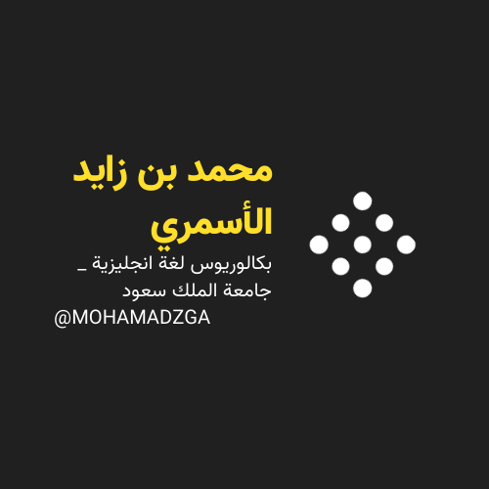

MOHAMADZGA M_zaid0

لا تنسوني من صالح دعائكم

