KINGOM OF SAUDI ARABIA …………………………………. Education directorate
MINISTRY OF EDUCATION ……………………………. Elementary school

12/5 _ 16/5 1st week |  |  |  | Unit 1  How old Are You?
P4 | P3 | P2 | Talk Time, Rhythms & Sounds
2nd week 19/5 _ 23/5
P7 | P6 | P5 | Rhythms & Sounds, Words
3rd week 26/5 _ 1/6
Evaluation unit1 | P9 | P8 | Phonics
Sunday 4th week 4/6 _ 8/6 |  |  |  | Unit 2  What’s This? What’s That?
P12 | P11 | P10 | Talk Time, Rhythms & Sounds
11/6 _ 15/6 5th week
P15 | P14 | P13 | Rhythms & Sounds, Words
18/6 _ 22/6 6th week
Evaluation unit2 | P17 | P16 | Phonics
7th week 2/7 _ 6/7 |  |  |  | Unit 3  Toys and Things
P20,21 | P19 | P18 | Talk Time, Rhythms & Sounds
8th week 9/7 _ 13/7
Evaluation unit3 | P24,25,35 | P22.23,34 | & Phonics, Phonics Pr Words
9th week 16/7 _ 20/7 Sunday |  |  |  | Unit 4  Food
P28,29 | P27 | P26 | Talk Time, Rhythms & Sounds
10th week 23/7 _ 27/7
Evaluation unit4 | P32,33,37 | P30.31,36 | & Phonics, Phonics Pr Words
11th week 1/8 _ 5/8

Remedial Plans
12th week 8/8 _ 12/8
Final Exams
Thursday
SYLLABUS DISTRIBUTION FOR 1st ELEMENTARY GRADE (WE CAN 1) (SECOND TERM) 1445

إجازة مطولة يوم التأسيس

Teacher…………….… Headmaster………………. Supervisor ……………….

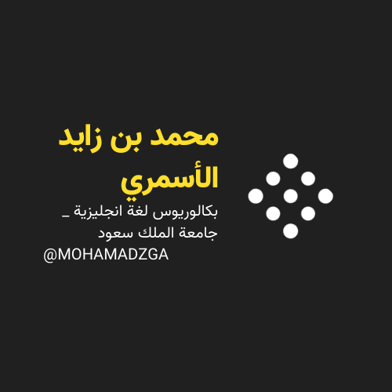

MOHAMADZGA M_zaid0

لا تنسوني من صالح دعائكم

