|  |  |  |  |
| --- | --- | --- | --- |
| **المملكة العربية السعودية**  **وزارة التعليم**  **الإدارة العامة للتعليم ب..... ابتدائية ....** | **http://tabuk2day.com/wp-content/uploads/IMG_3362.jpgبسم الله الرحمن الرحيم** **اختبار الفصل الدراسي الأول**  **للعام الدراسي 1444 هـ** | **المادة** | لغة انجليزية |
| **الصف** | الخامس |
| **الزمن** | ساعة ونصف |
| **الدور** |  |
| **الاسم: .............................................................................................................**   |  |  |  |  |  |  |  |  | | --- | --- | --- | --- | --- | --- | --- | --- | | **Total** | **6** | **5** | **4** | **3** | **2** | **1** | **Question** | |  |  |  |  |  |  |  |  | |  | | **Revised by:** | |  | | **Corrected by:** | | | | | |

**Q1General Questions:**

**6**

**A. Choose the suitable answer:**

1. **Where do you live ?**
2. I live in Qassim. **b-** I’m eleven years old. **c**- My name’s Ali.
3. **Whose shoes are these?**
4. They’re Steve’s**. b-** My name’s Hashim. **c**- Thank you.
5. **How do you go to school?**
6. I have one brother. **b-** I live in Makkah. **c-** by school bus.
7. **How old are you?**

**a-** I’m 13 years old. **b**- Thank you **c-** welcome

1. **What sport do you like?**

**a-** I like tennis **b-** Yes, I do **c-** I like English

1. **What chores do you like?**

**a-** No, I don’t **b-** I like washing dishes **c-** Nice to meet you

1. **Nice to meet you.**

**a-** thank **you b-** nice to meet you too. **c-**. Yes, I do

1. **What do you think about sharks?**

**a-** I think they’re scary **b-** yes, they are **c-** No, they aren’t

**B. Answer**

1- Do you like playing football? ……………………………………..

2- What do you think about seals? I think they’re ……………………..

**Q2.Controlled writing:**

**5**

**A-Match:**

|  |  |  |
| --- | --- | --- |
| feed |  | **1-**I think dolphins are \_\_\_\_\_\_\_\_\_. |
| golf |  | **2**-I’d like to try photography but I have no\_\_\_\_\_\_\_. |
| fast |  | **3**I usually \_\_\_\_\_\_\_\_\_\_\_\_\_\_ the fish |
| camera |  | **4**- Does your brother play\_\_\_\_\_\_\_\_\_\_\_\_\_\_\_. |

**B-Rearrange**

1. Riyadh – in – I – live . ……………………………………………………………
2. Like - basketball – I. …………………………………..….……………………..
3. is – think – I – seahorse – slow. ……………………………………………………

**5**

**Q3-Grammar:**

1. **Choose the correct answer:**
2. Seals are **(cute – cuter – cutest*)*** than starfish.
3. **(Who – What – How)** do you go to school?
4. Dolphins ( **is – are** - **am** ) cute.
5. A whale ( **is – are - am** ) big.
6. I (  **have – has** - **is** ) a bicycle.
7. Whose skirt is this ? It is ( **Nura – Nura's**).
8. My sister is a doctor. ( **Her – His -My** ) name is Nora.
9. They are my sisters. ( **My - Their – its** ) names are Nora and Alia.
10. She **( have – has – am)** a doll.
11. I think the whale is the **( big – biggest – bigger)** sea animal.

**6**

**Q4: Vocabulry:**

**Write the correct number under each picture:**

1.bicycle 2. Shark 3. Rain 4. Tie 5. Scuba diving 6.jellyfish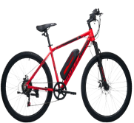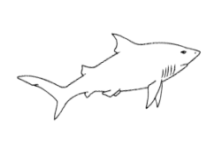

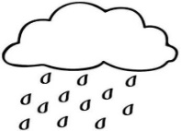**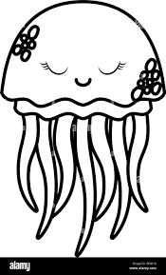**

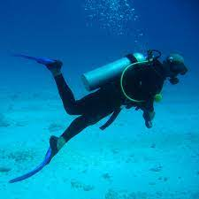

**( ) ( ) ( ) ( ) ( ) ( )**

**Q5: Reading:**

**4**

1. **Write the correct number under each picture:**
2. I am washing the dishes.
3. I like playing tennis.
4. I think whales are the biggest sea animals.
5. Bungee jumping is a dangerous sport.

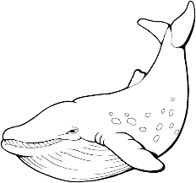 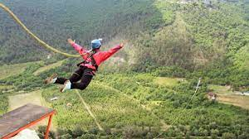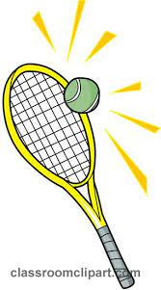

( ) ( ) ( ) ( )

**4**

**Q6: Orthography**

1. **Complete the missing letter :**

**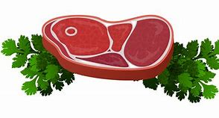**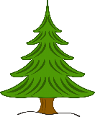**[ ee / ea / ie / i-e ]**

1) m\_\_ \_\_ t 2) p \_\_n \_\_ 3) sl\_\_ \_\_ p 5) p\_\_ \_\_

1. **Fill in the missing letters with [ oi / oy ]**

|  |  |
| --- | --- |
| **1. b\_\_\_\_** | **3. c\_\_\_\_n** |

1. **Unscramble**

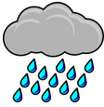

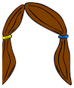

(nair) ……………… (aihr)………….

**Best Of Luck**

|  |  |  |
| --- | --- | --- |
| **المملكة العربية السعودية** |  | **اسم الطالب/ه .........................** |
| **وزارة التعليم** | **رقم الجلوس : .........................** |
| **إدارة تعليم منطقة .....................** | **المادة : انجليزي** |
| **مكتب التعليم ب........................** | **الزمن : ساعة ونصف** |
| **مدرسة : ..............................** | **الصف : فصل ( )** |
| **اسم المصحح / ه:** | **التوقيع :** | **الدرجة رقما :** |
| **اسم المراجع / ه :** | **التوقيع** : | **الدرجة كتابة :** |
| **اختبار نهاية الفصل الدراسي الأول للعام الدراسي 1445 – لغة انجليزية –– للصف........... ابتدائي** | | |

**1 : Choose the right answer:**

**6**

**General Questions**

|  |  |
| --- | --- |
| **A**. **I like some juice.** **B**. **I live in Riyadh.** | **1 – Where do you live?** |
| **A**. **I am 11 years old.** **B**. **I am fine.** | **2 – How old are you?** |
| **A**. **It's a seahorse.** **B**. **It's a seal.** | Funny Seal Cartoon Royalty Free SVG, Cliparts, Vectors, And Stock  Illustration. Image 13281545.**3- What is that?** |
| **A**. **I like painting.** **B** . **I like football.** | **4 – What sport do you like?** |
| **A**. **I play football.** **B** . **I clean up my room.** | **5- What chores do you do?** |
| **A**. **Yes, she does sometime**. **B.No, I don't** . | **6- Does she vacuum the floor?** |

**Q1 : Choose the right answer:**

**5**

**Controlled Writing**

|  |  |  |  |
| --- | --- | --- | --- |
| **.......................................................** | | | **1 – to - nice – you – meet . (Rearrange)** |
| **..........................................................** | | | **2 – horse - I – riding – like. (Rearrange)** |
|  |  |  | **3- set - I – table – the . (Rearrange)** |
| **clean** | **set** | **feed** | Cartoon vector illustration of a hand feeding fish in a bowl, isolated on  white background Stock Vector | Adobe Stock**(choose) 4- I \_\_\_\_ the fish.** |
| **activities** | **sports** | **chores** | **5- Football and volleyball are \_\_\_\_\_\_\_ (choose)** |

|  |  |  |
| --- | --- | --- |
| Danger swim stock vector. Illustration of sticker, expressive - 42139679**1. He can swim.** | 🗸 | 🗴 |
| 16,329 Cartoon Whale Stock Photos, Pictures & Royalty-Free Images - iStock**2. The whale is small.** | 🗸 | 🗴 |
| Shopping Trolley Clipart Man - Go To Supermarket Clipart, HD Png Download ,  Transparent Png Image - PNGitem**3. I go shopping.** | 🗸 | 🗴 |
| Cute Falcon Cartoon Flying . Illustration of Falcon Bird Stock Illustration  - Illustration of background, falcon: 126506246 **Falcons can see very far..4** | 🗸 | 🗴 |

**Q3: Choose (🗸) or (×):**

**Reading**

**4**

**Q4: Choose**

**Grammar**

**5**

|  |  |  |  |
| --- | --- | --- | --- |
| **your** | **my** | **his** | **1 – I am a teacher, \_\_\_\_\_ name is Ali.** |
| **Noras'** | **Nora's** | **Nora** | **2- Whose skirt is this? It's \_\_\_\_\_\_.** |
| **biggest** | **big** | **bigger** | **3 – The whale is \_\_\_\_\_\_.** |
| **as** | **more** | **most** | **4- Football is \_\_\_ exciting than jogging.** |
| **wash** | **washes** | **washs** | **5- She \_\_\_ the dishes.** |

**Q5: Write the right word under its picture:**

**Vocabulary**

**6**

**T-shirts – starfish – robot – fire - Scuba diving - computer games**

|  |  |  |  |  |  |
| --- | --- | --- | --- | --- | --- |
| C:\Users\Danae\Desktop\WC5\WC5_unit1\p5_TShirt.jpg | Happy Little Cute Kid Playing Video Game. the Boy Has Addiction To Computer  Game Stock Vector - Illustration of clipart, cartoon: 169919615 | Starfish cartoon hi-res stock photography and images - Alamy |  |  | Premium Vector | Cartoon fire flames, bonfire, campfire isolated on  background. |
| --------------- | ---------------------- | --------------- | -------------------------- | --------------- | --------------- |

**4**

**Q6:Fill in the missing letters:**

**Orthography**

Choose the correct letter: **( ee , ai , ou , ow , ar , ear , air , or )**

|  |  |  |  |  |  |  |  |
| --- | --- | --- | --- | --- | --- | --- | --- |
| cartoon illustration cool cow 6655953 Vector Art at Vecteezy | Wooden Chair Icon, Cartoon Style Stock Illustration - Illustration of  furniture, brown: 123843736 | Cartoon Mouse Vector Art, Icons, and Graphics for Free Download | Cartoon Bear Images – Browse 1,295,133 Stock Photos, Vectors, and Video |  Adobe Stock | EbuyChX Cartoon Stainless Steel Long Handle Spoon Fork Set Orange Gold Fork  : Amazon.in: Home & Kitchen | C:\Users\PC\AppData\Local\Microsoft\Windows\Temporary Internet Files\Content.IE5\BNTCI57X\rain_1[1].gif | C:\Users\PC\AppData\Local\Microsoft\Windows\Temporary Internet Files\Content.IE5\X799EHP1\sheep[1].jpg | Easter Posterity Promote رسم سيارات سهلة code actually Surichinmoi |
| **c\_ \_** | **Ch\_ \_ \_** | **m\_ \_se** | **b\_ \_ \_** | **f\_ \_k** | **r\_ \_n** | **Sh\_ \_p** | **c\_ \_** |

**GOOD LUCK**

|  |  |  |  |
| --- | --- | --- | --- |
|  | المملكة العربية السعودية  وزارة التعليم  الإدارة العامة للتعليم بتبوك  الابتدائية .................................. | الصف: |  |
| اليوم: |  |
| التاريخ: | / 4 / 1445هـ |
| الزمن: | ساعة ونصف |
| الاختبار النهائي لمادة **اللغة الإنجليزية** للفصل الدراسي **الأول** - الدور **الأول** للعام الدراسي **1445 هـ** | | | |
| **اسم الطالبة :** ..................................................................................................................... ا**لصف:** / رقم الجلوس: ( ) | | | |
| |  |  |  |  |  |  |  |  | | --- | --- | --- | --- | --- | --- | --- | --- | | **Total** | 6 | 5 | 4 | 3 | 2 | 1 | **Question** | | **30** | **4** | **6** | **5** | **4** | **5** | **6** | **Mark** | |  |  |  |  |  |  |  | |  | | Revised by: | |  | | Corrected by: | | | | | |

* ***Q1. General Questions***

|  |  |
| --- | --- |
| **1.** Where do you live? | **( ) He likes basketball.** |
| **2.** How do you go to school? | **( ) I wash the dishes.** |
| **3.** What sport does he like? | **( ) I think they're scary.** |
| **4.** What chores do you do? | **( ) It's ours.** |
| **5.** Whose books are these? | **( ) By car.** |
| **6.** What do you think about sharks? | **( ) I live in Jeddah.** |

**6**

* ***Q.2 Controlled Writing: Rewrite***

It’s nice to meet you.

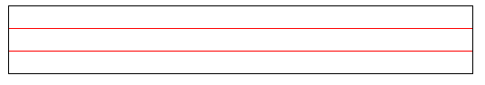

|  |
| --- |
| ⮚ **Rearrange**   1. **live – I – Duba – in ­** …………………………………………… 2. **ride – We – horses .** …………………………………………… |
| ⮚ **Correct the mistake**   1. You **folds** the laundry.   ………………………..…………………   1. Omar and **her** friends are playing**.**   ….……………..….…………………… |

**5**

* ***Q.3. Reading : Match*** *the sentences with the correct picture*

|  |  |  |  |
| --- | --- | --- | --- |
|  |  |  | **6**  **4** |
| ( ) | ( ) | ( ) | ( ) |
| 1. She likes horse riding.   2. You feed the fish.  3. I think a baby seal is cute.  4. Annie washes the dishes. | | | |
| * ***Q.4 Grammar:* *Choose*** *the correct answer* :  1. She **( is – am )** a doctor.   **5**   1. They **(are – is )** playing football. 2. This is my mother. **( Our – Her )** name is Fatmah. 3. I think a walrus is **( big – bigger )** than a whale. 4. You **( sets – set )** the table. 5. She **( has – have )** a new computer. 6. The polar bear is as **(stronger – strong )** as a lion . 7. I **( has – have )** a new class. 8. **( Whose – How )** book is this? 9. **( Do – Does )** she ski ? | | | |

* ***Q.5 Vocabulary: Match*** *the word with its picture:*

**6**

Q.2 **Controlled Writing**

**. day ◌ . clown ◌ . meat ◌ . rice ◌ . mouse ◌ .goat**

|  |  |  |  |  |  |
| --- | --- | --- | --- | --- | --- |
|  |  |  |  |  |  |
| ……………… | ……………… | ……………… | ……………… | ……………… | ……………… |

* ***Q.6 Orthography: Complete*** *the missing letters*: **( ar ※ oa ※ ee ※ oi )**

|  |  |  |  |
| --- | --- | --- | --- |
|  |  |  |  |
| **c\_ \_n** | **f\_ \_m** | **sh\_ \_p** | **b\_ \_t** |

**4**

✨ End of Questions ✨

Tr: Nadia Ahmad Pr. Amal

***I General Question***

**6**

**Choose:**

|  |  |
| --- | --- |
| a- My name is Amal  b –I'm fine, thank you | 1- What is your name ? |
| a- Whose    Shark Clipart-shark showing sharp numerous teeth clip artb- Where | 2-……………. book is this ? |
| a- It is a seal.  b- It is a shark. | 3- What is this? |
| a- I clean up my room  b- I wash the dishes. | 4- What chores do you do? |
| a- I live in Jeddah.  b- I fold the laundry . | 5- Where do you live? |
| a- Yes, he does.  b- Yes, I do. | 6- Does he play football? |

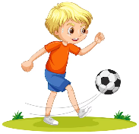

***II Controlled Writing***

**5**

***Rearrange the words:***

|  |  |
| --- | --- |
|  | 1- playing / She's / tennis |
|  | 2- Nice / to / you / meet |

***Complete:***

|  |  |
| --- | --- |
| ( can / can't ) | Dolphin Clipart Images – Browse 7,216 Stock Photos, Vectors, and Video |  Adobe Stock1- It …………… fly. |
| ( slow / fast) | 2- Dolphins are …………… |
| (scuba diving / basketball ) | 3- Dangerous sport is like …………… |

***III Reading short Sentences***

**4**

***Match:***

|  |  |
| --- | --- |
| Free Shopping Cliparts, Download Free Shopping Cliparts png images, Free  ClipArts on Clipart Library | **1- I set the table.** |
| set the table clipart - Clip Art Library | **2- I go shopping.** |
| fold laundry clipart - Clip Art Librarycute little girl taking out the trash in garbage bag into recycling bin  doing daily routine housework chores at home 23059081 Vector Art at Vecteezy | **3- I take out the trash.** |
|  | **4- I fold the laundry .** |

***Grammar***

**5**

***Choose:***

**1- I'm …………………….golf .**

|  |  |  |
| --- | --- | --- |
| play | playing | plays |

**2- She ……………..the fish.**

|  |  |  |
| --- | --- | --- |
| feeds | feeding | feed |

**3- The whale is the……………**

|  |  |  |
| --- | --- | --- |
| biggest | bigger | big |

**4- We …………… a cat .**

|  |  |  |
| --- | --- | --- |
| has | have | does |

**5- ………………you vacuum the floor?**

|  |  |  |
| --- | --- | --- |
| Do | Does | Did |

***Vocabulary***

**6**

**( starfish - seahorse - robot - horse riding – rock climbing - eel )**

|  |  |  |  |  |  |
| --- | --- | --- | --- | --- | --- |
| Sea Horse Single Clipart. Sea Horse Graphic. Digital Images - Etsy | Cartoon Robot Clipart | i2Clipart - Royalty Free Public Domain Clipart | Starfish Clipart Images – Browse 10,579 Stock Photos, Vectors, and Video |  Adobe Stock |  | Free Vectors | eel | Horse Clipart-boy preparing to go horseback riding clipart |
|  |  |  |  |  |  |

***VI Orthography***

**4**

***Fill in the missing letters***

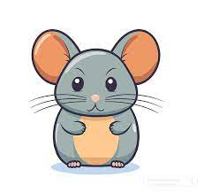***:***

|  |  |  |  |  |  |
| --- | --- | --- | --- | --- | --- |
|  | Cheese png graphic clipart design 19614416 PNG | Free Coat Clipart, Download Free Coat Clipart png images, Free ClipArts on  Clipart Library | Money coins clipart transparent background 24043960 PNG | Cute Yellow Car Clip Art Free PNG Image｜IllustoonDoctor clipart Vectors & Illustrations for Free Download | Freepik |  |
| **m………se**  (ou / ee) | **Ch………se**  (ow /ee) | **c………t**  (oa / ow) | **c………n**  (ay / oi) | **doct………**  (or / er) | **c………**  (er / ar) |

|  |  |
| --- | --- |
| Free Fork Clipart Black And White, Download Free Fork Clipart Black And  White png images, Free ClipArts on Clipart Library |  |
| **f………k**  **(or / er)** | **Ch………**  **( ere /air )** |

With my best wishes / Tr.