2th Grade Unit 1 Feelings
Name ……………………………………………………..Class………...
I can answer personal questions such as . . .

Answer the following questions :
1-What’s your name?
………………………………………………………………………………
2-How are you?
………………………………………………………………………………
3-It,s Nice to meet you!
………………………………………………………………………………
I can write the correct ordinal Numbers
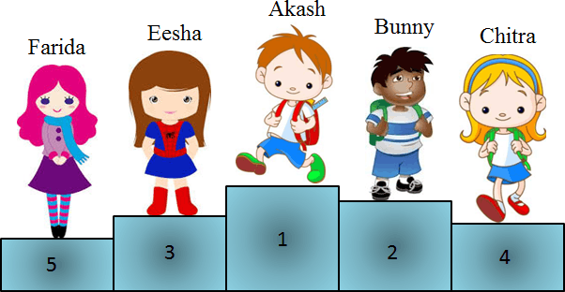
Mona
Mike
Faris
Sara
Farida
Choose :
1-Faris is the ( Second - First )
2- Mona is the ( Third – Fourth )
3-Sara is the ( Fifth – fourth )
5- Mike is the ( First – Nineth )
I can choose & fill in the blanks

Choose :
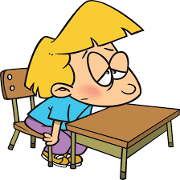
1-I am ( Happy – Hungry )
2-He is ( Thirsty – Sleepy )
3-They are ( Scared – Cold )
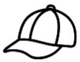
Fill in :
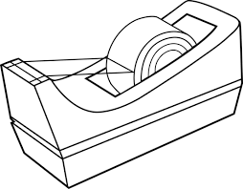
1-C__ p 2-C __ p __ 3-V __ s __
4-T __ p 5-T __ p __ 6-F __ c __
2th Grade Unit 2 Things We Wear
Name ……………………………………………………..Class………...
I can answer personal & belonging questions such as . . .

Answer the following questions :
1-I like your hat!
………………………………………………………………………………
2-Whose book is this?
………………………………………………………………………………
3-What are you wearing today?
………………………………………………………………………………
I can write about what I am wearing

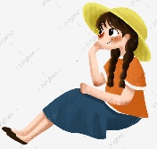
Rearrange :
1- am / I / and a blue skirt / a yellow hat / wearing
……………………………………………………………………………………….
3- wearing / a blue cap /He / and red T-shirt / is
………………………………………………………………………………………….
I can Match Clothes

Match :
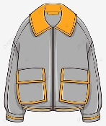
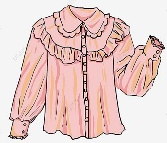
1- Skirt 2-Jacket
3-blouse 4-Glasses
I can fill in the blanks

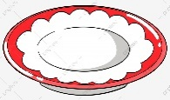

1- __ __ ate 2-__ __ack 3-__ __ ane
2th Grade Unit 3 Things We Do
Name ……………………………………………………..Class………...
I can answer with verbs followed by the -ing form . . .

Answer the following questions :
1-What are you doing ?
………………………………………………………………………………
2-What is he doing?
………………………………………………………………………………
3-What is your dad doing?
………………………………………………………………………………
I can write(T) for True & (F) for False.

Ture or False :
1- I am playing football ( )
2-I am doing Karate ( )
3-She is playing basketball ( )
I can describe things & match.

Match :
1- Thin cat. 2-Short tree.
3- Small bird. 4- Fat bear.
I can fill in the blanks

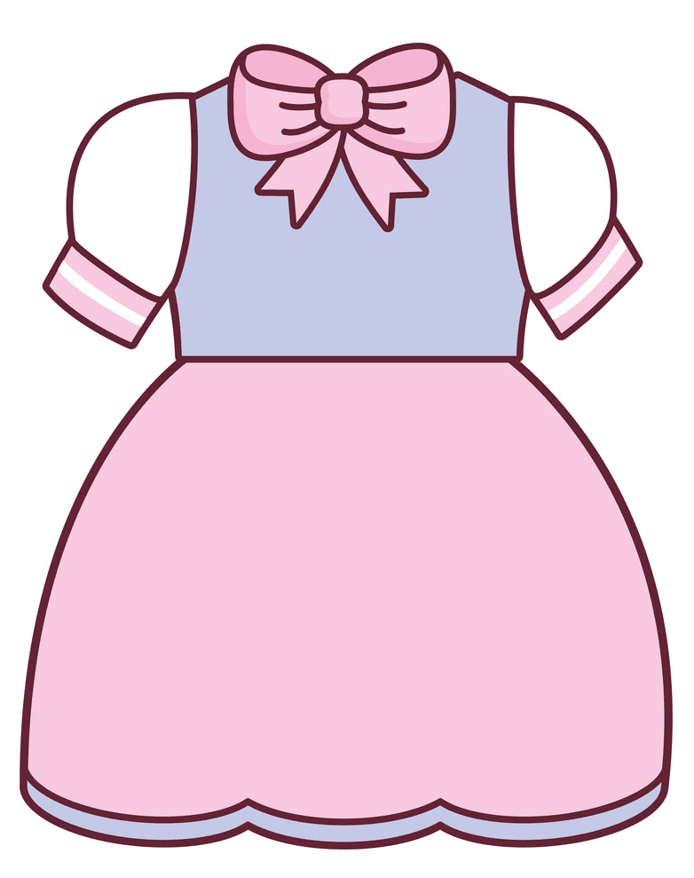

1- ele__ __ ant 2-__ __ink 3-__ __ ess 4-__ __ uck

