|  |  |  |  |
| --- | --- | --- | --- |
| **المملكة العربية السعودية**  **وزارة التعليم**  **الإدارة العامة للتعليم بـن مدرسة مستقبل ن الابتدائية** | **بسم الله الرحمن الرحيم** **اختبار الفصل الدراسي الثالث**  **للعام الدراسي 1444 هـ** | **المادة** | **لغة انجليزية** |
| **الصف** | **الرابع** |
| **الزمن** | **ساعة ونصف** |
| **الفصل** | **----- /4** |
| **اسم الطالب رباعيا: .............................................................................................................**   |  |  |  |  |  |  |  |  | | --- | --- | --- | --- | --- | --- | --- | --- | | **السؤال** | **1** | **2** | **3** | **4** | **5** | **6** | **المجموع** | | **الدرجة** |  |  |  |  |  |  |  | | **الدرجة** | 6 | 6 | 4 | 5 | 4 | 5 | 30 | | **المصحح** |  |  |  |  |  |  |  | | | | |

**I- General Questions:**

**6**

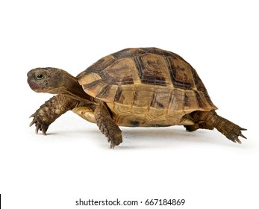**Q1: A- Choose the correct answer:**

**1. Do you have a pet?**

( Yes, I am 9 years old – Yes, I have a turtle - Yes, I am fine )

**2. What day do you like?**

**I like** ( Ali – windy - Friday ).



**3. What's the weather like today?**

It's ( sunny - Monday - cow ).

**B- Match the questions in column (A) with the correct answers in column (B):**

**6**

**6**

|  |  |
| --- | --- |
| **B** | **A** |
| **( ) I'm thirsty.**  **( ) Yes, I am.**  **( ) These are shirts.** | **1. Are you happy? 2. What's the matter? 3. What are these?** |

**Q2: A Write the correct number under each picture:**

****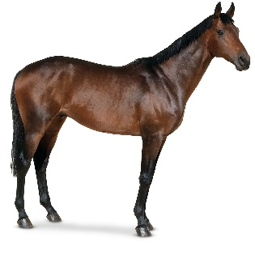**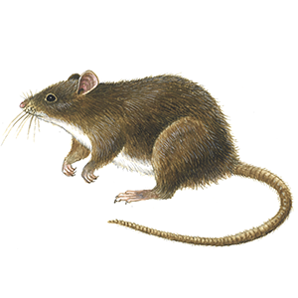1.zebra 2.mouse 3.umbrella 4.horse 5.rainy 6.hungry**





**( ) ( ) ( ) ( ) ( ) ( )**

**صورة تحتوي على قصاصة فنية

تم إنشاء الوصف تلقائياًQ3: Put ( 🗸 ) or ( X ):**

**4**

**1. I have a fish. ( )**



**2. It is a tiger. ( )**

**3.There was a farmer who had a horse. ( )**



**4. It is windy today. ( )**

**Q4: A. Choose the correct answer:**

**5**

1. **( Do – Is – Are ) you have a pet?**
2. **I ( likes – like - liking ) Sunday.**
3. **( He – She - We ) is scared.**
4. 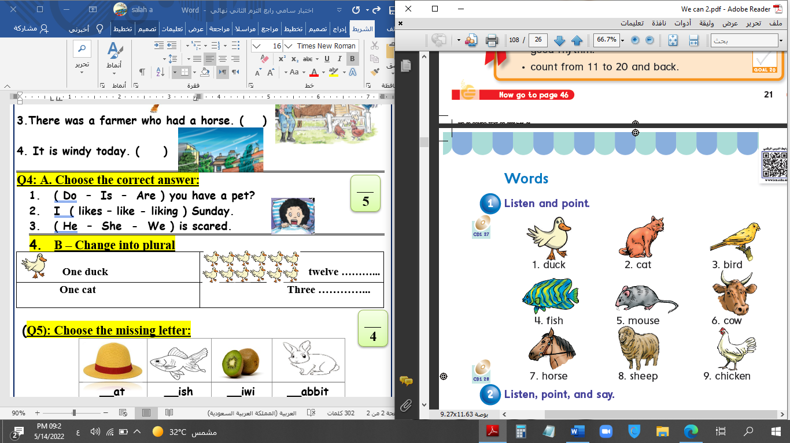******B – Change into plural**

|  |  |
| --- | --- |
| **One duck** | **twelve ----------** |
| **One cat** | **ten ----------** |

**4**

**Q5: Choose the missing letter:**

|  |  |  |  |
| --- | --- | --- | --- |
|  |  |  |  |
| __ase | **__olf** | **__loudy** | **__aptop** |
| F – V | **W - F** | **C - K** | **L - C** |

**Q6: Copy:**

**5**

**I have a new cap.**

|  |
| --- |
|  |
|  |
|  |

**End of Questions**



**التاريخ: / / 1444هـ**

**الصف: الرابع الابتدائي**

**المادة: اللغة الإنجليزية**



**وزارة التعليم**

**الإدارة العامة للتعليم بمنطقة ................**

**مكتب ...............**

**مدرسة ....................................**

**اختبار اللغة الإنجليزية نهائي – الدور الأول – للصف الرابع – الفصل الدراسي الثالث 1444هـ**

**اسم الطالب:**........................................................  **الفصل:**.............

**I- General Questions:**

A- Answer the following questions correctly:

6



1- What time is it?

A – It's seven o'clock. B – It's fife o'clock.

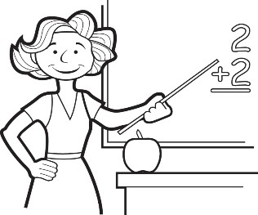

2- Is she a doctor?

A – Yes, she is. B – No, she isn't.

B- Match the questions in column (A) with the correct answers in column (B):

|  |  |
| --- | --- |
| B | A |
| ( ) I get up at 6 o'clock.  ( ) He's a teacher.  ( ) They are 7 days.  ( ) Sure. Here you go. | 1- How many days in the week?  2- Can I use your pen?  3- What does he work?  4- What time do you get up? |

**II- Controlled Writing:**

**summer**

**sunny**

**fly**

5

A- Complete the sentences with the correct word:

1- Ostriches can run but they can't ………………

2- It's ………………………… and very hot in ……………………

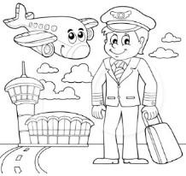B- Rearrange the words to form a sentence:

1- is / a / . / He / pilot

………………………………………………………………………………………………………………………….

2- is / a / This / . / watch

………………………………………………………………………………………………………………………….

**III- Reading Short Sentence:**

4

A- Read the sentences and match them with the correct pictures:

1- They are wallets. 2- It's a sheep. 3- It's snowy and cold. 4- They're cooks.

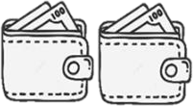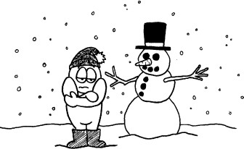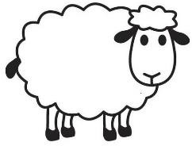

**IV- Grammar:**

5

A) Choose the correct word:

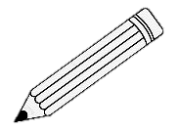

1- They ( is – are ) pencils.

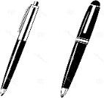2- What ( do – does ) she do?

3- ( That – These ) is my eraser.

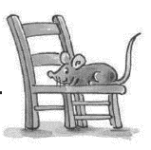4- What are ( this – these )?

5- The mouse is ( under – on )the chair.

**V- Vocabulary:**

6

A) Write the correct number under each picture:

**1**- candy **2**- watch **3**- MP3 player **4**- kangaroo **5**- scissors **6**- firefighter



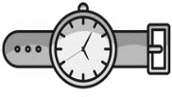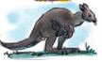

( ) ( ) ( ) ( ) ( ) ( )

**VI- Orthography:**

4

**ea - sp - sm - sw**

A) Choose the correct letter:

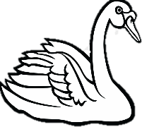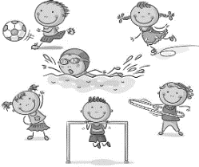



1- _ _ an 2- h _ _ d 3- _ _ ort 4-_ _ ile

**المادة: اللغة الانجليزية**

**الزمن : ساعة ونصف**

**المدرسة:**

**مدرسة : .....................**

اختبار مادة اللغة الانجليزية للصف الرابع الفصل الدراسي الثالث الدور الأول لعام1444



**المملكة العربية السعودية**

**إدارة تعليم الطائف**

**30**

**الاسم : ......................................................**

**ك**

**/**

Q1. General Questions :

A)- Match:

**1-What is the weather like?**

**2- Would you like to come in?**

**3- What time is it?**

**3**

**7**

A- 35 _____37______ 39______41______43

B- 50 ______ 70 _______ 80 _______

Q3. Complete numbers :

اقلب الصفحه

**It's 7:00 o'clock. please**

m / ee / ea / o / h

**5**

Q2. Controlled Writing :

A)- Complete with words from the box:

**1-gr _ _ n. 2- s_all . 3- h_ _ d**

**4- ro_m 5-fis_**

**Yes, please.**

**It's rainy.**

|  |  |  |
| --- | --- | --- |
| These | This | **1 – ……… are wallets.** |
| are | is | **2- These ……… books.** |

Q6. Writing :

A)- Copy 4 times :

I am playing football and tennis.



C)- Read and write the suitable word :

.............../................../.................../.................../ .................. /....................

**6**

Q5. Vocabulary:

Q4. Grammar:

A)- Complete :

{ **behind / on/ next to** }

**1-The elephant is………………………….. the board .**

**2- The mouse is …………………………the chair.**

**3-The cat is ………………………………..the box.**

B)- Choose the correct answer :

**.**

**5**

**4**

انتهت الأسئلة

Good Luck

bedroom / door / watch / sunny / scissors / doctor