# نتيجة بحث الصور عن شعار الوزارة شفاف

Super Goal 2 - English Language

**Second Intermediate Grade**

Third Term Final Exam 1444-2023

**First Round** | Time: 1.5 hour

Kingdom of Saudi Arabia

Ministry of Education

………. Education Directorate

……………Intermediate School

**المراجع**

**checker**

**أ /..........**

**الدرجة كتابه**

**Written**

**المجموع**

**Total / 30**

**المصحح**

**corrector**

**أ / راشد السلمي**

**Q16**

**Q26**

**Q37**

**Q4**

**4**

**Q57**

اسم الطالب

رقم الجلوس

Composition

**اللهّم لا سَهلَ إلا ما جعلتُه سَهلاً فإنكَ تَجعَلُ الحزنَ إذا شِئتَ سَهلاَ " "**

**Write about things you have to do at home ?**

* What chores do you do?
* When do you do them?
* What do you like to do?
* What don’t you like to do?

..................................................................................................................................................................................................................

..................................................................................................................................................................................................................

..................................................................................................................................................................................................................

..................................................................................................................................................................................................................

..................................................................................................................................................................................................................

..................................................................................................................................................................................................................

..................................................................................................................................................................................................................

..................................................................................................................................................................................................................

..................................................................................................................................................................................................................

..................................................................................................................................................................................................................

**6**

**اقلب الصفحة**



Comprehension

**6**

* **Read the following passage and answer the questions below:**

What’s the strangest food you have ever eaten? People in the U.S. and Europe think that bugs are a strange thing to eat. But many people around the world eat bugs every day.

Bugs are eaten in 36 African countries, 29 Asian countries, and 23 Central and South American countries.

Bugs that live on land are not very different from bugs that live in the sea. Many people think that shrimp, crab, and lobster are really just "sea bugs." And like sea bugs, land bugs are good for you. Many contain protein, iron, and calcium- nutrients your body needs to stay healthy.

Dave Gordon is a famous chef in the United States. He is called "The Bug Chef." He has written many books about why everyone should eat bugs. He says that grasshoppers, for example, have a lot more protein than chicken or beef. Also, bugs are an inexpensive food. They are everywhere! He wants Americans to eat more bugs. He travels to different places and shows people how to cook with them. Many people are surprised to find out that they can be delicious!

**A. Choose the correct answer:**

1. A nutrient your body needs to stay healthy is ____.

**a**. grasshopper  **b**. calcium **c**. chicken **d.** beef

1. Many people call shrimp, crab, and lobster ____.

**a**. sea bugs **b** land bugs **c** fish **d.** vegetables

1. Bugs are eaten in _____ Asian countries.

**a**. 36  **b**. 23 **c**. 12 **d.** 29

**B. Write (T) for True or (F) for False:**

|  |  |
| --- | --- |
| **4.**  Bugs are a healthy food to eat. |  |
| **5.** Many people around the world eat bugs every day. |  |
| **6.** Dave Gordon is a famous doctor. |  |

**اقلب الصفحة**



**7**

Grammar

* **Choose the correct answer**

1. **Karl:** What are you going to do tomorrow? **Larry:** _____

**a**. I go to study. **b**. I going to study. **c**. I’m going to study. **d.** I’m going studying

1. Riyadh is _______.

**a**. a beautiful city **b**. a city beautiful  **c**. a beautiful  **d.** beautiful a city

1. They _________ going to go by plane.

**a**. isn’t  **b**. are  **c**. is  **d.** am

1. **Jane:** Will it be sunny tomorrow? **Amira:** No, ______.

**a**. it won’t **b**. it will  **c**. won’t it **d.** will it

1. **Jim:** _____ on vacation? **Gordon:** We’ll probably go in the spring.

**a**. Where will you go **b**. Where you will go  **c**. When you will go **d.** When will you go

1. If the lake ___, the children will probably go ice-skating.

**a**. frozen **b**. freezes  **c**. freeze  **d.** will freeze

1. _____ he understand what you were talking about?.

**a**. Could **b**. cans  **c**. will can **d.** can not

1. My brother _____ play tennis now. He is in the field.

**a**. will not can **b**. can not  **c**. will can **d.** can

1. _________ carry that for you thank you.

**a**. can  **b**. let me  **c**. could  **d.** will

1. He was so surprised that he _____ speak.

**a**. was almost able to **b**. couldn’t hardly **c**. was able just to **d.** could hardly

1. There was so much traffic that I was _____ for work.

**a**. almost late **b**. just late  **c**. absolutely late **d.** hardly late

1. The injured runner didn’t win, but he_____ the race..

**a**. wasn’t able to finish **b**. could finish  **c**. was able to finish **d.** couldn’t finish

1. I _____ Italy last year.

**a**. has visited **b**. have visited  **c**. visited **d.** visit

1. **Max:** Have you ever seen snake? **Tom:** Yes, ____.

**a**. I has **b**. I have  **c**. I have seen **d.** I has seen

Orthography

**4**

* **Choose the correct letters :**

1. Are you going on va…..ation ? ( c – o – r )
2. Scuba di…ing in The Red Sea ( q – o – v )
3. Spring is usually c….ol ( v – o – r )
4. It gets very cold in win…er ( q – t – x )
5. Children Please put away your to….s ( v – o – y )
6. Can I borrow your cell p….one? ( q – h – x )
7. The ele….ator wasn’t working. ( v – o – y )
8. Have You Had an Exciting Li…e? ( x – o – f )

**اقلب الصفحة**



Vocabulary

* **Choose the correct answer:**

**7**

1. This quiet beach is ____.

**a**. noisy **b**. relaxing **c**. adventurous **d.** expensive

1. This hiking vacation in the mountains is ____.

**a**. adventurous **b**. luxurious  **c**. expensive  **d.** relaxing

1. It’s _______________ today. Hold on to your hat!

**a**. windy  **b**. sunny **c**. cloudy **d.** snows

1. Don’t forget your sunglasses. It’s very _____________.

**a**. cloudy **b**. rainy  **c**. sunny  **d.** windy

1. I have no idea mean ____________ .

**a**. I don't know **b**. I have no problem **c**. He knows  **d.** I have to say

1. I will bring some snacks from the_________.

**a**. bathroom **b**. the roof  **c**. Kitchen  **d.** garage

1. I _____ when I saw the snake. I was so surprised!

**a**. fired **b**. shrieked **c**. lightning  **d.** wounds

1. Did you see the storm last night? The _____ was amazing!

**a**. lightning **b**. wounds  **c**. fired  **d.** risk

1. A zorse is half zebra, half _________.

**a**. horse **b**. fish **c**. Elephant  **d.** Tiger

1. Which of the following sports are unusual:

**a**. Dennis **b**. Football  **c**. Basketball **d.** Hang gliding

1. **Definitely** means: _____________.

**a**. not sure **b**. certainty **c**. very frightened **d.** You’re crazy!

* **Write the correct word under the picture.**

Hospital – Desert – Scuba diving

**صورة تحتوي على داكن

تم إنشاء الوصف تلقائياً**صورة تحتوي على تلبيس, رجل, رسوم متحركة, الأحذية

تم إنشاء الوصف تلقائياً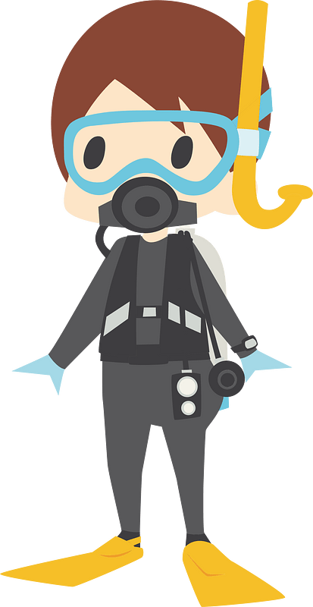

**14.**

**13.**

**12.**

………………………………….

………………………………….

………………………………….

**انتهت الأسئلة .. ..**

**وبالله التوفيق والنجاح ..**

**الأستاذ / راشد السلمي**

**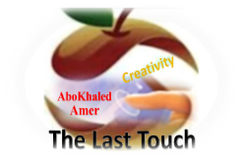****المملكة العربية السعودية**

**Kingdom of Saudi Arabia**

**Ministry of Education**

**------- Educational Directorate**

**------- Future Educational Schools**

**2nd grade intermediate 2022**

**3rd Term – Final Exam**

**وزارة التعليم**

**الإدارة العامة للتعليم بن**

**مدارس م ن التعليمية**

**الصف الثاني المتوسط**

**الاختبار النهائي للفصل الدراسي الثالث1443**

|  |  |  |  |  |  |  |  |
| --- | --- | --- | --- | --- | --- | --- | --- |
| **Total**  **written** | **5 spelling** | **4 Vocabulary** | **3 Grammar** | **2 Comprehension** | | **1 Composition** | **Q. NO.** |
|  |  |  |  |  | |  | **Mark Given** |
| **30** | **4** | **7** | **7** | **6** | | **6** | **Mark** |
|  | | | **Reviser** | |  | | **Corrector** |
|  | |

**زمن الاختبار: ساعتان**

**اسم الطالب: ------------------------------------ رقم الجلوس: ------------- الصف الثاني المتوسط**

**6**

1) **Composition**

**1- Write a paragraph about “How the Weather Affects you "**

**You may talk about the following words: Feel – rainy – window – spend – trouble**

…………………………………………

………………………………………………………………………………………………………………………………………………………………………………………………………………………………………………………………………………………………………………………………………………………………………………………………………………………………………………………………………………………………………………………………………………………………………………………………………………………………….

**2) Comprehension**

**6**

**2- Read the following passage then answer the questions:**

**Wonderful Vacation**

**Last vacation I went with my family to Egypt. At the beginning, we went on a cruise on the River Nile. We left Cairo on Friday morning and got back on Monday evening. It was a wonderful experience. Then we stayed in Cairo for five days. We went sightseeing and we visited the Egyptian Museum, too. There were so many interesting things to see there. We also visited the Pyramids in Giza and took lots of pictures. They were amazing! My parents and I also tried camel riding. It was lots of fun. I really want to visit Egypt again. It’s beautiful and there are many things to see and do there!**

**A- Put ( ) or ( x ):**

**1.Last vacation, they went on vacation to Egypt. ( )**

**2.They stayed in Cairo for seven days. ( )**

**3.They visited the pyramids and the museum. ( )**

**4.They all tried horse riding in the pyramids. ( )**

**5. They really want visit Egypt again. ( )**

**B- Choose the correct answer:**

**1. The family left Cairo on (**Monday – Sunday – Friday**) morning.**

**2. They went (**sightseeing – hang gliding – scuba diving**) in Egypt.**

**3. The vacation to Egypt was lots of (**fan – fat – fun**).**

**4. There were (**few – many – lot**) things to see and do in Egypt.**

**C- Answer the following questions:**

**1. Where did the family go last summer?.........................**

**2. Did they enjoy their stay there?...........................**

**3. What is the river they went on a cruise on? ..................**

**3) Grammar**

**A: Choose the correct answer:**

**7**

**1. He is (**go to – goes to – going to**) spend happy time.**

**2. (**What – Where – When**) are they going to leave for London?**

**3. Maybe, she (**will – am going to – have**) visit us next holiday.**

**4. What is the weather like today? (**He is – She is – It is**) sunny.**

**5. Can you (**clear – clears – clearing**) my way, please?**

**6. (**Let – Tell – Lets**) me help you with this box.**

**7. They (**waiting – were waiting – wait**) for the bus when it started raining.**

**8. We have (used – use – uses) all the toothpaste.**

**B: Chang into Negative:**

**1. We are going to brush our teeth.**

…………………………………………………………………………………………………………………………………………………………………………………………………………………

**2. He was feeding the fish.**

……………………………………………………………………………………………………………………………………

3. **She has spoiled all the nail polish.**

……………………………………………………………………………………………………………………………………

**C: Make Yes/No question:**

**1. They will set the table.**

……………………………………………………………………..……………………………………………………………

**2. They were washing the dishes.**

……………………………………………………………………………………………………………………………………

**3. I have finished all the cooking.**

……………………………………………………………………………………………………………………………………

**4) vocabulary:**

**7**

**A- Match the words with the pictures:**

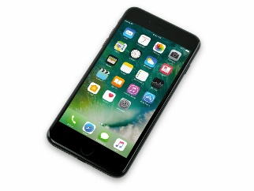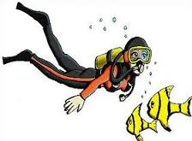**anaconda – cellphone – relaxing – snowy – scuba diving – safari**

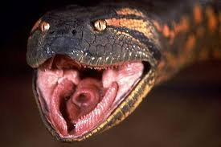****

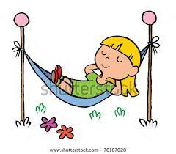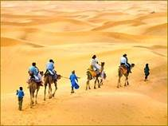

**……………. ……………. ……..……. ………..…… …………… …………..**

**B- Match the answers:**

|  |  |
| --- | --- |
| a. introduce news | **1. We went to the mountains for -------** |
| b. very cold | **2. Wild animals usually live in the --------** |
| c. cliff hanging | **3. How many months are there in a year? ---------** |
| d. jungle | **4. We say, " I hear " when we ---------** |
| e. twelve months | **5. The temperature is "below zero" means it is ---------** |

**C- Circle the correct spelling:**

**1. windy - widny – winyd**

**2. parot – parrat - parrot**

**3. wierd – weird – weired**

**5) Orthography**:

**4**

**A- Fill in the missing letters:**

**1- des__rt**

**p – s – u – e – t**

**2- zookee__er**

**3- ho__pital**

**4- pop__lar**

**B- Choose the odd one out:**

**1. can could will Ali**

**2. helped cleaned worked sleep**

**3. stormy parrot foggy snowy**

**4. scuba diving hang gliding cliff hanging doctor**

**End of Questions**

**Best of Luck https://t.me/abokhaledamer**

******المملكة العربية السعودية**

**Kingdom of Saudi Arabia**

**Ministry of Education**

**------- Educational Directorate**

**------- Future Educational Schools**

**2nd grade intermediate 2022**

**3rd Term – Final Exam**

**وزارة التعليم**

**الإدارة العامة للتعليم بن**

**مدارس م ن التعليمية**

**الصف الثاني المتوسط**

**الاختبار النهائي للفصل الدراسي الثالث1443**

|  |  |  |  |  |  |  |  |
| --- | --- | --- | --- | --- | --- | --- | --- |
| **Total**  **written** | **5 spelling** | **4 Vocabulary** | **3 Grammar** | **2 Comprehension** | | **1 Composition** | **Q. NO.** |
|  |  |  |  |  | |  | **Mark Given** |
| **30** | **4** | **7** | **7** | **6** | | **6** | **Mark** |
|  | | | **Reviser** | |  | | **Corrector** |
|  | |

**زمن الاختبار: ساعتان**

**اسم الطالب: ------------------------------------ رقم الجلوس: ------------- الصف الثاني المتوسط**

**6**

1) **Composition**

**1- Write a paragraph about “Your Best Friend "**

**You may talk about the following words: His name – His age – His favorite color – His father job – His favorite subject – His favorite sport – His future job**

…………………………………………

………………………………………………………………………………………………………………………………………………………………………………………………………………………………………………………………………………………………………………………………………………………………………………………………………………………………………………………………………………………………………………………………………………………………………………………………………………………………….

**2) Comprehension**

**6**

**2- Read the following passage then answer the questions:**

**Bill's Family**

**My name’s Bill. I’m 12 years old. I have two brothers and one sister. My father is a doctor, and my mother is an English teacher. I live in a flat with my family. Our flat is on the second floor and there are three bedrooms and one kitchen. We also have a beautiful balcony. Our favorite day of the week is Saturday. We all get up at about 10 o’clock and have breakfast. Then I play computer games with my sister. After lunch, I go to the park to play football with my brothers. In the evening, I often play basketball with my friends. I like it but my brothers love football.**

**A- Put ( ) or ( x ):**

**1.In this passage, the boy's name is Billa. ( )**

**2.His father is a doctor. ( )**

**3.His flat is on the fourth floor. ( )**

**4.On Sunday, they have breakfast at 10 o'clock. ( )**

**5. He plays computer games with his brothers. ( )**

**B- Choose the correct answer:**

**1. Bill's mother is an (**science – math - English**) teacher.**

**2. In his flat, they have a beautiful (**horse – yard – balcony**).**

**3. He plays (**tennis – football – computer games**) with his brothers.**

**4. Bill's family are (**six – seven – eight**) members.**

**C- Answer the following questions:**

**1. How old is Bill?.............................**

**2. How many brothers does Bill have?...........................**

**3. Where does he go after lunch? ..............................**

**3) Grammar**

**A: Choose the correct answer:**

**7**

**1. They (am – is – are) going to visit their uncle.**

**2. (What – Where – Who) is he going to spend the weekend?**

**3. I (will – am going to – have) probably travel to Abha next summer.**

**4. (Why – When – What) is the weather like today?**

**5. (Could – Have – Are) you help me with this bag?**

**6. Let me (carry – carrying – carries) this box for you.**

**7. Hans (walk – was walking – walking) to college when he saw Samir.**

**8. She has (cleans – cleaning – cleaned) her own room.**

**B: Chang into Negative:**

**1. He is going to wash the car.**

…………………………………………………………………………………………………………………………………………………………………………………………………………………

**2. They were cooking lunch at home.**

……………………………………………………………………………………………………………………………………

3. **They have watched TV with their kids.**

……………………………………………………………………………………………………………………………………

**C: Make Yes/No question:**

**1. He will do his homework.**

……………………………………………………………………..……………………………………………………………

**2. Ali was helping his mom in the kitchen.**

……………………………………………………………………………………………………………………………………

**3. We have brushed our teeth.**

……………………………………………………………………………………………………………………………………

**4) vocabulary:**

**7**

**A- Match the words with the pictures:**

****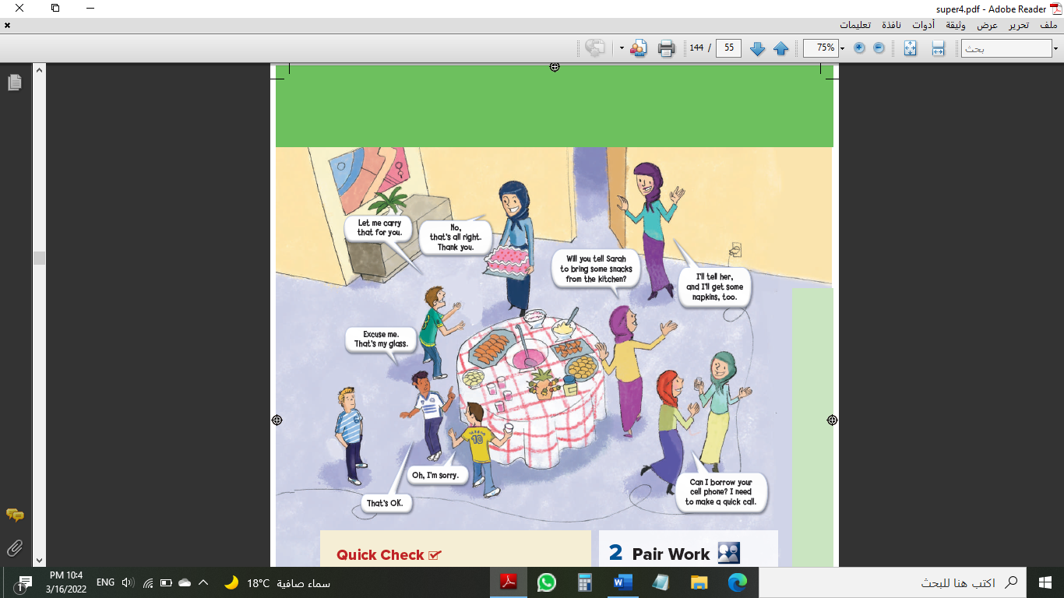**cake – parrot – pyramids – cliff hanging – graduation – rainy**

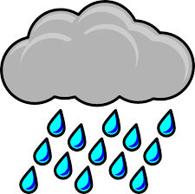

**……………. ……………. ……..……. ………..…… …………… …………..**

**B- Match the answers:**

|  |  |
| --- | --- |
| a. not certain | **1. We go the sea for ------** |
| b. No problem | **2. We say: "It depends" when we are ------** |
| c. scuba diving | **3. How many seasons are there in a year? ------** |
| d. Lost his job | **4. Can you open the door for me, Please? ------** |
| e. Four seasons | **5. He was "fired" means that he -------** |

**C- Circle the correct spelling:**

**1. awesome - awosome – owesome**

**2. snaek – snake - sanke**

**3. emergancy – emargency – emergency**

**5) Orthography**:

**4**

**A- Fill in the missing letters:**

**1- saf__ri**

**l – a – c – o – n**

**2- wor__d**

**3- fav__r**

**4- atta__k**

**B- Choose the odd one out:**

**1. written taken seen eat**

**2. going reading sing working**

**3. sunny cloudy year snowy**

**4. zebra doctor turtle zorse**

**End of Questions**

**Best of Luck https://t.me/abokhaledamer**