# نتيجة بحث الصور عن شعار الوزارة شفاف

Super Goal 3 - English Language

**Third Intermediate Grade**

Third Term Final Exam 1444-2023

**First Round** | Time: 1.5 hour

Kingdom of Saudi Arabia

Ministry of Education

………. Education Directorate

……………Intermediate School

**المراجع**

**checker**

**أ /..........**

**الدرجة كتابه**

**Written**

**المجموع**

**Total / 30**

**المصحح**

**corrector**

**أ / راشد السلمي**

**Q16**

**Q26**

**Q37**

**Q4**

**4**

**Q57**

اسم الطالب

رقم الجلوس

Composition

**اللهّم لا سَهلَ إلا ما جعلتُه سَهلاً فإنكَ تَجعَلُ الحزنَ إذا شِئتَ سَهلاَ " "**

**Write about the kinds of people you like to be friends with. What characteristics do they have?**

Guide words:

**( interests – supportive - spending time – responsible – grow up – personality – friendship - respect )**

..................................................................................................................................................................................................................

..................................................................................................................................................................................................................

..................................................................................................................................................................................................................

..................................................................................................................................................................................................................

..................................................................................................................................................................................................................

..................................................................................................................................................................................................................

..................................................................................................................................................................................................................

..................................................................................................................................................................................................................

..................................................................................................................................................................................................................

..................................................................................................................................................................................................................

**6**

**اقلب الصفحة**



Comprehension

**6**

* **Read the following passage and answer the questions below:**

**Visit Italy**

Italy is the fifth most visited country in the world. Why? Because there is so much to see and do there! People visit Italy to see its fantastic architecture, to explore ancient ruins and learn about their history, and–of course–to eat wonderful Italian food!

Visit Rome

See the Coliseum. This huge arena was built about 72 C.E., and it’s still standing! Many people think it is the greatest work of Roman architecture ever built. Explore the Coliseum and learn what the ancient Romans used this enormous building for.

Visit Florence

This is wonderful city for exploring museums and looking at beautiful architecture.

Visit Venice

Venice is one of the most beautiful cities in the world. A popular thing to do in this city is to eat a delicious Italian dinner and then take a gondola boat through the canals.

Visit Pompeii

Explore the ancient city of Pompeii. Walk through the ruins and experience history. Discover what life was like for Romans in 79. C.E. when the city was buried by the eruption of the volcano Mount Vesuvius.

**A. Choose the correct answer:**

1. _____ is one of the most beautiful cities in the world.

**a**. Rome  **b**. Florence **c**. Venice **d.** Pompeii

1. In Pompeii, you can learn about life in ____..

**a**. 79 c.e. **b** 72 c.e. **c** 790 c.e. **d.** the 1700s

1. A gondola is a ________.

**a**. car  **b**. boat **c**. bicycle **d.** helicopter

**B. Write (T) for True or (F) for False:**

|  |  |
| --- | --- |
| **4.**  Italy is the third most popular country to visit in the world |  |
| **5.** Florence is home to many museums |  |
| **6.** A popular thing to do in Florence is to ride in a gondola |  |

**اقلب الصفحة**



**7**

Grammar

* **Choose the correct answer**

1. We were sitting in the café when a thief _____ my bag!

**a**. steal **b**. stole  **c**. was stealing **d.** stolen

1. Jack was talking on the phone _____ he was driving.

**a**. that **b**. while **c**. where **d.** which

1. She was cooking dinner _____ I arrived .
2. when **b**. while **c**. where **d.** which
3. I _____ at the monument when someone called my name.
4. look **b**. looked  **c**. am looking  **d.** was looking
5. Have you ______ washed the clothes ?

**a**. already **b**. yet  **c**. just  **d.** already not

1. The salesperson was _____ pushy that I left the store without buying anything.
2. so **b**. such **c**. much **d.** so much
3. He enjoys _____ in the high-tech computer field.
4. work **b**. worked  **c**. working **d.** to work
5. He has ________books that he can hardly carry them .
6. so much **b**. much **c**. so many **d.** that many
7. **Bart:** Do you prefer to walk or take the bus? **Bob:**_________________.

**a**. I rather walk **b**. I had rather walk  **c**. I did rather walk **d.** I would rather walk

1. I wish I _____ so much homework.
2. had **b**. hadn’t  **c**. didn’t have **d.** not have
3. If fewer people _____ their cars, there wouldn’t be so much traffic.
4. drove **b**. will drive  **c**. would drive **d.** drive
5. I wish I _____ what to do. Can you give me some advice?
6. will know **b**. would know **c**. know **d.** knew
7. I miss ____________________ time with my friends.

**a**. to spend **b**. spends  **c**. spend **d.** spending

1. I’m sorry. I didn’t expect ____________________ out so late.
2. is be **b**. being  **c**. to be **d.** be

Orthography

**4**

* **Choose the correct letters :**

1. The people who live in the city are always in a hur….y ( c – r – k )
2. The watches that the man was s….lling were fakes . ( e – h – n )
3. I hate this program. I’m going to turn it of…. ( c – f – k )
4. Have you taken the garbage o…t yet? ( e – h – u )
5. If I don’t wear cool clothes, I won’t fi….. in ( t – f – k )
6. If I study for this test, I’ll pas…. ( e – h – s )
7. Remember to stand in li….e ! ( t – n – k )
8. Try not to spread dust and mud in the ho…se ( u – h – s )

**اقلب الصفحة**



**7**

Vocabulary

* **Choose the correct answer:**

1. **Max:** Why are the police talking to Jerry? **Jason:** He saw a man who tried to __________ a bag

**a**. steal **b**. fake  **c**. pretend **d.** in a hurry

1. That diamond is not real. It is ____________________.

**a**. thief  **b**. give direction  **c**. fake **d.** steal

1. Some people are always ____________________. They don’t have time to talk and relax.

**a**. pretend **b**. in a hurry  **c**. steal  **d.** give direction

1. You use a toothbrush and _______________to brush your teeth.

**a**. toothpaste **b**. hair dryer  **c**. shampoo **d.** scissors

1. You use ____________________ to cut paper.

**a**. dishwashing liquid **b**. scissors  **c**. hair dryer **d.** mirror

1. You use a ____________________ to dry your hair when it is wet.

**a**. shampoo **b**. toothpaste  **c**. hairbrush  **d.** hair dryer

1. If you drive too fast, you’ll get a____________.

**a**. ticket **b**. conservationist  **c**. benefit **d.** scenic

1. Donna tries too hard to ________. She always does what other people are doing.

**a**. cheat **b**. scenic  **c**. pollution **d.** fit in

1. One __________ to being a professional sports player is that they make a lot of money.

**a**. generate **b**. pollution  **c**. benefit  **d.** conservationist

1. Americans usually introduce themselves with their ________________ name.

**a**. Second **b**. last  **c**. middle  **d.** first

1. Ali thanks his friend the_______ for his hospitality .

**a**. late **b**. host  **c**. Rush  **d.** Break

* **Write the correct word under the picture.**

Tennis player – Taxi – Dishes

**صورة تحتوي على مركبة, سيارة طرق وعرة, عجلة, المواصلات

تم إنشاء الوصف تلقائياً**صورة تحتوي على نص

تم إنشاء الوصف تلقائياً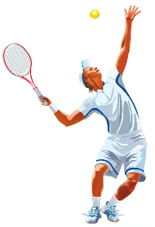

**12.**

**14.**

**13.**

…………………..……….

…………………..……….

…………………..……….

**انتهت الأسئلة .. ..**

**وبالله التوفيق والنجاح ..**

**الأستاذ / راشد السلمي**

**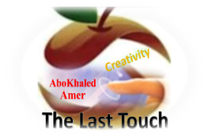****المملكة العربية السعودية**

**Kingdom of Saudi Arabia**

**Ministry of Education**

**------- Educational Directorate**

**------- Future Educational Schools**

**3rd grade intermediate 2022**

**3rd Term – Final Exam**

**وزارة التعليم**

**الإدارة العامة للتعليم بن**

**مدارس م ن التعليمية**

**الصف الثالث المتوسط**

**الاختبار النهائي للفصل الدراسي الثالث1443**

|  |  |  |  |  |  |  |  |
| --- | --- | --- | --- | --- | --- | --- | --- |
| **Total**  **written** | **5 spelling** | **4 Vocabulary** | **3 Grammar** | **2 Comprehension** | | **1 Composition** | **Q. NO.** |
|  |  |  |  |  | |  | **Mark Given** |
| **30** | **4** | **7** | **7** | **6** | | **6** | **Mark** |
|  | | | **Reviser** | |  | | **Corrector** |
|  | |

**زمن الاختبار: ساعتان**

**اسم الطالب: ------------------------------------ رقم الجلوس: ------------- الصف الثالث المتوسط**

**6**

1) **Composition**

**1- Write a paragraph about “Your Favorite Place "**

**You may use these words: Abha – last summer – family – shopping – friends - …**

…………………………………………

………………………………………………………………………………………………………………………………………………………………………………………………………………………………………………………………………………………………………………………………………………………………………………………………………………………………………………………………………………………………………………………………………………………………………………………………………………………………….

**2) Comprehension**

**6**

**2- Read the following passage then answer the questions:**

**Culture Shock**

**Standing in a line at checkout counters at the supermarket. Listening to people talking on phones in restaurants. It's annoying. When people talk on their cell phones and drive. Rushing to phone and out it's a telemarketer who's calling. People who lost weight now and try to control what others eat. People who are always late, and don't apologize. When salespeople try talk you into buying something you don't want or need. People who don't say "Please" or "Thank you". When people enter a door or an elevator and don't hold it open for the others who are right behind them. I can't stand people who chew with their mouths. People who borrow stuff without give it back. People who don’t give up their subway or bus to seats seniors or to those with disabilities.**

**A- Put ( ) or ( x ):**

**1.Listening to people talking on cellphones in restaurants is annoying. ( )**

**2. People who are always late, and don't apologize is good. ( )**

**3. People who don't say "Please" or "Thank you" is good. ( )**

**4.It's bad when people talk on their phone while driving. ( )**

**5. We should give up our seats to people with disabilities. ( )**

**B- Choose the correct answer:**

**1. Standing in a (**lion – line – lone**) at the supermarket is good.**

**2. People who don't hold the (**elevator – escalator – book**) door.**

**3. "Call up" means (**phone – learn – let someone have**).**

**4. "Give back" means (**phone – learn - return**).**

**C- Answer the following questions:**

**1. What we should do at the supermarket?........................**

**2. Is it OK you chew with your mouth open?.........................**

**3. What should you do when you borrow a stuff? .................**

**3) Grammar**

**A: Choose the correct answer:**

**7**

**1. A rude person is someone (**who – which - where**) isn't polite.**

**2. While I (**watched – watching – was watching**) TV, my mom was cooking lunch.**

**3. She hasn't cleaned her room (**just – already – yet**).**

**4. We enjoy (**watched – watching – watches**) movies with our friends.**

**5. Your shoes are dirty. Please, take (**it – us – them**) off.**

**6. If you help me, I (**thanked – thanks – will thank**) you.**

**7. I choose to (**eats – eating – eat**) burger for lunch.**

**8. (**Swim – Swims – Swimming**) is my favorite sport.**

**B: Chang into Negative:**

**1. It is a good idea to work at night.**

…………………………………………………………………………………………………………………………………………………………………………………………………………………

**2. He was making the bed.**

……………………………………………………………………………………………………………………………………

3. **I have helped my little brother.**

……………………………………………………………………………………………………………………………………

**C: Make Yes/No question:**

**1. They will set the table.**

……………………………………………………………………..……………………………………………………………

**2. He was helping the lady.**

……………………………………………………………………………………………………………………………………

**3. She has studied English.**

……………………………………………………………………………………………………………………………………

**4) vocabulary:**

**7**

**A- Match the words with the pictures:**

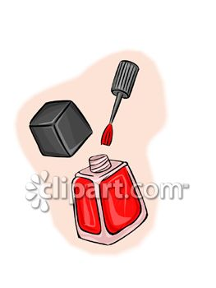**chopsticks – airshow – nail polish – garbage – police officer – gold fish**

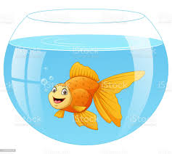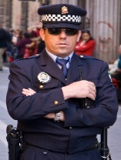



**……………. ……………. ……..……. ………..…… …………… …………..**

**B- Match the answers:**

|  |  |
| --- | --- |
| a. thief | **1. A talkative person is someone who -------** |
| b. ticket | **2. He tried to steal the boy's backpack; he is a ---------** |
| c. speaks a lot | **3. He was driving so fast, so he took a ----------** |
| d. No kidding | **4. When you are undecided, you are ----------** |
| e. up in the air | **5. When you are surprised and can't believe, you say ------** |

**C- Circle the correct spelling:**

**1. scissors - sicossrs – sicorsses**

**2. chioces – choices - shoices**

**3. geust – guset – guest**

**5) Orthography**:

**4**

**A- Fill in the missing letters:**

**1- wat__h**

**o – m – t – c – f**

**2- mirr__r**

**3- environ__ent**

**4- cus__oms**

**B- Choose the odd one out:**

**1. athletic clever friendly book**

**2. thief police officer work guide**

**3. done go eaten gotten**

**4. pedal cab taxi bus doctor**

**End of Questions**

**Best of Luck https://t.me/abokhaledamer**

******المملكة العربية السعودية**

**Kingdom of Saudi Arabia**

**Ministry of Education**

**------- Educational Directorate**

**------- Future Educational Schools**

**3rd grade intermediate 2022**

**3rd Term – Final Exam**

**وزارة التعليم**

**الإدارة العامة للتعليم بن**

**مدارس م ن التعليمية**

**الصف الثالث المتوسط**

**الاختبار النهائي للفصل الدراسي الثالث1443**

|  |  |  |  |  |  |  |  |
| --- | --- | --- | --- | --- | --- | --- | --- |
| **Total**  **written** | **5 spelling** | **4 Vocabulary** | **3 Grammar** | **2 Comprehension** | | **1 Composition** | **Q. NO.** |
|  |  |  |  |  | |  | **Mark Given** |
| **30** | **4** | **7** | **7** | **6** | | **6** | **Mark** |
|  | | | **Reviser** | |  | | **Corrector** |
|  | |

**زمن الاختبار: ساعتان**

**اسم الطالب: ------------------------------------ رقم الجلوس: ------------- الصف الثالث المتوسط**

**6**

1) **Composition**

**1- Write a paragraph about “Customs and Culture Shock "**

**You may use these words: in Mediterranean Countries - in England – in Japan - in Asian Country – in Mexico – in India – in United States and China – in Germany**

…………………………………………

………………………………………………………………………………………………………………………………………………………………………………………………………………………………………………………………………………………………………………………………………………………………………………………………………………………………………………………………………………………………………………………………………………………………………………………………………………………………….

**2) Comprehension**

**6**

**2- Read the following passage then answer the questions:**

**Omar Ibn Alkattab**

**Amir EL-Momeneen Omar Ibn Alkattab, may Allah bless him, was the second Caliph. He was a kind man and a good Muslim. He often gave food to the poor. Omar sometimes walks through the streets at night he walked alone, he had no soldiers with him. He had ordinary clothes on, and nobody knew that he was the Caliph. He listened to people to know their problems. One night, Omar was having a walk in a poor part of the city. He could smell food cooking. Many people were having dinner.**

**A- Put ( ) or ( x ):**

**1. Omar Ibn Alkattab was the third caliph. ( )**

**2. Omar Ibn Alkattab was a good Muslim. ( )**

**3. Omar Ibn Alkattab never walked through the streets at night. ( )**

**4. Omar Ibn Alkattab had very high and expensive clothes. ( )**

**5. Omar Ibn Alkattab made sure that many people were having dinner. ( )**

**B- Choose the correct answer:**

**1.Omar Ibn Alkattab gave food to the (**rich – wealthy – poor**) people.**

**2. At night, he had no (**visitors – soldiers – guides**) with him.**

**3. He could smell (**food – books – cars**) cooking.**

**4. At night, nobody knew that he was the (**caliph – captain – poor)

**C- Answer the following questions:**

**1. Who was the second caliph?........................**

**2. Was Omar Ibn Alkattab a kind man?.........................**

**3. Why did he listen to the people? .................**

**7**

**3) Grammar**

**A: Choose the correct answer:**

**1. People (**who – which – when**) live in glass houses shouldn't throw stones.**

**2. They stop (**playing – play – to play**) tennis in winter. They no longer play.**

**3. If you (**sleep – sleeping – sleeps**) in the class, the teacher won’t be happy.**

**4. He has (**yet – already – no**) come home.**

**5. I expect him (**arrive – arriving – to arrive**) home early.**

**6. He was cancelling his flight (**when – while – what**) we were calling him.**

**7. The floor is very messy. Can you clean (**it – them – him**) up.**

**8. (**Helping – helped – Helps**) my friends is a great fun.**

**B: Do as shown between brackets:**

**1. I can’t stand watch scary films. (**Correct**)**

**------------------------------------------------------------------------------------------**

**2. I have done my homework. (**Change into Negative**)**

**------------------------------------------------------------------------------------------**

**3. used – football – He – to – play (**Rearrange**)**

**------------------------------------------------------------------------------------------**

**4. She was (clean) the room when her brother entered the room. (**Correct**)**

**------------------------------------------------------------------------------------------**

**5. Turn the TV down. (**Change into two-word verb**)**

**------------------------------------------------------------------------------------------**

**6. Have they gone to school yet? (**Answer**)**

**------------------------------------------------------------------------------------------**

**4) vocabulary:**

**7**

**A- Match the words with the pictures:**

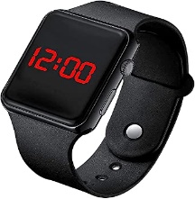**toothpaste – shopping – watch – pedal cab – iron – remove shoes**

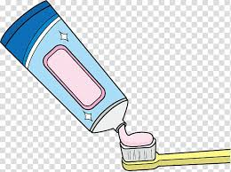****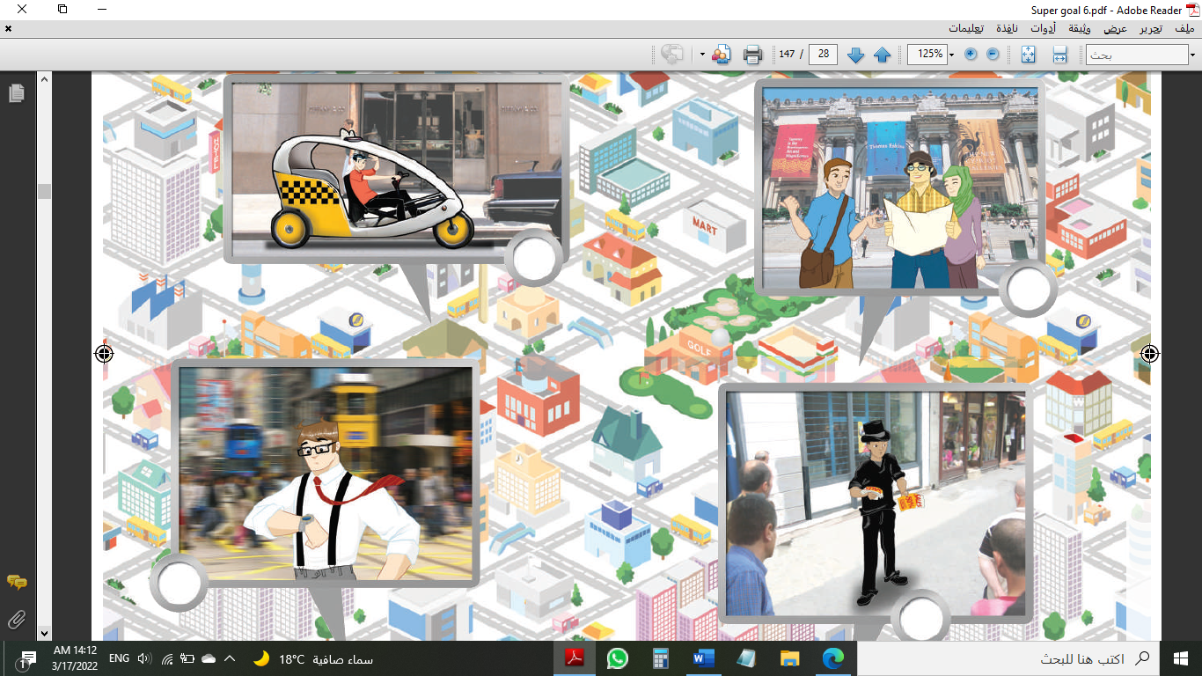

**……………. ……………. ……..……. ………..…… …………… …………..**

**B- Match the answers:**

|  |  |
| --- | --- |
| a. guide | **1. A fashionable person is someone who -------** |
| b. phoned me | **2. He shows the tourists the important places, he is a ------** |
| c. dresses well | **3. He "called me up", means he -------** |
| d. Of course, | **4. When you say, " At long lat." You mean --------** |
| e. Finally | **5. If you want to say, "Yes" in a strong way, you say -------** |

**C- Circle the correct spelling:**

**1. shampo - shampoo – shompoo**

**2. people – poeple - peopel**

**3. tickit – tickete – ticket**

**5) Orthography**:

**4**

**A- Fill in the missing letters:**

**1- cult__re**

**o – a – u – v - f**

**2- polluti__n**

**3- compl__in**

**4- talkati__e**

**B- Choose the odd one out:**

**1. eating reading working sing**

**2. Germany India China Hassan**

**3. done sleep eaten gotten**

**4. funny clever bus athletic**

**End of Questions**

**Best of Luck https://t.me/abokhaledamer**