# نتيجة بحث الصور عن شعار الوزارة شفاف

Super Goal 1 - English Language

**First Intermediate Grade**

Third Term Final Exam 1444-2023

**First Round** | Time: 1.5 hour

Kingdom of Saudi Arabia

Ministry of Education

………. Education Directorate

……………Intermediate School

**المراجع**

**checker**

**أ /..........**

**الدرجة كتابه**

**Written**

**المجموع**

**Total / 30**

**المصحح**

**corrector**

**أ / راشد السلمي**

**Q16**

**Q26**

**Q37**

**Q4**

**4**

**Q57**

اسم الطالب

رقم الجلوس

Composition

**اللهّم لا سَهلَ إلا ما جعلتُه سَهلاً فإنكَ تَجعَلُ الحزنَ إذا شِئتَ سَهلاَ " "**

**Write about what you are going to do on your next vacation.**

Guide words:

**( enjoy – exploring – new food – activities – the weather – the place – language – relaxing – city – trip )**

..................................................................................................................................................................................................................

..................................................................................................................................................................................................................

..................................................................................................................................................................................................................

..................................................................................................................................................................................................................

..................................................................................................................................................................................................................

..................................................................................................................................................................................................................

..................................................................................................................................................................................................................

..................................................................................................................................................................................................................

..................................................................................................................................................................................................................

..................................................................................................................................................................................................................

**6**

**اقلب الصفحة**



Comprehension

**6**

* **Read the following passage and answer the questions below:**

Ali usually has a relaxing Saturday. He doesn’t have work, so he always wakes up late on Saturdays—usually at 10 A.M. Then he has a cup of coffee and makes a big breakfast. He eats breakfast and then reads the news online. Sometimes he goes to visit his cousin on Saturday afternoons, and sometimes he goes for a long walk with his brother. He usually watches a football game on Saturday evenings. Sometimes he meets his family at a restaurant to have dinner. He watches TV at night, and then goes to bed at 10 P.M. so that he’s ready for work on Sunday.

**A. Choose the correct answer:**

1. The text is about Ali’s ____________ .

**a**. Saturdays  **b**. Sundays **c**. weekends **d.** Mondays

1. Ali _____________ wakes up late on Saturdays.

**a**. never **b** sometimes **c** usually **d.** always

1. Ali usually eats a big _____________ on Saturdays.

**a**. food  **b**. breakfast **c**. lunch **d.** dinner

**B. Write (T) for True or (F) for False:**

|  |  |
| --- | --- |
| **4.**  Ali sometimes goes for a long walk with his brother . |  |
| **5.** Ali usually watches a football game on Saturday mornings . |  |
| **6.** Ali goes to bed at 10 P.M |  |

**اقلب الصفحة**



**7**

Grammar

* **Choose the correct answer**

1. He can’t surf, but he _____ water-ski.

**a**. can’t **b**. can  **c**. not can **d.** don’t can

1. **Aisha:** Do they like to relax on the beach? **Lucy:** Yes, _____.

**a**. they do **b**. do they  **c**. not they  **d.** they don’t

1. I _____ play volleyball, but I can play tennis.

**a**. can **b**. am can  **c**. can’t  **d.** am can’t

1. I’m not going to buy jeans. ____________ pants.

**a**. I’m going to buy **b**. I buying  **c**. I’m going buying **d.** I going to buy

1. Susan ____________ a dress. She’s going to wear a skirt and blouse.

**a**. isn’t wear **b**. not wearing  **c**. isn’t going to wear **d.** isn’t going to wearing

1. They ____________ suits. They’re going to wear jeans.

**a**. not wearing **b**. not going to wearing **c**. aren’t going wear **d.** aren’t going to wear

1. _____ Bob to our house!

**a**. We invite **b**. Let invite  **c**. Let’s invite **d.** Let’s us invite

1. Do you _____ a film on TV tonight?

**a**. want to watch **b**. want watch  **c**. want watching **d.** want to watching

1. You _____ the street when the light is red.

**a**. mustn’t cross **b**. should cross not **c**. must not to cross **d.** should cross

1. My grandfather _____ a car salesman.

**a**. was **b**. were  **c**. not **d.** be

1. Majed Ahmed Abdullah _____ in Jeddah.

**a**. is born **b**. are born  **c**. was born **d.** were born

1. When I was a child, I _____ a good student.

**a**. wasn’t be **b**. not **c**. wasn’t **d.** weren’t

1. We didn’t go to the football game yesterday. We_____ to the museum.

**a**. go **b**. went  **c**. are **d.** going

1. Sally didn’t drink coffee. She _____ water.

**a**. is drink **b**. drinking  **c**. drink **d.** drank

Orthography

**4**

* **Choose the correct letters :**

1. You can go sho…..ping and meet friends. ( v – p – r )
2. You can fly to pla…..es. ( n – o – c )
3. Nawal is going to buy aba…..a ( y – o – r )
4. You need warm clothes it’s …..old in Abha ( n – o – c )
5. I don’t have an in…itation to the party ( y – v – r )
6. Let’s get some ca…ds for the National Day ( r – o – c )
7. Balad, the old pa…t of Jeddah ( y – v – r )
8. Ahmed was pleased with his prese…tation ( o – t – n )

**اقلب الصفحة**



Vocabulary

* **Choose the correct answer:**

**7**

1. You can _____ at the pool.

**a**. swim **b**. surf  **c**. rollerblade **d.** sail

1. My friends like to _____. They enjoy looking at underwater attractions.

**a**. swim **b**. sail  **c**. surf  **d.** snorkel

1. He’s going to wear a shirt and a ____________.

**a**. shoes **b**. tie  **c**. shorts **d.** white

1. Do you need to buy new ____________ to play basketball?

**a**. suit **b**. shirt  **c**. sneakers  **d.** blouses

1. On December 2nd, they _____ Federation of the Emirates in the UAE.

**a**. parades **b**. decorate  **c**. celebrate **d.** share

1. In Saudi Arabia, people fly _____ on September 23rd.

**a**. flags **b**. streets  **c**. fireworks  **d.** celebrations

1. In old Riyadh, many houses were made from ____ bricks.

**a**. ruins **b**. town  **c**. mud **d.** city

1. In modern Riyadh, you can see many ______.

**a**. skyscrapers **b**. walls  **c**. population  **d.** areas

1. **Adel:** What did you do last night? **Ali:** I went to a friend’s house and watched _____.

**a**. a car race **b**. the zoo  **c**. a computer club **d.** home

1. **Peter:** Do you have any clean clothes? **Andy:** Yes, I do. I did my _____ yesterday.

**a**. closet **b**. laundry  **c**. home  **d.** house

1. **Chang:** What did you do yesterday? **Todd:** I went to the _____ and played volleyball.

**a**. car race **b**. beach  **c**. museum  **d.** zoo

1. **Sabah:** What did you do yesterday? **Aisha:** I went to a _____. I love history.

**a**. restaurant **b**. closet **c**. mall **d.** museum

* **Write the correct word under the picture.**



Graduation day – Gym – calendar

صورة تحتوي على نص, نافذة, مبنى

تم إنشاء الوصف تلقائياً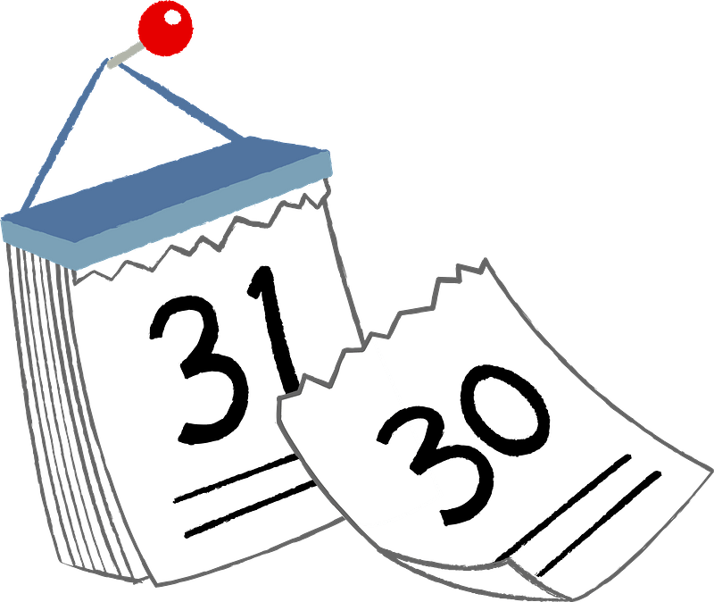

**14.**

**13.**

**12.**

………………………….…

………………………….…

………………………….…

**انتهت الأسئلة .. ..**

**وبالله التوفيق والنجاح ..**

**الأستاذ / راشد السلمي**

**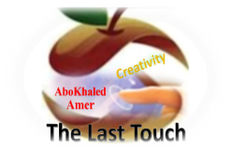****المملكة العربية السعودية**

**Kingdom of Saudi Arabia**

**Ministry of Education**

**------- Educational Directorate**

**------- Future Educational Schools**

**1st grade intermediate 2022**

**3rd Term – Final Exam**

**وزارة التعليم**

**الإدارة العامة للتعليم بن**

**مدارس م ن التعليمية**

**الصف الاول المتوسط**

**الاختبار النهائي للفصل الدراسي الثالث1443**

|  |  |  |  |  |  |  |  |
| --- | --- | --- | --- | --- | --- | --- | --- |
| **Total**  **written** | **5 spelling** | **4 Vocabulary** | **3 Grammar** | **2 Comprehension** | | **1 Composition** | **Q. NO.** |
|  |  |  |  |  | |  | **Mark Given** |
| **30** | **4** | **7** | **7** | **6** | | **6** | **Mark** |
|  | | | **Reviser** | |  | | **Corrector** |
|  | |

**زمن الاختبار: ساعتان**

**اسم الطالب: ------------------------------------ رقم الجلوس: ------------- الصف الأول المتوسط**

**6**

1) **Composition**

**1- Write a paragraph about “Your Favorite Clothes"**

**You may use the following words: favorite – cool – wear – home - weather- school-…**

…………………………………………

………………………………………………………………………………………………………………………………………………………………………………………………………………………………………………………………………………………………………………………………………………………………………………………………………………………………………………………………………………………………………………………………………………………………………………………………………………………………….

**2) Comprehension**

**6**

**2- Read the following passage then answer the questions:**

**Janadriyah Festival**

**Every year in Saudi Arabia, many people from all over the country and from abroad attend the Janadriyah national heritage and culture festival. The festival takes place in a village near Riyadh, and it is normally held between November and March when the heat is less extreme. The festival celebrates symbols of Saudi identity. There are camel races and horse races, displays of regional costumes, cuisines, and crafts such a carpet-weaving, and pottery. There are donkey rides, which are very popular with children. The festival lasts for two weeks.**

**A- Put ( ) or ( x ):**

**1.The text is about camel racing in Saudi Arabia. ( )**

**2.Only people who live in Saudi Arabia can attend the festival. ( )**

**3.The festival is usually held when the temperatures are cooler. ( )**

**4.Children like the donkey rides. ( )**

**5. The festival lasts for two weeks. ( )**

**B- Choose the correct answer:**

**1. Janadriyah is Every (**month – season – year**) in Saudi Arabia.**

**2. There are camel races and horse (**eating – races – graces**).**

**3. The festival celebrates symbols of Saudi (**flag – people – identity**)**

**4. The festival is between November and (**April – March – May**).**

**C- Answer the following questions:**

**1. What is the name of the festival?.............................**

**2. Where does Janadriyah take place?...........................**

**3. How long does the festival last? ..............................**

**3) Grammar**

**A: Choose the correct answer:**

**7**

**1. She is good at English. She (**can – can't – is**) speak it well**

**2. He (**don't like – doesn't like – isn't like**) to cook food.**

**3. They (**am – is – are**) going to sleep early.**

**4. I want to meet my neighbors. I don’t know (**them – him – her**)**

**5. We need (**to buy – buy – buying**) some snacks.**

**6. He (**was – were – are**) at home.**

**7. They (**went – goes – going**) to the beach last summer.**

**8. Did he play football? Yes, he (**is – did – didn't**).**

**B: Chang into Negative:**

**1. I can clean my room.**

…………………………………………………………………………………………………………………………………………………………………………………………………………………

**2. She is going to help her mom.**

……………………………………………………………………………………………………………………………………

3. **They watched TV at home.**

……………………………………………………………………………………………………………………………………

**C: Make Yes/No question:**

**1. She can cook lunch.**

……………………………………………………………………..……………………………………………………………

**2. They are going to study English.**

……………………………………………………………………………………………………………………………………

**3. He worked hard.**

……………………………………………………………………………………………………………………………………

**4) vocabulary:**

**7**

**A- Match the words with the pictures :**

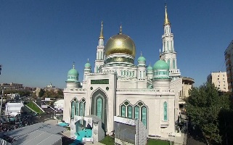**pizza 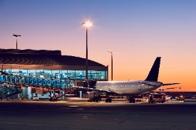– shoes – graduation – mosque – airport – exercise**



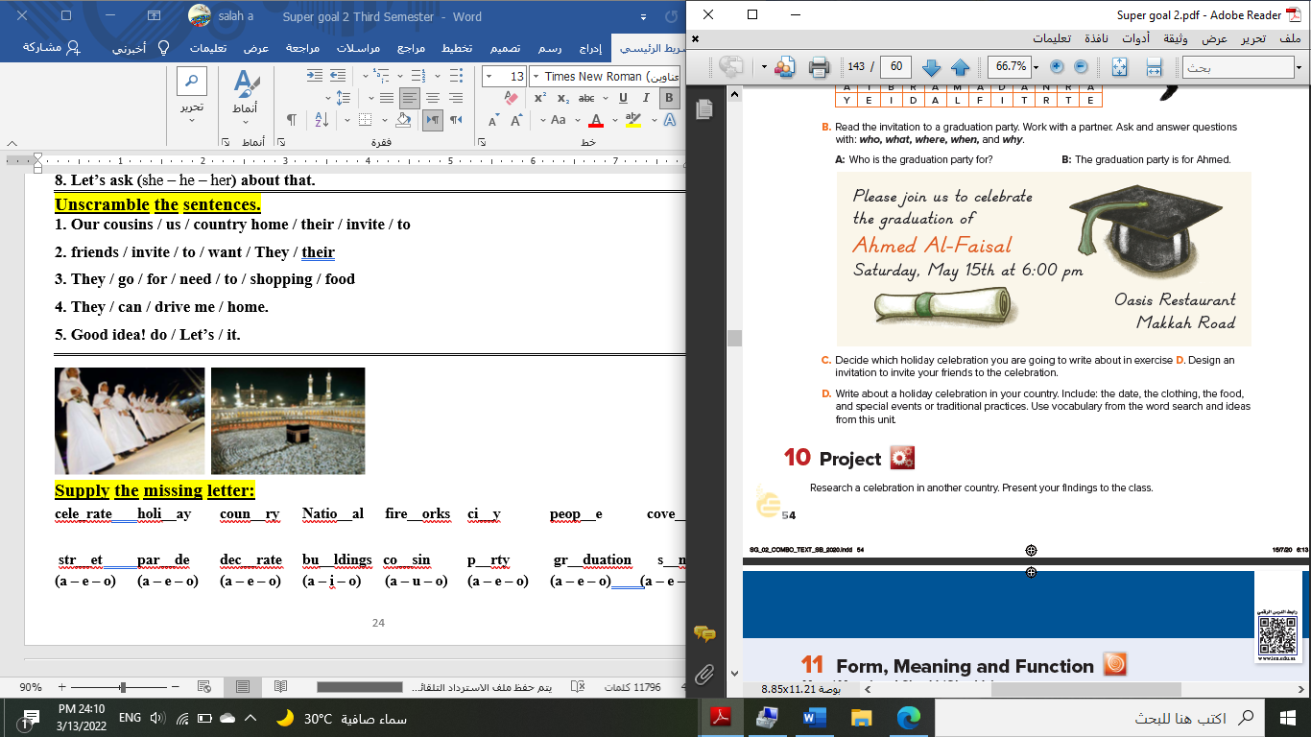****

**……………... ……………. ……..………. ………… …………… …………..**

**B- Match the answers:**

|  |  |
| --- | --- |
| a. National Day | **1. Visitors can sleep there. --------** |
| b. Vacation | **2. Women wear these formal clothes.** -------- |
| c. hotel | **3. In Saudi Arabia, people celebrate the -**------ |
| d. abayas | **4. Majed Ahmed Abdullah was a famous** ------- |
| e. footballer | **5. We traveled to Egypt during the summer ---------** |

**C- Circle the correct spelling:**

**1. moring - morning – marning**

**2. skyscraper – skyskraper - ckyscraper**

**3. celebote – celeprate – celebrate**

**5) Orthography**:

**4**

**A- Fill in the missing letters:**

**1- cl__thes**

**a – o – u – s – c**

**2- book__tore**

**3- par__de**

**4- pop__lation**

**B- Choose the odd one out:**

**1. shorts jeans pants TV**

**2. school restaurant gym eat**

**3. watched TV Played tennis helped Ali eat fish**

**4. footballer doctor scientist car**

**End of Questions**

**Best of Luck https://t.me/abokhaledamer**

******المملكة العربية السعودية**

**Kingdom of Saudi Arabia**

**Ministry of Education**

**------- Educational Directorate**

**------- Future Educational Schools**

**1st grade intermediate 2022**

**3rd Term – Final Exam**

**وزارة التعليم**

**الإدارة العامة للتعليم بن**

**مدارس م ن التعليمية**

**الصف الاول المتوسط**

**الاختبار النهائي للفصل الدراسي الثالث1443**

|  |  |  |  |  |  |  |  |
| --- | --- | --- | --- | --- | --- | --- | --- |
| **Total**  **written** | **5 spelling** | **4 Vocabulary** | **3 Grammar** | **2 Comprehension** | | **1 Composition** | **Q. NO.** |
|  |  |  |  |  | |  | **Mark Given** |
| **30** | **4** | **7** | **7** | **6** | | **6** | **Mark** |
|  | | | **Reviser** | |  | | **Corrector** |
|  | |

**زمن الاختبار: ساعتان**

**اسم الطالب: ------------------------------------ رقم الجلوس: ------------- الصف الأول المتوسط**

**6**

1) **Composition**

**1- Write a paragraph about “Your Favorite Place"**

**You may use 50 words:**

…………………………………………

………………………………………………………………………………………………………………………………………………………………………………………………………………………………………………………………………………………………………………………………………………………………………………………………………………………………………………………………………………………………………………………………………………………………………………………………………………………………….

**2) Comprehension**

**6**

**2- Read the following passage then answer the questions:**

**The Sports Center**

**I like to go to the sports center. I go there every weekend. At the sports center, you can do many things. For example, you can play golf or tennis. There is a pool, so you can also swim or relax by the pool. There is a beach next to the sports center. You can swim, water-ski, or windsurf in the ocean. You can also sail on windy days. There aren’t any fish near the beach, so you can’t snorkel. When I go to the sports center, I like to play volleyball on the beach. I also like to jog on the beach. I can’t swim well, so I don’t like to water-ski or windsurf.**

**A- Put ( ) or ( x ):**

**1. The writer likes the sports center. ( )**

**2. You can swim in the pool or in the ocean. ( )**

**3. People can windsurf in the pool. ( )**

**4. You can’t use a boat in the ocean. ( )**

**5. In the sports center, there aren't many things. ( )**

**B- Choose the correct answer:**

**1. There is a (**peach – beach – fetch**) next to the sports center.**

**2. There aren’t any (**fish – meat – fruit**) near the beach**

**3. He doesn’t like to water-ski or (**windows – doors – windsurf**).**

**4. You can also sail on (**rainy – snowy – windy**) days.**

**C- Answer the following questions:**

**1. Where does the writer like to go?.............................**

**2. When does he go?...........................**

**3. What does he play on the beach? ..............................**

**3) Grammar**

**A: Choose the correct answer:**

**7**

**1. She (**can – can't – does**) cook well. She is bad at cooking.**

**2. We (**don't like – doesn't like – isn't like**) to stay up for late hours.**

**3. She (**am – is – are**) going to visit her friends.**

**4. Ali is a nice guy. I want you to meet (**them – him – her**)**

**5. He wants (**to reads – to read – to read**) some books.**

**6. We (**was – were – are**) at home, waiting for you.**

**7. They (**eat – eating – ate**) a delicious meal last weekend.**

**8. Did you do your homework? No, I (**is – did – didn't**).**

**B: Chang into Negative:**

**1. They can play football.**

…………………………………………………………………………………………………………………………………………………………………………………………………………………

**2. He is going to dust his room.**

……………………………………………………………………………………………………………………………………

3. **We stopped at the supermarket to buy ice cream.**

……………………………………………………………………………………………………………………………………

**C: Make Yes/No question:**

**1. He can read English well.**

……………………………………………………………………..……………………………………………………………

**2. She is going to call her friend.**

……………………………………………………………………………………………………………………………………

**3. We visited our friends in Najran.**

……………………………………………………………………………………………………………………………………

**4) vocabulary:**

**7**

**A- Match the words with the pictures:**

****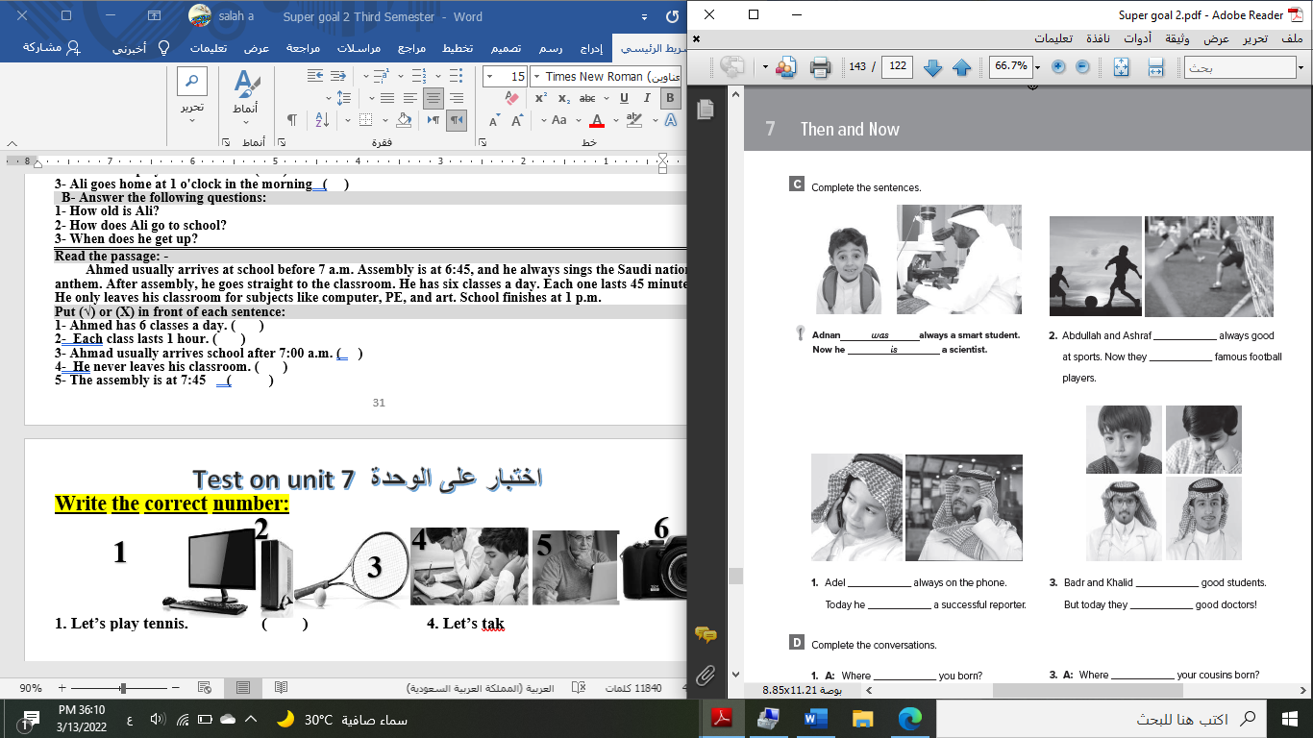**doctor - meal – shirt – bus stop – fireworks – beach**

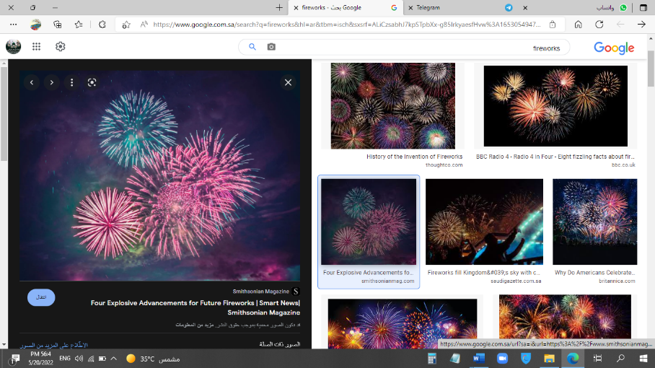

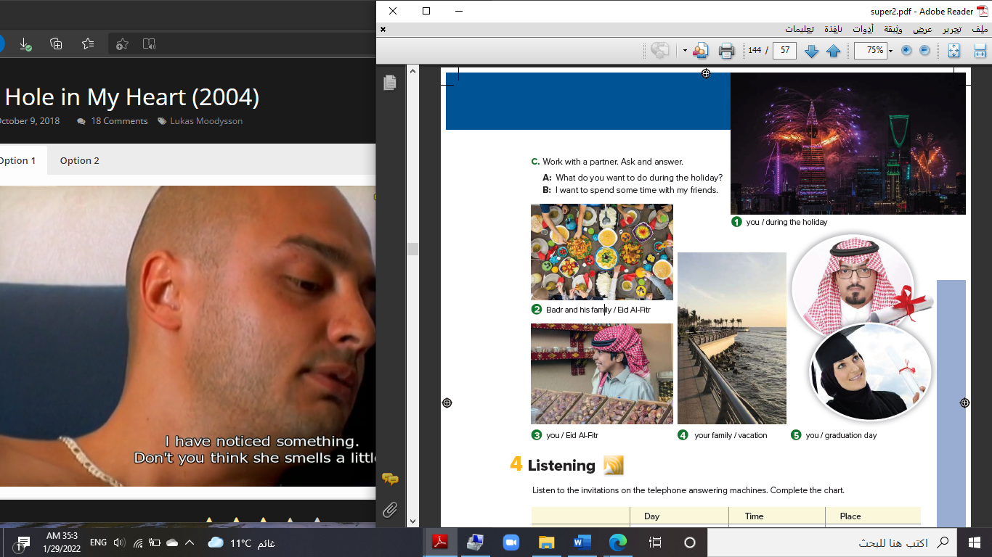****

**……………... ……………. ……..………. ……..…… ………… …………..**

**B- Match the answers:**

|  |  |
| --- | --- |
| a. green color | **1. You can open an account. ------** |
| b. Riyadh | **2. Men wear it for work. ------** |
| c. bank | **3. In Saudi Arabia, people decorate houses in ------** |
| d. thobe | **4. The King of Saudi Arabia is ------** |
| e. King Salman | **5. It was a traditional place then i**t **became the capital ------** |

**C- Circle the correct spelling:**

**1. natonial - nashional – national**

**2. house – huoes - hosue**

**3. yesteday – yesterday – yetserday**

**5) Orthography**:

**4**

**A- Fill in the missing letters:**

**1- buil__ing**

**p – u – r – o – s**

**2- cons__le**

**3- celeb__ation**

**4- air__ort**

**B- Choose the odd one out:**

**1. suit jeans tie abaya**

**2. watch school help eat**

**3. Emirates Kuwait under Oman**

**4. teacher morning afternoon evening**

**End of Questions**

**Best of Luck https://t.me/abokhaledamer**