******المملكة العربية السعودية**

**Kingdom of Saudi Arabia**

**Ministry of Education**

**------- Educational Directorate**

**------- Future Educational Schools**

**1st Grade High School 2022**

**3rd Term – Final Exam**

**وزارة التعليم**

**الإدارة العامة للتعليم بن**

**مدارس م ن التعليمية**

**الصف الأول الثانوي**

**الاختبار النهائي للفصل الدراسي الثالث1443**

|  |  |  |  |  |  |  |  |
| --- | --- | --- | --- | --- | --- | --- | --- |
| **Total**  **written** | **5**  **Vocabulary** | **4**  **Grammar** | **3**  **Free Composition** | **2**  **Guided Composition** | | **1 Comprehension** | **Q. NO.** |
|  |  |  |  |  | |  | **Mark Given** |
| **30** | **6** | **6** | **6** | **6** | | **6** | **Mark** |
| **6** | | | **Reviser** | |  | | **Corrector** |
|  | |

**زمن الاختبار: 3 ساعات**

**اسم الطالب: ------------------------------------ رقم الجلوس: ------------- الصف الأول الثانوي**

**1)** **Comprehension**

**Read the following passage then answer the questions**

David Copperfield is a beautiful story. It is about a boy whose father died before he was born. The boy lived his early years happily with his mother, Carla. Few years his mother got married to Edward Murdstone who was very cruel. David's stepfather used to beat him then he sent David to boarding school. David 's mother died and the boy was sent to work in London. After finishing school, he trained to become a lawyer while he married to beautiful woman, Dora, but few years she died. David left to Switzerland to find comfort on Alps. While living there he worked on his book that his friend published it. Later, he became a famous novelist.

***A)* Answer the following questions*:*  
1. What is this story about?**

**---------------------------------------------------------------.**

**2. Did David's mother get married after her husband's death?**

**----------------------------------------------------------------.**

**3. Where did David go after his mother's death?**

**----------------------------------------------------------------.**

**4. Was David's book published?**

**----------------------------------------------------------------.**

***B)* Put ( √ ) or ( X ):  
5. While David was in London he worked on his book. ( )  
6. David became a famous novelist.( )**

**7. David's friend helped him to publish his book. ( )**

**8. David never got married. ( )**

***C)* Complete*:*  
9. David's mother name was --------------------------------.  
10. David's wife name was -----------------------------------.**

***D)* Choose the correct answer*:***

**11. Line 7: the underlined word (there) refers to: (**London – Home – Switzerland**)**

**12. Line 7: the underlined word (he) refers to: (**stepfather – David – friend**)**

**2) Guided Composition**

**6**

**There are some important inventions that have changed our life. Write a short paragraph about one of the inventions that affects your life.**

**(**Write not less than 150 word **(**

**Guiding words:**

(computer – useful – assignment – search – watch – play …)

-------------------------------------------------------

--------------------------------------------------------------------------------------------------------------------------------------------------------------------------------------------------------------------------------------------------------------------------------------------------------------------------------------------------------------------------------------------------------------------------------------------------------------------------------------------------------------------------------------------------------------------------------------------------------------------------------------------------------------------------------------------------------------------------------------------------------------------------------------------------------------------------------------------------------------------------------------------------------------------------------------------------------------------------------------------------------------------------------------------------------------------------------------------------------------------------------------------------------------------------------------------------------------------------------------------------------------------------------------------------------------------------------------

**3) Free Composition**

**6**

**Choose one topic from the following to write about.**

**1. Imagine that a friend has written to you for advice about a problem that he has at school or work. Write a reply to your friend.**

**2. You moved to a new apartment but unfortunately it is unsuitable.**

**(**Write not less than 100 word**).**

-------------------------------------------------------

--------------------------------------------------------------------------------------------------------------------------------------------------------------------------------------------------------------------------------------------------------------------------------------------------------------------------------------------------------------------------------------------------------------------------------------------------------------------------------------------------------------------------------------------------------------------------------------------------------------------------------------------------------------------------------------------------------------------------------------------------------------------------------------------------------------------------------------------------------------------------------------------------------------------------------------------------------------------------------------------------------------------------------------------------------------------------------------------------------------------------------------------------------------------------------------------------------------------------------------------------------------------------------------------------------------------------------------------------------------------------------------------------------------------------------------------------------------------------------------

**4) Grammar**

**6**

**A: Choose the correct answer:**

**1. The car seats need to be (**fix – fixes – fixed – fixing**)**

**2. The shirt is not OK. The tailor sewed the (tear – torn – tears – tearing) shirt.**

**3. After she (**cooks – cooked – cooking – had cooked**) lunch, she watched TV.**

**4. You haven't eaten all day. You (can't – must – may – might) be starving.**

**5. If you had played well, you (will – can – would – may) have won the game.**

**6. Ali said that he (was – is – has – can) at home waiting for me.**

**Do as shown between brackets:**

**1. Ali asked, "Where do they play tennis?" (Reported speech)**

-------------------------------------------------------------------------------------------------.

**2. He should have (call) me before coming to visit me. (Correct the verb)**

-------------------------------------------------------------------------------------------------.

**3. He is sick at home. He (must) be at school. (Correct)**

-------------------------------------------------------------------------------------------------.

**4. By the time he arrived home, his dad had (drive) his car. (Correct)**

-------------------------------------------------------------------------------------------------.

**5. My car is broken. I'll take it to the mechanic to ---------------------------- (repair)**

**6. If he had had enough time, he would have -------------------------- (Complete)**

**5) vocabulary:**

**6**

**A- Match the words with the pictures:**

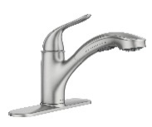**Meteorite – wheel – iron – faucet – pomegranate – volcano**

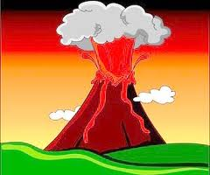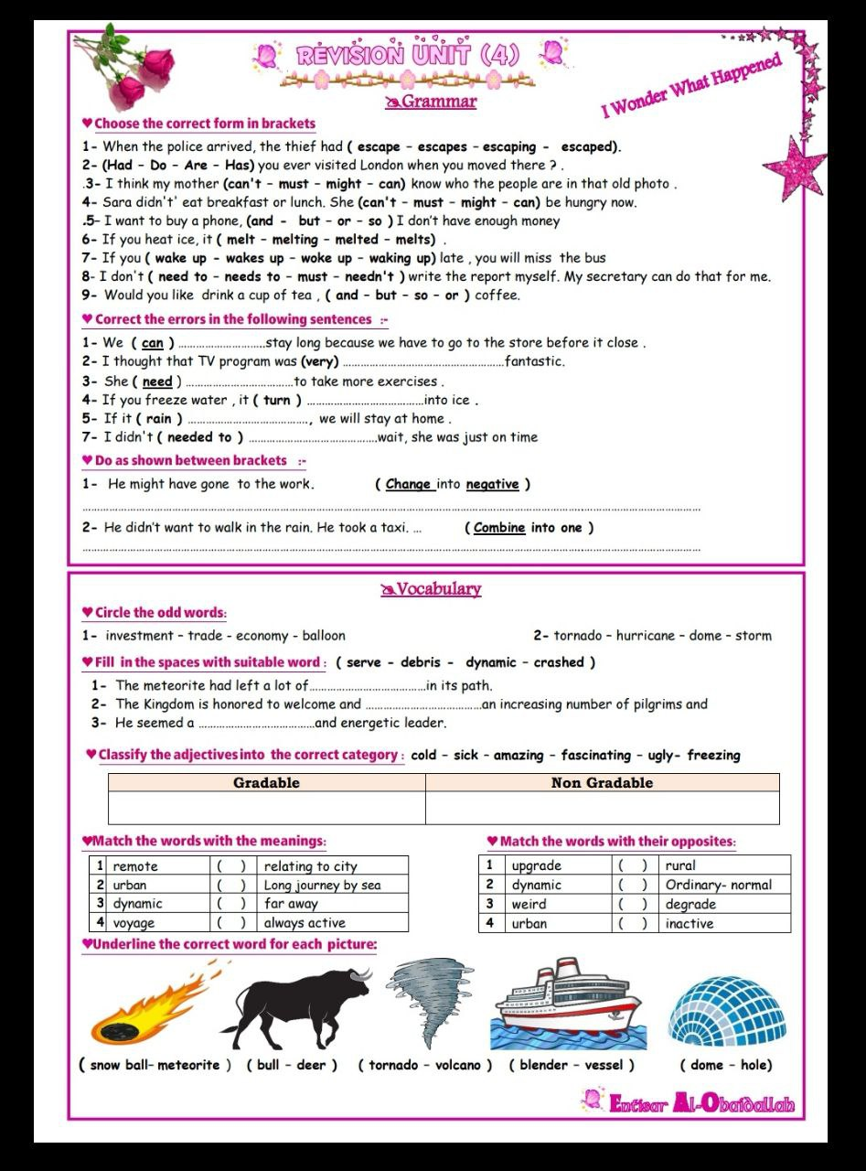****

**------ --------- ----------- ---------- --------- --------**

**A) Match to form new words or expressions:**

**1. oil ---- a. guard**

**2. scan ---- b. well**

**3. hair ---- c. get an image**

**4. devasted ---- d. style**

**5. meat ---- e. destroyed**

**6. security ---- f. grinder**

**End of Questions**

**Best of Luck** [**https://t.me/abokhaledamer**](https://t.me/abokhaledamer)

******المملكة العربية السعودية**

**Kingdom of Saudi Arabia**

**Ministry of Education**

**------- Educational Directorate**

**------- Future Educational Schools**

**1st Grade High School 2022**

**3rd Term – Final Exam**

**وزارة التعليم**

**الإدارة العامة للتعليم بن**

**مدارس م ن التعليمية**

**الصف الأول الثانوي**

**الاختبار النهائي للفصل الدراسي الثالث1443**

|  |  |  |  |  |  |  |  |
| --- | --- | --- | --- | --- | --- | --- | --- |
| **Total**  **written** | **5**  **Vocabulary** | **4**  **Grammar** | **3**  **Free Composition** | **2**  **Guided Composition** | | **1 Comprehension** | **Q. NO.** |
|  |  |  |  |  | |  | **Mark Given** |
| **30** | **6** | **6** | **6** | **6** | | **6** | **Mark** |
| **6** | | | **Reviser** | |  | | **Corrector** |
|  | |

**زمن الاختبار: 3 ساعات**

**اسم الطالب: ------------------------------------ رقم الجلوس: ------------- الصف الأول الثانوي**

**1)** **Comprehension**

**Read the following passage then answer the questions**

**Regrets**

**My name's Jack and I want to tell you about something I regret. It happened over twenty years ago. I must have been around five years old. It was a summer day and I was in a park playing with some other kids from the neighborhood. There was a boy *there* named Jeremy who I didn't like very much, but I can't remember why. Anyway, we were playing near a pond. The water was very dirty and it was full of weeds and slime. You can guess what I did, right…? I waited until he was standing near the edge of the pond, and then I crept up behind *him* and gave him a good hard push in the back. He went flying straight into the filthy, slimy water! His dad rushed over and pulled him out. Jeremy was crying and pointed at me, saying "It was him. He pushed me!" Of course, I denied *it*. My parents were there, but I insisted I was innocent and without any proof they took my side. The bad thing is that Jeremy's parents and mine used to be good friends, but after that they never spoke to each other again. I should have told my parents the truth, but I didn't. To this day, I still regret pushing that boy into the pond**

***A)* Answer the following questions*:*  
1. What is the name of the writer?----------------------------------------------------------.**

**2. Where was the writer playing? -----------------------------------------------------------.**

**3. How was the water in the pond? -------------------------------------------------------------.**

**4. Who pulled the young boy out of the pond? -----------------------------------------------.**

***B)* Put ( √ ) or ( X ):  
5. There was a boy *there* named Jeremy. (refer to) in the park. ( )**

**6. I crept up behind *him.* (refer to) Jack`s parents. ( )**

**7. I denied *it*. (refer to) pushing him in the pond. ( )**

**8. The writer regrets pushing the boy in the pond. ( )  
*C)* Complete*:*  
9. The story happened over --------------------------------.  
10. Without any proof, the writer's parents -----------------------------------.**

**D) Choose the correct meaning:**

**11. neighborhood = (**nearness – farness – distance**)**

**12. innocent = (**guilty – guiltless – faulty**)**

**2) Guided Composition**

**6**

**You are living in Najran and you think it is the best place in Saudi Arabia. Write an email inviting your friend to visit you during the weekend.**

**(**Write not less than 150 word **(**

**Guiding words:**

(weather – Okhdod Area – Najran Dam – green farms – hospitable people - …)

-------------------------------------------------------

--------------------------------------------------------------------------------------------------------------------------------------------------------------------------------------------------------------------------------------------------------------------------------------------------------------------------------------------------------------------------------------------------------------------------------------------------------------------------------------------------------------------------------------------------------------------------------------------------------------------------------------------------------------------------------------------------------------------------------------------------------------------------------------------------------------------------------------------------------------------------------------------------------------------------------------------------------------------------------------------------------------------------------------------------------------------------------------------------------------------------------------------------------------------------------------------------------------------------------------------------------------------------------------------------------------------------------------

**3) Free Composition**

**6**

**Choose one topic from the following to write about.**

**1. Imagine that you are going to have a party for your brother's graduation. Send an email to your friend, invite him to your occasion.**

**2. You bought a new cellphone, but you found out that it is faulty. Send an email of complaint to the company asking for refund.**

**(**Write not less than 100 word**).**

-------------------------------------------------------

--------------------------------------------------------------------------------------------------------------------------------------------------------------------------------------------------------------------------------------------------------------------------------------------------------------------------------------------------------------------------------------------------------------------------------------------------------------------------------------------------------------------------------------------------------------------------------------------------------------------------------------------------------------------------------------------------------------------------------------------------------------------------------------------------------------------------------------------------------------------------------------------------------------------------------------------------------------------------------------------------------------------------------------------------------------------------------------------------------------------------------------------------------------------------------------------------------------------------------------------------------------------------------------------------------------------------------------

**4) Grammar**

**6**

**A: Choose the correct answer:**

**1. The window needs to be (**cleans – cleaning – cleaned – clean**).**

**2. I had my new room (paint – paints – painting - painted).**

**3. Before we visited friends, we (had called –have called –calling –call) them.**

**4. Nora is abroad with her family. she (can't – must – may – might) be home.**

**5. If they had slept early, they would have (be – been – bees – are) on time.**

**6. Ahmad said that she (cooks – cook – cooked - cooking) a delicious meal.**

**Do as shown between brackets:**

**1. Nora asked, "Does he like watching TV?" (Reported Speech)**

-------------------------------------------------------------------------------------------------.

**2. They didn't study for the final exam. (Use: should have)**

-------------------------------------------------------------------------------------------------.

**3. I'm not sure, it has wings. It (must) be a bird. (Correct)**

-------------------------------------------------------------------------------------------------.

**4. After Ali (clean) his room, he went out to play. (Correct)**

-------------------------------------------------------------------------------------------------.

**5. The vase is broken. Please, throw the ------------------------------- vase away.**

**(Write the adjective)**

**6. If Hassan (visit) me, I would have told him the whole story. (Correct)**

-------------------------------------------------------------------------------------------------.

**5) vocabulary:**

**6**

**A- Match the words with the pictures:**

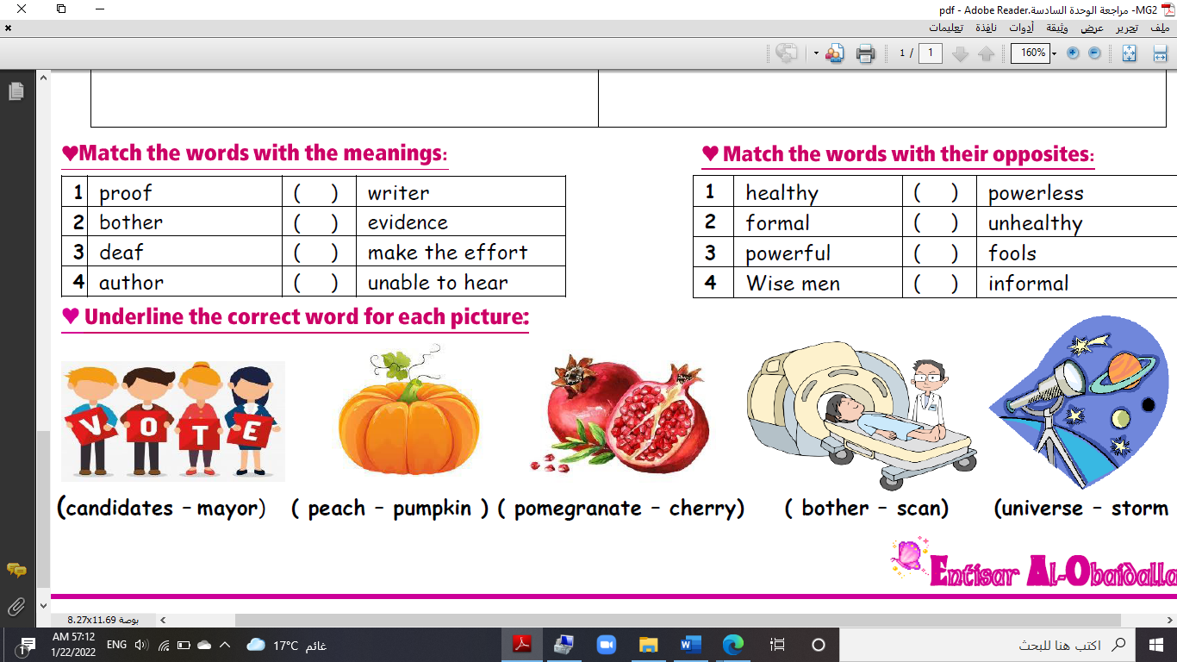**pumpkin – meteorite – bull – battery – oil well – tornado**

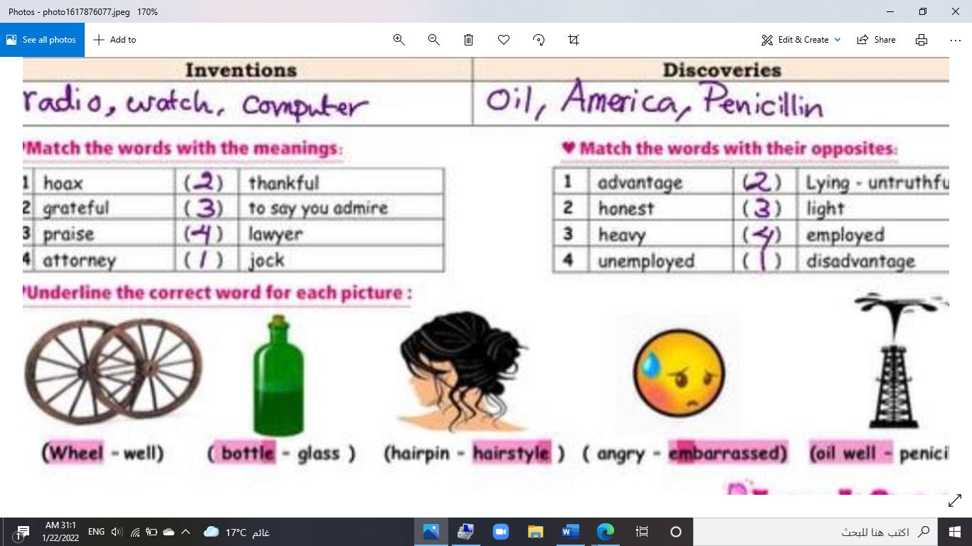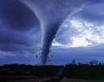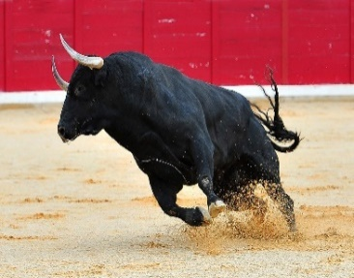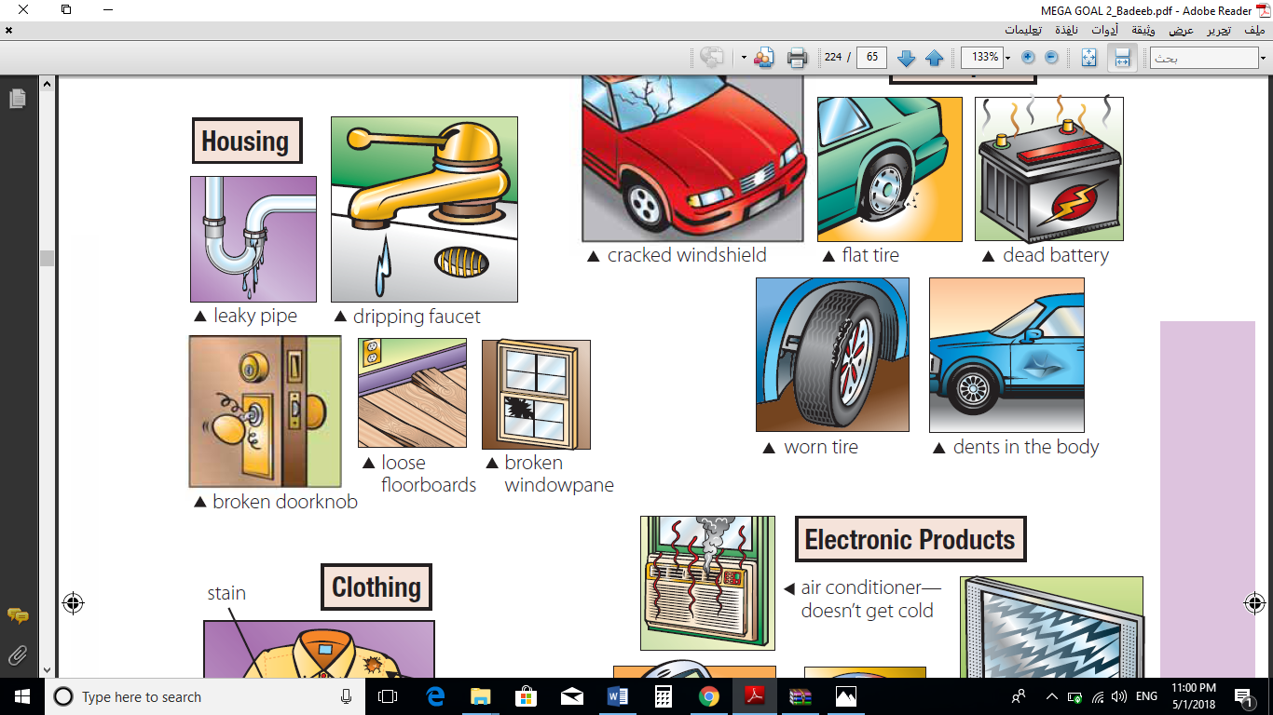

**------ --------- ----------- ---------- --------- --------**

**A) Match to form new words or expressions:**

**1. electric ---- a. evidence**

**2. remote ---- b. bulb**

**3. hair ---- c. distant**

**4. devasted ---- d. dryer**

**5. baby ---- e. destroyed**

**6. proof ---- f. stroller**

**End of Questions**

**Best of Luck** [**https://t.me/abokhaledamer**](https://t.me/abokhaledamer)



6

**Kingdom of Saudi Arabia English Language Final Exam**

**Ministry of Education The Second Trimester,1st Session, 1443**

**General Directorate of Education in Makkah The 1.3 Secondary Grade**

**South Education Office Time: 3 hours**

**14th Secondary School No. of pages: 3**

**I- Composition**:

12

**A- Guided Composition:**

**Write an email to complain about a** **charger** you bought

**Guided words**: purchased, promotional material, returned, packaging, intact, conveying, regret, incident, refrain, retail outlet.

Anker

Customer Service Department.

231 Abdelaziz Road

Riyadh, SA 12340

4 Ramadan 1443



………………………………………………………………………………………………………………………………………………………………………………………………………………………………………………………………………………………………………………………………………………………………………………………………………………………………………………………………………………………………………………………………………………………………………………………………………………………………………………………………………………………………………………………………………………………………………………………………………………………………………………………………………………………………………………………………………………………………………………………………………………………………………………………………………………………………………………………………………………………………………………………………………………………………………………………………………………………………………………………………………………………………………………………………………………………………………………………………………………………………………………………………………………………………………………………………………………………………………………………………………………………………………………………………………………………………………………………………………………………………………………………………………………………………………………………………………………………………………………………………………………………………………………………………………………………………………………………………………………………………………………………………………………………………………………………………………………………………………………………………………………………………………………………………………………………………………………………………………………………………………………………………………………………………………………………………………..…………………………………………………………………………………………………………………………………………

Dear Sir

Your sincerely,

A displeased former customer.

6

**B- Free Composition:**

**Write an essay about (inventions) Or a ( Voyage expedition)**

…………………………………………………………………………………………………………………………………………………………………………………………………………………………………………………………………………………………………………………………………………………………………………………………………………………………………………………………………………………………………………………………………………………………………………………………………………………………………………………………………………………………………………………………………………………………………………………………………………………………………………………………………………………………………………………………………………………………………………………………………………………………………………………………………………………………………………………………………………………………………………………………………………………………………………………………………………………………………………………………………………………………………………………………………………………………………………………………………………………………………………………………………………………………………………………………………………………………

**II -Grammar:**

6

**A-Choose the correct answers:**

1- We’re **[ got- get - getting]** the rooms decorated.

2-​ The jacket needs to be **[ sew- sewed- sewn]**.

3- By the time It [ **rained- raining- rains**], we had gathered in the park.

4- A small asteroid **[has exploded- exploded- exploding**] over Siberiasince 1990.

5- When [ **did- does- do**] IBM introduce the first PC?

6- Yes, it’s a good idea.” My friend **[ assured –** **agreed – told ]** it was a good idea.

**B-Do as shown between brackets:**

1- you-want to–know-what-Don’t–happened? [**Unscramble to make a sentence**]

----------------------------------------------------------------------------------------------

2-" Is he bothering you?"

She asked me……………………………………………………………………………  **[ Report the questions ]**

3 - She **has guessed** the result a month ago…………………………………………...  **[Correct ]**

**4-** I won’t persuade my mom to come. **[Express disagreement]**

………………………………………………………………………………………………………………………………….

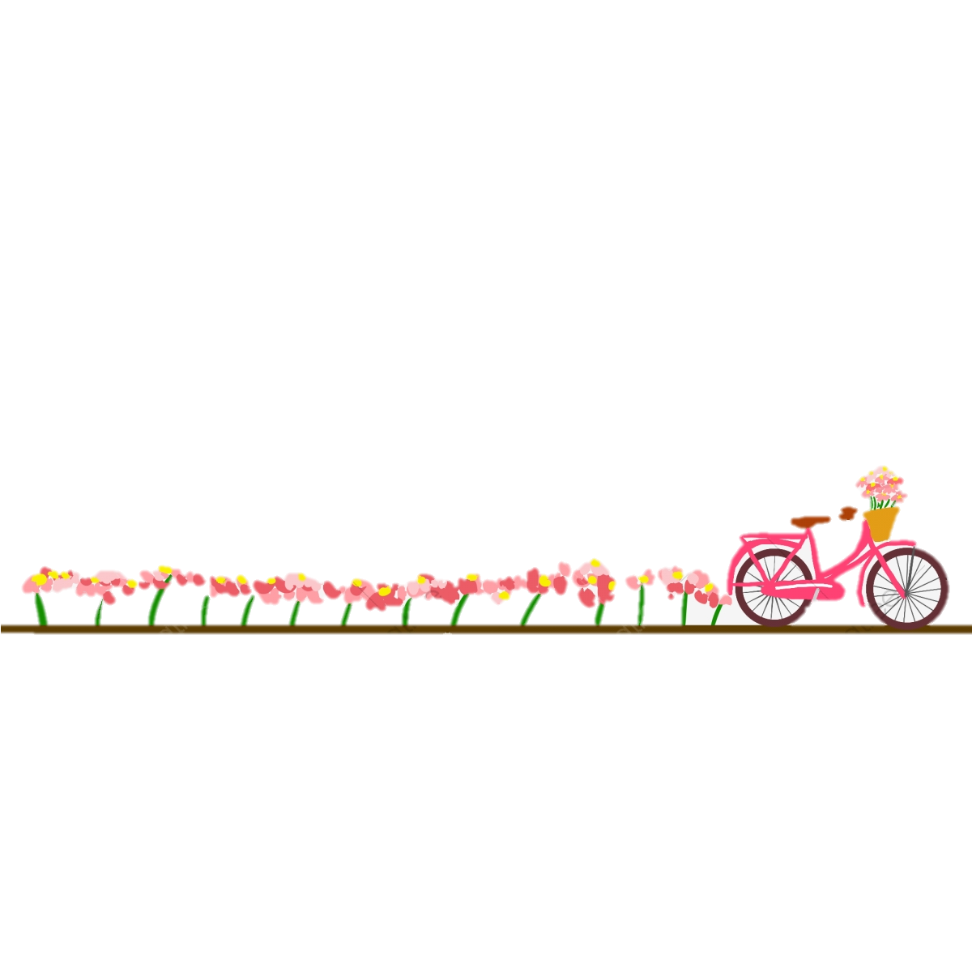

**III- Vocabulary:**

6

**A-Match between the words and their pictures:**

1-

1- stain 2- oil well **3-** Tornado **4-** candidate **5-** scan

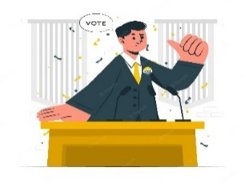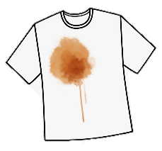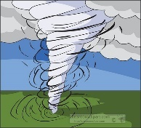

( ) ( ) ( ) ( )

**2- Match the words with the meanings:**

|  |  |
| --- | --- |
| 1- purchase | ( ) break down |
| 2- weird | ( ) dig |
| 3- drill | ( ) very strange |
| 4- deteriorate | ( ) buy |
| 5- reschedule |  |

**3- Circle the Odd words**

a**-** Oil- computer - airplanes- smart phone

b- screen-signal-pip-dent

**4-Give the antonyms for the words:**

a-filthy #.....................................

b**-** immature #...............................

:

6

**IV-Reading**

**Read the following passage and answer the questions below:**

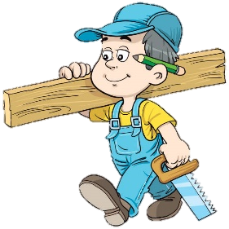An elderly carpenter was ready to retire. He told his employer-contractor of his plans to leave the house-building business to live a more leisurely life with his wife and enjoy his extended family. He would miss the paycheck each week, but he wanted to retire. They could get by.

The contractor was sorry to see his good worker go & asked if he could build just one more house as a personal favor. The carpenter said yes, but over time it was easy to see that his heart was not in his work. He resorted to shoddy workmanship and used inferior materials. It was an unfortunate way to end a dedicated career.

When the carpenter finished his work, his employer came to inspect the house. Then he handed the front-door key to the carpenter and said, "This is your house... my gift to you." The carpenter was shocked!

What a shame! If he had only known he was building his own house, he would have done it all so differently.

So it is with us. We build our lives, a day at a time, often putting less than our best into the building. Then, with a shock, we realize we have to live in the house we have built. If we could do it over, we would do it much differently.

But, you cannot go back. You are the carpenter, and every day you hammer a nail, place a board, or erect a wall. Someone once said, "Life is a do-it-yourself project." Your attitude, and the choices you make today, help build the "house" you will live in tomorrow. Therefore, Build wisely!

**A-Answer these question:**

**1 –What was carpenter plan?**

………………………………………………………………………………………………………………………………………………………………………………

**2 -What did he want?**

………………………………………………………………………………………………………………………………………………………………………………

**3-Did his employer come to inspect his house?**

……………………………………………………………………………………………………………………………………………………………………………

**B- Write [ T ] for True or [ F ] for False :**

|  |  |
| --- | --- |
| 1. His employer handed the front-door key to the carpenter |  |
| 1. An elderly carpenter was ready to retire. |  |

**C- Choose the right answer:**

1. He would have done it all so …………..

**a-** **differently. b-beautiful c-awesome**

2. Someone once said, "Life is a do-it-yourself…………"

**a-work b- project c-building**

**D-Find the antonym**:

a- fortunate**** #..................................... b-started #......................



**Kingdom of Saudi Arabia English Language Final Exam**

**Ministry of Education The Second Trimester,1st Session, 1444**

**General Directorate of Education in Makkah The 1.3 Secondary Grade**

**South Education Office Time: 3 hours**

**14th Secondary School No. of pages: 3**

12

**12**

**12**

**I- Composition**:

**A- Guided Composition:**

**Write an email to complain about a** **charger** you bought

**6**

6

**Guided words**:

Anker

Customer Service Department.

231 Abdelaziz Road

Riyadh, SA 12340

4 Ramadan 1443

****Dear Sir …………………………………………………………………………………………………………………………………………………………………………………………………………………………………………………………………………………………………………………………………………………………………………………………………………………………………………………………………………………………………………………………………………………………………………………………………………………………………………………………………………………………………………………………………………………………………………………………………………………………………………………………………………………………………………………………………………………………………………………………………………………………………………………………………………………………………………………………………………………………………………………………………………………………………………………………………………………………………………………………………………………………………………………………………………………………………………………………………………………………………………………………………………………………………………………………………………………………………………………………………………………………………………………………………………………………………………………………………………………………………………………………………………………………………………………………………………………………………………………………………………………………………………………………………………………………………………………………………………………………………………………………………………………………..…………………………………………………………………………………………………………………………………………

**Any possible answer**

**2 idea**

**2 structure**

**2 spelling**

Your sincerely,

A displeased former customer.

**6**

6

B- **Free Composition:**

**Write an essay about (inventions) Or a ( Voyage expedition)**

………………………………………………………………………………………………………………………………………………………………………………………………………………………………………………………………………………………………………………………………………………………………………………………………………………………………………………………………………………………………………………………………………………………………………………………………………………………………………………………………………………………………………………………………………………………………………………………………………………………………………………………………………………………………………………………………………………………………………………………………………………………………………………………………………………………………………………………………………………………………………………………………………………………………………………………………………………………………………………………………………………………………………………………………………………………………………………………………………………

**Any possible answer**

**2 idea**

**2 structure**

**2 spelling**

**II -Grammar**:

**6**

6

**A-Choose the correct answers: [½ for each]**

1- We’re **[got- get- getting]** the rooms decorated.

2-​ The jacket needs to be **[sew-sewed-sewn]**.

3- By the time It [ **rained- raining-rains**], we had gathered in the park.

4- A small asteroid **[has exploded-exploded-exploding**] over Siberiasince 1990.

5- When [ **did-does-do**] IBM introduce the first PC?

6- Yes, it’s a good idea.” My friend **[ assured –** **agreed – told ]** it was a good idea.

**B-Do as shown between brackets: [ (1) for each]**

1- you-want to–know-what-Don’t–happened? [**Unscramble to make a sentence**]

Don't you know what happened?

2-" Is he bothering you?"

She asked if he was bothering me. **[ Report the questions ]**

3 - She **has guessed** the result a month ago…… **guessed** ……...  **[Correct ]**

I won’t persuade my mom to come. **[Express disagreement]** 4-

I will.



**III- Vocabulary: [½ for each]**

**6**

6

**A-Match between the words and their pictures:**

1-

1- stain 2- oil well **3-** Tornado **4-** scan **5-** candidate



( 5 ) ( 3 ) ( 2 ) ( 1 )

**2- Match the words with the meanings:**

|  |  |
| --- | --- |
| 1- purchase | ( 4 ) break down |
| 2- weird | ( 3 ) dig |
| 3- drill | ( 2 ) very strange |
| 4- deteriorate | ( 1 ) buy |
| 5- reschedule |  |

**3- Circle the Odd words**

a**-** Oil- computer - airplanes- smart phone

b- screen-signal-pip-dent

:

**4-Give the antonyms for the words:**

a-filthy # clean.

b**-** immature # mature

**6**

6

**IV-Reading**

**Read the following passage and answer the questions below:**

An elderly carpenter was ready to retire. He told his employer-contractor of his plans to leave the house-building business to live a more leisurely life with his wife and enjoy his extended family. He would miss the paycheck each week, but he wanted to retire. They could get by.

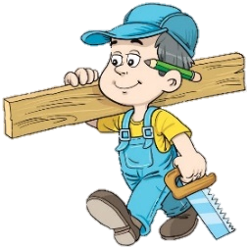The contractor was sorry to see his good worker go & asked if he could build just one more house as a personal favor. The carpenter said yes, but over time it was easy to see that his heart was not in his work. He resorted to shoddy workmanship and used inferior materials. It was an unfortunate way to end a dedicated career.

When the carpenter finished his work, his employer came to inspect the house. Then he handed the front-door key to the carpenter and said, "This is your house my gift to you." the carpenter was shocked!

What a shame! If he had only known he was building his own house, he would have done it all so differently.

So it is with us. We build our lives, a day at a time, often putting less than our best into the building. Then, with a shock, we realize we have to live in the house we have built. If we could do it over, we would do it much differently.

But, you cannot go back. You are the carpenter, and every day you hammer a nail, place a board, or erect a wall. Someone once said, "Life is a do-it-yourself project." Your attitude, and the choices you make today, help build the "house" you will live in tomorrow. Therefore, Build wisely!

**A-Answer these question:** **[ (1) for each]**

**1 –What was carpenter plan?**

**To leave the house-building business to live a more leisurely life with his wife and enjoy his extended family**

**2 -What did he want?**

He wanted to retire.

3**-Did his employer come to inspect his house**?

Yes, he did.

**B- Write [ T ] for True or [ F ] for False : [½ for each]**

|  |  |
| --- | --- |
| 1. His employer handed the front-door key to the carpenter | T |
| 1. An elderly carpenter was ready to retire. | T |

**C- Choose the right answer :**

1. He would have done it all so …………..

**a-** **differently. b-beautiful c-awesome**

2. Someone once said, "Life is a do-it-yourself…………"

**a-work b- project c-building**

**D-Find the antonym** :

a- fortunate**** **# unfortunate**  b-started #. **finished**