

English Language

Intermediate Grade 2nd

period Exam

Kingdom of Saudi Arabia

Ministry of Education

……………… intermediate school

Student's Name : class:

|  |
| --- |
|  |
| 5 |

1-Read the following passage and answer the questions below:

The winter months are December , January and , February . It's cold and rains in winter . We wear heavy clothes in winter . The summer months are June , July and August . It's hot in summer . People wear light clothes . They go to the to the park or to the sea , some children like to play football and fly9 their kites .

**A-Choose the correct answer:**

1-It's hot in ……………..

a- winter b-spring c-summer

2-It …………………………… in winter.

a-rains b- takes c-water

3-We wear light ………………… in summer.

a-months b-jacket c-clothes

**B) Put (√ ) or (×):**

1- The opposite of cold is hot. ( )

2- The winter months are June , July and August . ( )

|  |
| --- |
|  |
| 5 |

**2-choose the correct answer**

1- They are going to ( play – played – plays ) bowling.

2- Noura is a ( loudly – loud – louds ) speaker.

3-(what – where – who ) are they going to write to ?

4--If you heat the water to 100ْC , it( boil – boils – boiling ).

5- I will ( travel – traveling _ travels ) to Jeddah.

6- How will he ( gets – getting -get) to work?

7- Imad is ( go – goes – going ) to climb a mountain.

8- Omar drives ( slow – slows – slowly ).

9- Will they ( going – goes – go ) to the park.

10- If it’s hot and humid, I don’t ( feel – feels – felt ) very active.

|  |
| --- |
|  |
| 6 |

**3. Do as shown between brackets.**

**A-(Correct)**

1- Amal is going to **cooked** the dinner. …………………

2- - If it rains, I won't **played** tennis . …………..

3- Sabah is a **quietly** speaker…………………

4- Ali will **is** ten next year . ……………….

B**-( use adverb of manner)**

1- Asma is a good writer

……………………………………………………………………………………………

C-**(Give the negative)**

1- It’ll be cold and snowy

…………………………………………………………………………………………….

**D-(answer)**

1- Will it rain afternoon?

-No, …………………………………………

2-is he going to play tennis?

Yes,……..……………………………….

|  |
| --- |
|  |
| 4 |

**4- A. Choose the correct answer.**

1-t’s going to (rain – dry) today. You need your umbrella.

2-It will be 40 degrees Celsius today. That’s (hot – cold).

**5-write the opposite of these words.**

1-unusual ≠ …………………… 2-inexpensive≠ ………………….

6-**write the correct word for each picture.**

Windy relaxing snowy noisy

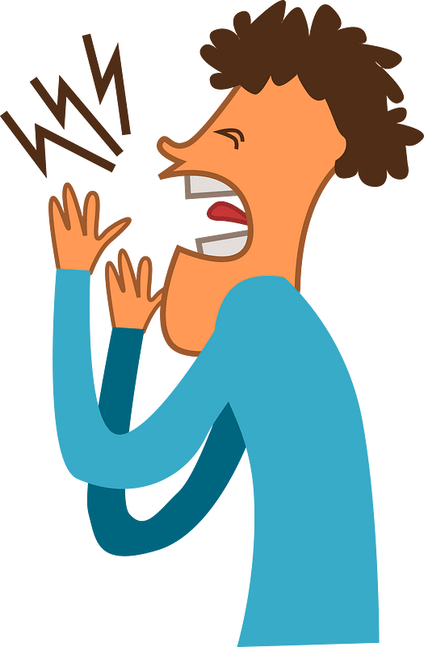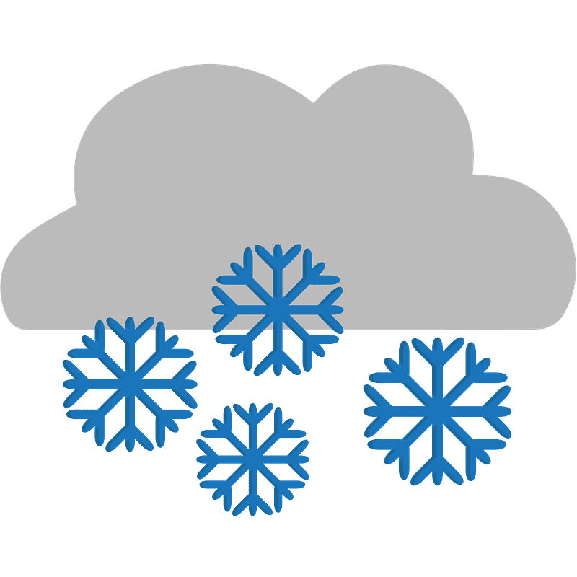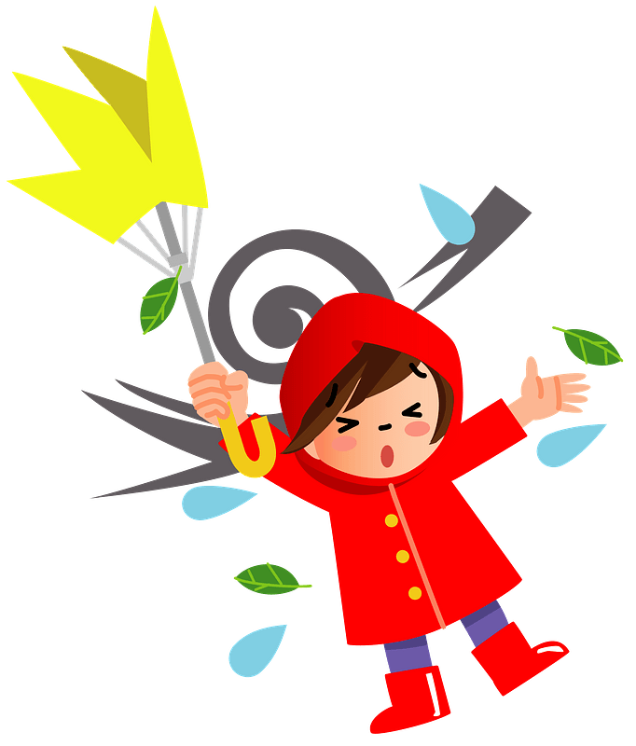

………………..

………………..

………………..

………………..

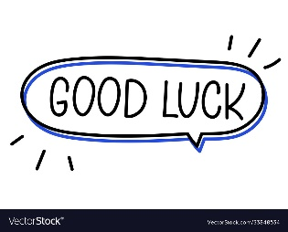



Your teacher



Kingdom of Saudi Arabia

Ministry of Education

………… Education Directorate

……………….. Intermediate School

**Super Goal 2** - **Test** unit 12 & 13

By **Rashed Alsulami** | **Telegram:** https://t.me/iRashed

Name :………………………………………………………………………… Class:…….……….

**Comprehension**

2 Marks

* **Read the text and answer the questions. Write T or F at the end of each question/statement.**

The best place to shop for a bargain is a yard sale. Many people in the U.S. have yard sales. They gather things from their home that they don’t use anymore and put them out in the front yard for other people to buy. You can buy almost anything at a yard sale, but there are usually clothes, appliances, toys, furniture, and DVDs. Usually these things are in good condition and the owner just doesn’t need them anymore. Items at a yard sale are usually very cheap, so you can get good bargains. Some people go to yard sales every week. They drive around neighborhoods every weekend looking for bargains. Sometimes they look for items that they can sell to someone for a higher price at their own yard sale!

1. You can buy almost anything at a yard sale. ( )
2. People sell things they don’t use anymore. ( )
3. Yard sale items are usually expensive. ( )
4. Yard sales are held in stores.( )

**Grammar**

* **Choose the best answer to fill in the blank in each question.**

5 Marks

1. Jeddah is__________________.

**a**. a beautiful city **b**. a city beautiful **c**. a beautiful **d.** beautiful a city

1. They _________ going to go by plane.

**a**. isn’t **b**. are  **c**. is **d.** am

1. _______ is he going to leave ?

**a**. What **b**. Which  **c**. When  **d.** Who

1. **Jane:** Will it be sunny tomorrow? **Amira:** No, ______________.____________________.

**a**. it won’t **b**. it will **c**. won’t it **d.** will it

1. If the hurricane hits Florida, it _________ a lot of damage.

**a**. may causing **b**. causes **c**. might cause  **d.** will causes

**اقلب الصفحة**



* **Write the correct adverb to fill in the blank.**

1.5 Marks

1. My grandmother is a good cook. She cooks ____________________.
2. Majid is a fast learner. He learns ______________.
3. They have a peaceful life in the village. The people in the village live ____________.

* **Use Information Questions ( How – Where – What ).**

1.5 Marks

1. _______________will you do in the summer? I’ll probably trave.
2. ______________ will you go? I’ll go to Jordan.
3. ______________will you go? Maybe I’ll drive.

**Vocabulary**

* **Choose the best answer to fill in the blank in each question.**

5 Marks

1. This quiet beach is __________.

**a**. noisy **b**. relaxing  **c**. adventurous **d.** expensive

1. I go to this place to relax because it is ___________.

**a**. noisy **b**. cultural  **c**. historical **d.** peaceful

1. This place is ________. It was built thousands of years ago.

**a**. adventurous **b**. historical  **c**. relaxing  **d.** noisy

1. It’s _______________ today. Hold on to your hat.

**a**. windy  **b**. sunny **c**. cloudy **d.** snows

1. It will be _______________ this afternoon. You should bring your umbrella.

**a**. windy **b**. cloudy **c**. rainy  **d.** sunny

* **Write the correct word under the picture.**

3 Marks

Partly cloudy – Desert – Rainforest

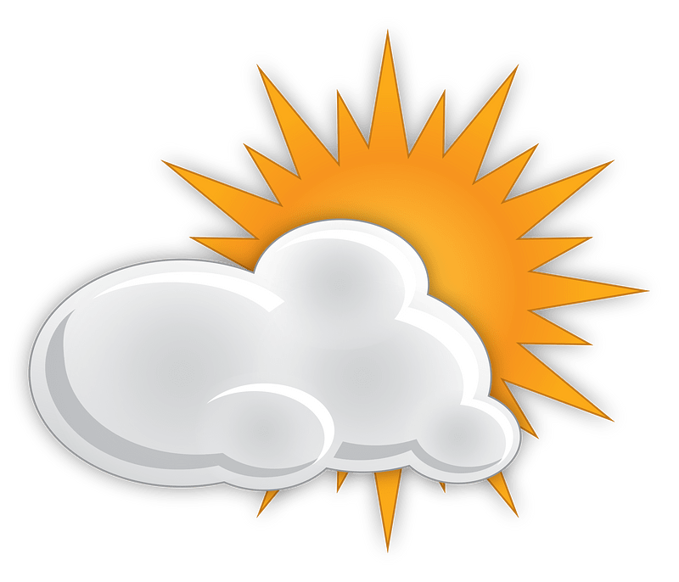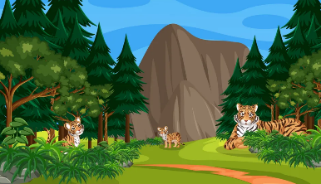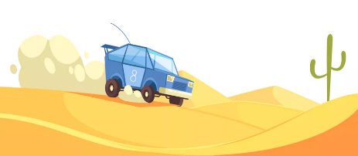

………………………………………….

………………………………………….

………………………………………….

**Orthography**

* **Choose the correct letter.**

2 Marks

* Are you going on va…..ation ? ( c – o – r )
* Spring is usually c….ol ( v – o – r )

**انتهت الأسئلة....**

**التوفيق والنجاح دوماً في طريقكم أبنائي.. تذكروا دائماً بأنني فخور بكم فأنتم مستقبل هذا الوطن الغالي إن شاء الله ونجاحكم هو نجاحي..**

**الأستاذ / راشد السلمي**