**King of Saudi Arabia**

**Ministry of Education**

**3rd Term 1444/2023**

**English Language**

**2nd Grade**

**Midterm Exam**

Student's name/ ....................................................................... Class/ 2 /

**Section A / Reading**

Read the following passage and answer the questions **below.**

Hi, my name is Eyad. Every morning I go to the gym and read in the afternoons. But I still have a lot of free time. Going to the gym takes me about two hours, including the road time and the post-gym shower. And I usually read for one hour. Another activity that I do is watching documentaries. I study history, and I love historical documentaries. I learn a lot from them. I watch documentaries for one and a half hours four or five times a week.

***A)*** Put (T) for True **OR** (F) for False: _

|  |  |
| --- | --- |
|  | **1. Eyad always reads for one hour.** |
|  | **2. He likes to watch wild documentaries.** |
|  | **3. The time to arrive at the club is Tow hours.** |

**Section B / Grammar**

(1) Ali speaks ______

**a) loud b) loudly c) slow**

(2) **A:** _________ is he going to travel? **B:** He's going to travel by bus.

**a) What b) Where c) How**

(3) She will ______ her room.

**a) cleans b) clean c) cleaning**

(4) If heat the water to 100 C, it _____

**a) boiling b) boils c) boil**

(5) They are going to _____ a movie at a home.

**a) watching b) watch c) watches**

(6) **A:** ________ he go to a bank? **B:** No, he won't

**a) Does b) Will c) Is**

Do as shown between brackets: _

**A- (Correct).**

(1) Ali plays **good** " ........................"

**B- (Give the negative for each sentence)**

(1) We are going to swim. .........................................................................................................

(2) They will go to a park. ..........................................................................................................

**Section C/ Vocabulary**

**A) Choose the correct answer from column (B)**

|  |  |
| --- | --- |
| **B** | **A** |
| **(a) relaxing** | 1. A way to introduce news. ( ) |
| **(b) I hear** | 2.They have a______ life in the village. ( ) |
| **(c) winter** | 3. This quiet beach is _________ ( ) |
| **(d) peaceful** | 4. I’ll probably go ice-skating or skiing this _______ ( ) |

**Section D / Write each word under each picture.**

|  |  |  |  |
| --- | --- | --- | --- |
| Party cloud | Rainy | Cloud | Sunny |



.......................... ......................................

**Section E/ Orthography**

A) Choose the correct letter: _

(1) He needs to play football on Tu_sday ( **i _ e _ a )**

(2) This street is very noi_y **( c _ s_ z)**

~

1

~



**Grade 1**

**1**

**th**

**Mid**

**-**

**Term Exam /**

**Third**

**semeste**

**r**

Student's Name:

……………………………………………………………………………..

Class:

……………………

Subject:

**English**

**A)**

**Match**

**:**

**1.**

_____

enhance

a. real, not false

**2.**

_____ equivalent

b. to increase energy or activity

**3.**

_____ hearty

c. strong and with feeling

**4.**

_____

stimulate

d. related to the medical care of children

**5.**

_____ pediatric

e.

to impr

ove

**6**

**.**

_____

genuine

e. equa

l

**B**

**)**

**Fill in the**

**gaps**

**with the**

**correct**

**word**

**:**

**toxins**

**fascinated**

**irritated**

**aroma**

**bilingual**

**bitter**

**.**

**1**

Paint has lots of ____________________ in it, so you should try not to breathe

in the fumes.

**2**

**.**

I put a lot of sugar and milk in my coffee, because otherwise

it tastes

too _

_________.

**3.**

The ____

______ of fresh baked bread in the kitchen is

making my mouth water.

**4**

**.**

Someone who can speak both Arabic and English is

________

______.

**5**

**.**

Someone who is amazed at something is

____

___

____

___.

**6**

**.**

Someone who is annoyed at something is

____

___

____

___.



**0.5**

**each**



**0.5**

**each**

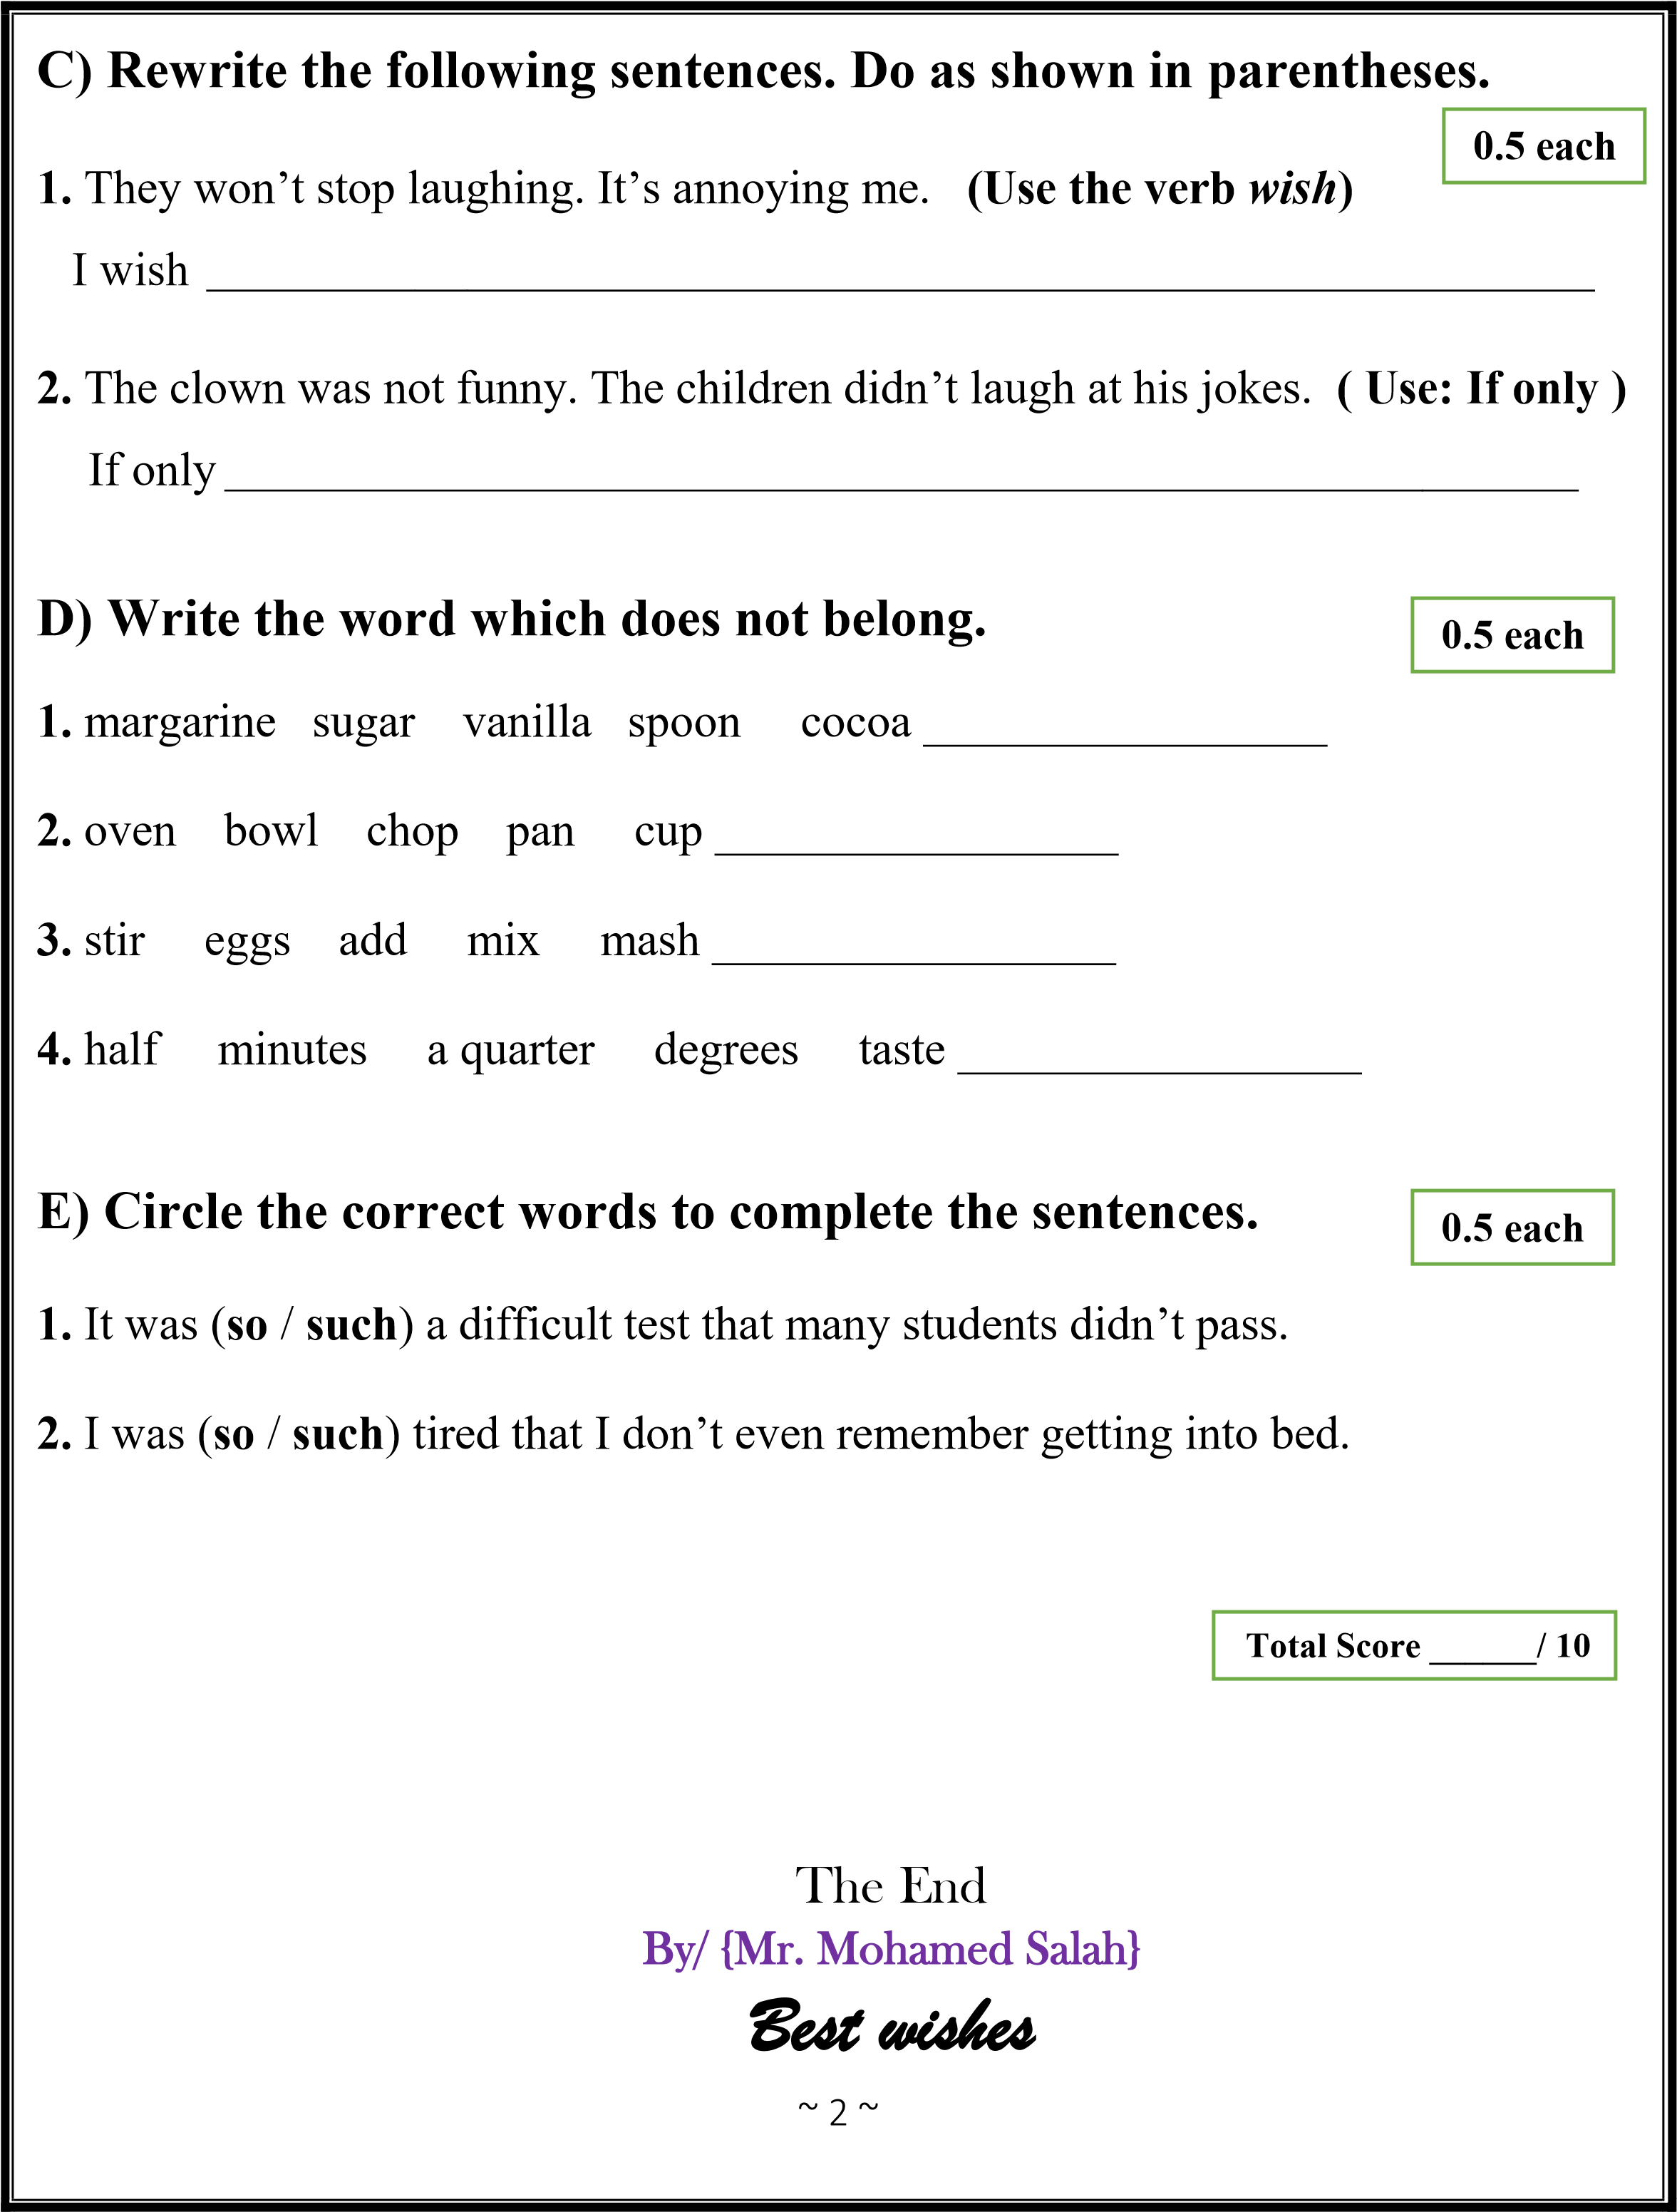

10

الاسم:................................................ الصف:..................... رقم الاختبار:2 رقم النموذج : 1



المملكة العربية السعودية

وزارة التعليم

الإدارة العامة للتعليم بمحافظة الأحساء

مدرسة الإمام جعفر الصادق الثانوية

**Question (1) Fill in the blank with a word from the box:**

existence- licensed- toxins - staple- substitute

1 each

1. …………………… the presence of something in reality.
2. Paint has lots of …………………… in it, so you should try not to breathe in the fumes.
3. Tom wants to get …………………to fish so that he can catch some of the food his family eats.
4. …………………… a common or important item.

0.5 each

**Question (2) Do as between brackets:**

1. He ran to the supermarket because we ran………………. milk **(Complete with three-phrasal verb)**

…………………………………………………………………………………………………….

1. Bill’s tired of pizza. Let’s eat something else. **(Use a pronoun object in place of the noun object)**

…………………………………………………………………………………………………….

**Question (3) Mark the nouns with C for count or N for noncount:**

0.5 each

1. ………. Banana c) ………. egg

1. ………. Milk d) ………. sugar

1 each

**Question (4) Match with the correct answer:**

|  |  |  |  |
| --- | --- | --- | --- |
| **-** | **A** | **-** | **B** |
| **1** | Spread |  | Someone who sells something |
| **2** | Whipped it up |  | Very quickly |
| **3** | in no time |  | Made it quickly and easily |
| **-** | - |  | An abundant meal laid out on a table |

10

الاسم:................................................ الصف:..................... رقم الاختبار:1 رقم النموذج : 1



المملكة العربية السعودية

وزارة التعليم

الإدارة العامة للتعليم بمحافظة الأحساء

مدرسة الإمام جعفر الصادق الثانوية

**Question (1) Fill in the blank with a word from the box:**

prompt - remarkable - antibodies - bilingual - puzzled

1 each

1. Something that is incredible can also be called……………………
2. Keiko is ………………………………………She was born in Japan, but moved to the U.S. when she was young. Now she can speak Japanese and English perfectly.
3. ………………………… substance produced by the body to fight germs and infection.
4. ……………………….. to cause someone to do something.

0.5 each

**Question (2) Do as between brackets:**

1. He was a small child that people sometimes thought he was a baby **(use: such)**

…………………………………………………………………………………………………….

1. You know winter is coming when it starts …………………….earlier. **(use: get + an adjective)**

**Question (3) Fill in the blank with the correct tense**

0.5 each

1. When Jack found out that he wasn’t accepted to his first choice of university, he was…………………. The news was ……………………. (**disappoint**)

1. Gisele was supposed to be home an hour ago. I’m ……………………… (**worried**)

1 each

**Question (4) Match with the correct answer:**

|  |  |  |  |
| --- | --- | --- | --- |
| **-** | **A** | **-** | **B** |
| **1** | Getting to |  | Make you feel happier |
| **2** | Blow me away |  | Annoying or bothering |
| **3** | Cheer you up |  | To increase energy or activity |
| **4** | Stimulate |  | Really impress me |
| **-** | - |  | To improve |

ET: Ammar Al Eid