1st Grade Unit 1 Skills Evaluation
3rd TERM
Name ……………………………………………………. Class………...
1-Write guided short answers to written questionsمهارة: كتابة الاجابة على الأسئلة. بشكل صحيح

Answer:-
- Do you have a pet?

- Do you have a pet?

2-Utter simple words and numbers (cardinal numbers 1-19) مهارة: معرفة الأرقام من 1-19

Count the numbers of the drinks , then circle the number next to it.
18 5 4
9 12 13
2 6 1
8 10 6
3 19 14
16 10 11

3- Be willing to listen to short prepared digital and recoded مهارة: الاستماع لمقطع صوتي. صوتي كتابةالاالاجابة على الأسئلة materials
مهارة: معرفة الأرقام من 1-19

Listen to PACO chant then answer :
1-PACO is a ( rabbit , horse , sheep)
2-There was a ( farmer , teacher , doctor ) who had a horse.
3-The horse’s name is ( S-A-B-O / P-A-C-O / D-A-C-O)
4- Identify and talk about food, animals, clothes مهارة: التحدث عن الطعام, الحيوان, الملابس.

5- Read and match words to photos/drawings مهارة: قراءة الكلمات والتوصيل بالصورة.

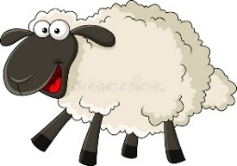
Write then match:
6
5
4
3
2
1
1-RBID
2-PEESH
3-UCKD
4-HSIF
5-OWC
6-TAC
U | S
V | T
Circle then write the word:
6- Recognize and match sounds to letters مهارة: التعرف على الأصوات وتوصيلها بالحروف.

1-
U | S
V | T
2-
U | S
V | T
3-
U | S
V | T
4-
7- Copy words, numbers and simple short sentences مهارة: نسخ كلمات وأرقام وجمل.

8- Use lined paper correctly with headline, midline, and baseline مهارة: معرفة واتقان الكتابة بين السطور.

9- Write upper/lower case letters correctly مهارة: معرفة واتقان الحروف الكبيرة والصغيرة.

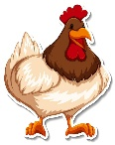  Chicken | 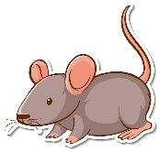  Mouse | 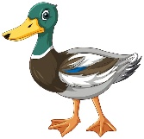  Duck | 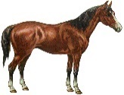  Horse
Copy
21 11 16 30

1st Grade Unit 1 Skills Evaluation
3rd TERM
Name ……………………………………………………. Class………...
1-Write guided short answers to written questionsمهارة: كتابة الاجابة على الأسئلة. بشكل صحيح

Answer:-
- Do you have a pet?
Yes, I have. I have a turtle.

- Do you have a pet?
No, I don’t have.

2-Utter simple words and numbers (cardinal numbers 1-19) مهارة: معرفة الأرقام من 1-19

Count the numbers of the drinks, then circle the number next to it.
18 5 4
2 6 1
9 12 13
8 10 6
3 19 14
16 10 11

3- Be willing to listen to short prepared digital and recoded مهارة: الاستماع لمقطع صوتي. صوتي كتابةالاالاجابة على الأسئلة materials
مهارة: معرفة الأرقام من 1-19

Listen to PACO chant then answer :
1-PACO is a ( rabbit , horse , sheep)
2-There was a ( farmer , teacher , doctor ) who had a horse.
3-The horse’s name is ( S-A-B-O / P-A-C-O / D-A-C-O)
4- Identify and talk about food, animals, clothes مهارة: التحدث عن الطعام, الحيوان, الملابس.

5- Read and match words to photos/drawings مهارة: قراءة الكلمات والتوصيل بالصورة.

Write then match:
6
5
4
3
2
1
Bird
1-RBID
4
6
Sheep
2-PEESH
2
Duck
3-UCKD
Fish
4-HSIF
1
3
Cow
5-OWC
5
Cat
6-TAC
U | S
V | T
Circle then write the word:
Sun
6- Recognize and match sounds to letters مهارة: التعرف على الأصوات وتوصيلها بالحروف.

1-
Tiger
U | S
V | T
2-
U | S
V | T
Umbrella
3-
U | S
V | T
Vase
4-
7- Copy words, numbers and simple short sentences مهارة: نسخ كلمات وأرقام وجمل.

8- Use lined paper correctly with headline, midline, and baseline مهارة: معرفة واتقان الكتابة بين السطور.

9- Write upper/lower case letters correctly مهارة: معرفة واتقان الحروف الكبيرة والصغيرة.

Chicken | Mouse | Duck | 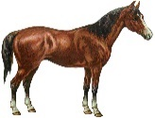  Horse
Chicken | Mouse | Duck | Horse
Copy
21 11 16 30

30
16
11
21

