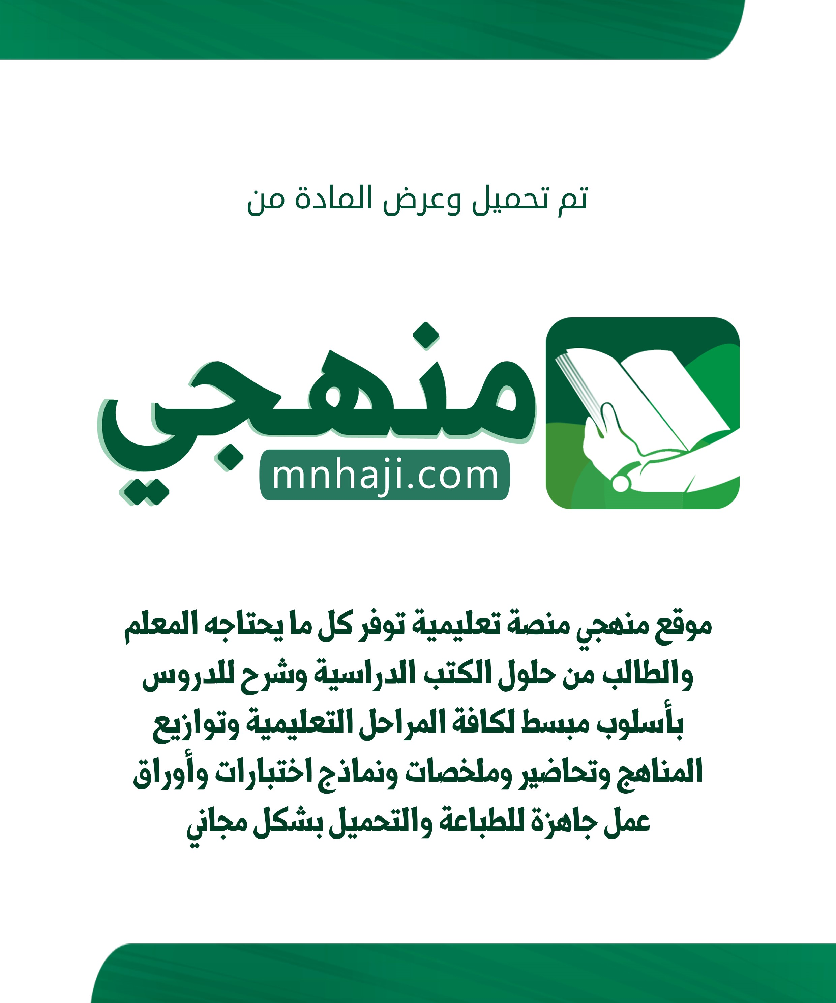

Kingdom of Saudi Arabia English Language Final Listening Exam
Ministry of Education Grade: ___ (Model A)
____________________ GSecondary.D. of Education School Term: Time: 25 minutes 2nd – 1444
Mark out of  5 |  | _____________________________________  _____________________________________ | Graded by:
 |  |  | Revised by:

اختبار استماع مادة )اللغة الإنجليزية 2.2 - الفصل الدراس ي الثاني ( للصف الثاني ثانوي - للعام الدراس ي 1444هـ - نظام المسارات اسـم الطالب : ____________________________________________________________ رقم الجلوس : ___________ اللجنة: ___________ رَ ِّبِ اشْرحَْ لِي صَدْرِي وَيَ ِّسِرْ لِي أَمْرِ ي
Listen to the interview, and then answer the following questions
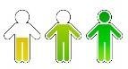
1) Choose the correct answer: (½ mark each)

- The interviewer is talking to ___________Baker
a- | chef | b- | teacher | c- | doctor | d- | worker
2) | Maintaining body temperature is one of ___________
a- | body function | b- | physical activity | c- | digesting food | d- | energy
3) | Sports, manual work, or housework are examples of ___________
a- | body function | b- | physical activity | c- | digestive food | d- | Physical Education
- Match each activity with its used percentage: (½ mark each)

Activity |  | Percentage
1. Body function ( | ) | a. 10% - 20%
2. Physical activities ( | ) | b. 16% - 17%
3. Digesting food ( | ) | - 20% - 30%  - 60% - 70%
- Put ( T ) for true or ( F ) for false sentences : (½ mark each)

  - [_____] ¾ of our energy is used to keep the body working.
  - [_____] We get calories from food.
  - [_____] Energy is used only to eat.
  - [_____] We use more energy if we don't do any kind of physical activity.

Finished – Best Wishes
- Essa Al Hussaini -
to listen to / download the audio

Kingdom of Saudi Arabia English Language Final Listening Exam Ministry of Education Grade: ___ (Model A)
____________________ GSecondary School.D. of Education Term: Time: 25 minutes 2nd – 1444

اختبار استماع مادة )اللغة الإنجليزية 2.2 - الفصل الدراس ي الثاني ( للصف الثاني ثانوي
- للعام الدراس ي 1444هـ - نظام المسارات

Audio Script
Energy our Bodies Use

Interviewer: Dr Baker, can you tell us 20 to 30 percent of the total energy about the energy our bodies use? output of the body .
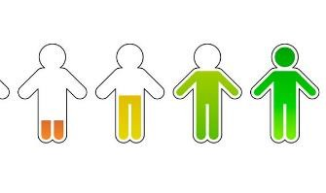
Dr Baker: Sure. Many people Interviewer: That leaves about don’t realize that most of the 10 to 20 per cent. How do we body’s energy– 60 to 70 per use that? cent – is used just for body
Dr Baker: That last 10 to
functions like heartbeat,
20 per cent of energy is
respiration, and used to digest food. maintaining body
temperature. Interviewer: So, we
use energy to eat? Interviewer: Really?
Almost three quarters of Dr Baker: Yes, to eat our energy is used just to keep the and to digest our food. body working?
Interviewer: Right. Where does our Dr Baker: That’s right. Of course, if we energy come from? do any kind of physical activity, we
Dr Baker: Mainly from calories, which
use more energy. I’m thinking of we get from different types of food. things like sports, manual work, or housework. This represents another Interviewer: That’s very interesting. What ….

Finished
–

Best Wishes

-

Essa Al Hussaini
-

to listen to / download the audio

