******المملكة العربية السعودية**

**Kingdom of Saudi Arabia**

**Ministry of Education**

**------- Educational Directorate**

**------- Educational Schools**

**1st grade intermediate 2022**

**1st Term – Final Exam**

**وزارة التعليم**

**الإدارة العامة للتعليم بن**

**مدارس م ن التعليمية**

**الصف الاول المتوسط**

**الاختبار النهائي للفصل الدراسي الأول 1444هـ**

|  |  |  |  |  |  |  |  |
| --- | --- | --- | --- | --- | --- | --- | --- |
| **Total**  **written** | **5 spelling** | **4 Vocabulary** | **3 Grammar** | **2 Comprehension** | | **1 Composition** | **Q. NO.** |
|  |  |  |  |  | |  | **Mark Given** |
| **30** | **4** | **7** | **7** | **6** | | **6** | **Mark** |
|  | | | **Reviser** | |  | | **Corrector** |
|  | |

**زمن الاختبار: ساعتان**

**اسم الطالب: ------------------------------------ رقم الجلوس: ------------- الصف الأول المتوسط**

**Composition**

**6**

**1- Write a paragraph about “Your Best Friend"**

**\* Who is your best friend? * How old is he? * Where is he from?**

**\* What's his nationality? *What is he like? * What subjects does he like?**

**\* What sports does he play? * Why do you like him?**

…………………………………………

………………………………………………………………………………………………………………………………………………………………………………………………………………………………………………………………………………………………………………………………………………………………………………………………………………………………………………………………………………………………………………………………………………………………………………………………………………………………….

**2) Comprehension**

**6**

**2- Read the following passage then answer the questions:**

**Flipper is a dolphin, and he is 5 years old. That is young for a dolphin. It is the age of an 18-year-old person. Flipper is a baby in human years, but he is a teen in dolphin years. Marla is old even for a turtle. She is 95 years old. Cleo the cat is one year old. In human years, she is a 15-year-old adolescent.**

**A- Put ( ) or ( x ):**

**1. Flipper is a baby in animal years. ( )**

**2. Marla is old even for a turtle. ( )**

**3. Flipper is a teen in dolphin years. ( )**

**4. Cleo is a 25-year-old adolescent. ( )**

**B- Choose the correct answer:**

**1. Cleo the cat is (**one – two – three**) years old.**

**2. Marla is (**97 - 96 - 95**) years old.**

**3. Flipper is (**old – young – fat**) for a dolphin.**

**4. Marla is (**old – young – fat**) even for a turtle.**

**C- Answer the following questions:**

**1. What is Flipper?** ………………………………………………………………….

**2. How old is Flipper?** …………………………..………………………………………

**3. What is the name of the cat?** …………………………………………………..

**4. What is the name of the turtle?** ……………………………………………………

**7**

**3) Grammar**

**A: Choose the correct answer:**

**1. I (**am – is – are**) very happy.**

**2. This is my brother. (**Her – His – My**) name is Ali.**

**3. English classes are (**in – on – at**) Mondays and Wednesdays.**

**4. (**Who – How – What**) old are you?**

**5. This (**am – is – are**) my pencil.**

**6. (**Isn’t – Doesn’t – Don’t**) touch that painting.**

**7. Mr. Omar is here (**in – on – at**) business.**

**8. (**When – What – Where**) are you from?**

**9. I (**have – has – is**) a sister.**

**10. Do you have (**a – any – some**) brothers and sisters?**

**B: Do as shown between brackets:**

**1. She is Nora. (**Make Negative**)**

……………………………………………………………………………………………………………………………………

**2. What day is today? (**Answer the question**)**

……………………………………………………………………………………………………………………………………

**3. That is --------- calculator. (**Put indefinite article a / an**)**

……………………………………………………………………………………………………………………………………

**4. She is from Saudi Arabia. (**Make Yes/No Question**)**

……………………………………………………………………………………………………………………………………

**4) vocabulary:**

**7**

**A- Write the correct number under its picture:**

**1. camera 2. parrot 3. family 4. scissors 5. reindeer 6. headphones 7. night**

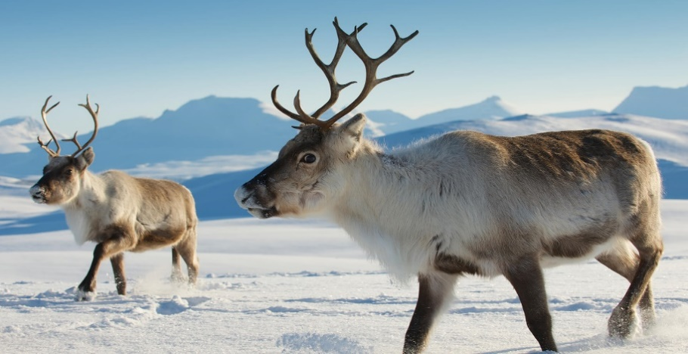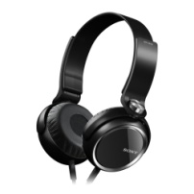****



**( ) ( ) ( ) ( ) ( ) ( ) ( )**

**B- Match the Real Talk:**

**1. I’ve got a. Not very much**

**2. Not really b. I have**

**3. Guess what? c. A reply to “Thank you.”**

**4. You’re welcome d. tell a surprise**

**C- Circle the correct spelling:**

**1. skelton - skeltan – skeleton**

**2. family – familiy - famliy**

**3. vacotion – vacation – vecation**

**5) Orthography**:

**4**

**A- Fill in the missing letters:**

**1. m__rning**

**b – r – o – u**

**2. num__ers**

**3. muse__m**

**4. wo__ld**

**B- Circle the odd one out:**

**1. morning afternoon evening school**

**2. father mother Jeddah sister**

**3. doctor Brazil Egypt Canada**

**4. Sunday Mom Monday Tuesday**

**End of Questions**

**Best of Luck https://t.me/abokhaledamer**

**ABOKHALEDAMER**

**0557325813**