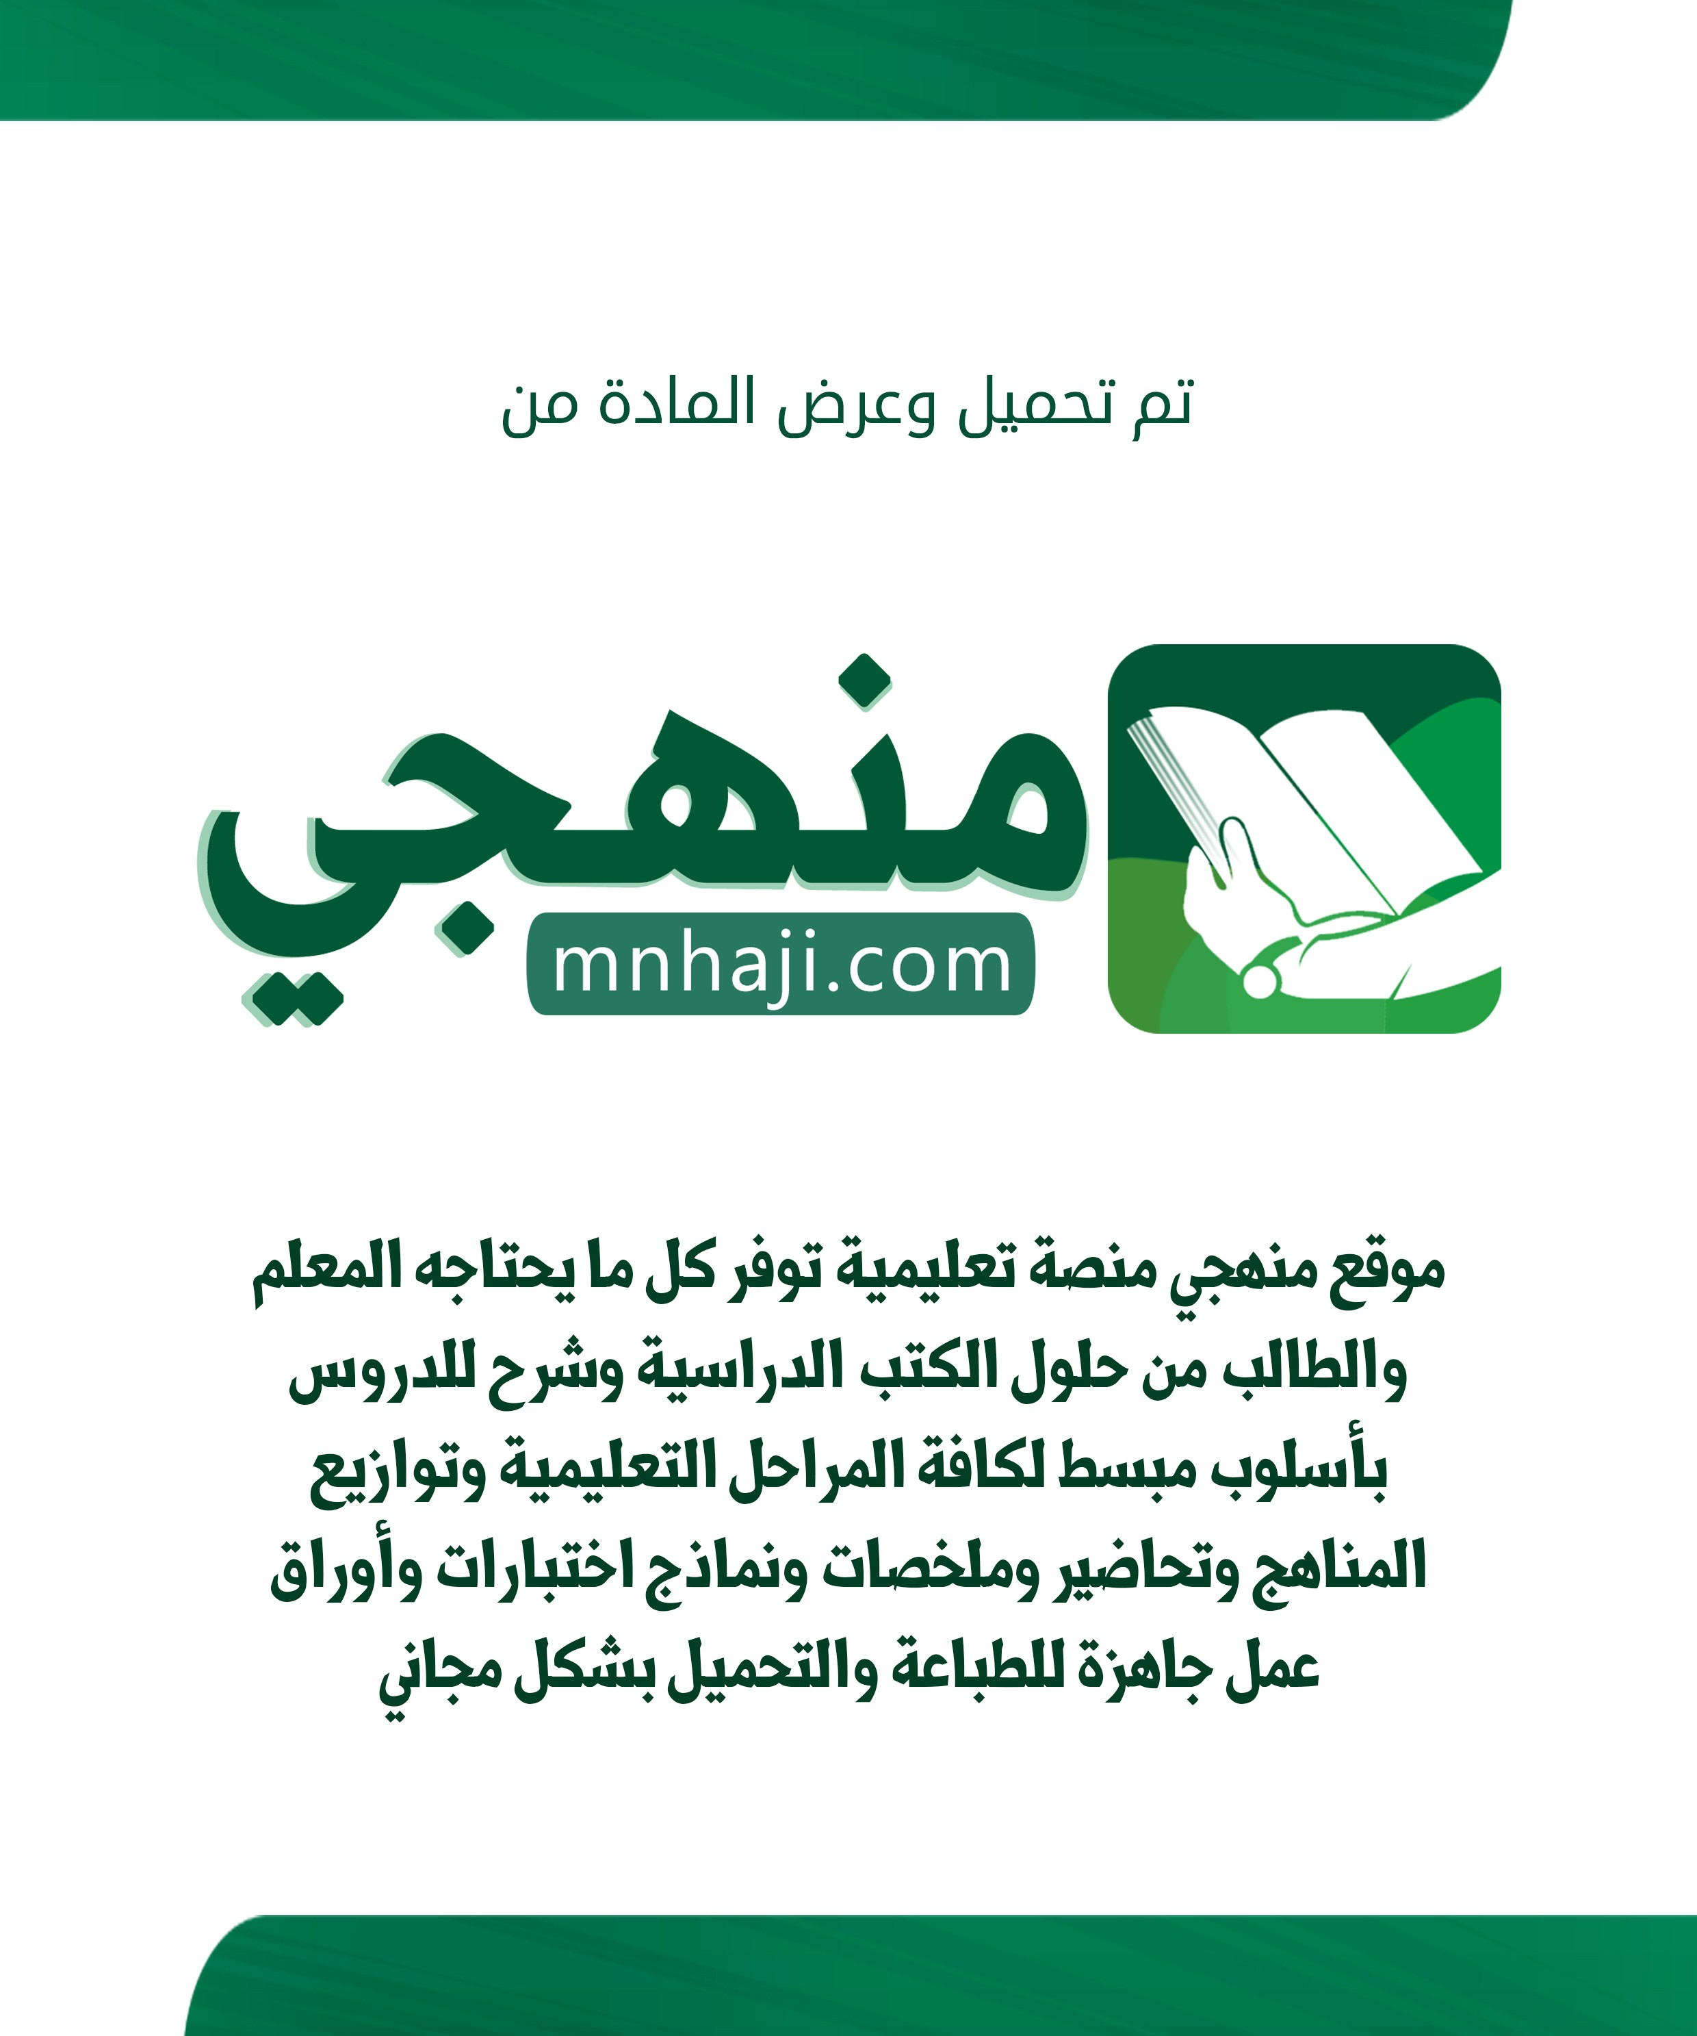

5th Grade Unit 1 Feelings
Name ……………………………………………………..Class………...
I can answer personal questions such as . . .

Answer the following questions :
1-What’s your name?
……………………………………………………………………………… 2-How are you?
……………………………………………………………………………… 3-It,s Nice to meet you!
………………………………………………………………………………
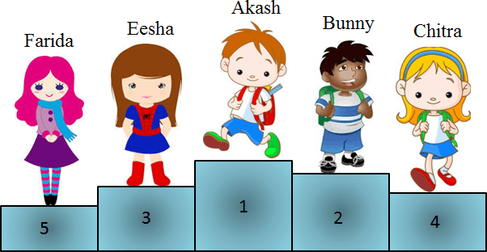
Choose :
1-Faris is the ( Second - First ) 2- Mona is the ( Third – Fourth )
3-Sara is the ( Fifth – fourth )
Farida
Mona
Mike
Faris Sara
I can write the correct ordinal Numbers

5- Mike is the ( First – Nineth )

Choose :
I can choose & fill in the blanks
1-I am ( Happy – Hungry ) 2-He is ( Thirsty – Sleepy )
3-They are ( Scared – Cold )

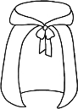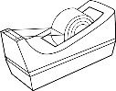Fill in :
1-C p 2-C p
4-T p 5-T p

3-V s
6-F c

5th Grade Unit 2 Things We Wear
Name ……………………………………………………..Class………...
I can answer personal & belonging questions such as . . .

Answer the following questions :
1-I like your hat!
……………………………………………………………………………… 2-Whose book is this?
……………………………………………………………………………… 3-What are you wearing today?
………………………………………………………………………………
I can write about what I am wearing

Rearrange :
1- am / I / and a blue skirt / a yellow hat / wearing
………………………………………………………………………………………. 3- wearing / a blue cap /He / and red T-shirt / is
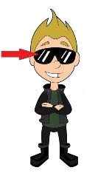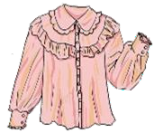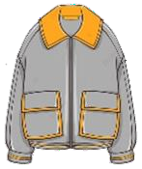………………………………………………………………………………………….
I can Match Clothes
Match :
1- Skirt
2-Jacket
3-blouse
4-Glasses
I can fill in the blanks
1- ate 2- ack 3- ane

5th Grade Unit 3 Things We Do
Name ……………………………………………………..Class………...
I can answer with verbs followed by the -ing form . . .

Answer the following questions :
1-What are you doing

?
……………………………………………………………………………… 2-What is he doing?
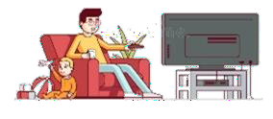
……………………………………………………………………………… 3-What is your dad doing?
………………………………………………………………………………
I can write(T) for True & (F) for False.

Ture or False :
1- I am playing football ( ) 2-I am doing Karate ( )
3-She is playing basketball ( )
I can describe things & match.
Match :
1- Thin cat.
2-Short tree.
3- Small bird.
4- Fat bear.

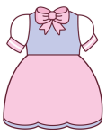1- ele ant 2- ink 3- ess 4- uck
I can fill in the blanks

